In this homework COlOR TONE I have written algorithm and tested using 4 images
which are
1)First image which I tested was this beautiful image and as u can see it has some colors and among with them we can see similar but stronger colors ,for example blue and strong blue.So what we expect after our algorithm its obvious the lightness of the picture has to decrease.
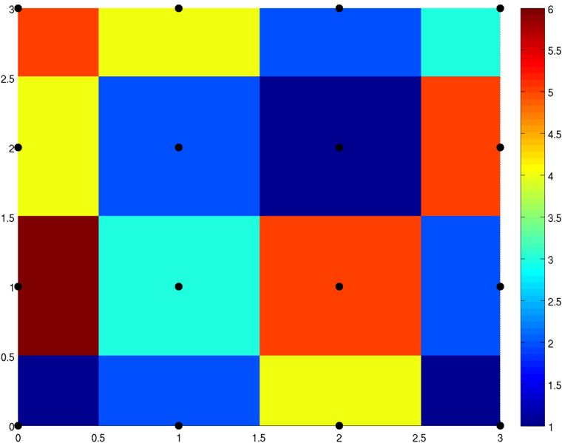
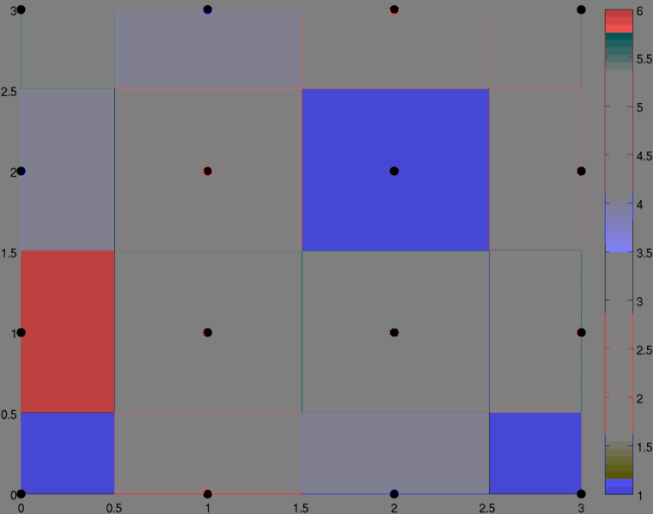

When it has decreased we can see just colors which before was strong color,and rest of them is has reduced their lightness.
I was interested if I will put black color what will happen.What I got was just black color.



So that’s mean white color has to decrease lightness and become to gray
And I was right



And finally I tried black and white obviously I got black and gray color



So depending on my search I think this method is good for science and Biology may be .
Let’s imagine we need to see where is the small dot in really light picture , this where can be used.
For example there is an object in front of sun and sun light is so high that human eye can’t see it.

