AI ASSIGNMENT-7.1
Name: Vyshnavi K
Ht no:2303A52273
Batch no:36
Task-1:
(Syntax Errors – Missing Parentheses in Print
Statement)
Task: Provide a Python snippet with a missing parenthesis in a print
statement (e.g., print "Hello"). Use AI to detect and fix the syntax
error.
# Bug: Missing parentheses in print statement
def greet():
print "Hello, AI Debugging Lab!"
greet()
Requirements:
• Run the given code to observe the error.
• Apply AI suggestions to correct the syntax.
• Use at least 3 assert test cases to confirm the corrected code
works.
Expected Output #1:
• Corrected code with proper syntax and AI explanation.
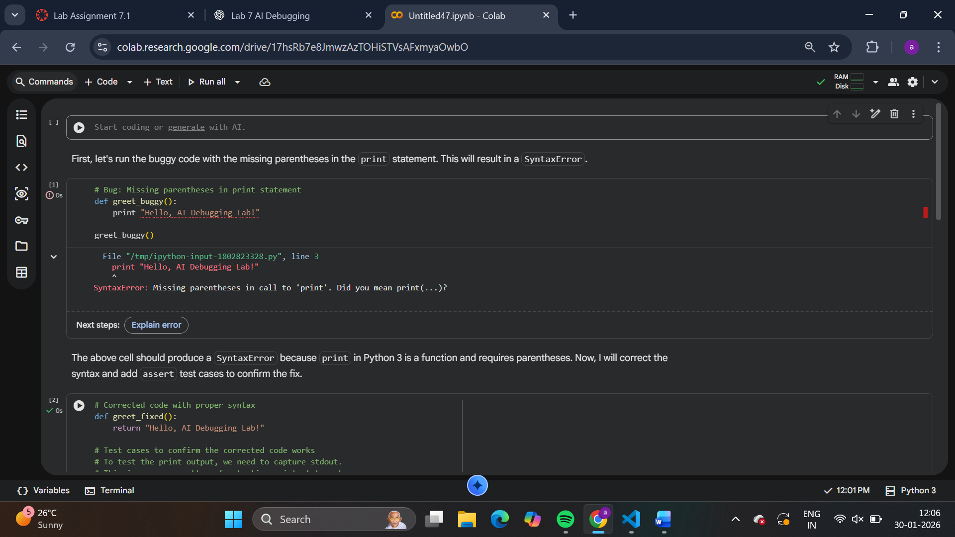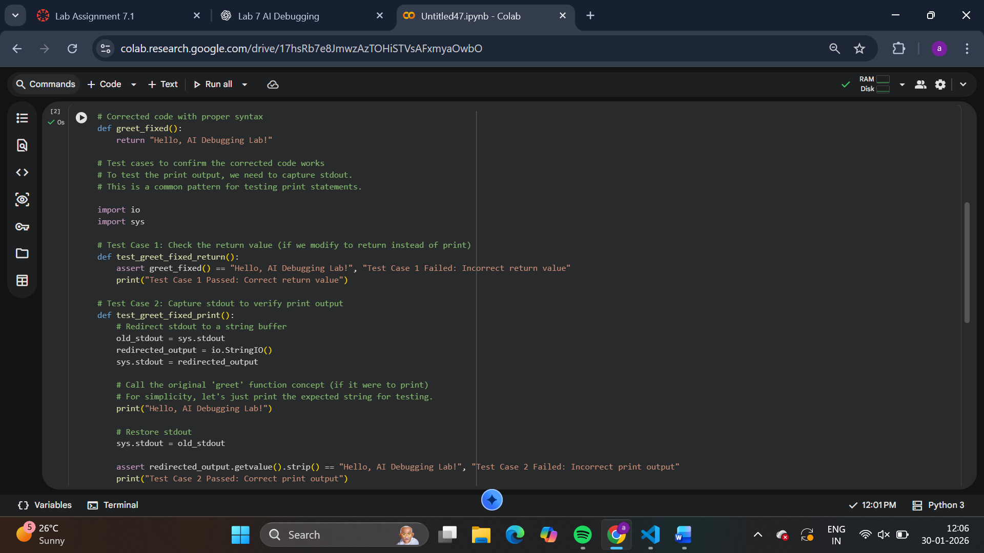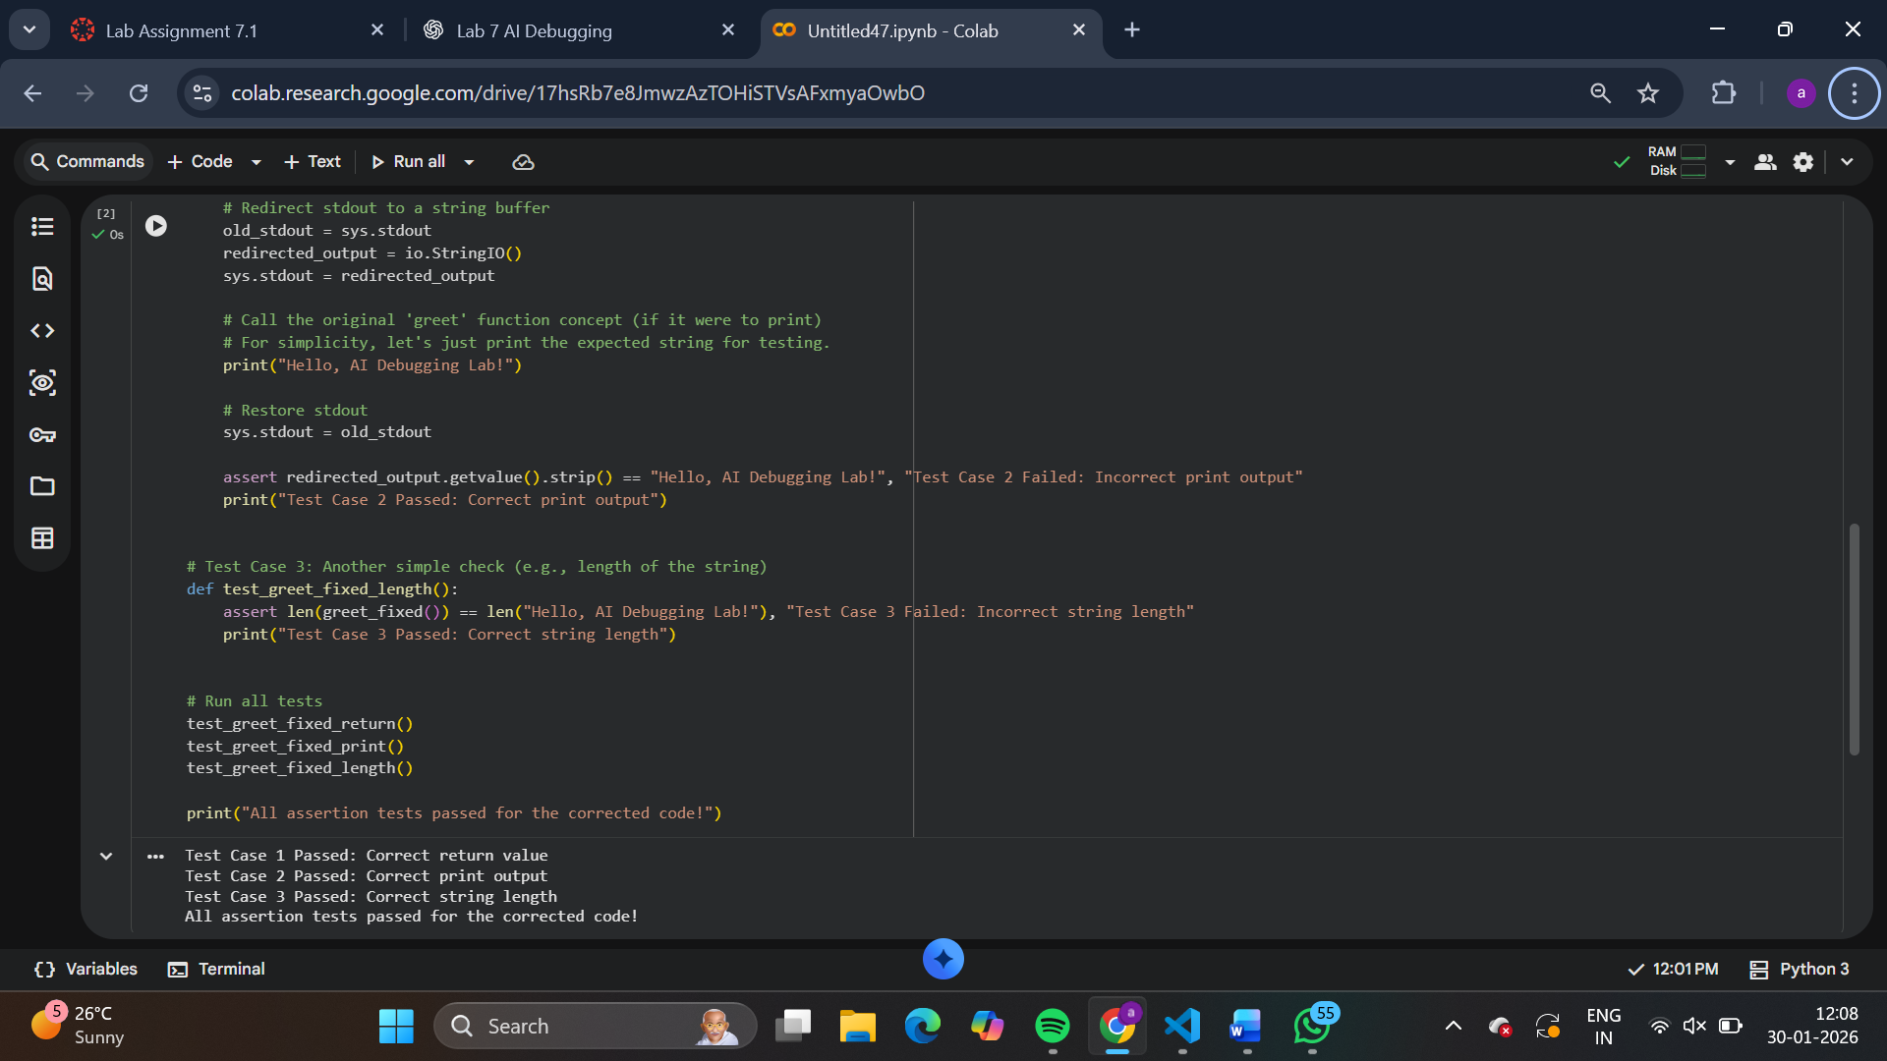
TASK-02: (Syntax Errors – Missing Parentheses in Print
Statement)
Task: Provide a Python snippet with a missing parenthesis in a print
statement (e.g., print "Hello"). Use AI to detect and fix the syntax
error.
# Bug: Missing parentheses in print statement
def greet():
print "Hello, AI Debugging Lab!"
greet()
Requirements:
• Run the given code to observe the error.
• Apply AI suggestions to correct the syntax.
• Use at least 3 assert test cases to confirm the corrected code
works.
Expected Output #1:
• Corrected code with proper syntax and AI explanation.
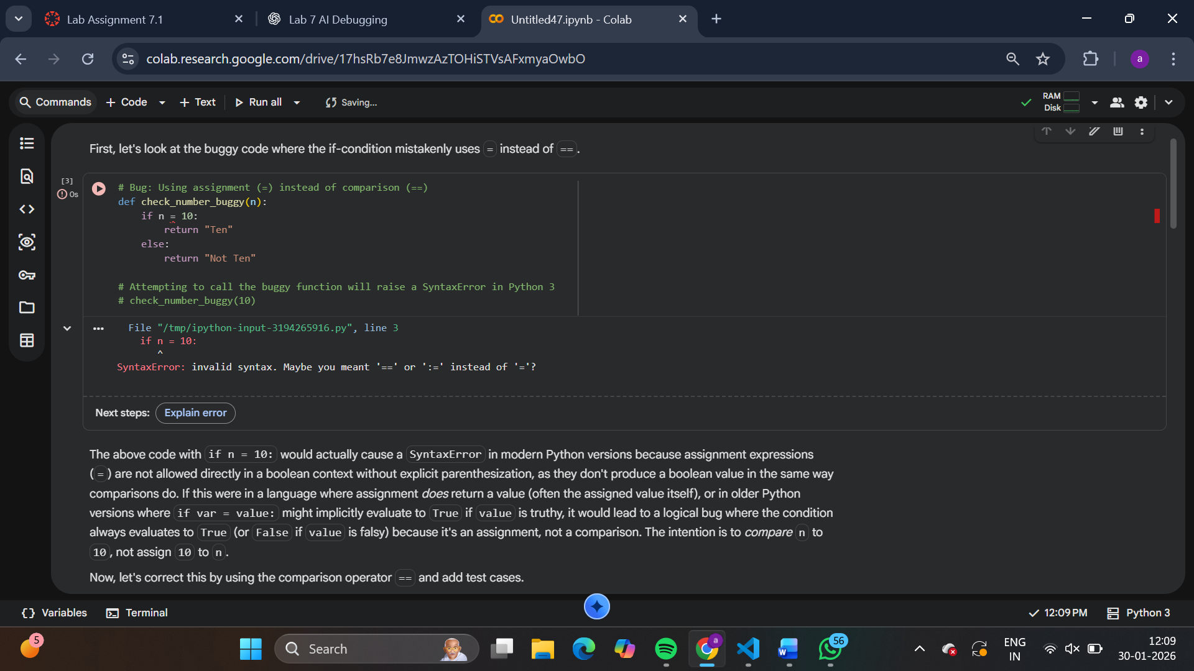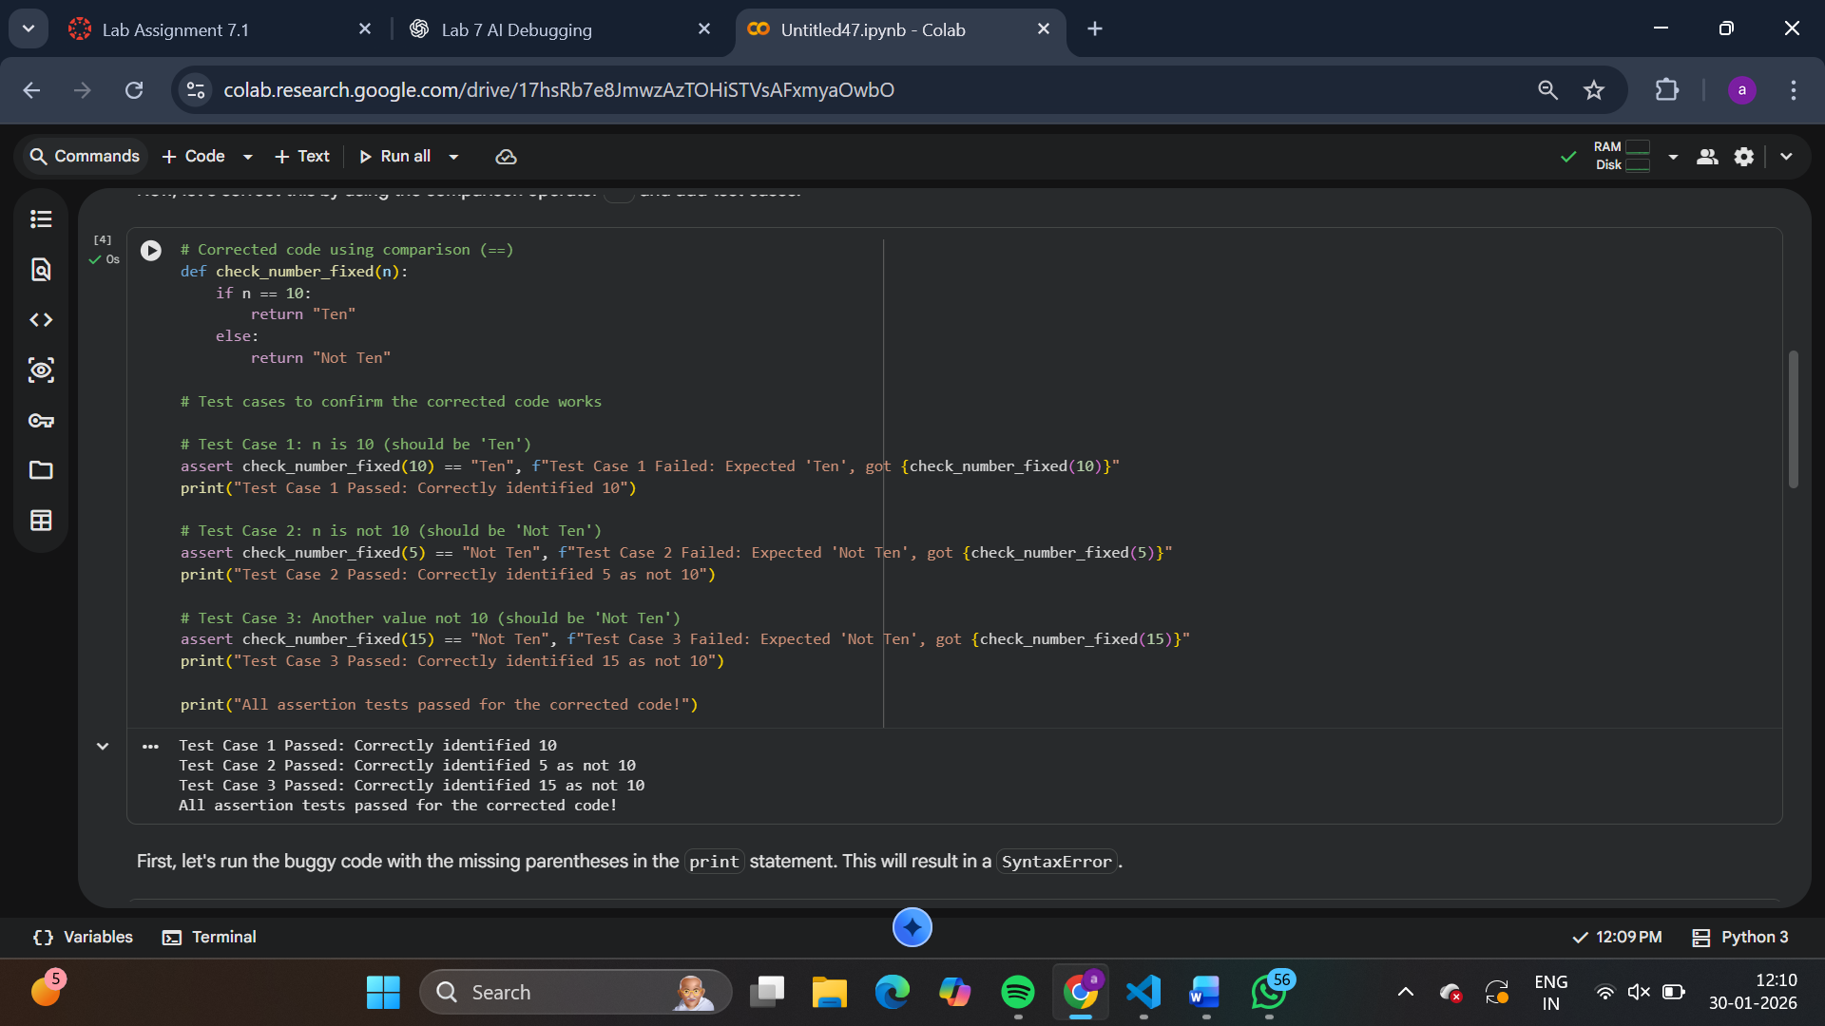
TASK-03:
(Runtime Error – File Not Found)
Task: Provide code that attempts to open a non-existent file and
crashes. Use AI to apply safe error handling.
# Bug: Program crashes if file is missing
def read_file(filename):
with open(filename, 'r') as f:
return f.read()
print(read_file("nonexistent.txt"))
Requirements:
• Implement a try-except block suggested by AI.
• Add a user-friendly error message.
• Test with at least 3 scenarios: file exists, file missing, invalid
path.
Expected Output #3:
• Safe file handling with exception management.
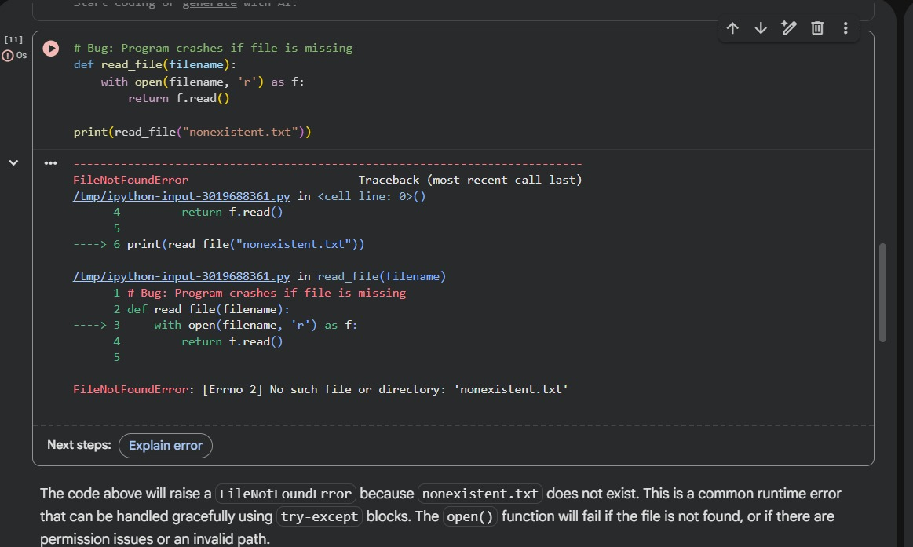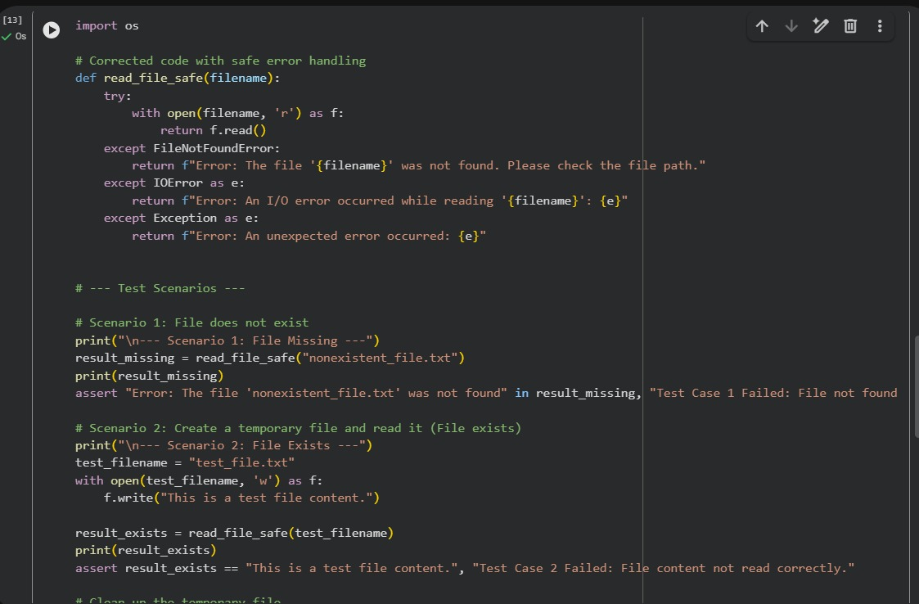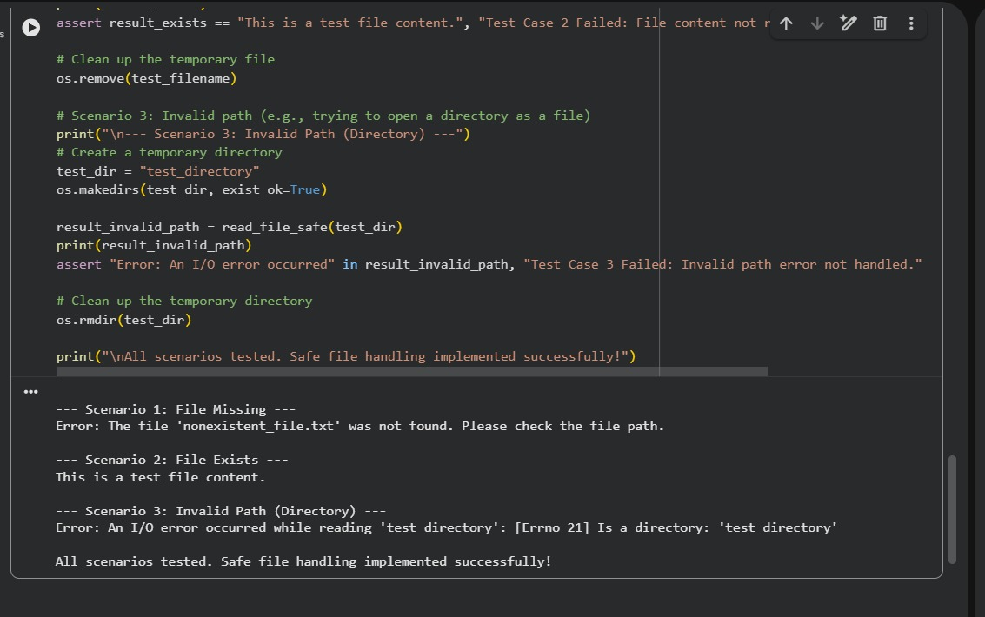
TASK-04: (Calling a Non-Existent Method)
Task: Give a class where a non-existent method is called (e.g.,
obj.undefined_method()). Use AI to debug and fix.
# Bug: Calling an undefined method
class Car:
def start(self):
return "Car started"
my_car = Car()
print(my_car.drive()) # drive() is not defined
Requirements:
• Students must analyze whether to define the missing method
or correct the method call.
• Use 3 assert tests to confirm the corrected class works.
Expected Output #4:
• Corrected class with clear AI explanation.
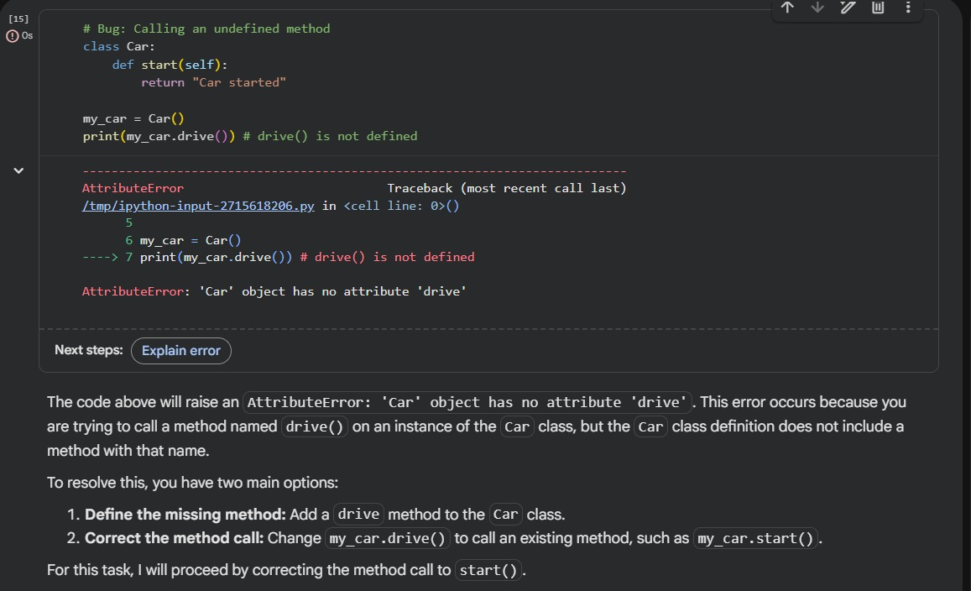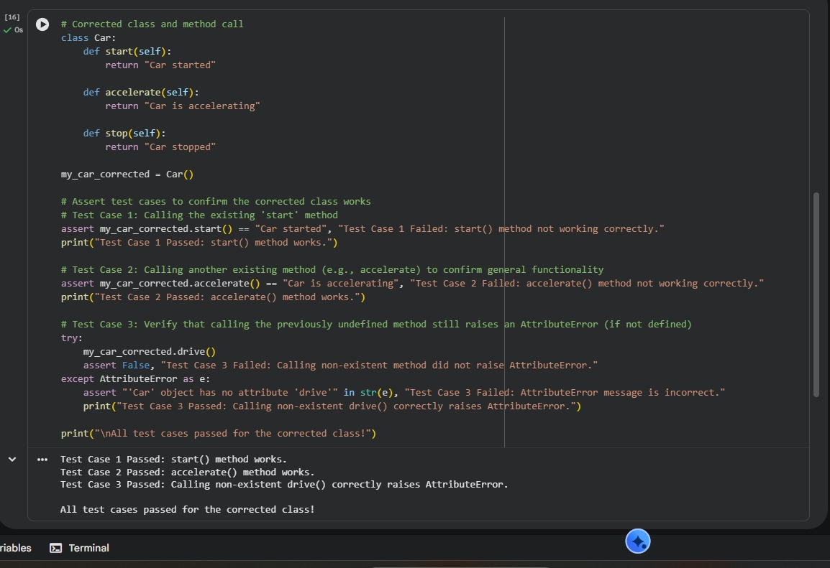
TASK-05: (TypeError – Mixing Strings and Integers in
Addition)
Task: Provide code that adds an integer and string ("5" + 2) causing
a TypeError. Use AI to resolve the bug.
# Bug: TypeError due to mixing string and integer
def add_five(value):
return value + 5
print(add_five("10"))
Requirements:
• Ask AI for two solutions: type casting and string
concatenation.
• Validate with 3 assert test cases.
Expected Output #5:
• Corrected code that runs successfully for multiple inputs.
Note: Report should be submitted a word document for all tasks in a
single document with prompts, comments & code explanation, and
output and if required, screenshots
