**Index Page –**

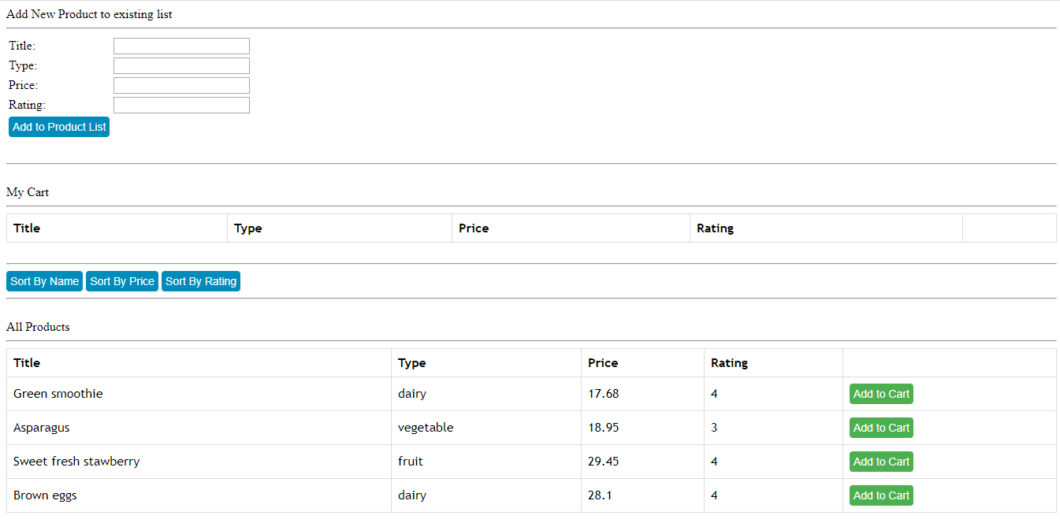

**When products are added in My Cart –**

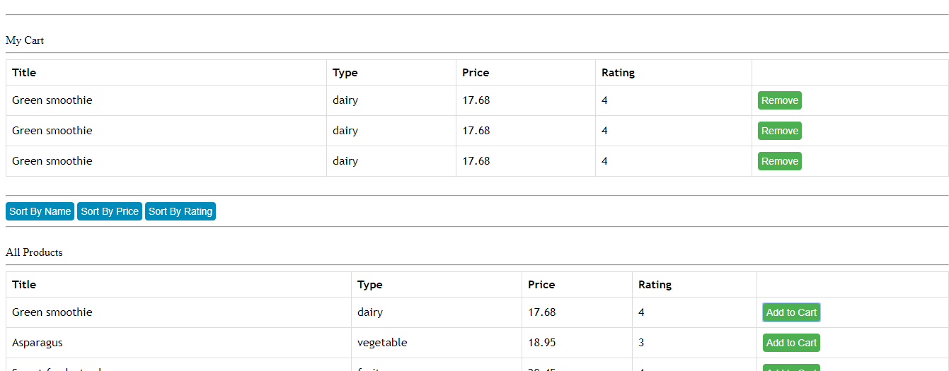

**When one product is removed from My Cart –**

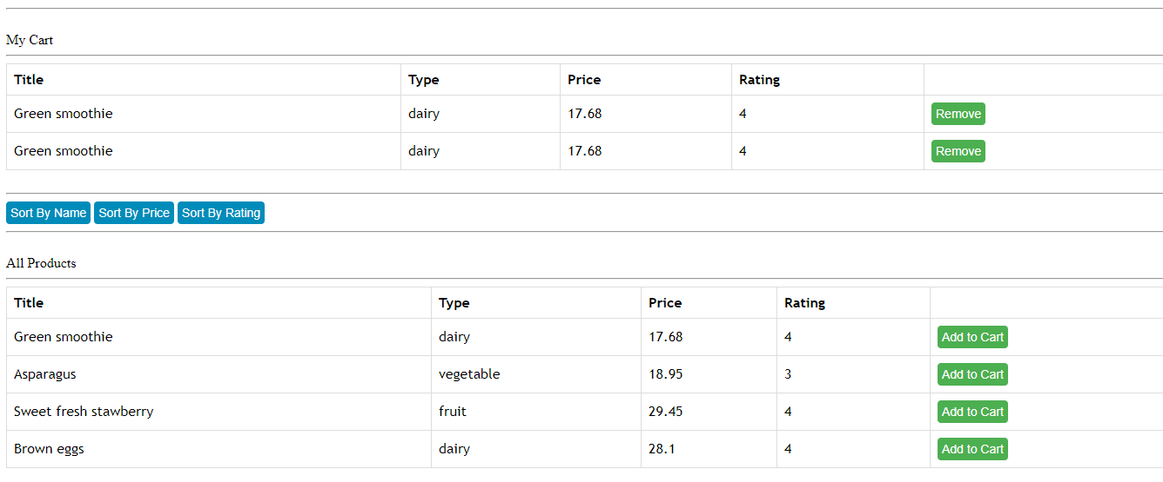

**When ‘sort by rating’ option is used –**

