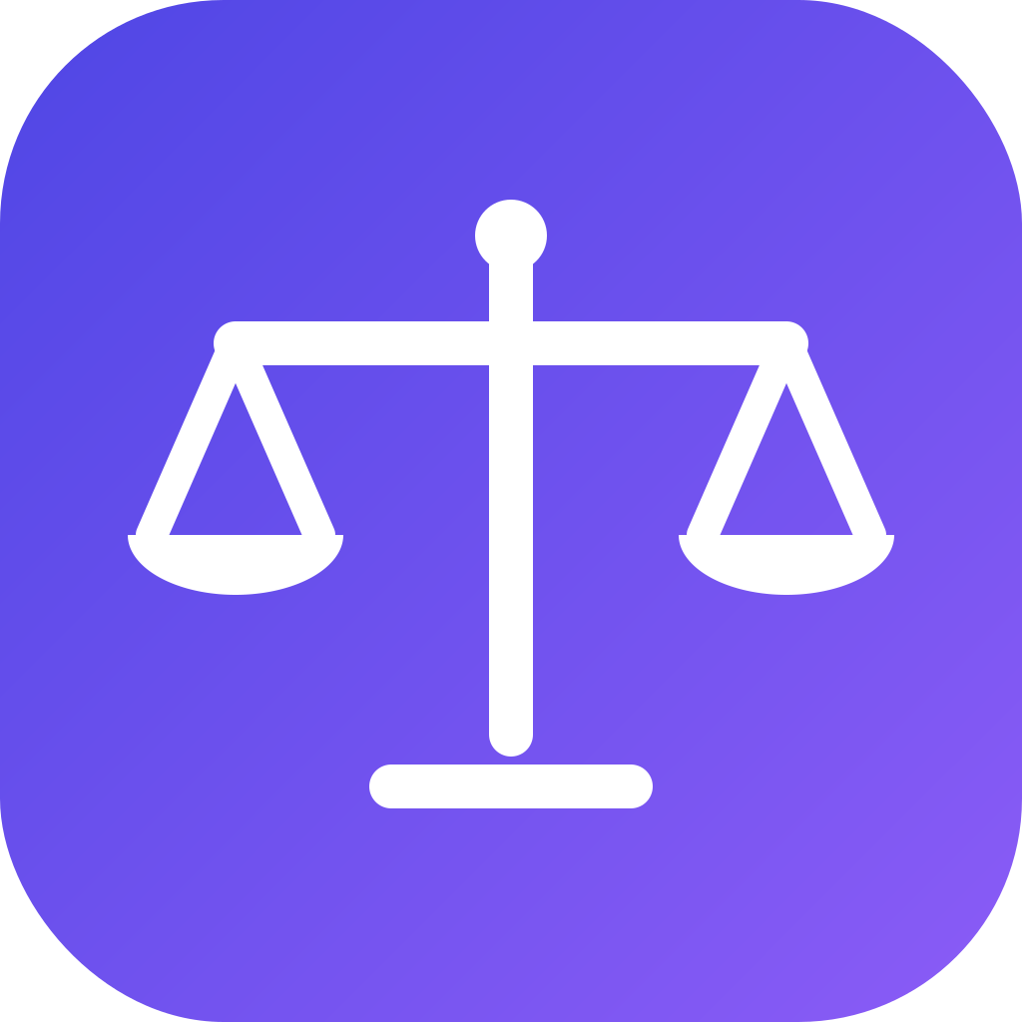

OneGov AI
AI-Powered Access to Zimbabwean Law

Solution Specification Document
2026 POTRAZ Innovation Expo and Conference

Competition Category: Seed Level
Sub-theme: Emerging Technologies and Digital Transformation for Industry Solutions

Organisation: Longacre Technologies (Private) Limited
Team Leader: Kudzai Zhuwaki
Team Member: Presson Zhou
kudziezhuwaki@gmail.com
Live platform: onegovai.app

Table of Contents
1. | Cover Page | 1
2. | Table of Contents | 2
3. | Team Composition | 2
4. | Solution Specification | 2
5. | Target Market | 3
6. | Business and Revenue Model | 3
7. | Design | 3
8. | Implementation | 5
9. | Social and Technological Impact | 5
10. | Previous Projects | 6
11. | User/Product Manual | 6
3. Team Composition
OneGov AI is developed by Longacre Technologies (Private) Limited, a registered Zimbabwean technology company (Company Registration No. 128915A0272026, incorporated 23 July 2026; ZIMRA TIN 2002584718). Kudzai Zhuwaki, Team Leader and Lead Developer, is a software developer responsible for the platform's architecture, data engineering, artificial intelligence integration and cloud operations; contact kudziezhuwaki@gmail.com. Presson Zhou, Co-Developer, works across the platform's development, testing and product refinement. This lean two-person team designed, built and deployed the entire national-scale service, and will expand with legal research and business development roles as revenue grows.
4. Solution Specification
Problem addressed. Access to the law in Zimbabwe is fragmented, technical and expensive. Laws and judgments are scattered across multiple websites and archives, many as scanned PDF files that cannot be searched. Establishing the current state of the law, including which instrument amends or repeals which, is difficult without professional help. Legislation is written in dense legal drafting that most citizens and small businesses cannot interpret confidently, while professional legal advice is unaffordable for the majority. Many SMEs therefore operate without knowing their compliance obligations and many citizens do not know their constitutional rights.
Solution objectives. OneGov AI unifies the Constitution, over 7,000 Acts, Statutory Instruments, General Notices and Government Gazettes, and more than 5,000 court judgments into a single platform where anyone can ask a legal question in plain language and receive an accurate answer with citations and links to the original official documents. The objectives are to provide free, plain-language, cited legal answers to every Zimbabwean with an internet connection, to maintain a continuously updated machine-readable corpus of national law from official public sources, and to serve professionals and institutions with advanced research tools and an integration API.
User and stakeholder needs. Citizens need simple answers about their rights and obligations. SMEs and entrepreneurs need to understand licensing, tax and labour compliance. Legal practitioners and researchers need fast, reliable search across legislation and case law. Institutions such as banks, insurers and NGOs need legal data they can integrate into their own systems.
Key functional features: conversational question answering grounded in retrieved official documents with verifiable citations; hybrid semantic and keyword search across the full corpus; a browsable case-law library with court and year filters; downloads of original gazetted documents; user accounts with free and paid tiers; local Paynow payments; and a developer API. Key non-functional features: answers stream in real time with a median response of about 25 seconds; the service runs on modest cloud resources with high availability; and every answer is constrained to cite only retrieved official sources, which removes the risk of AI fabrication.
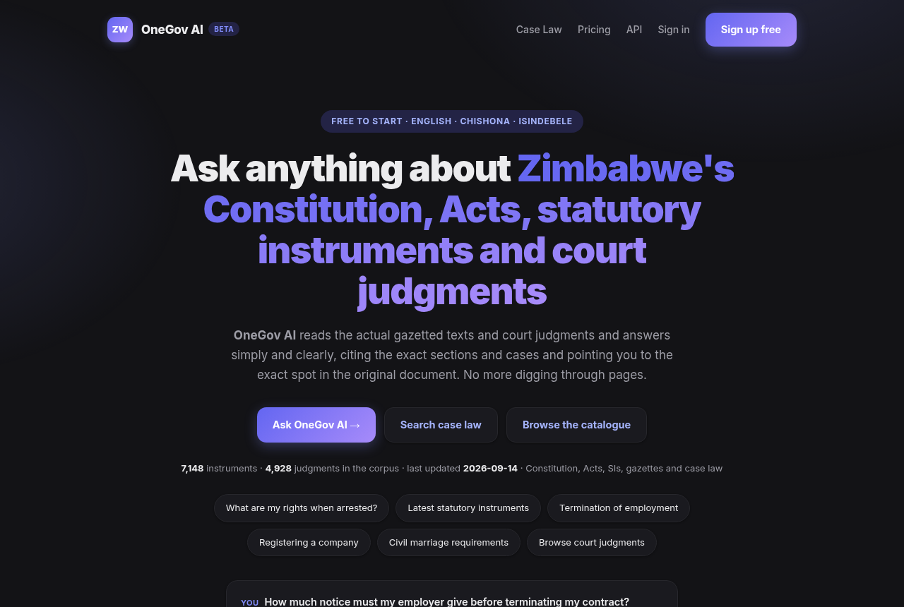
Figure 1: OneGov AI live at onegovai.app
5. Target Market
The primary segments are Zimbabwe's approximately 4,000 registered legal practitioners and their firms; corporate compliance, banking and insurance teams; NGOs and civic organisations; universities and law students; SMEs and entrepreneurs; and the general public. The value proposition differs by segment: citizens get free plain-language answers to legal questions that would otherwise require a paid consultation; professionals get research in seconds that currently takes hours across scattered sources; and institutions get structured legal intelligence through an API that no other Zimbabwean provider offers. As the first mover in AI-based Zimbabwean legal information, OneGov AI is creating this market segment, with more than 1,700 unique visitors reached organically every month.
6. Business and Revenue Model
Revenue streams. The platform operates a freemium model with a free tier for citizens and paid Plus and Pro subscriptions for professionals, offering advanced research, document export and gazette watchlists. The first paying subscribers have already been acquired through Paynow. Metered API licensing to institutions is the primary growth line, alongside gazette-watch alert services for regulated industries.
Cost structure and pricing. Operating costs are limited to cloud hosting for a single container and per-query AI fees, so total monthly running costs are low and largely usage-driven. Subscription pricing is set for the local market and payable in local channels, with institutional API pricing metered per call volume.
Sales channels and sustainability. Growth is currently organic through search and word of mouth, and will be extended through partnerships with law firms, professional bodies, universities and NGOs. Because marginal cost per additional user is close to zero and corpus maintenance is automated, the model reaches sustainability at modest subscription volumes and scales profitably from there.
7. Design
The solution is a cloud-native service organised in four layers. The ingestion layer uses automated Python pipelines that collect new gazettes, statutory instruments and judgments weekly from official public sources, remove duplicates across sources, extract text from PDF documents and divide it into more than 134,000 semantically coherent passages. The retrieval layer is a hybrid engine that combines ChromaDB open-source vector search with BM25 keyword ranking, a neural cross-encoder reranker that reads each candidate passage against the question, and a knowledge graph of relationships between instruments such as amendments and citations. The reasoning layer is a large language model agent that plans searches, reads the retrieved law and composes plain-language answers constrained to cite only retrieved documents, with every cited section automatically verified against the retrieved sources before the answer is delivered. The application layer is a FastAPI web application serving the chat interface, AI drafting of eleven legal document types, the case-law library, document downloads, accounts, payments and the developer API.
User interface. The web interface is a clean chat screen where answers stream in real time with inline citations that open the original documents, plus a case-law browsing page with court and year filters. It is lightweight, mobile-friendly and works on any modern phone or computer without installing an application.
Technical specifications. Python 3 and FastAPI backend; ChromaDB vector database and BM25 lexical index held in memory for speed; large language model APIs for reasoning; SQLite on persistent cloud storage for accounts, sessions and analytics; Docker container of about 3 GB including the full corpus, deployed on Azure Container Apps with 2 vCPU and 4 GB of memory and automatic HTTPS.
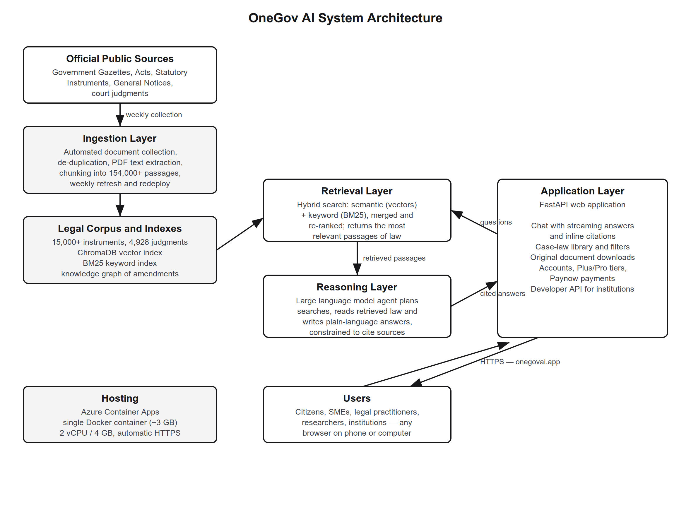
Figure 2: OneGov AI system architecture
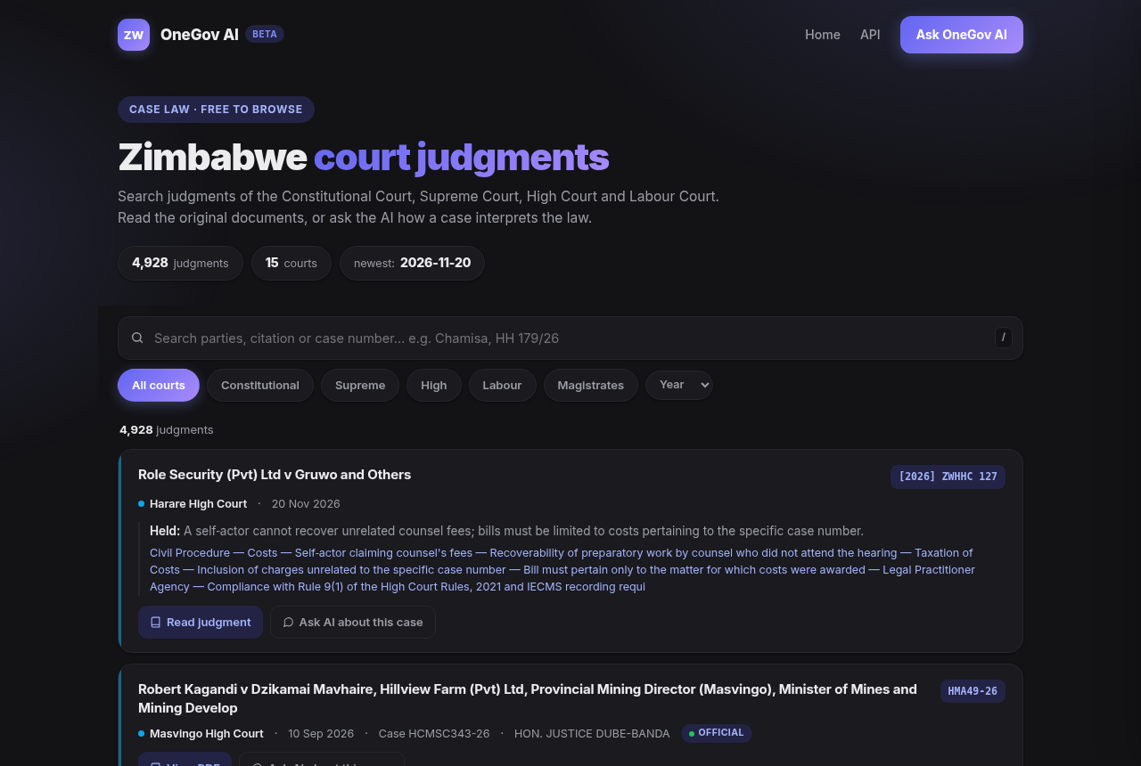
Figure 3: Case-law library with 4,928 judgments
8. Implementation
The platform was developed iteratively using an open-source stack, which allowed the full system to be built and taken to market in weeks rather than years. Development followed a pipeline approach: document collection was built for each official source, then extraction, de-duplication, chunking and indexing were automated into a single weekly refresh cycle that ends with an automated redeployment of the production container. Retrieval quality is tested continuously against known legal questions to confirm that the correct Acts, Statutory Instruments and judgments are surfaced, and answer accuracy is validated through built-in user feedback collection. The service is fully deployed in production at onegovai.app and has been serving the public since July 2026, with verified metrics of 1,722 unique visitors and 3,369 visits in the past 30 days, 30 registered users including first paying Plus and Pro subscribers, and more than 1,000 logged question and answer interactions. Deployment of new corpus updates or features takes minutes through the scripted build-and-release process.
9. Social and Technological Impact
Social impact. OneGov AI democratises access to justice. A vendor in Mbare, a farmer in Gokwe or a founder in Bulawayo can ask what licence they need or what their rights as a tenant are, and receive an accurate, cited answer in seconds at no cost. The platform supports SME formalisation, civic education on constitutional rights and equal information access for rural communities, in direct service of SDG 16 on peace, justice and strong institutions. Inclusion is built in: anonymous use requires no account, the free tier serves those who cannot pay, and the plain-language interface serves those without legal training.
Technological impact. The platform introduces retrieval-augmented generation to Zimbabwe's legal and e-government sector for the first time and demonstrates a replicable blueprint for AI-driven transformation of any national public-records domain, exportable across the SADC region.
Sustainability and ethical considerations. The service has no physical infrastructure and a minimal energy footprint. Ethically, every answer is grounded in official documents with citations the user can verify, the platform presents legal information rather than legal advice and encourages users to consult practitioners for specific matters, and privacy is protected by design: analytics use salted one-way hashes of IP addresses, passwords are stored only as salted cryptographic hashes, all traffic is encrypted over HTTPS, and no advertising trackers are used.
10. Previous Projects
The team founded and registered Longacre Technologies (Private) Limited, the Zimbabwean technology company under which OneGov AI is developed and operated. OneGov AI is the company's flagship deployed product and is publicly verifiable at onegovai.app, including the live chat assistant, the case-law library of 5,078 judgments and the document download service. The underlying corpus pipeline, which collects, de-duplicates and indexes thousands of official documents weekly, is the team's prior engineering work that the platform builds upon.
11. User/Product Manual
Using the platform requires no installation. Open onegovai.app in any browser on a phone or computer. Type a legal question in plain language, in the same way one would ask a person, for example “what documents do I need to register a private company?” The assistant searches the law, streams its answer within seconds and lists the Acts, Statutory Instruments or judgments it relied on; selecting a citation opens the original official document. The Case Law page allows browsing and filtering of judgments by court and year, each with a full-text view and download. Anonymous visitors receive a set of free questions; creating an account with an email address extends use, and Plus or Pro subscriptions, payable through Paynow, unlock professional features such as extended limits, document export and gazette watchlists. Institutions can request API keys to integrate the corpus into their own systems. For the Expo the product will be demonstrated live on a screen where visitors ask their own questions and watch cited answers appear in real time.

