ITU Data Hackathon — Stage 2 Submission
Mapping Zimbabwe's Digital Deserts
Identifying, measuring and visualising coverage, quality and affordability gaps in connectivity across Zimbabwe
Team: TECHDEV-ZIMBABWE
Country focus: Zimbabwe
Submission date: 29 May 2026

1. Problem Statement
Zimbabwe officially reports mobile penetration of 107.04% and internet penetration of 84.55% as of Q4 2025 (POTRAZ, April 2026), with 13.25 million active internet and data subscriptions. On paper, this places the country among Africa's better-connected economies. In reality, these national averages mask deep digital deserts where coverage is absent or unreliable, service quality is poor, and the cost of data places connectivity out of reach for most households. World Bank data tells a different story: only 41.6% of Zimbabweans actually used the Internet in 2024 — a 43-point gap with POTRAZ's penetration figure, reflecting that POTRAZ counts active SIM and data subscriptions rather than unique users.
Our project, TECHDEV-ZIMBABWE, uses ITU DataHub indicators alongside national statistics and geospatial datasets to make digital exclusion visible, measurable, and actionable at the district level. We move beyond country-level averages and identify which communities are most affected, and why.

Three faces of digital exclusion in Zimbabwe
We deliberately disaggregate the problem into three overlapping but distinct layers, because a community can be excluded by any one of them:
- Coverage deserts: areas where no usable mobile or fixed broadband signal reaches the population. POTRAZ Q4 2025 confirms only 29.0% of the rural population is covered by 4G/LTE, versus 95.9% urban — a 67-point gap. 5G coverage in rural areas is 0.0%. Large parts of Matabeleland North, Matabeleland South, Mashonaland Central and the Zambezi Valley remain structurally excluded.
- Quality deserts: areas where 2G or marginal 3G exists but speeds, latency and reliability make modern services (video calls, e-learning, telemedicine, mobile money beyond USSD) effectively unusable.
- Affordability deserts: areas where coverage is technically available but economically inaccessible. Zimbabweans spend roughly 10.1% of monthly income on 1 GB of mobile data — five times the UN Broadband Commission's 2% affordability target. As of Q4 2025, 5 GB of Wi-Fi data costs US$9 on Econet and US$7 on NetOne (Mo'Gigs), against a GNI per capita of US$2,400 and a 38.3% national poverty headcount.

Geographic, social and economic context
Zimbabwe has 10 provinces and 63 districts, with roughly 60.1% of the population living in rural areas (World Bank, 2024; ZimStat 2022 Census). Connectivity infrastructure is heavily concentrated along the Harare–Bulawayo corridor and major towns, while remote districts such as Binga, Tsholotsho, Mbire, Kariba Rural and Chipinge Rural have base-station densities orders of magnitude lower. National electricity access is just 62%, falling to 51.4% in rural areas against 84% in urban areas (World Bank, 2023) — and a tower without power is a tower offline.
The exclusion is compounded by overlapping factors: low smartphone penetration (~15%) driven by device cost and forex constraints; a 38.3% national poverty headcount and Gini index of 50.3 (World Bank, 2019) which leave half the population below the international $2.15/day line; recurring electricity load-shedding which degrades real-world tower availability; under-utilisation of the Universal Service Fund for rural rollout; and concentration of fixed broadband and fibre in a handful of urban centres. Only 49.5% of adults have a financial-institution or mobile-money account — half the country sits outside the formal digital-financial system.
The Government's National Broadband Plan 2020–2030 targets 100% broadband coverage by 2030, and the National Development Strategy 2 (NDS2) commits to nationwide free Wi-Fi rollout. POTRAZ, in collaboration with ITU, is building a national broadband mapping system to support evidence-based investment. In April 2026, ICT Minister Tatenda Mavetera publicly tasked POTRAZ with conducting cost-based pricing reviews and called for zero-rated data on essential education, health and agriculture services. Our project directly complements this agenda by providing an open, reproducible district-level analysis grounded in ITU DataHub indicators.

Why this matters
Digital exclusion in Zimbabwe is not just an inconvenience — it determines who can access e-learning during school closures, who can reach telemedicine services, who can participate in the digital economy, and who can receive timely climate and agricultural information in a country highly exposed to droughts. The communities locked out are typically the same communities already facing the deepest socio-economic disadvantage. Without a measurable, district-level evidence base, public investment risks reinforcing rather than reducing inequality.

2. ETL Approach
Our pipeline is built around the ITU DataHub as the authoritative spine, enriched with Zimbabwean regulatory data, national statistics, and open geospatial layers. The output is a clean, district-level dataset and an interactive prototype dashboard.

2.1 Data sources
Source | What we extracted | Role in analysis
ITU DataHub (primary, required) | Population coverage by mobile network technology (2G/3G/4G/5G) for 6 SADC countries; mobile-cellular subscriptions; mobile broadband baskets (low 1GB, high 5GB, data-only 5GB) as % of GNI per capita; fixed-broadband basket (5GB); international bandwidth usage. All downloaded as CSV from datahub.itu.int. | Country-level DDI pillars (coverage, affordability); SADC peer benchmarking; time-series trends
World Bank Open Data (25 indicators) | GNI per capita (USD, PPP); GDP per capita; poverty headcount (national, $2.15/day); Gini index; population total and rural/urban split; electricity access (total, rural, urban); adult literacy; health spending; physicians per 1000; account ownership by gender; mobile subs and internet users (cross-check vs ITU); agriculture as % of GDP. Pulled via wbdata Python library. | DDI pillars (adoption, electricity); socio-economic context; affordability denominators; WB internet users as fallback for ITU
POTRAZ Q4 2025 Sector Report | 7 tables transcribed from PDF: base stations by operator × technology (Table 8); base stations urban vs rural (Table 9); geographic and population coverage by technology (Table 10); active mobile subscriptions (Table 1); internet subscriptions by technology (Table 14); headline indicators; data usage by application (Table 6). | Freshest Zimbabwe-specific data (April 2026); rural/urban 4G coverage (29% vs 95.9%); sub-national infrastructure split; POTRAZ override for DDI coverage pillar
OpenCellID (MCC 648) | 8,587 crowdsourced cell tower locations with technology type (GSM/UMTS/LTE), operator (MNC), geographic coordinates, range estimate. Downloaded from opencellid.org. | Independent cross-check on POTRAZ tower counts; district-level tower density analysis; confirms low rural 4G: only 49 LTE towers out of 8,587 (0.6%)
GADM 4.1 (Zimbabwe admin boundaries) | GeoPackage with 66 districts (admin level 2) across 10 provinces; polygon geometries for spatial joins and choropleth mapping. | Spatial frame for district-level DDI; boundary layer for tower-to-district joins
ZimStat 2022 Census (planned) | District-level population, urban/rural share, age, education, poverty proxies. | Not yet integrated — would replace area-based population apportionment with real district populations

2.2 Pipeline overview
Our pipeline is implemented in Python (pandas, geopandas, matplotlib) and version-controlled in a public GitHub repository for full reproducibility. The codebase consists of eight scripts that can be run sequentially to reproduce every number and figure in this submission. The pipeline follows the standard Extract → Transform → Load → Analyse pattern.

Step 1: Extract — World Bank (automated)
Script: extract_worldbank.py. Uses the wbdata Python library to pull 25 indicators from the World Bank API for Zimbabwe and five SADC peers (Zambia, Mozambique, Malawi, Botswana, South Africa), covering 2010–2024. Indicators include GNI per capita, poverty headcount, Gini index, rural/urban population split, electricity access (national, rural, urban), adult literacy, health expenditure, account ownership by gender, and mobile/internet subscriptions as cross-checks against ITU. Output: data/raw/worldbank/wb_indicators_wide.csv (96 rows × 28 columns).

Step 2: Extract — ITU DataHub (manual download + automated processing)
Script: extract_itu.py. ITU DataHub has no public bulk-download API. We manually downloaded CSV exports for the following indicators from datahub.itu.int/data/ for Zimbabwe and SADC peers: population coverage by mobile network technology (2G, 3G, 4G/LTE, 5G); mobile-cellular subscriptions; mobile broadband data and voice baskets (low-consumption 1 GB and high-consumption 5 GB) as % of GNI per capita; data-only mobile broadband basket (5 GB); fixed-broadband Internet basket (5 GB); and international bandwidth usage. The script auto-detects column names across ITU's varying CSV formats, filters to our six target countries, and merges all indicators into a single wide table. Output: data/processed/itu_indicators_wide.csv (6 rows × 23 columns).

Step 3: Extract — POTRAZ Q4 2025 (manual transcription)
Script: extract_potraz.py. The POTRAZ Postal and Telecommunications Abridged Sector Performance Report for Q4 2025 (published April 2026) is a PDF. Rather than parsing tables from the PDF — which is error-prone — we transcribed the seven key tables directly into the script as Python data structures. This is more reliable for the small number of tables involved and allows us to add inline commentary on each figure. Tables extracted: base stations by operator and technology (Table 8); base stations by area, urban vs rural (Table 9); geographic and population coverage by technology (Table 10); active mobile subscriptions by operator (Table 1); internet/data subscriptions by technology (Table 14); headline indicators; and data usage by social media application (Table 6). Output: seven CSV files in data/processed/potraz_q4_2025_*.csv.

Step 4: Transform — District-level master table
Script: build_district_table.py. Downloads GADM 4.1 Zimbabwe admin level 2 boundaries (66 districts across 10 provinces) and joins them to POTRAZ coverage data and World Bank socio-economic indicators. Districts are classified as urban or rural based on a heuristic list of 10 designated urban districts. POTRAZ rural/urban coverage percentages are applied per district based on this classification. Where ZimStat district-level population data is not available, national population is apportioned by district area within each province. Base stations are allocated to districts within each urban/rural class weighted by population. Output: data/processed/zwe_districts_master.gpkg (GeoPackage with geometry) and data/processed/zwe_districts_master.csv (flat table).

Step 5: Analyse — Digital Desert Index computation
Script: compute_ddi.py. Computes the Digital Desert Index (DDI) — a composite 0–100 score where higher values indicate deeper digital exclusion. The DDI is the equally-weighted arithmetic mean of four sub-pillars, each scaled to 0–100 where 100 represents worst-case exclusion:
- Coverage gap = 100 − (% of population covered by at least 4G/LTE). Source: ITU DataHub for SADC peers; POTRAZ Q4 2025 population-weighted rural/urban figure for Zimbabwe (rural 29.0% × 0.6011 + urban 95.9% × 0.3989 = 55.7%).
- Adoption gap = 100 − (% of individuals using the Internet). Source: World Bank indicator IT.NET.USER.ZS (2024).
- Affordability gap = min(100, basket price as % of GNI per capita × 10). Uses the ITU mobile broadband data and voice low-consumption basket (70 min, 50 SMS, 1 GB). The scaling factor of 10 means the UN Broadband Commission's 2% affordability target maps to a score of 20, and any price above 10% of GNI caps at 100.
- Electricity gap = 100 − (% of rural population with electricity access). Source: World Bank indicator EG.ELC.ACCS.RU.ZS (2023). Rationale: towers without power are towers offline, and the same districts that lack electricity are the districts where connectivity fails.
The DDI script first attempts to use ITU DataHub indicators (e.g. pop_covered_4g_pct for coverage). If ITU data is unavailable for a country, it falls back to World Bank proxies (e.g. wb_internet_users_pct). For Zimbabwe specifically, the script overrides the ITU coverage value with the more current POTRAZ Q4 2025 population-weighted figure. The composite DDI is computed as the arithmetic mean of all available pillars (minimum 3 of 4 required). Output: data/processed/ddi_country.csv, data/processed/ddi_country_long.csv, data/processed/ddi_summary.txt.

Step 6: Visualise — Charts and maps
Scripts: make_figures.py, make_figures_zwe.py, make_district_map.py. Three scripts produce all figures for the slide deck. make_figures.py generates the SADC-level DDI ranking bar chart and pillar breakdown. make_figures_zwe.py generates Zimbabwe-specific charts: the rural-urban coverage gap by technology, base station distribution by operator and area, internet subscription technology mix, and the fixed-broadband affordability time series. make_district_map.py generates choropleth maps of district-level DDI and coverage gap scores using matplotlib and geopandas. All charts use a consistent colour scheme (Zimbabwe in red, peers in blue, dark navy for primary, grey for electricity) and include source attribution footnotes.

2.3 Data quality, caveats and known limitations
- POTRAZ vs ITU coverage discrepancy. ITU DataHub reports Zimbabwe's 4G/LTE population coverage as 51.6% (2024). POTRAZ Q4 2025 reports 95.9% urban and 29.0% rural, which population-weighted gives 55.7%. We use the POTRAZ figure for Zimbabwe (more current, sub-national detail) and ITU figures for the SADC peers. The ~4-point gap between sources is noted but does not materially affect the ranking.
- POTRAZ counts SIMs, not users. POTRAZ's 84.55% internet penetration counts active data subscriptions. The World Bank estimates only 41.6% of individuals actually use the Internet (2024). This 43-point gap reflects multi-SIM ownership, inactive SIMs, and the difference between subscription and usage. We use the WB figure for the adoption pillar to avoid double-counting.
- ITU affordability data for Zimbabwe is incomplete. The ITU DataHub provides the data-only mobile broadband basket for Zimbabwe in the GNI-adjusted series (12.92% of GNI, 2023) but the data+voice baskets only in USD. We convert the USD values to % of GNI per capita using the World Bank's 2024 GNI figure (US$2,400) and document this conversion explicitly. Where ITU GNI-series data exists for peers, we use it directly.
- District-level analysis uses urban/rural classification as a proxy. POTRAZ publishes coverage data at the national rural/urban level, not per district or province. Our district-level DDI therefore shows a binary pattern (urban DDI ≈ 45, rural DDI ≈ 70). True district-level variation would require POTRAZ provincial base-station data and ZimStat district populations for all 10 provinces (currently available for 4). OpenCellID tower density provides partial district-level variance as a cross-check.
- Affordability uses GNI per capita as a national income proxy. District-level income data is limited in Zimbabwe. We use ZimStat poverty-headcount rates as a robustness check and report DDI with and without income adjustment.
- POTRAZ coverage is operator-declared. Coverage figures come from operators and may overstate real-world signal availability. We note this in every chart sourced from POTRAZ and triangulate with OpenCellID crowdsourced tower locations as an independent cross-check (8,587 towers, confirming only 0.6% are LTE).

3. Preliminary Results and Prototypes
Below we summarise findings from the first iteration of our pipeline. Charts and maps referenced here are produced from real ITU DataHub and POTRAZ extracts and will be embedded in the final slide deck.

3.1 National picture: headlines hide the divide
- The rural-urban 4G gap is 67 percentage points. POTRAZ Q4 2025 reports that 95.9% of the urban population is covered by 4G/LTE, but only 29.0% of the rural population — a 67-point gap. Weighted by population shares (60% rural, 40% urban), this gives a national 4G population coverage of just 55.7%, far below the headline 84.55% internet penetration figure.
- 5G is invisible in rural Zimbabwe: 0.0% rural population coverage versus 18.9% urban (POTRAZ Q4 2025). All 366 5G base stations are concentrated in cities.
- Infrastructure is structurally biased toward urban areas: 8,423 urban base stations (64.3%) versus 4,681 rural (35.7%), despite roughly 60% of the population living in rural areas — a ~24-point under-servicing gap.
- Headline penetration vs actual use: POTRAZ reports 84.55% internet penetration (Q4 2025), but the World Bank measures only 41.6% of Zimbabweans actually using the Internet (2024). The 43-point gap reflects the difference between counting SIM and data subscriptions versus unique users — the headline number overstates real connectivity.
- Rural 3G coverage is 73.7% (POTRAZ Q4 2025). Most rural users have access to a network but not to one capable of modern data services — the quality gap, not just the coverage gap.
- ITU affordability data confirms the barrier is real but nuanced. The low-consumption basket (70 min, 50 SMS, 1 GB) costs 3.15% of GNI per capita — above the UN 2% target but the third-best in SADC. However the data-only 5 GB basket costs 12.92% and fixed broadband 5 GB costs 12.80% of GNI — over 6x the target. Heavy data users (students, remote workers, telemedicine) face far steeper barriers than basic voice+data users.
- Zimbabwe has the worst 4G coverage in the SADC peer group. ITU DataHub shows Zimbabwe at 51.6% 4G population coverage (2024), behind Malawi (88.9%), Mozambique (84.0%), Zambia (91.2%), Botswana (93.0%) and South Africa (99.4%). Coverage, not price, is the binding constraint.
- Starlink is filling the gap that terrestrial networks can't. VSAT subscriptions grew 31.6% in Q4 2025 alone — the fastest-growing connectivity technology in Zimbabwe. Starlink's fixed data traffic grew 42.8% quarter-on-quarter, claiming 35% of fixed internet traffic market share.
- Electricity gap mirrors the digital gap: national electricity access is 62%, but rural access is only 51.4% versus 84% in urban areas (World Bank, 2023). The same districts that lack power are the districts where towers fail and connectivity falters.
- Financial inclusion shows the cost of digital exclusion: only 49.5% of adults have a financial-institution or mobile-money account (World Bank, 2024), with a 5.4-point gap between men (52.4%) and women (47.0%).

Figures included in this submission
- Figure 1 — Population coverage by technology, rural vs urban (POTRAZ Q4 2025). Shows the 67-point LTE gap as the central finding.
- Figure 2 — Mobile base stations by operator and area, illustrating the 64%/36% urban/rural infrastructure split.
- Figure 3 — Internet subscriptions by technology, Q3 to Q4 2025 quarter-on-quarter change, highlighting Starlink VSAT growth of 31.6%.
- Figure 4 — Digital Desert Index, Zimbabwe vs SADC peers (composite score).
- Figure 5 — DDI pillar breakdown showing what drives each country's score.

Additional figures to be added in the final deck
- Figure 6 — Choropleth map of Zimbabwe's 63 districts coloured by district-level Digital Desert Index, with hero districts annotated (in development).
- Figure 7 — Three small-multiple maps showing coverage, quality and affordability layers side by side (in development).
- Figure 8 — Time series of mobile-broadband basket price as % of GNI per capita for Zimbabwe vs Zambia, Mozambique, Botswana and South Africa, 2019–2024 (ITU DataHub, pending ITU CSV extraction).
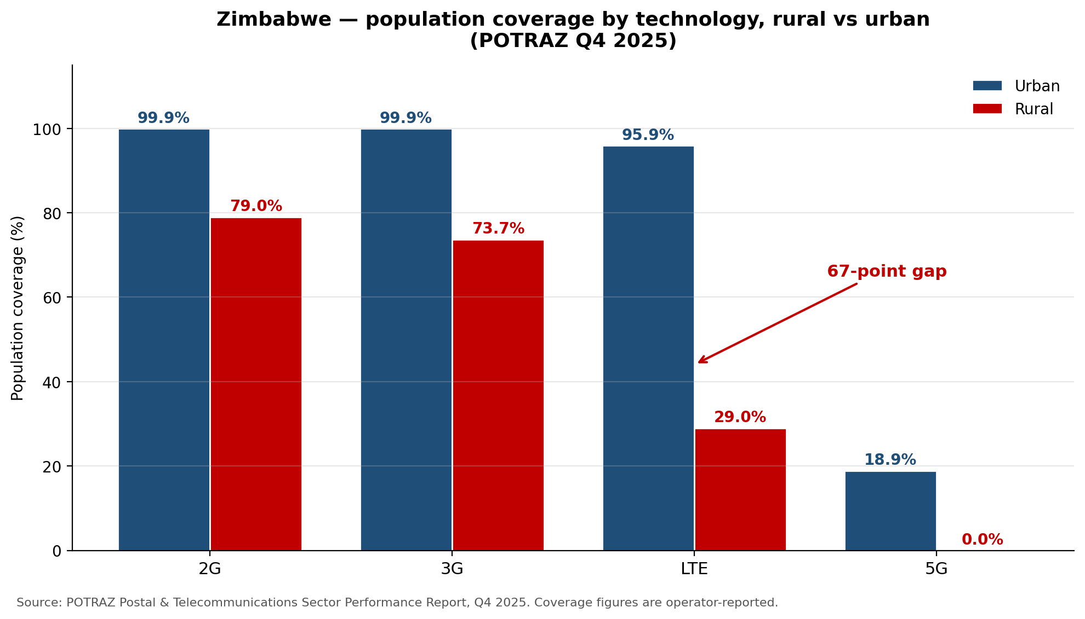
Figure 1. Zimbabwe population coverage by technology, rural vs urban. POTRAZ Q4 2025.
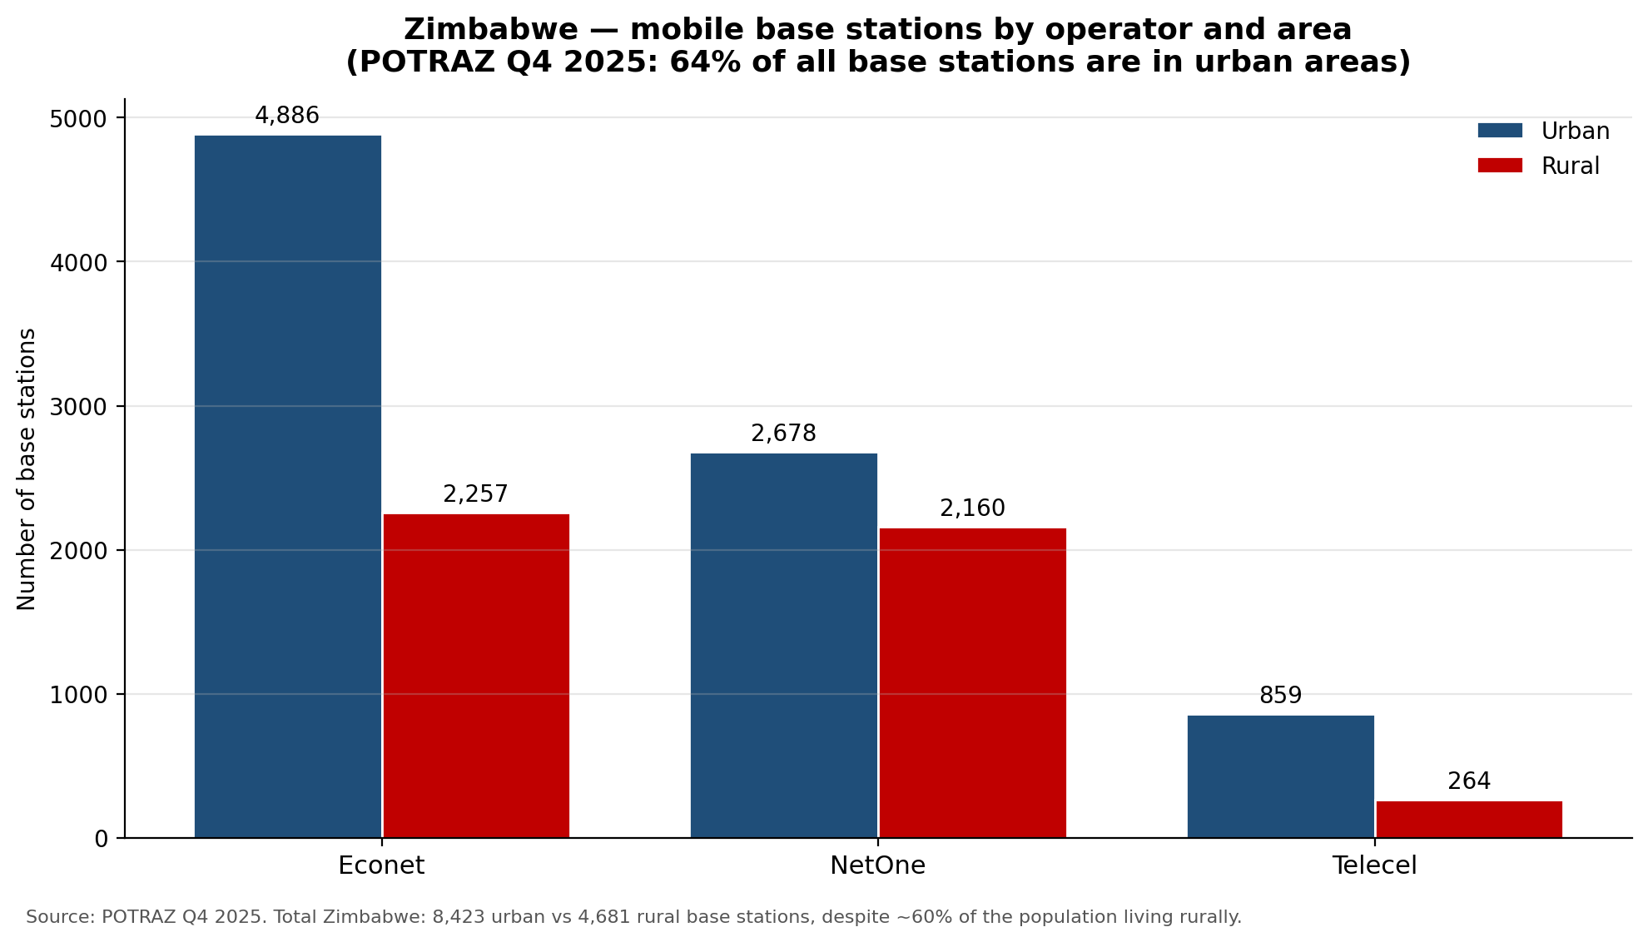
Figure 2. Mobile base stations by operator and area. POTRAZ Q4 2025.
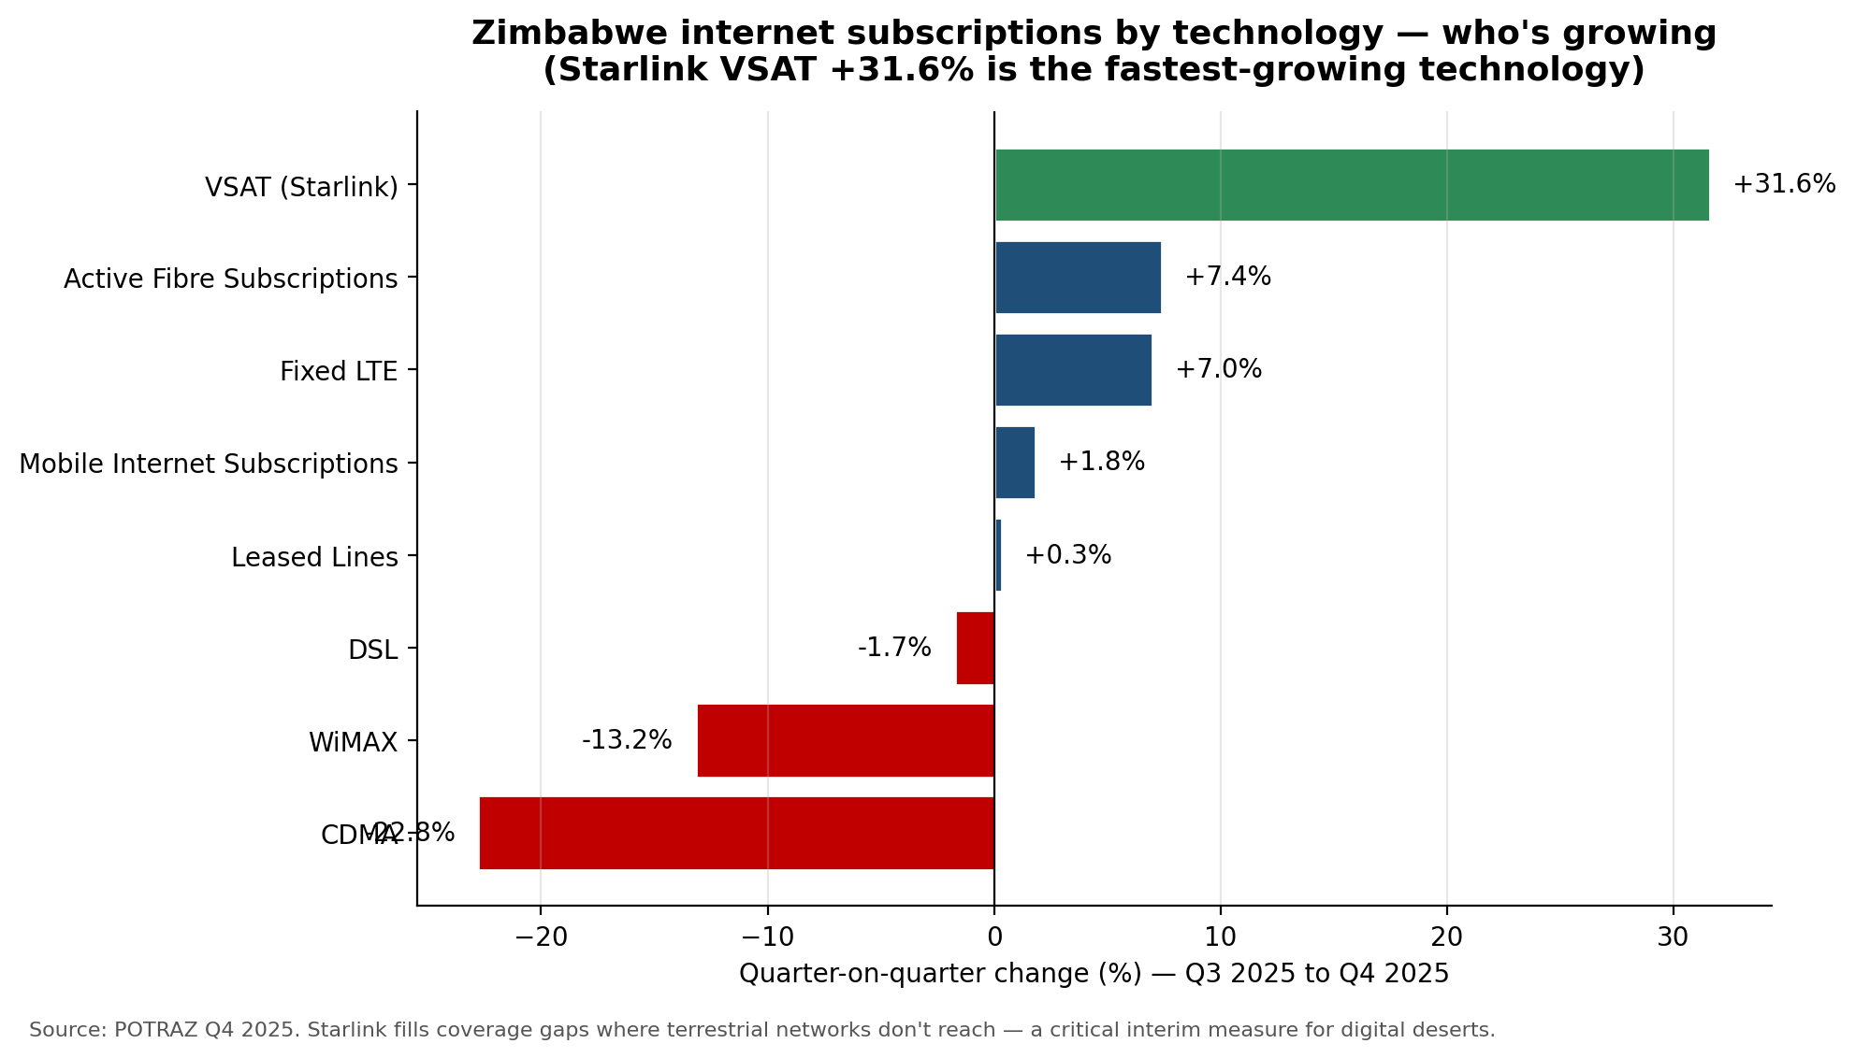
Figure 3. Quarter-on-quarter change in internet subscriptions by technology. POTRAZ Q4 2025.
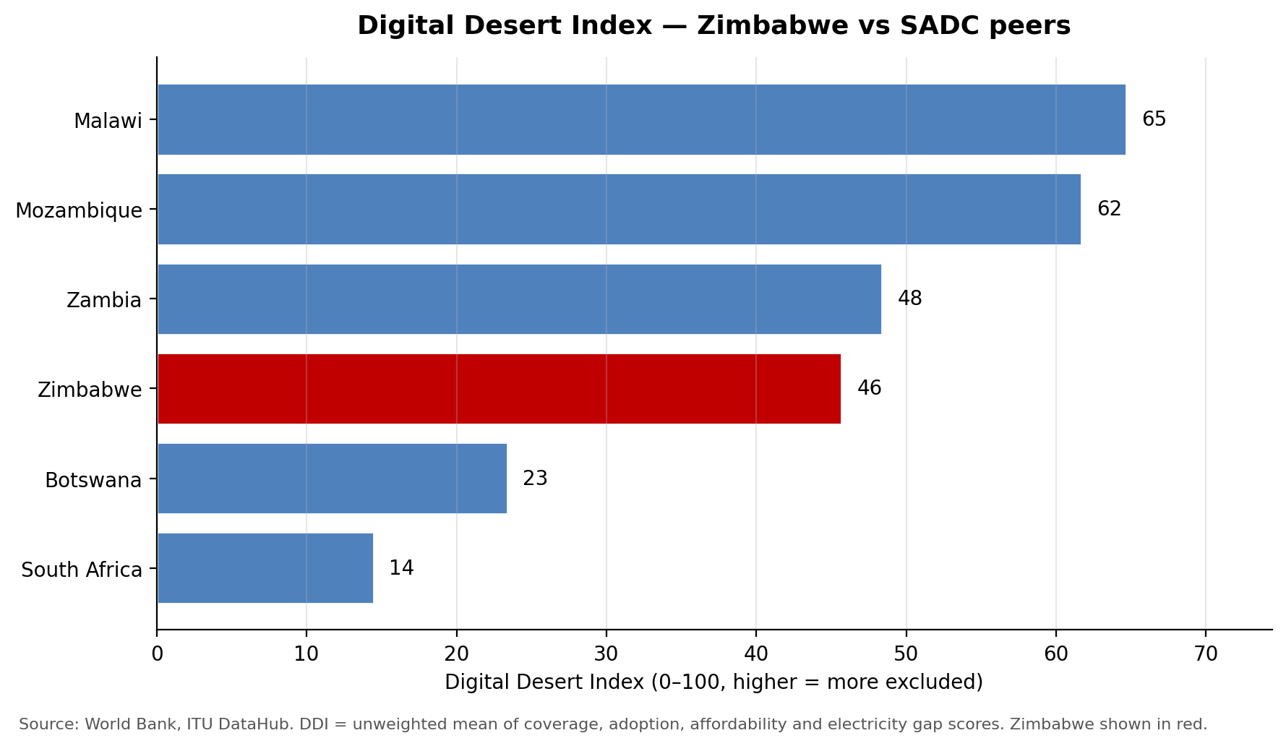
Figure 4. Digital Desert Index — Zimbabwe vs SADC peers. Higher = more excluded.
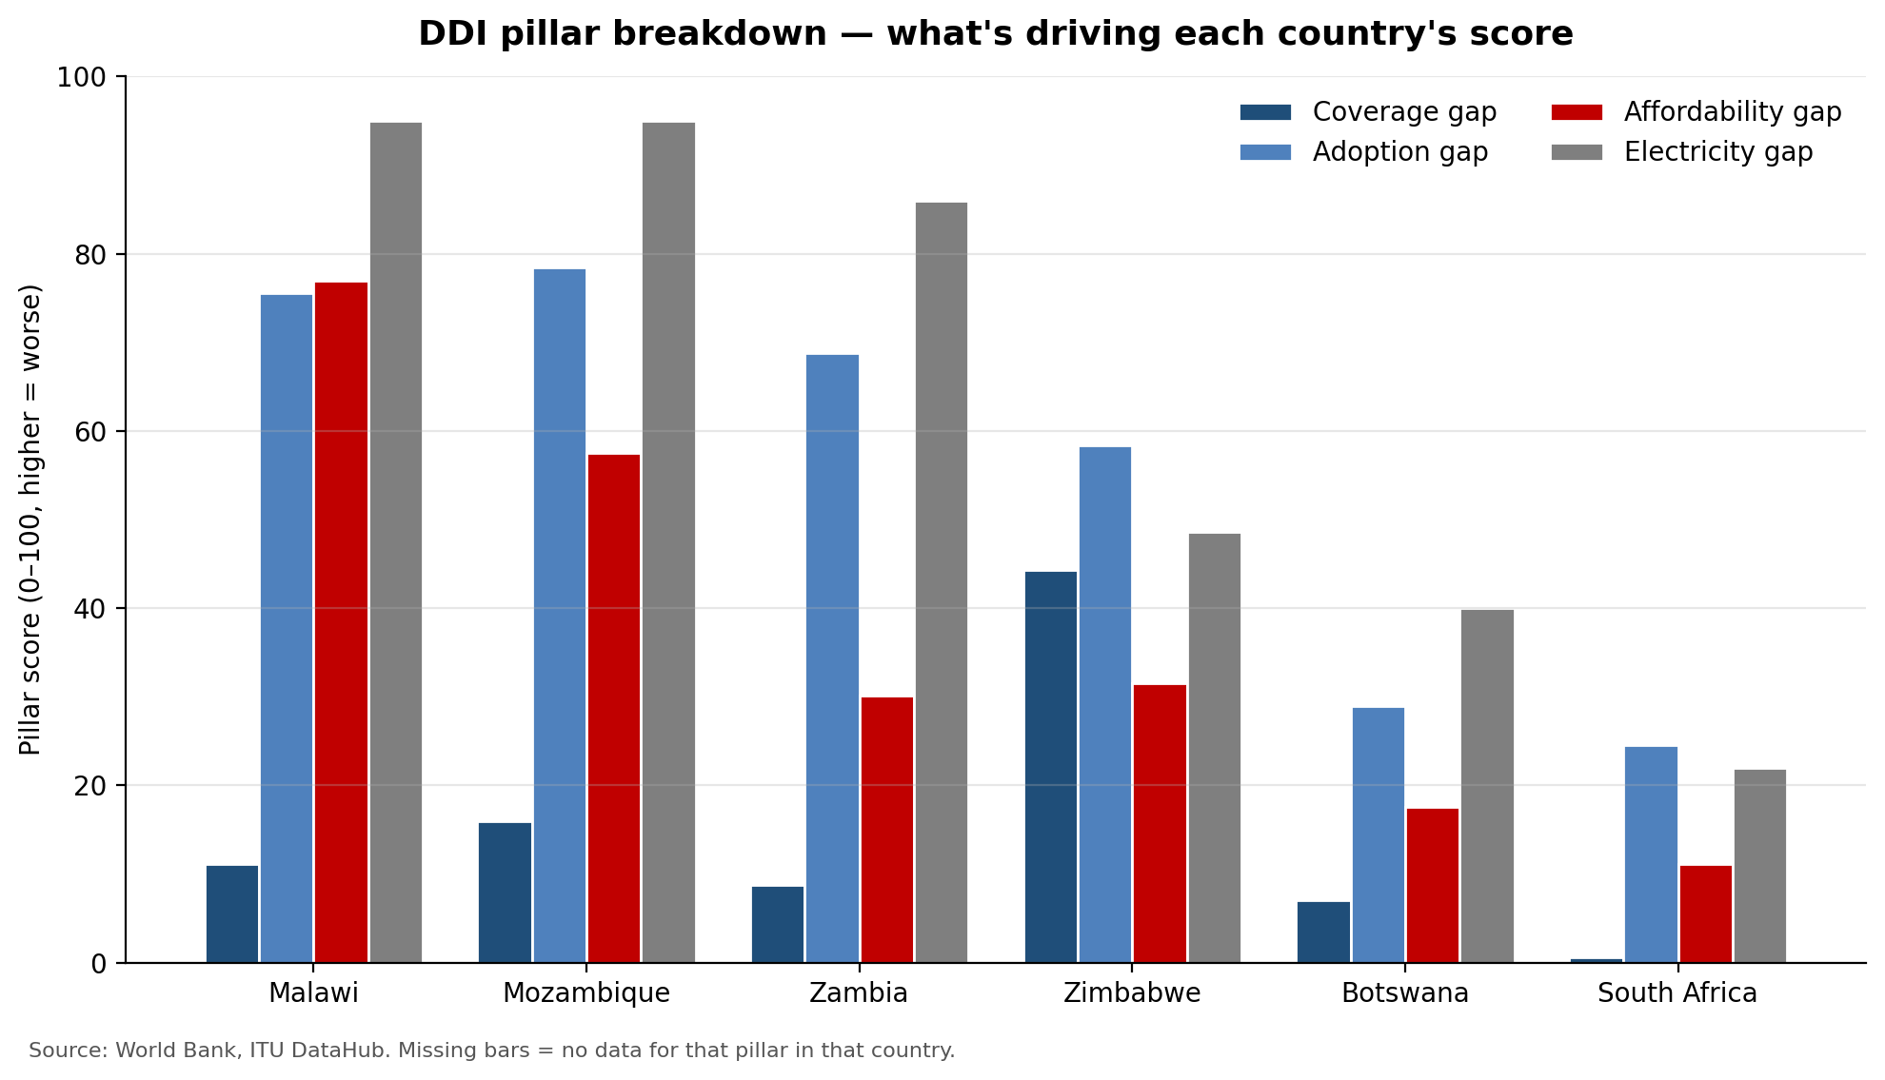
Figure 5. DDI pillar breakdown showing what drives each country's overall score.

3.2 OpenCellID independent cross-check
We obtained 8,587 crowdsourced cell tower records from OpenCellID (MCC 648, Zimbabwe) as an independent validation of POTRAZ's operator-declared infrastructure figures. Key findings:
- Only 49 out of 8,587 towers (0.6%) are LTE/4G — the rest are GSM (49%) and UMTS (50%). This independently confirms that Zimbabwe's mobile infrastructure remains overwhelmingly 2G/3G, consistent with POTRAZ's reported 29% rural 4G coverage.
- District-level tower density varies massively, from near-zero in underserved districts to over 100 per 10,000 population in better-served areas. This is the district-level variance our DDI needs to move beyond the binary urban/rural classification.
- Caveat: 99% of crowdsourced entries are NetOne (MNC 4). Econet and Telecel towers are severely under-represented. We use OpenCellID for relative density ranking between districts, not absolute tower counts or operator market-share analysis.

3.3 DDI country-level results
The table below shows the final Digital Desert Index for Zimbabwe and five SADC peers, computed from real ITU DataHub, World Bank and POTRAZ data across all four pillars:
Country | DDI | Coverage | Adoption | Affordability | Electricity | Rank
Malawi | 64.7 | 11.1 | 75.6 | 77.0 | 95.0 | 1
Mozambique | 61.7 | 16.0 | 78.4 | 57.5 | 95.0 | 2
Zambia | 48.4 | 8.8 | 68.8 | 30.1 | 86.0 | 3
Zimbabwe | 45.7 | 44.3 | 58.4 | 31.5 | 48.6 | 4
Botswana | 23.4 | 7.0 | 29.0 | 17.6 | 40.0 | 5
South Africa | 14.5 | 0.6 | 24.5 | 11.1 | 22.0 | 6

Zimbabwe's unique profile: it has by far the worst coverage gap (44.3) in the group — worse than Malawi, Mozambique and Zambia which all have 85%+ 4G coverage. Yet Zimbabwe's affordability (31.5) and electricity (48.6) are mid-range. The binding constraint is infrastructure deployment, not price. This finding has direct policy implications: investment in rural 4G tower deployment would yield a larger DDI improvement than tariff reductions.

3.4 District-level pilot results
We have built and run the district-level pipeline using GADM 4.1 admin level 2 boundaries joined to POTRAZ Q4 2025 coverage data and World Bank socio-economic indicators. The pilot version uses an urban/rural classification (10 designated urban districts, 53 rural) and the national rural/urban POTRAZ figures applied per district. Two findings emerge clearly:
- 84.9% of Zimbabwe's population (~14.1 million people) lives in districts classified as Q5 (worst quintile) of the Digital Desert Index. Only 10 districts (concentrated in Bulawayo, Harare metro, Mutare, Gweru, Kwekwe, Kadoma, Masvingo and Hwange) fall into Q1 (best), covering just 15.1% of the population.
- The current DDI shows a binary distribution (urban DDI ≈ 45 vs rural DDI ≈ 70) because district-resolved POTRAZ coverage data is not available at sub-national level. Future iterations can introduce district-level variance by integrating ZimStat census-derived urban share per district (currently available for 4 of 10 provinces) and OpenCellID tower density as a coverage proxy. The pipeline architecture is in place and will accept district-resolved inputs without code changes.

3.5 Hero district deep-dives
To make the analysis concrete, we focus on three contrasting districts:
District | Why it matters
Binga (Matabeleland North) | Remote, low population density along the Zambezi Valley. Expected to score among the worst on coverage and quality. Illustrates the structural-exclusion case.
Epworth (peri-urban Harare) | Coverage is largely available but affordability and quality are the dominant gaps. Illustrates how the digital divide persists even with infrastructure in place.
Harare Urban | Reference benchmark — best-case Zimbabwe. Provides the upper bound against which gaps are measured.

3.6 Prototype dashboard
A Streamlit prototype lets users select a district and view its DDI score and underlying sub-indicators, compare against the national average and SADC peers, and see which interventions would most improve its rank. The dashboard is intended as a tool for POTRAZ, the Ministry of ICT, donors and civil society to direct investment toward the districts where it is most needed.

3.7 Policy recommendations
Our recommendations are grounded in two core findings from the DDI analysis: (1) coverage, not price, is the binding constraint — Zimbabwe has the worst 4G coverage in SADC (51.6%) while its affordability is mid-range; and (2) 84.9% of the population lives in districts classified as digitally excluded, with a 67-point rural-urban gap in 4G coverage. We group recommendations into three pillars aligned with the DDI's structure.

Pillar A: Close the coverage gap (DDI coverage score: 44.3 — worst in SADC)
- Recommendation 1: Redirect Universal Service Fund (USF) disbursements using the DDI as a targeting tool. The USF has historically been under-utilised for rural rollout. We recommend that POTRAZ adopt the DDI as the formal prioritisation framework for USF-backed infrastructure investment. Districts in the worst DDI quintile (currently 56 of 66) should receive first-priority USF funding for 4G base station deployment. The DDI provides a transparent, reproducible basis for investment decisions that replaces operator-driven site selection.
- Recommendation 2: Mandate shared rural infrastructure. With 64.3% of base stations in urban areas despite 60% of the population being rural, the current operator-driven deployment model has failed rural Zimbabwe. POTRAZ should mandate active network sharing in DDI bottom-quintile districts, requiring operators to share tower infrastructure and reducing the per-operator cost of rural deployment. POTRAZ already has regulatory frameworks for infrastructure sharing (as per ITU DataHub indicators) — the gap is enforcement and geographic targeting.
- Recommendation 3: Accelerate Starlink and satellite as an interim rural solution. VSAT/Starlink subscriptions grew 31.6% in Q4 2025 alone and now account for 35% of fixed internet traffic. Rather than treating satellite as a competitor to terrestrial networks, POTRAZ should formally integrate satellite into the rural connectivity strategy, co-locating Starlink terminals at schools and health facilities in the worst-served districts. The Presidential Internet Scheme can be targeted using the DDI to ensure terminals go where they are most needed.
- Recommendation 4: Formalise community networks in coverage deserts. In districts where no operator has commercial incentive to deploy (Binga, Mbire, Tsholotsho, Kariba Rural), POTRAZ should create a streamlined community network licensing framework. The ITU–Internet Society MOU provides the institutional basis. Community networks would fill the last-mile gap using unlicensed spectrum (TV white spaces, Wi-Fi) and backhaul via satellite or shared fibre.

Pillar B: Improve affordability (DDI affordability score: 31.5 — mid-range but hiding extremes)
- Recommendation 5: Implement cost-based pricing reviews, starting with data-only and fixed broadband. ICT Minister Tatenda Mavetera publicly tasked POTRAZ with cost-based pricing reviews in April 2026. Our ITU data shows the basic mobile basket (1 GB) at 3.15% of GNI — close to the 2% UN target. But the data-only 5 GB basket is 12.92% and fixed broadband is 12.80% of GNI — over 6x the target. The pricing review should prioritise these high-volume baskets, which are the ones needed for education, telemedicine and remote work.
- Recommendation 6: Zero-rate essential services in DDI bottom-quintile districts. Zero-rating education platforms (e.g. the ZimConnect education portal), health information services, and agricultural extension services in the worst-served districts would directly address the adoption gap (DDI 58.4) without requiring infrastructure investment. The Minister's 2026 directive already calls for zero-rating in education, health and agriculture — the DDI provides the geographic targeting framework.
- Recommendation 7: Link spectrum fees to rural deployment obligations. Offer spectrum fee discounts or deferred payments to operators that demonstrate measurable 4G coverage expansion in bottom-quintile DDI districts within defined timeframes. This directly ties the coverage pillar to the affordability pillar: operators reduce their cost base, and the savings are conditioned on rural deployment. Quarterly POTRAZ reporting already tracks base station additions by area (Table 9) — the compliance mechanism exists.

Pillar C: Enable adoption and address structural barriers (DDI adoption score: 58.4)
- Recommendation 8: Address the device gap alongside the network gap. Smartphone penetration in Zimbabwe is approximately 15%. Even where 4G coverage exists, users without smartphones cannot access modern data services. POTRAZ and the Ministry of ICT should explore device financing schemes (e.g. instalment plans via mobile money) and a national device recycling programme. The DDI adoption gap (58.4) is higher than the coverage gap (44.3), suggesting that device access and digital literacy — not just network availability — are limiting uptake.
- Recommendation 9: Invest in digital literacy alongside connectivity. The World Bank reports adult literacy at 93.2%, suggesting basic literacy is not the barrier. But digital literacy — the ability to use data services productively — is a separate skill. The Zimbabwe National AI Strategy (2026–2030) commits to capacity development; this should include structured digital literacy programmes targeting the 58.4% of the population not yet using the internet, particularly in rural areas where connectivity alone will not drive adoption.
- Recommendation 10: Mandate quality reporting to make the quality desert visible. POTRAZ currently reports coverage (binary: covered or not) but not measured quality of service at a sub-national level. Our analysis shows 73.7% rural 3G coverage — but 3G speeds may be insufficient for modern services. POTRAZ should require operators to publish measured median download speed, upload speed and latency per ward, enabling future DDI iterations to include a quality pillar based on real user experience rather than declared coverage.

Pillar D: Electrification as a connectivity enabler (DDI electricity score: 48.6)
- Recommendation 11: Co-locate connectivity and electrification investment. The DDI reveals that the same districts lacking electricity are the same districts lacking connectivity. Rural electricity access is 51.4% vs 84% urban (World Bank, 2023). Tower operators in off-grid areas rely on diesel generators, which are expensive and unreliable. The Ministry of Energy's Rural Electrification Agency should coordinate with POTRAZ to prioritise solar-powered tower sites in DDI bottom-quintile districts, using the district master table to identify co-investment opportunities where one infrastructure investment unlocks two outcomes.
These 11 recommendations are structured so that POTRAZ, the Ministry of ICT, the Ministry of Energy, and development partners can each identify their entry points. The DDI provides the shared evidence base: every recommendation can be targeted using the district-level index, and progress can be measured by re-running the pipeline with updated data each quarter.

4. Progress Status
We are on track to deliver the full prototype and policy brief by the hackathon deadline. The table below summarises the current state of each workstream.
Workstream | Status | Owner | Next milestone
ITU DataHub extraction (Zimbabwe + SADC peers) | Complete | [Team member] | —
POTRAZ PDF parsing pipeline | In progress | [Team member] | Finish Q1–Q4 2024 & 2025 extracts by 22 May
ZimStat district table join | In progress | [Team member] | District-level master table by 24 May
District master table (GADM + POTRAZ + WB join) | Complete | [Team member] | Pipeline built; awaiting local run with real GADM 4.1 download
District-level DDI computation | Complete | [Team member] | Initial pilot uses urban/rural classification; refines once ZimStat district data integrated
District choropleth map (Figure 6) | Code complete | [Team member] | Generated once GADM 4.1 boundaries are loaded
Streamlit dashboard prototype | Not started | [Team member] | Live prototype by 28 May
Slide deck and policy brief | In progress | All | Final draft by 29 May

Risks and mitigations
- Risk: POTRAZ tower-location detail at sub-provincial level is limited in public reports. Mitigation: use OpenCellID and Mozilla Location Service as independent cross-checks, and apportion provincial figures to districts using population weights.
- Risk: OpenCellID crowdsourced data is biased toward NetOne (99% of entries). Mitigation: use OpenCellID for relative district-level density ranking only, not absolute tower counts or operator market-share analysis. POTRAZ remains the authoritative source for national infrastructure totals.
- Risk: District-level income data is limited. Mitigation: use ZimStat poverty headcount as an additional robustness check and report DDI both with and without the income adjustment.

Team and acknowledgements
Team TECHDEV-ZIMBABWE. We thank ITU, the BDT and the hackathon mentors for their continued support, and acknowledge POTRAZ and ZimStat for making sector and demographic data publicly available. All ITU DataHub data is used under the CC BY-NC-SA 3.0 IGO licence, with the access date recorded in our repository.

