Criterion B: Design

As I mentioned before, I am writing the majority of code in python. This code will be found in one of the three programs I am making. The first is the backend that records data sent to. It’ll hear requests sent to it from a browser, and do things based on the ending of the url inputted. Because it’ll be running on flask, it only does something when prompted. For each student, it’ll record twice, taking time, date, first and last name, writing to a csv file. It records one time when a student has left, and it will record once again when the student returns. This is because the html pages are unable to write to a file themselves.

This is where my second and third “programs” come in. The first will be a webpage that collects data from students signing out, and POSTS it to my recorder. This data will just be their first and last name. It speaks to the recorder twice, once when it signs in, and another to sign out. The variables such as time and date will be sourced from the system, so there is no need to send them. My third and final program is the sign-in page. This webpage is opened when a student signs out. When this happens, a counter is started, like a stopwatch. This allows the page to actively track and show the time the student spent out. And when this time reaches a threshold, the screen will alert the user. The page will also have a sign in button, which when clicked, sends the time spent out and time to the recorder to record.
Wc= 279

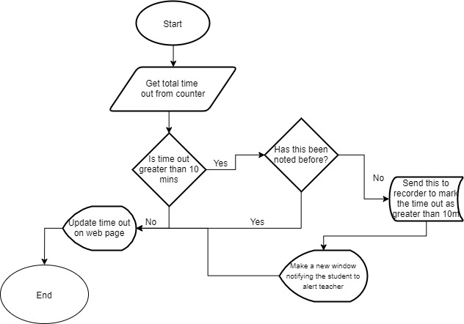

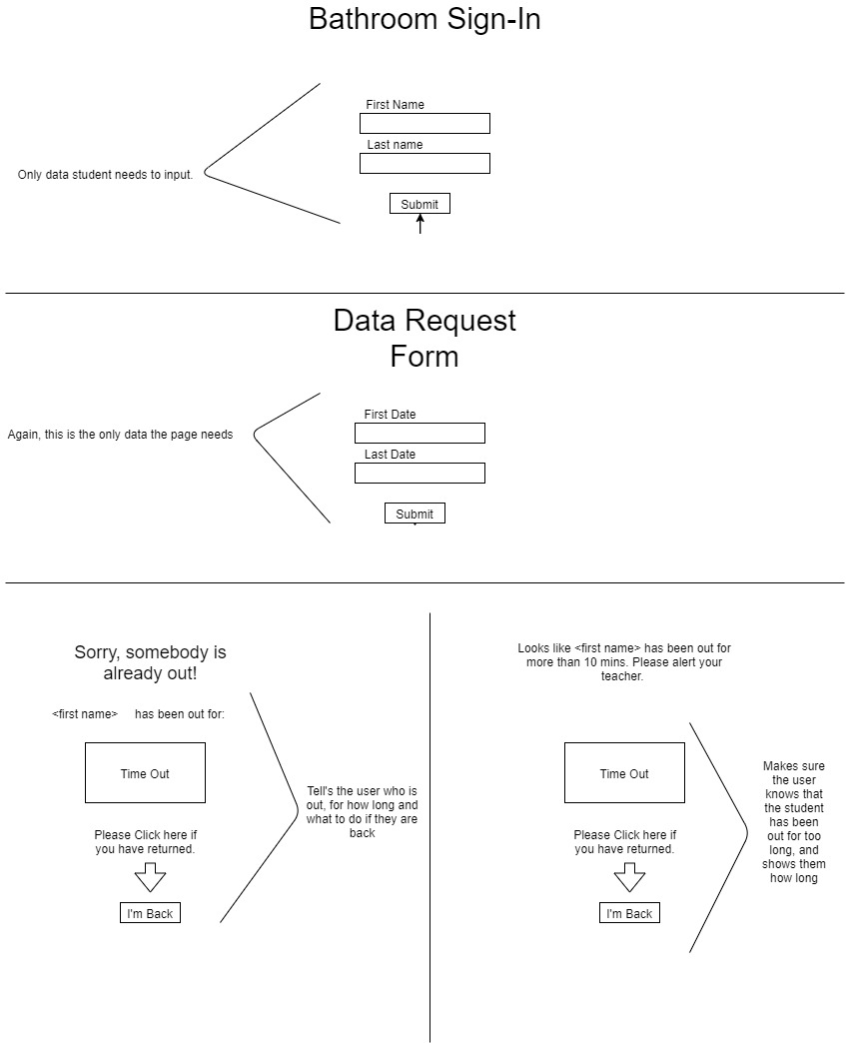

Test Criteria
Testing Scenario | Nature of Test | Example
Webpage keeps track of time properly | Leave and start a stopwatch. If the timers match it works | Leave for 6 mins, bothe the webpage and stopwatch display 6 mins.
CSV keeps track of time out | Sign out and verify time out with stopwatch | Sign out and wait 10 mins. If csv displays 10 mins it is keeping track
Back-End successfully records data received | Input data and make sure it is displayed correctly | Input name, and leave and come back. If the csv displays the correct name it is correct
Spreadsheet is created for each new date | Make a spreadsheet on 1/17th and 1/18th and verify it has named them correctly | Sign in and out on one day, and again the next day and verify there are 2 csv files. If so, it has passed.
Counter creates alert window after set amount of time has passed | Sign out and wait the required time to see if it alerts | Sign out and wait 10 mins. If it alerts at the 10 min mark it has passed.

