Arthur Kynan Wong Jun Siang

Technical Assessment for Mode Fair Software Developer (AI)

This assessment’s task was to develop an algorithm that finds the best route for a fleet of vehicles of different types so that the deliveries are completed at the lowest cost while satisfying all hard constraints.

I have decided to utilize and implement genetic algorithms. While knowledgeable of genetic algorithms I have not implemented it in code. With this assessment I decided to challenge myself through this assessment.

Implementing through a class for the vehicles, customers, and solution for an easier code reusing.

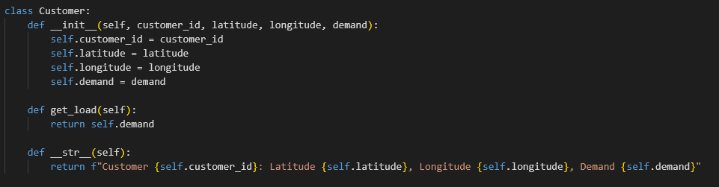

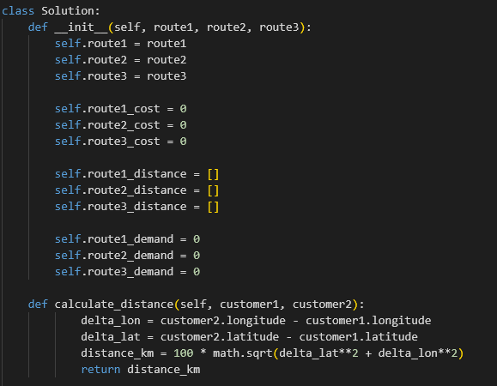

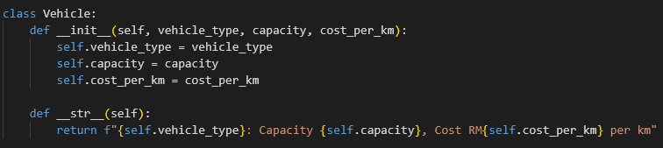

With genetic algorithms, it’s often best used when the solution allows for duplicated values. With this challenge, due to the hard constraints of all customers needs to be visited once, I’ve used order crossover with rule checking. Ensuring that each chromosome follows those rules.

