The rapid responses that are taken to overcome the climate’s change and its effects

A Class SDG

By: **StellarX**

**Table of contents**

Introduction: 3

_____________________________________________

Part one: (Climate? What do you mean?)

1 – What is meant by climate? 5

2 – What are the layers of the atmosphere? 8

3 – How do we interact with the climate every day? 11

_____________________________________________

Part two: (Climate changes)

1 – The factors that affect the climate. 13

2 – Risks??, when the climate changes?? 16

3 – The climate’s catastrophes. 18

_____________________________________________

Part three: (Climate’s effects)

1 – Understanding and dealing with the climate. 23 _____________________________________________

Summary: 31

References: 32

**Introduction**

We are on the verge of a game-changing play, a topic that may – and will if we don’t take action – change our lives, ecosystems, and communities for good. “How’s the weather today?” that question can change your mood for the entirety of the day and here’s the proof. (One of the questions that was asked in my blog topic proposal was how summer affects your mood. I found an article online that had statistics from a study by two researchers, Howard and Hoffman in 1984. In this study they found a significant correlation between weather and mood, especially in regards to humidity. These two researchers found that as the hours of sunshine increase, so does their optimism. Three factors that all had the most significant effect on mood were temperature, humidity and hours of sunshine).

The world is changing and we MUST adapt and change accordingly, the skies are raining loads of 1 kg of ice per piece, the ground is sucking every water source dry so droughts are a thing now, the wind is constantly shifting incredibly fast so then hurricanes exist.

We need to wake up to this ridiculously under-estimated topic and take our own precautions and by doing so, we encourage it others to imitate us and soon – *maybe sooner than you can imagine* – **we live in a healthy, beautiful, and green world**

**Part one**

**(Climate? What do you mean?)**

**1**

We all heard about the word “climate”, whether it was in school, university, or even at home. Doesn’t that make you wonder what does that “repeatedly” used word mean?

Well, it does make me wonder, so I learned more about it and I found out that basically, Climate refers to the long-term average weather conditions in a particular region. It encompasses factors like temperature, wind patterns, and humidity. Unlike weather, which describes short-term atmospheric conditions, climate represents a region's typical weather patterns over a significant period, typically at least 30 years. Climate is influenced by various factors, including latitude, altitude, proximity to bodies of water, and ocean currents (lakes, ponds, seas, etc). Ladies and gentlemen allow me to enlighten any ambiguity that may arise after these 8 complex lines. Climate is the weather that is standardly known around any region, much easier wouldn’t you say?

All-in-all Climate is “How’s the weather?” usually like in a specific landmass.

While climate is a relatively straightforward concept, there are some common misconceptions that people often make:

1. **Weather vs. Climate:**

* **Weather:** Refers to the day-to-day atmospheric conditions in a specific location.
* **Climate:** Describes the long-term average weather patterns in a region over a significant period (typically at least 30 years).
* **Confusing Weather and Climate:** Many people mistakenly use these terms interchangeably, leading to misunderstandings about long-term trends and patterns.

1. **Climate Change and Weather Events:**

**Climate Change:** Refers to long-term shifts in global weather patterns, including temperature, precipitation, and sea levels.

**Extreme Weather Events:** While climate change can increase the frequency and intensity of extreme weather events (like hurricanes, droughts, and heatwaves), it's important to note that any single weather event cannot be directly attributed to climate change.

**Confusing Weather Events with Climate Change:** People often mistakenly attribute every extreme weather event to climate change, which can oversimplify the complex relationship between the two.

**Short-Term Fluctuations:**

* **Climate Trends:** Climate refers to long-term trends, not short-term fluctuations.
* **Misinterpreting Short-Term Data:** Focusing too much on short-term weather patterns can lead to misleading conclusions about climate change.

**4. Regional vs. Global Climate:**

* **Regional Variations:** Climate can vary significantly across many different regions, even within the same country.
* **Overgeneralizing Global Trends:** Applying global climate trends to specific regions without considering regional variations mostly leads to inaccuracies.

**5. Natural vs. Human-Induced Climate Change:**

* **Natural Factors:** While natural factors like volcanic eruptions and solar cycles can change climate, the current warming trend is primarily driven by human activities, such as the burning of fossil fuels.
* **Underestimating Human Impact:** Some people may underestimate the role of human activities in climate change, leading to a false sense of security or complacency

**2**

**The atmosphere is composed of several layers, each with distinct characteristics:**

1. **Troposphere:**
   * The lowest layer, extending from the Earth's surface to an average height of about 7 miles (11 kilometers).
   * Contains most of the Earth's weather and almost all of the atmospheric water vapor and particulate matter.
   * Temperature decreases with altitude.
2. **Stratosphere:**
   * Extends from the top of the troposphere to an altitude of about 31 miles (50 kilometers).
   * Contains the ozone layer, which absorbs harmful ultraviolet radiation from the sun.
   * Temperature increases with altitude due to the absorption of UV radiation.
3. **Mesosphere:**
   * Extends from the top of the stratosphere to an altitude of about 53 miles (85 kilometers).
   * The coldest layer of the atmosphere, with temperatures reaching below -100 degrees Celsius.
   * Meteoroids burn up in this layer, creating shooting stars.
4. **Thermosphere:**
   * Extends from the top of the mesosphere to an altitude of about 310 miles (500 kilometers).
   * The hottest layer, with temperatures reaching over 2,000 degrees Celsius.
   * Contains the International Space Station and most satellites.
   * The air is extremely thin, consisting mainly of oxygen and nitrogen atoms.
5. **Exosphere:**
   * The outermost layer of the atmosphere, extending from the top of the thermosphere to outer space.
   * There is no clear upper boundary to the exosphere, as it gradually fades into interplanetary space.
   * The air is extremely thin, and there is no clear distinction between the atmosphere and outer space.

Each layer of the atmosphere plays a vital role in the Earth's climate and weather systems. Understanding the structure and characteristics of these layers is essential for understanding the processes that drive our planet's environment.

Here is an illustrative image:



“**Sourced from: NASA**”

The climate is mainly connected to the ***Tropospheric layer,*** which is what we will mainly focus on today, as NASA tends to give you super accurate information, we need to keep our focus on the climate now…

**3**

Most people don’t understand the fact that their mood is directly connected to the weather (climate) in the region. Think of it that way, imagine a young kid who is begging his/her parent to go swim in the sea under the rays of the beautiful sunlight, in contrast with another kid, who just wishes to be able to go out with his/her friends but it is too cold.

The general weather (climate) affected the first kid in a positive way, while the second kid, not so much, frankly it even deprived the kid from his/her innocent positivity

What am I hinting to?

That would be the simple fact that you are emotionally

– involuntarily – connected to the climate you live in, and as long as you know that, this shouldn’t be a problem, or will it be if the climate was always bad?

____________________________________________________

**Part two**

**(Climate changes)**

**1**

The worldly climate has several factors controlling it (as the strings that control a puppet), where these factors get mainly affected by the human’s monstruous behavior.

Factors affecting the climate:

* 1. **Human-Induced Factors:**

1. **Greenhouse Gas Emissions:** The burning of fossil fuels, deforestation, and industrial processes release greenhouse gases into the atmosphere, trapping heat and contributing to global warming.
2. **Land Use Change:** Deforestation, urbanization, and agriculture can alter the Earth's surface, affecting local and regional climates.
3. **Aerosols:** Tiny particles suspended in the atmosphere can influence temperature and precipitation patterns.
   1. **Natural Factors:**
4. **Latitude:** The distance from the equator determines the amount of solar radiation a region receives. Places closer to the equator receive more direct sunlight, leading to warmer temperatures.
5. **Altitude:** Elevation affects temperature. As altitude increases, the air becomes thinner and less able to retain heat, resulting in colder temperatures.
6. **Ocean Currents:** Large-scale ocean currents transport heat from warmer equatorial regions to colder polar regions, influencing coastal climates.
7. **Prevailing Winds:** Wind patterns can transport moisture and heat, affecting precipitation and temperature.
8. **Topography:** The shape of the land, such as mountains and valleys, can influence temperature and precipitation patterns.
9. **El Niño-Southern Oscillation (ENSO):** This natural climate phenomenon can cause significant fluctuations in temperature and precipitation patterns worldwide.

**In summary,** climate is a complex system influenced by a multitude of factors, both natural and human-induced.

Understanding these factors is essential for predicting and mitigating climate change.

__________________________________________________

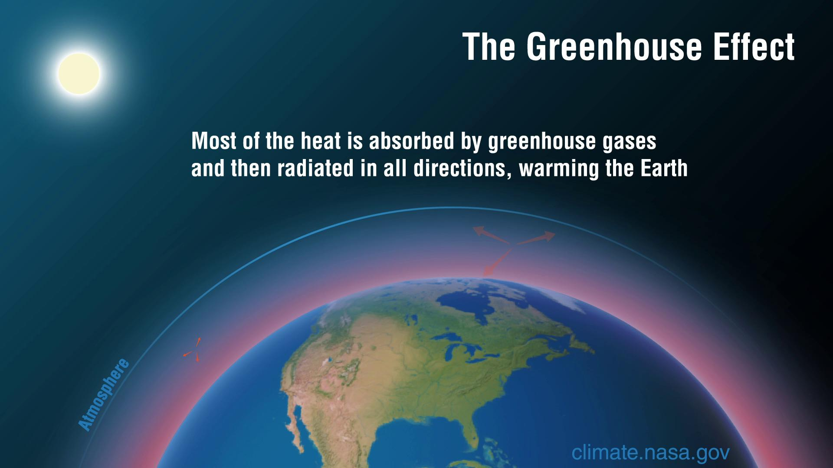

(An example of one of the factors that affect the climate)

(Sourced by: NASA)

**Humans** play an important role in affecting the climate, whether for the better or for the worse and if it was for the worse then, humans will pay, and it isn’t going to end well…

So yeah, humans need to restore stability to these factors, make sure that the factors are well-noted, preserve their normal climate because what you are about to see is what happens when they ignore this **ONE** simple rule.

**2**

There isn’t an easy way to say this but this is the damage that the climate can do if the situation is worsened…

**Environmental Impacts**

* **Rising Sea Levels:** As glaciers and ice caps melt, sea levels will rise, inundating coastal cities and islands.
* **Extreme Weather Events:** More frequent and intense hurricanes, floods, droughts, and heatwaves can lead to widespread damage and loss of life.
* **Biodiversity Loss:** Climate change can disrupt ecosystems, leading to habitat destruction and species extinction.
* **Ocean Acidification:** Increased carbon dioxide in the atmosphere can make oceans more acidic, harming marine life.

**Economic Impacts**

* **Agricultural Disruption:** Changes in temperature and precipitation patterns can affect crop yields, leading to food shortages and price increases.
* **Infrastructure Damage:** Extreme weather events can damage infrastructure, such as roads, bridges, and power grids.
* **Economic Displacement:** Rising sea levels and extreme weather events may force people to relocate, leading to economic disruption and displacement.

**Health Impacts**

* **Heat-related Illnesses:** Rising temperatures can increase the risk of heat-related illnesses, such as heatstroke and dehydration.
* **Waterborne Diseases:** Changes in precipitation patterns can affect water quality and increase the risk of waterborne diseases.
* **Respiratory Problems:** Air pollution and extreme weather events can exacerbate respiratory problems.

**Social Impacts**

* **Conflict and Instability:** Climate change can exacerbate existing social and economic inequalities, leading to conflict and instability.
* **Migration:** As people flee climate-related disasters, migration patterns may change, leading to social and political tensions.

I can’t even describe them all as they are uncountable and there will be tragedies, if this problem was to happen.

**3**

A worsening climate poses significant threats to our planet and its inhabitants. Here are some of the most severe potential catastrophes:

**Extreme Weather Events**

* **Intensified storms:** Hurricanes, typhoons, and cyclones are expected to become more powerful and frequent, leading to increased coastal erosion, flooding, and property damage.
* **Severe droughts:** Prolonged periods of dryness can cause water shortages, crop failures, and wildfires.
* **Heatwaves:** Extreme heat can lead to heat-related illnesses and deaths, as well as agricultural losses.
* **Heavy rainfall:** Intense precipitation can result in flooding, landslides, and damage to infrastructure.

**Rising Sea Levels**

* **Coastal inundation:** As sea levels rise, coastal cities and islands will be more vulnerable to flooding, erosion, and saltwater intrusion.
* **Displacement of populations:** Millions of people living in low-lying areas may be forced to relocate, which isn’t easy.
* **Loss of ecosystems:** Coastal wetlands and habitats will be threatened, leading to biodiversity loss.

**Food Insecurity and Water Scarcity**

* **Crop failures:** Climate-related factors such as droughts, heatwaves, and pests can reduce crop yields and lead to food shortages.
* **Water shortages:** Diminished water supplies can affect agriculture, drinking water, and sanitation.
* **Conflict and migration:** Competition for resources can exacerbate tensions and lead to conflict, potentially triggering mass migration.

**Biodiversity Loss**

* **Habitat destruction:** Climate change can alter ecosystems, leading to habitat loss and species dying out.
* **Coral bleaching:** Rising ocean temperatures has the potential to cause coral reefs to bleach and die, impacting marine biodiversity.
* **Disruption of food chains:** Changes in climate can disrupt food chains, leading to cascading effects on ecosystems.

**Health Impacts**

* **Disease outbreaks:** Warmer temperatures can create favorable conditions for the spread of various infectious diseases.
* **Heat-related illnesses:** Extreme heat can lead to heatstroke, dehydration, and other serious health problems.
* **Mental health issues:** Climate-related disasters and uncertainty can contribute to stress, fear, anxiety, and depression.

____________________________________________________

All of these problems can be simply avoided if the right procedures were taken, too bad that people often underestimate this problem and when it happens, the damage will be extremely severe in a way that might even affect their mental health as preceded.

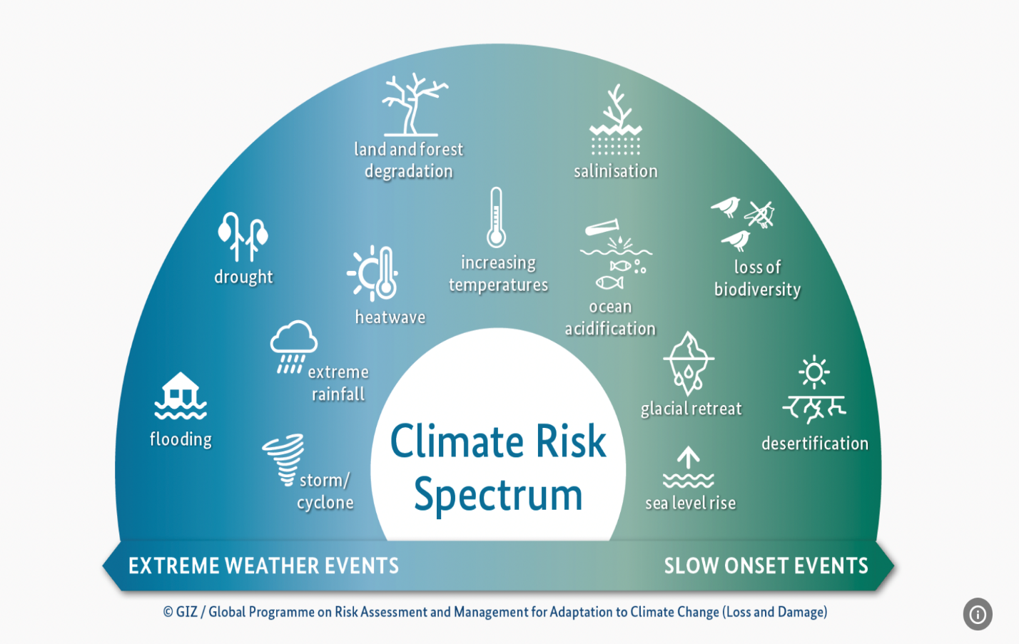

“Illustrative image”

ALONG WITH

**Part three**

**(Climate’s effect)**

**1**

Climate change is one of the most pressing challenges facing humanity today. Rising temperatures, extreme weather events, and increasing carbon emissions threaten ecosystems, economies, and communities **worldwide**. To combat these issues, it is essential to implement effective procedures that benefit the climate and reduce the resulting damage. This essay outlines several key strategies that can be undertaken collectively at local, national, and global levels to create a more sustainable future.

**Understanding the Severity of Climate Change**

Before we delve into procedures, it is crucial to acknowledge the severity of climate change impacts, which include:

* Increased global temperatures
* Severe weather events like hurricanes and floods
* Ocean acidification and rising sea levels
* Loss of biodiversity and ecosystems
* Health impacts, including heat-related illnesses and respiratory problems

By understanding these consequences, the urgency for action becomes undeniable.

**Transition to Renewable Energy**

One of the most effective ways to address climate change is to transition from fossil fuels to renewable energy sources. This shift can be achieved through the following procedures:

* **Invest in Solar and Wind Energy:**
  + Expand solar panel installations on rooftops and in solar farms.
  + Construct wind turbines in suitable areas, both onshore and offshore.
* **Enhance Energy Storage Technologies:**
  + Develop and improve battery storage systems to store renewable energy.
  + Invest in smart grid technologies to optimize energy distribution.
* **Promote Geothermal and Hydropower:**
  + Tap into geothermal resources for clean heating and energy.
  + Implement sustainable hydropower projects that minimize ecological impacts.

**Energy Efficiency Improvements**

Improving energy efficiency is another powerful means to combat climate change. Procedures to enhance energy efficiency include:

* **Upgrade Buildings:**
  + Insulate buildings effectively to reduce heating and cooling needs.
  + Implement energy-efficient lighting, such as LED bulbs.
* **Support Energy-Efficient Appliances:**
  + Encourage the use of Energy Star-rated appliances in homes and businesses.
  + Offer incentives for upgrades to more efficient systems, such as HVAC.
* **Implement Smart Technology:**
  + Use smart thermostats and sensors to optimize energy usage in homes.
  + Incentivize companies to adopt energy monitoring systems.

**Sustainable Transportation Solutions**

Transportation is another significant contributor to greenhouse gas emissions. To reduce this impact, we must implement sustainable transportation solutions:

* **Promote Public Transportation:**
  + Invest in efficient and reliable public transit systems to reduce car dependency.
  + Provide subsidies to reduce fare costs and encourage usage.
* **Encourage Electric Vehicles (EVs):**
  + Expand charging infrastructure for EVs in urban and rural areas.
  + Offer tax incentives or rebates for purchasing electric or hybrid vehicles.
* **Support Active Transport:**
  + Develop infrastructure for biking and walking, such as bike lanes and sidewalks.
  + Increase awareness of the health and environmental benefits of cycling and walking.

**Sustainable Agriculture Practices**

Agriculture plays a critical role in both climate impact and mitigation strategies. The following procedures promote sustainable agricultural practices:

* **Promote Organic Farming:**
  + Encourage farmers to adopt organic practices that enhance soil health.
  + Reduce chemical fertilizers and pesticides, which contribute to emissions.
* **Implement Regenerative Agriculture:**
  + Utilize cover crops and crop rotation to improve soil health and sequester carbon.
  + Promote agroforestry practices that integrate trees into farming systems.
* **Reduce Food Waste:**
  + Educate consumers about proper food storage and meal planning.
  + Encourage local food sharing programs and composting initiatives.

**Conservation and Reforestation Efforts**

Forests and natural ecosystems are vital for absorbing carbon dioxide and supporting biodiversity. To bolster these systems, we can:

* **Protect Existing Forests:**
  + Implement and enforce laws against illegal logging and land conversion.
  + Support indigenous land stewardship practices that protect forests.
* **Reforest Degraded Lands:**
  + Launch community reforestation programs to plant native tree species.
  + Create incentives for landowners to participate in reforestation efforts.
* **Protect Biodiversity:**
  + Establish wildlife corridors to facilitate migration and genetic diversity.
  + Prevent habitat destruction through strong conservation policies.

**Climate Education and Advocacy**

Education plays a crucial role in fostering awareness and action against climate change. Effective procedures include:

* **Integrate Climate Education in Schools:**
  + Include climate science and sustainability in curricula from an early age.
  + Encourage project-based learning focused on environmental stewardship.
* **Promote Community Engagement:**
  + Organize workshops and public forums to discuss climate issues and solutions.
  + Create community-led initiatives to address local climate challenges.
* **Support Climate Advocacy:**
  + Engage with local and global organizations to advocate for policy change.
  + Encourage individuals to voice their concerns to policymakers.

**Global Cooperation and Policy Change**

Addressing climate change requires collective action at local, national, and global levels. Important procedures include:

* **Adopt International Agreements:**
  + Support and adhere to international agreements such as the Paris Agreement.
  + Facilitate technology transfer to developing nations to promote sustainable practices.
* **Enact Climate Legislation:**
  + Advocate for legislation that limits greenhouse gas emissions.
  + Support policies promoting renewable energy and energy efficiency.
* **Strengthen Climate Resilience:**
  + Develop national and local plans to prepare for climate impacts, such as floods and droughts.
  + Invest in infrastructure that supports adaptation to changing climate conditions.

**Conclusion**

The need to benefit the climate and reduce the damage inflicted by a deteriorating environment is paramount. By implementing the procedures outlined above—transitioning to renewable energy, promoting energy efficiency, improving transportation, and advocating for sustainable agriculture, conservation, education, and global cooperation—we can forge a path toward a more sustainable and resilient future. The collective efforts of individuals, communities, governments, and organizations can create lasting positive impacts on our planet, ensuring that future generations inherit a healthier and more stable world. Now is the time to act, for the benefit of the climate and all life on Earth.

____________________________________________________

**Summary**

Climate is a vast topic that couldn’t be described in my mere words, but what should be grasped about its reality that it is the weather that has “delicate health”, and we – as humans – need to do our absolute best in trying to limit the harmfulness which we destroy the climate with (and eventually this will backfire on us in dire consequences, which will make us pay the price).

The weather, that is “usual” to us, is what we adapted to and if that weather changed (negatively), I can’t help but to imagine what kind of miserable creatures will we become if that happens.

Our bad habits are directly proportional to the bad climate that is upon us, and by saying so ladies and gentlemen, I hope to internally establish our abasement for these bad habits, hoping to keep ourselves safe.

**References**

[Introduction’s (mood x weather) part](https://sites.udel.edu/ninaspin/2014/03/11/correlation-between-weather-and-mood/#:~:text=Another%20study%20by%20Sanders%20and,vigor%2C%20elation%20and%20affection%E2%80%9D.)

[Nasa’s image](https://science.nasa.gov/earth/earth-atmosphere/earths-atmosphere-a-multi-layered-cake/)

[Nasa’s 2nd image](https://climate.nasa.gov/climate_resources/240/the-greenhouse-effect-simplified/)

[Illustrative image](https://www.weforum.org/agenda/2022/09/better-financial-metrics-climate-risk/)

[Gemini](https://gemini.google.com)