Bio picture :
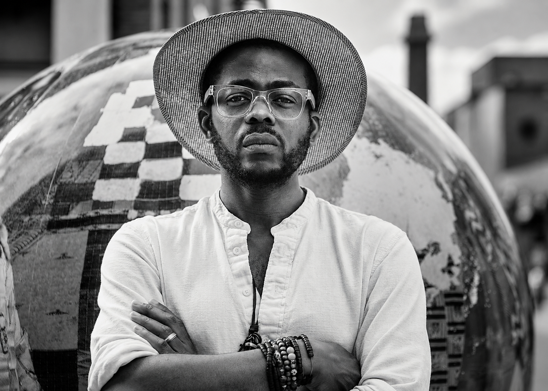
ÀSÌKÒ
ARTIST / ANCESTRAL FUTURIST
Àsìkò is a British-Nigerian multidisciplinary artist creating new visual languages from Yoruba philosophy, ancestral memory and contemporary life. Working across photography, film, mixed media and artificial intelligence, he explores how culture evolves as it travels between generations, geographies and technologies. Born in London and raised between Lagos and Britain, his practice occupies the space between cultures, guided by a simple principle: to look backwards in order to imagine forward.
Yoruba concepts of ancestry, spirituality and destiny run throughout his work. Ideas such as Ase, the life force that gives things the power to become; Egúngún, the return of ancestors to the world of the living; and Ori, our inner consciousness and destiny, become starting points for contemporary explorations of identity, migration, womanhood and belonging. In works such as New World Giants, ancestral masquerades appear within everyday British landscapes, creating a powerful meeting point between cultural memory and the present.
Àsìkò moves fluidly between analogue and digital image-making, increasingly using AI to extend rather than replace ancestral storytelling. His work has been presented at Gagosian London, 1-54 Contemporary African Art Fair, Photo London, NOW Gallery and Southbank Centre, with his recent The Ori That Speaks commission for Nieuwe Instituut bringing Yoruba philosophy into an AI-assisted moving-image work. Across his practice, Àsìkò asks how ancestral knowledge can remain alive not by standing still, but by continually becoming something new.

LINKS
- Website : https://asiko-artist.format.com
- Instagram : https://www.instagram.com/asiko_artist/?hl=en
- MOVART Gallery : https://movartgallery.com/collaboration/asiko/
- Aesthetica Art Prize : https://artprize.aestheticamagazine.com/projects/asiko/

TOPICS
ANCESTRAL FUTURES — YORUBA PHILOSOPHY — CULTURAL IDENTITY — DIASPORA — ART & AI — MYTHOLOGY — BLACK REPRESENTATION — WOMANHOOD — RITUAL — MEMORY — MIGRATION — CULTURAL TRANSFORMATION

FEATURED WORK
- New World Giants :https://www.theguardian.com/artanddesign/2023/mar/29/yoruban-masqueraders-newcastle-asikos-best-photograph
thumbnail :
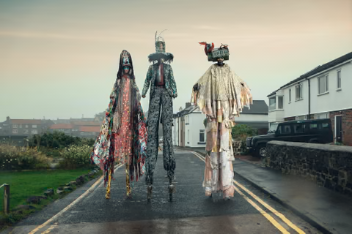
- The Ori That Speaks : https://nieuweinstituut.nl/en/articles/screen-commission-asiko
Thumbnail :
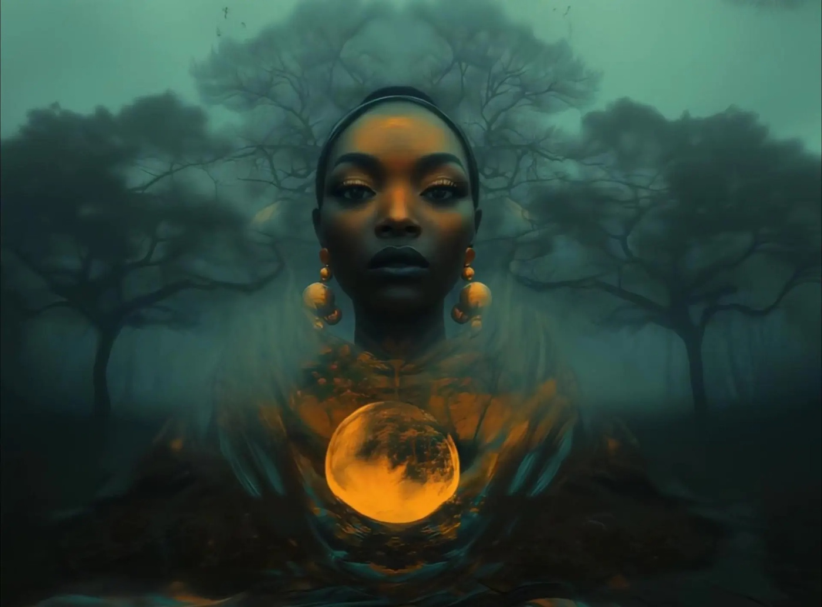
- Ase : https://griotmag.com/en/asikos-visual-representation-of-emotions-the-personal-becomes-universal/
thumbnail :
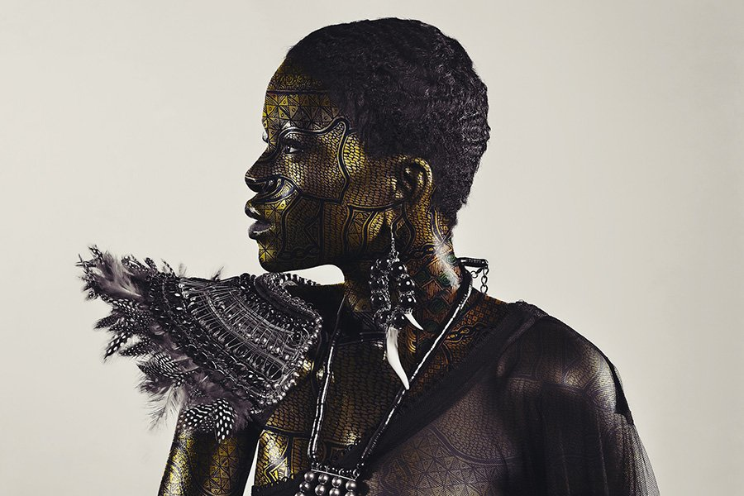
- Conversations ( please send link and thumbnail )

