项目A自动化测试报告
Feature | Scenario | Step | Screenshot | Result | Err
Login1 | Successful login | Given open the login page |  | Fail | Page.goto: Timeout 30000ms exceeded.  Call log:  - navigating to "https://www.saucedemo.com/", waiting until "load"
 |  | When input user "testAccount" |  | Skip | 前置步骤失败，跳过执行
 |  | And click login button |  | Skip | 前置步骤失败，跳过执行
 |  | Then login with "successful" account |  | Skip | 前置步骤失败，跳过执行
Login1  Login1  Login1  Login1  Login1  Login1 | sort and add Sauce Labs Backpack in cart -- @1.1  sort and add Sauce Labs Bike Light in cart -- @1.2  sort and add Sauce Labs Bolt T-Shirt in cart -- @1.3  sort and add Sauce Labs Fleece Jacket in cart -- @1.4  sort and add Sauce Labs Onesie in cart -- @1.5  sort and add Test.allTheThings() T-Shirt (Red) in cart -- @1.6 | Given sort all item | 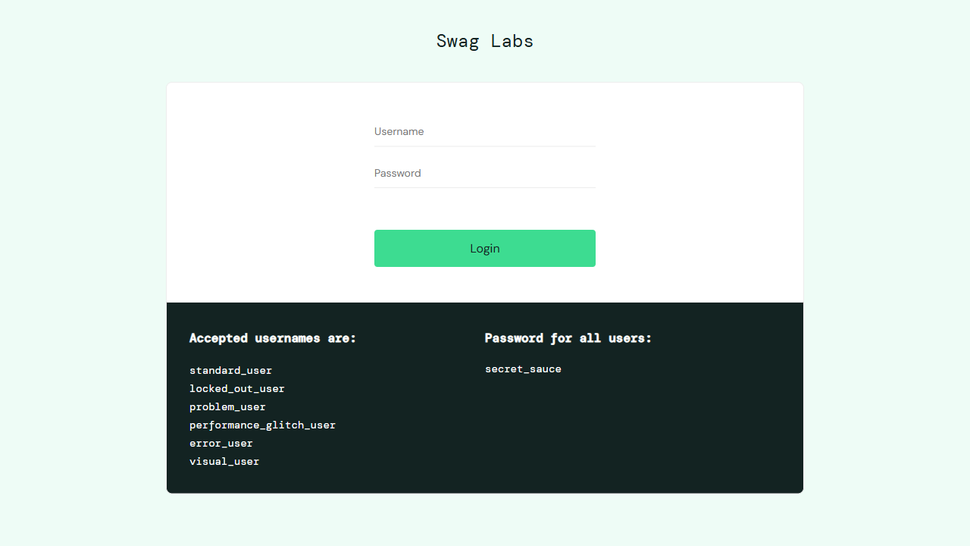 | Fail | Page.select_option: Target page, context or browser has been closed  Call log:  - waiting for locator("//*[@id=\"header_container\"]//select[@class=\"product_sort_container\"]")
 |  | When click "Sauce Labs Backpack" and check details |  | Skip | 前置步骤失败，跳过执行
 |  | And add in cart |  | Skip | 前置步骤失败，跳过执行
 |  | Then check if "Sauce Labs Backpack" is in cart |  | Skip | 前置步骤失败，跳过执行
 |  | Then back to all items page |  | Skip | 前置步骤失败，跳过执行
 |  | Given enter the cart |  | Fail | Page.click: Target page, context or browser has been closed
 |  | When remove "Sauce Labs Backpack" |  | Skip | 前置步骤失败，跳过执行
 |  | Then check if "Sauce Labs Backpack" is removed |  | Skip | 前置步骤失败，跳过执行
 |  | Given sort all item |  | Fail | Page.select_option: Target page, context or browser has been closed
 |  | When click "Sauce Labs Bike Light" and check details |  | Skip | 前置步骤失败，跳过执行
 |  | And add in cart |  | Skip | 前置步骤失败，跳过执行
 |  | Then check if "Sauce Labs Bike Light" is in cart |  | Skip | 前置步骤失败，跳过执行
 |  | Then back to all items page |  | Skip | 前置步骤失败，跳过执行
 |  | Given enter the cart |  | Fail | Page.click: Target page, context or browser has been closed
 |  | When remove "Sauce Labs Bike Light" |  | Skip | 前置步骤失败，跳过执行
 |  | Then check if "Sauce Labs Bike Light" is removed |  | Skip | 前置步骤失败，跳过执行
 |  | Given sort all item |  | Fail | Page.select_option: Target page, context or browser has been closed
 |  | When click "Sauce Labs Bolt T-Shirt" and check details |  | Skip | 前置步骤失败，跳过执行
 |  | And add in cart |  | Skip | 前置步骤失败，跳过执行
 |  | Then check if "Sauce Labs Bolt T-Shirt" is in cart |  | Skip | 前置步骤失败，跳过执行
 |  | Then back to all items page |  | Skip | 前置步骤失败，跳过执行
 |  | Given enter the cart |  | Fail | Page.click: Target page, context or browser has been closed
 |  | When remove "Sauce Labs Bolt T-Shirt" |  | Skip | 前置步骤失败，跳过执行
 |  | Then check if "Sauce Labs Bolt T-Shirt" is removed |  | Skip | 前置步骤失败，跳过执行
 |  | Given sort all item |  | Fail | Page.select_option: Target page, context or browser has been closed
 |  | When click "Sauce Labs Fleece Jacket" and check details |  | Skip | 前置步骤失败，跳过执行
 |  | And add in cart |  | Skip | 前置步骤失败，跳过执行
 |  | Then check if "Sauce Labs Fleece Jacket" is in cart |  | Skip | 前置步骤失败，跳过执行
 |  | Then back to all items page |  | Skip | 前置步骤失败，跳过执行
 |  | Given enter the cart |  | Fail | Page.click: Target page, context or browser has been closed
 |  | When remove "Sauce Labs Fleece Jacket" |  | Skip | 前置步骤失败，跳过执行
 |  | Then check if "Sauce Labs Fleece Jacket" is removed |  | Skip | 前置步骤失败，跳过执行
 |  | Given sort all item |  | Fail | Page.select_option: Target page, context or browser has been closed
 |  | When click "Sauce Labs Onesie" and check details |  | Skip | 前置步骤失败，跳过执行
 |  | And add in cart |  | Skip | 前置步骤失败，跳过执行
 |  | Then check if "Sauce Labs Onesie" is in cart |  | Skip | 前置步骤失败，跳过执行
 |  | Then back to all items page |  | Skip | 前置步骤失败，跳过执行
 |  | Given enter the cart |  | Fail | Page.click: Target page, context or browser has been closed
 |  | When remove "Sauce Labs Onesie" |  | Skip | 前置步骤失败，跳过执行
 |  | Then check if "Sauce Labs Onesie" is removed |  | Skip | 前置步骤失败，跳过执行
 |  | Given sort all item |  | Fail | Page.select_option: Target page, context or browser has been closed
 |  | When click "Test.allTheThings() T-Shirt (Red)" and check details |  | Skip | 前置步骤失败，跳过执行
 |  | And add in cart |  | Skip | 前置步骤失败，跳过执行
 |  | Then check if "Test.allTheThings() T-Shirt (Red)" is in cart |  | Skip | 前置步骤失败，跳过执行
 |  | Then back to all items page |  | Skip | 前置步骤失败，跳过执行
 |  | Given enter the cart |  | Fail | Page.click: Target page, context or browser has been closed
 |  | When remove "Test.allTheThings() T-Shirt (Red)" |  | Skip | 前置步骤失败，跳过执行
 |  | Then check if "Test.allTheThings() T-Shirt (Red)" is removed |  | Skip | 前置步骤失败，跳过执行
Login1 | checkout user1 -- @1.1 | Given enter the cart |  | Fail | Page.click: Target page, context or browser has been closed
 |  | When enter checkout page |  | Skip | 前置步骤失败，跳过执行
 |  | Then inpput "user1" and finish |  | Skip | 前置步骤失败，跳过执行
Login1 | checkout user2 -- @1.2 | Given enter the cart |  | Fail | Page.click: Target page, context or browser has been closed
 |  | When enter checkout page |  | Skip | 前置步骤失败，跳过执行
 |  | Then inpput "user2" and finish |  | Skip | 前置步骤失败，跳过执行
Login1 | checkout user3 -- @1.3 | Given enter the cart |  | Fail | Page.click: Target page, context or browser has been closed
 |  | When enter checkout page |  | Skip | 前置步骤失败，跳过执行
 |  | Then inpput "user3" and finish |  | Skip | 前置步骤失败，跳过执行
Login1 | checkout user4 -- @1.4 | Given enter the cart |  | Fail | Page.click: Target page, context or browser has been closed
 |  | When enter checkout page |  | Skip | 前置步骤失败，跳过执行
 |  | Then inpput "user4" and finish |  | Skip | 前置步骤失败，跳过执行
Login1 | checkout user5 -- @1.5 | Given enter the cart |  | Fail | Page.click: Target page, context or browser has been closed
 |  | When enter checkout page |  | Skip | 前置步骤失败，跳过执行
 |  | Then inpput "user5" and finish |  | Skip | 前置步骤失败，跳过执行
Login1 | checkout user6 -- @1.6 | Given enter the cart |  | Fail | Page.click: Target page, context or browser has been closed
 |  | When enter checkout page |  | Skip | 前置步骤失败，跳过执行
 |  | Then inpput "user6" and finish |  | Skip | 前置步骤失败，跳过执行

