

ECOMMERCE DATABASE DESIGN

PART1



By:

Adedayo Kukoyi

May 24, 2024

Part 1: **Perform a Bottom-up Database Design**

Link to Online Form.

<https://www.bing.com/images/search?view=detailV2&ccid=IgUGD4MH&id=C9A4EE1CFB29B7855CAADA165B6A3989F1EADC3E&thid=OIP.IgUGD4MHK_8gYQ8Ri4GsnwHaKe&mediaurl=https%3A%2F%2Fi.pinimg.com%2Foriginals%2F19%2F37%2Fb0%2F1937b0081c838c227b488ad482e1eb6e.jpg&cdnurl=https%3A%2F%2Fth.bing.com%2Fth%2Fid%2FR.2205060f83072bff20610f118b81ac9f%3Frik%3DPtzq8Yk5alsW2g%26pid%3DImgRaw%26r%3D0&exph=2339&expw=1654&q=form+sample+containing+customer%2c+products%2c+order+and+order+details&simid=608052196055212944&form=IRPRST&ck=06C4D77EE36F129DE1265B9EC27E9680&selectedindex=7&itb=0&ajaxhist=0&ajaxserp=0&vt=0&sim=11>

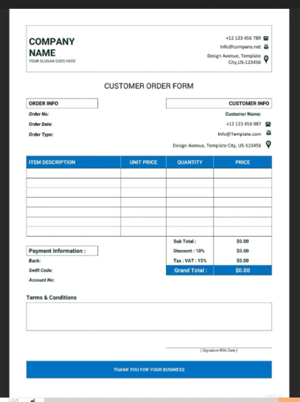

**Figure 1.0**: Customer Order Form. (By Adedayo Kukoyi IT525 Unit 7 Assignment, 05/20/2024)

1. **Form Attributes**

|  |  |  |  |  |  |  |  |  |  |  |  |
| --- | --- | --- | --- | --- | --- | --- | --- | --- | --- | --- | --- |
| Order no/Id | Customer Id | Order date | Order type | Customer Name | Customer email | Customer phone | Customer address | Product ID | Product Name | Product Description | Product Quantity |

|  |  |  |  |  |  |  |  |  |  |  |  |
| --- | --- | --- | --- | --- | --- | --- | --- | --- | --- | --- | --- |
| Product Unit Price | Product Price | Payment  id | Payment Method | Payment Date | Payment Amount | Ordered Items ID | Ordered items Quantity |  |  |  |  |

**2.0 Dependencies Determinant**

To determine the dependencies, the following should be determined.

1. Find Functional dependencies e.g. Customer information, Order details, and Product details.
2. Primary key identification e.g. Orde No/ID, Customer ID, Product ID, Payment ID, and Ordered Items ID.
3. Match entity group members e.g. Customer ID (Pk), First_name, Last_name, Email, Phone.

**3.0 Entity and Attributes with Common Determinant**

The attributes are grouped in the entity order to show the entity supertype and subtype classes.

Entity Name - Order:

Group Attributes

* Order_ID (This is the table's Primary key)
* Order_Date
* Order_Type
* Customer_ID (This is a foreign key that references table Customer(Customer_ID))

Entity Name - **Customer:**

Group Attributes

* Customer_ID (This is the table's primary key)
* First_Name
* Last_Name
* Phone_Number
* Email
* Address (Separated by address, state, and zip code)
* State
* Zip_Code

Entity Name - **Product**

Group Attributes

* Product_ID (This is the table's primary key)
* Product_Name
* Product_Description
* ProductUnit_price
* Product_Quantity
* Product_Price

Entity Name - **OrderItems (Associative Entity)**

Group Attributes

* OrderItems_ID (This is the table's primary key)
* Order_ID (This is a foreign key that references table Order(Order_ID))
* Product_ID (This is a foreign key that references table Product(Product_ID))

Entity Name - **Payment**

Group Attributes

* PaymentID (This is the table's primary key)
* Order_ID
* Payment_Method
* Payment_Date
* Payment_Amount

**4.0 Entity Pairs**

The entity will be paired as follows:

* Customer: Order
* Order: Order Items
* Product: Order Items
* Order: Payments

**5.0 Entity pair and relationship.**

Pair - Relationships:

* Customer: Order - One customer (Customers table) can have many orders (Orders table) - One-to-Many relationship.
* Order: Order Items - One order (Orders table) can have many order items (OrderItems table) - One-to-Many relationship.
* Product: Order Items - One product (Products table) can be included in many orders (OrderItems table) - Many-to-Many relationship (represented by the OrderItems table).

Order: Payments - One order (Orders table) can have one payment (Payments table) - One-to-One relationship. (Kendall and Kendall, 2020).

6.0 Entity Relationship Diagram (ERD) for the Customer Order Database Design.

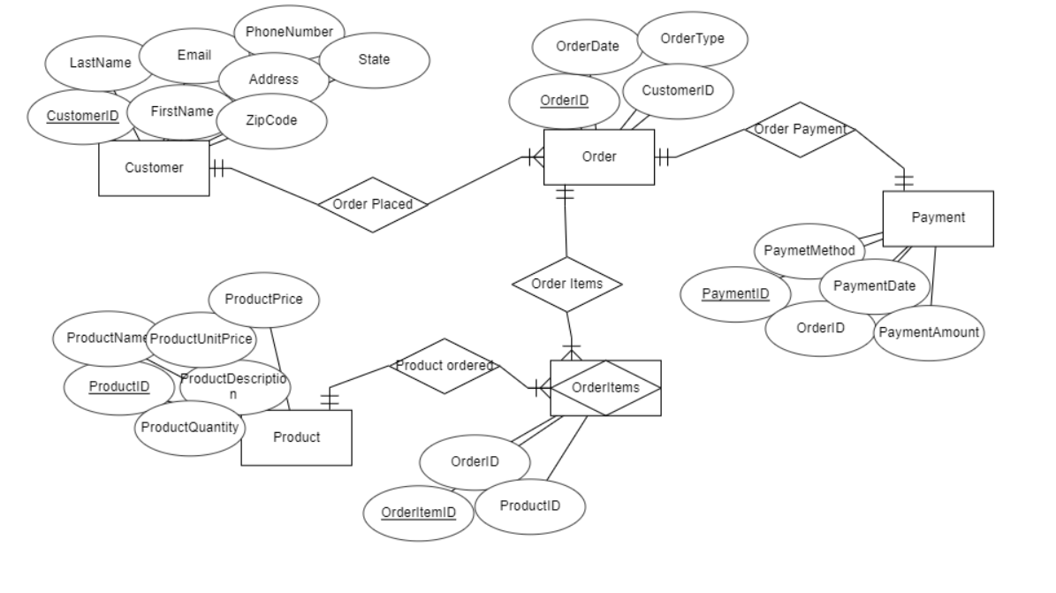

Figure 2.0 Customer Order ERD. (By Adedayo Kukoyi, 05/20/024)

The Entity relationship diagram has been normalized by removing repeating groups, partial, and transitive dependencies. (Kendall and Kendall, 2020).

**REFERENCES**

* Kendall, E. K and Kendall, E. J (2020). *Systems Analysis and Design 10th Edition. (pp. 409-439).*Pearson Education Limited.