ECOMMERCE DATABASE DESIGN PROJECT

By:

Adedayo Kukoyi

May 24, 2024

PART 2: **BEGIN DESIGNING A DATABASE**

**PART 1. DATABASE DEFINITION**

The purpose of this database is to enable online orders of products. The database stores information about customers, products, orders, and payments.

The database enables easy monitoring of order transactions placed by customers.

The data provided by the database can be used to support other activities like marketing to track sales and revenue generated through the ordering activities.

**PART 2. DATABASE DESIGN**

**List of Tables (Entity Types):**

1. **Customer:** Signifies order placed by customer.
2. **Product:** Signifies product being purchased.
3. **Order:** Signifies customer's order.
4. **Order Item:** Associative entity connects orders to products.
5. **Payment:** Signifies payment for the order purchased.

**Business Rules:**

**Customer - Order**

One customer can place many orders. (A one-to-many relationship).

Many orders can be placed by one customer.

Customer 1:M Orders.

**Order - Order Items (Associative Entity).**

One order (Orders table) can have many order items (OrderItem table). (One-to-Many relationship).

Order 1:M OrderItems.

**Product - OrderItems (Associative Entity).**

One product (Products table) can be included in many orders (OrderItems table)

Order M:1 OrderItems

**Order - Payment**

One order (Orders table) can have one payment (Payments table)

One payment should be made for an order placed.

Order 1:1 Payment.

(Kendall and Kendall, 2020).

**PART 2. ERD SCHEMA**

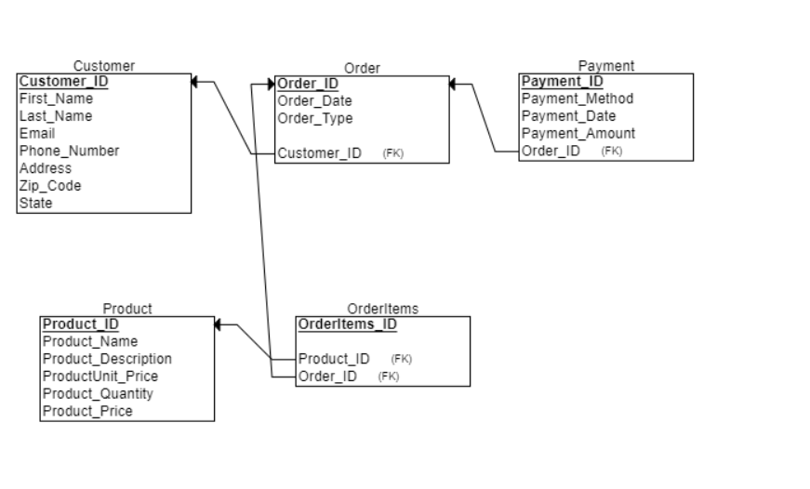

**Figure 3.0 Customer ERD SCHEMA** (By Adedayo Kukoyi, 05/20/024)**.**

**REFERENCES**

* Kendall, E. K and Kendall, E. J (2020). *Systems Analysis and Design 10th Edition. (pp. 409-439).*Pearson Education Limited.