作业1-SQL编程实验

1. SQL编写
2. 查询“Northwind”示例数据库中供应商的ID、公司名称、地区、城市和电话字段的值。其中的一些供应商位于MA或OR地区，另外一些供应商所在的城市是Berlin的

select SupplierID,CompanyName,Region,City,Phone

from Suppliers

where Region='MA' or Region='OR' or City='Berlin'

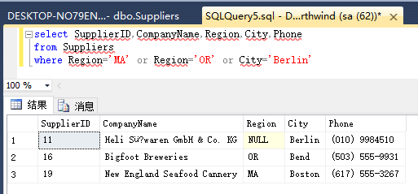

1. 查询“Northwind”示例数据库中供应商的ID、公司名称、地区、城市和电话字段的值。条件是“地区等于MA”并且“联系人头衔等于销售代表”

select SupplierID,CompanyName,Region,City,Phone

from Suppliers

where Region='MA' and ContactTitle='Sales Representative'

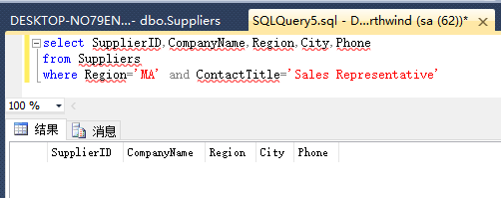

1. 查询“10248”和“10254”号订单的订单ID、运货商的公司名称、订单上所订购的产品的名称

select Orders.OrderID,ShipName,ProductName

from Orders,[dbo].[Order Details],Products

where (Orders.OrderID='10248' or Orders.OrderID='10254')

and Orders.OrderID=[dbo].[Order Details].OrderID

and [dbo].[Order Details].ProductID=Products.ProductID

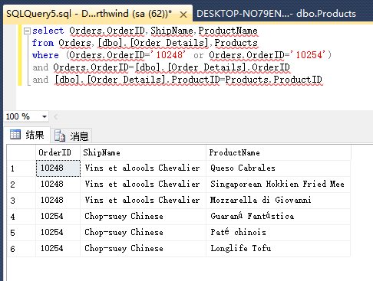

1. 查询“10248”和“10254”号订单的订单ID、订单上所订购的产品的名称、数量、单价和折扣

select Orders.OrderID,ProductName,Quantity,[dbo].[Order Details].UnitPrice,Discount

from Orders,[dbo].[Order Details],Products

where (Orders.OrderID='10248' or Orders.OrderID='10254')

and Orders.OrderID=[dbo].[Order Details].OrderID

and [dbo].[Order Details].ProductID=Products.ProductID

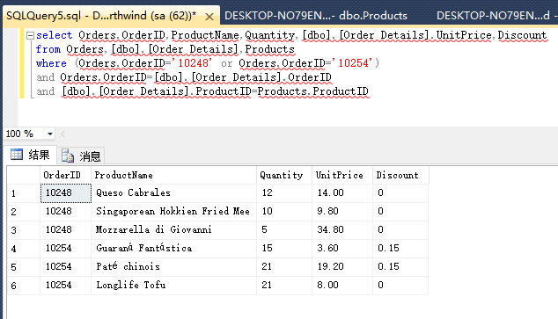

1. 查询“10248”和“10254”号订单的订单ID、订单上所订购的产品的名称及其销售金额

select Orders.OrderID,ProductName,Quantity*[dbo].[Order Details].UnitPrice*(1-Discount) as Sales

from Orders,[dbo].[Order Details],Products

where (Orders.OrderID='10248' or Orders.OrderID='10254')

and Orders.OrderID=[dbo].[Order Details].OrderID

and [dbo].[Order Details].ProductID=Products.ProductID

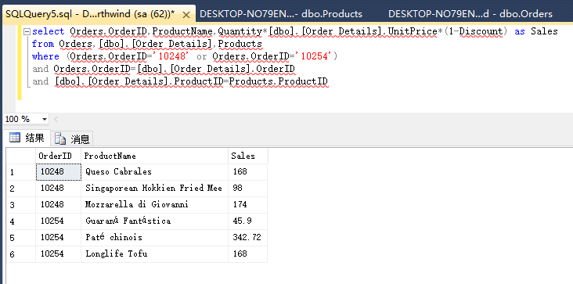

1. 查询单价大于20元的所有产品的产品名称、单价以及供应商的公司名称、电话

select ProductName,UnitPrice,CompanyName,Phone

from Products,Suppliers

where UnitPrice>20

and Products.SupplierID=Suppliers.SupplierID

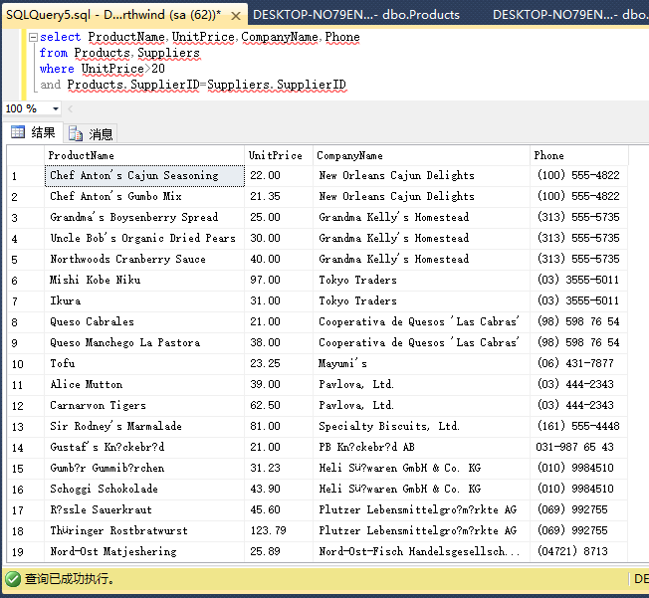

1. 查询在Berlin和London的客户在1996年订购的所有订单的订单ID、所订购的产品名称和数量

select Orders.OrderID,ProductName,Quantity

from Orders,[dbo].[Order Details],Products

where ShipCity in ('Berlin' ,'London')

and year(OrderDate)=1996

and Orders.OrderID=[dbo].[Order Details].OrderID

and [dbo].[Order Details].ProductID=Products.ProductID

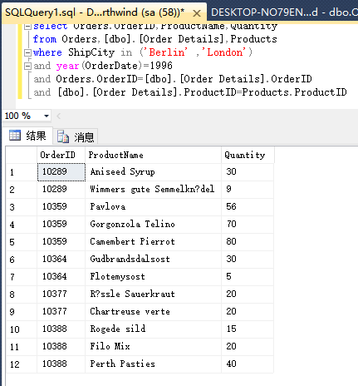

1. 查询在BC的客户的每份订单的订单ID、产品名称和销售金额

select Orders.OrderID,ProductName,Quantity*[dbo].[Order Details].UnitPrice*(1-Discount) as Sales

from Orders,[dbo].[Order Details],Products

where ShipRegion='BC'

and Orders.OrderID=[dbo].[Order Details].OrderID

and [dbo].[Order Details].ProductID=Products.ProductID

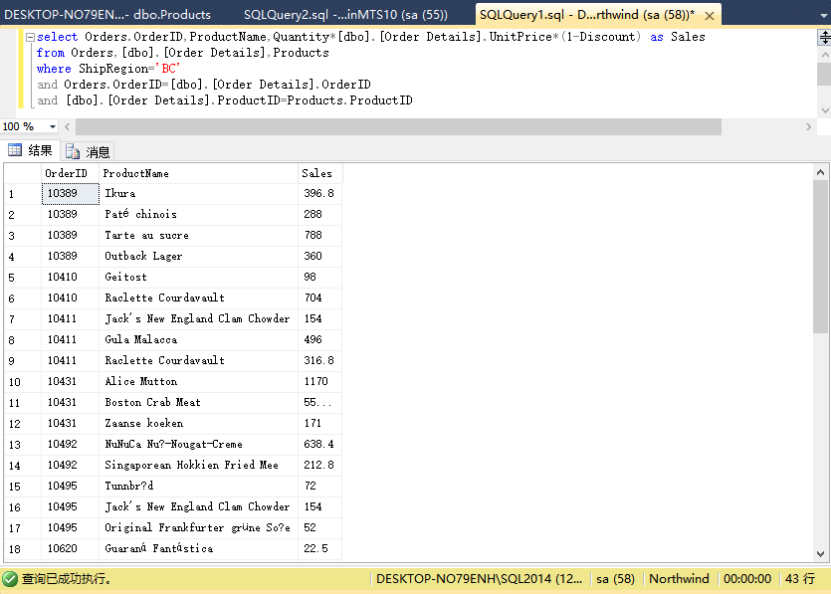

1. 按运货商公司名称，统计1997年由各个运货商承运的订单的总数量

select CompanyName,count(OrderID) as OrderCount

from Orders,Shippers

where year(OrderDate)=1997

and ShipVia=ShipperID

group by CompanyName

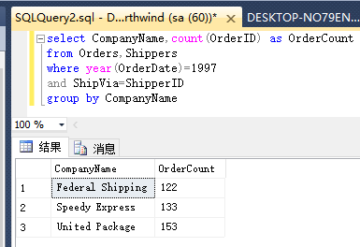

1. 统计各类产品的平均价格，并按价格降序排序

select CategoryID,avg(UnitPrice) as AvgUnitPrice

from Products

group by CategoryID

order by AvgUnitPrice desc

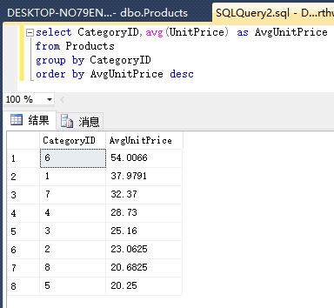

1. 统计1997年上半年的每份订单上所订购的产品的总数量

select ProductID,Quantity,OrderDate

from Orders,[dbo].[Order Details]

where year(OrderDate)=1997

and month(OrderDate)<=6

and Orders.OrderID=[dbo].[Order Details].OrderID

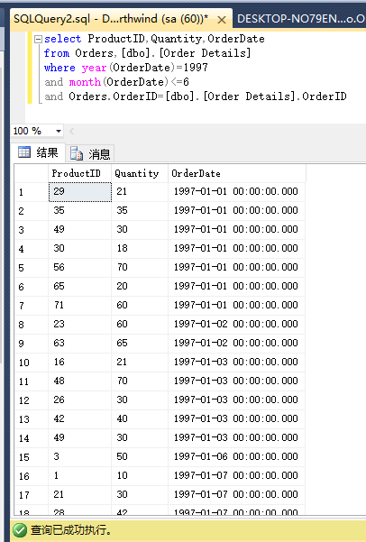

1. 统计各类产品的平均价格

select CategoryID,avg(UnitPrice) as AvgUnitPrice

from Products

group by CategoryID

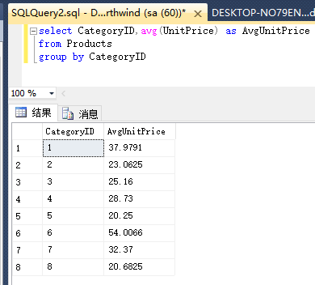

1. 统计产品销量前五名排行的供应商、产品名称、销量、总销售金额

SELECT TOP 5 Suppliers.CompanyName,Products.ProductID,

SUM(Quantity) as sumQuantity,

SUM(Quantity*[Order Details].UnitPrice*(1-DisCount)) as sumPrice

FROM Suppliers,Products,[Order Details]

WHERE Suppliers.SupplierID = Products.SupplierID

and Products.ProductID = [Order Details].ProductID

GROUP BY Suppliers.CompanyName,Products.ProductID

ORDER BY sumPrice DESC

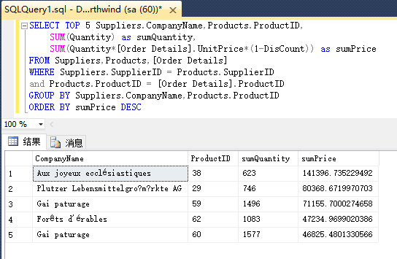

1. 存储过程实验
2. 编写存储过程，实现查询订购日期在1996年7月1日至1996年7月15日之间的订单的订购日期、订单ID、相应订单的客户公司名称、负责订单的雇员的姓氏和名字等字段的值，并将查询结果按雇员的“姓氏”和“名字”字段的升序排列，“姓氏”和“名字”值相同的记录按“订单 ID”的降序排列

create proc proc1

as

select OrderDate,OrderID,CompanyName,LastName,FirstName

from Orders,Customers,Employees

where year(OrderDate)=1996

and month(OrderDate)=7

and day(OrderDate)<16

and Orders.CustomerID=Customers.CustomerID

and Orders.EmployeeID=Employees.EmployeeID

order by LastName,FirstName,OrderID desc

go

exec proc1

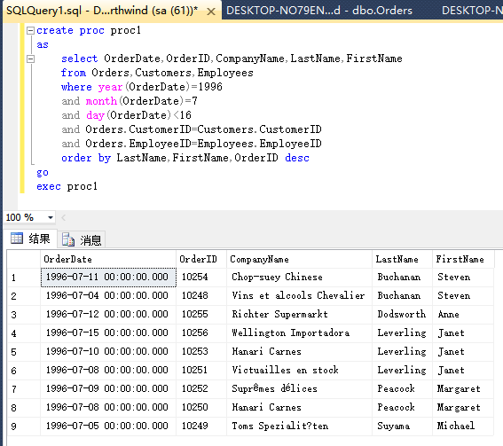

1. 将上题存储过程中的订购日期改为两个输入参数

create proc proc1_1(@startId varchar(20), @endId varchar(20))

as

select OrderDate,OrderID,CompanyName,LastName,FirstName

from Orders,Customers,Employees

where OrderDate between convert(datetime,@startId, 20) and convert(datetime,@endId, 20)

and Orders.CustomerID=Customers.CustomerID

and Orders.EmployeeID=Employees.EmployeeID

order by LastName,FirstName,OrderID desc

go

exec proc1_1 '1996-07-01','1996-07-15'

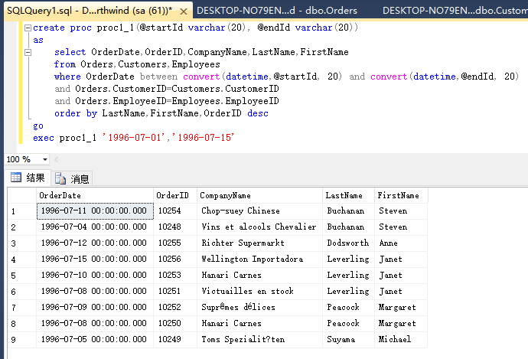

1. 编写存储过程，实现客户名为{@CustomerID nchar(5)}的，定单ID，订单日期，预计到达日期，运送日期

create proc proc2(@CustomerID nchar(5))

as

select CustomerID,OrderID,OrderDate,RequiredDate,ShippedDate

from Orders

where CustomerID=@CustomerID

go

exec proc2 'ANTON'

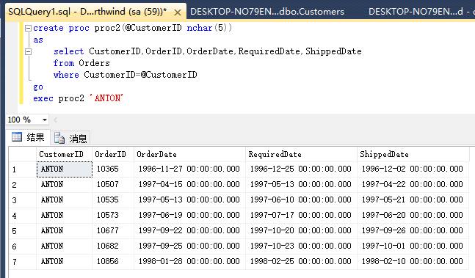

1. 编写存储过程，实现订单名为{@OrderID}的，产品名，单价，数量，打折，总价钱

create proc proc3(@OrderID nchar(5))

as

select OrderID,ProductName,[dbo].[Order Details].UnitPrice,Quantity,Discount,

Quantity*[dbo].[Order Details].UnitPrice*(1-Discount) as Sales

from [dbo].[Order Details],Products

where OrderID=@OrderID

and [dbo].[Order Details].ProductID=Products.ProductID

go

exec proc3 '10254'

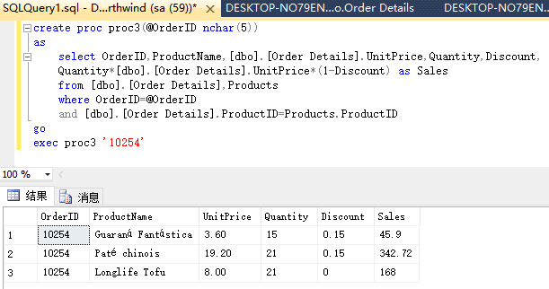

1. 编写存储过程，运用游标，将Northwinds数据库中Products表中价格全部打8折

原表(打折前)：

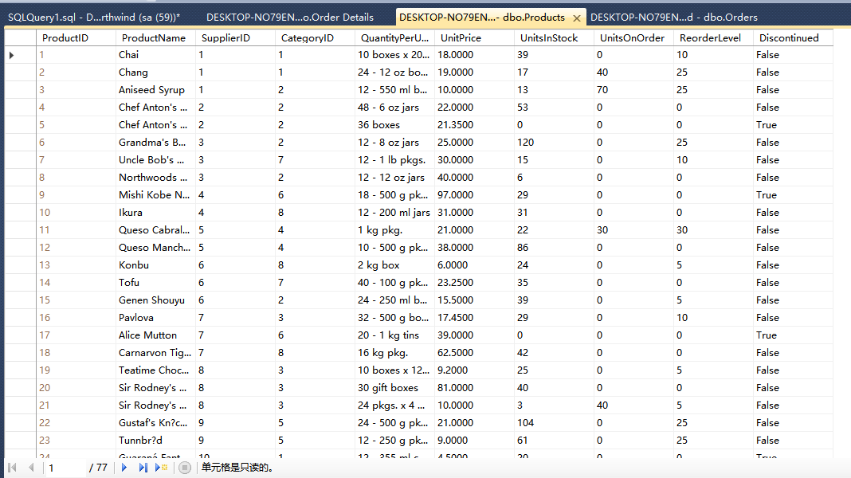

打印出打折后的结果：

create proc proc4

as

declare c_prod cursor for select CONVERT(varchar, ProductID)+' '

+CONVERT(varchar, UnitPrice*0.8) from Products

OPEN c_prod

declare @x nvarchar(20)

fetch next from c_prod INTO @x

print('ProductID UnitPrice')

while @@FETCH_STATUS=0

begin

print(@x)

fetch next from c_prod INTO @x

end

CLOSE c_prod

go

exec proc4

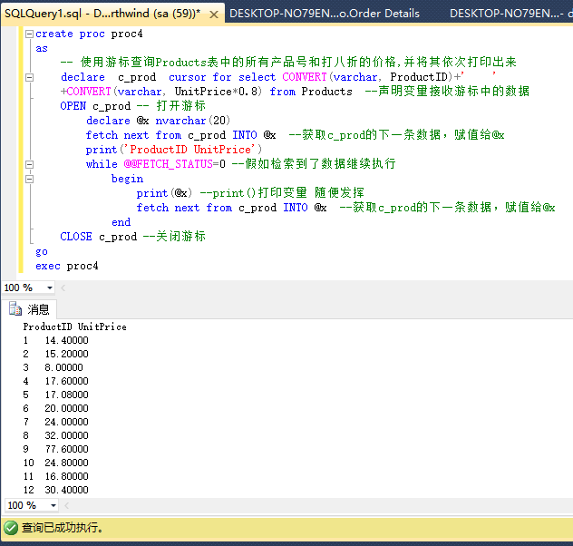

1. 在Orders表中增加订单总价字段（Total），编写存储过程，运用游标，给该字段赋值

create procedure addTotal

as

--declare @UnitPrice money

--declare @Quantity smallint

--declare @Discount real

declare @OrderID int

declare c_total cursor for

select OrderID from [dbo].[Orders]

open c_total

fetch next from c_total into @OrderID

while @@FETCH_STATUS=0

begin

update [dbo].[Orders] set Total=

(select sum(UnitPrice*(1-Discount)*Quantity)

--(UnitPrice*(1-Discount)*Quantity)

from [dbo].[Order Details]

where OrderID=@OrderID

group by OrderID

)

fetch next from c_total into @OrderID

end

close c_total

go

exec addTotal

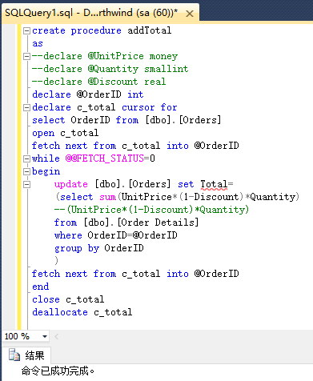

1. 编写一个触发器，当在Order Details中新增一条记录时，自动在Orders表中，更新Total字段的值

create trigger tri_total on [dbo].[Order Details]

for insert

as

begin

declare @OrderID int,@UnitPrice money,@Quantity smallint,@Discount real;

select @OrderID=OrderID,@UnitPrice=UnitPrice,@Quantity=Quantity,@Discount=Discount

from inserted

update [dbo].[Orders] set Total=

(select sum(UnitPrice*(1-Discount)*Quantity)

--(UnitPrice*(1-Discount)*Quantity)

from [dbo].[Order Details]

where OrderID=@OrderID

group by OrderID

)

end

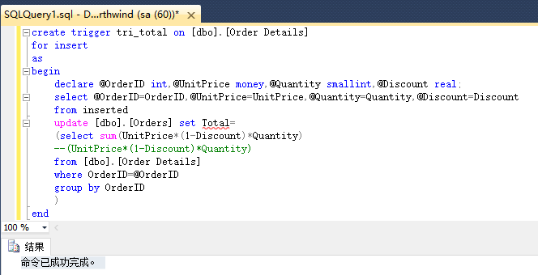

1. 编写存储过程，根据年份作为参数，计算该年度各类产品销售额占比

create procedure salesVolume

as

declare @year datetime

begin

select

((select sum(Quantity*(1-Discount)*[dbo].[Order Details].UnitPrice)

from [dbo].[Order Details],[dbo].[Orders],[dbo].[Products]

where year(OrderDate)=@year

and [dbo].[Orders].OrderID=[dbo].[Order Details].OrderID

and [dbo].[Order Details].ProductID=[dbo].[Products].ProductID

group by [dbo].[Products].ProductID

)/(select sum(Quantity*(1-Discount)*[dbo].[Order Details].UnitPrice)

from [dbo].[Order Details],[dbo].[Orders]

where year(OrderDate)=@year

and [dbo].[Orders].OrderID=[dbo].[Order Details].OrderID

group by year(OrderDate)

)

)as salesVolume

end

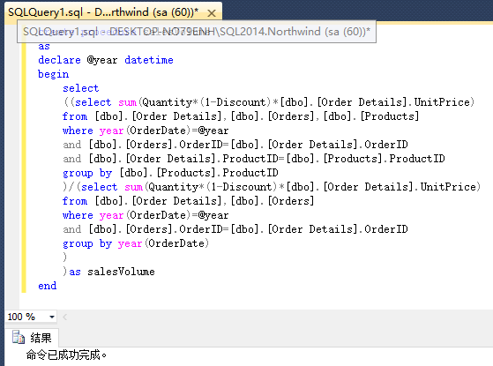

1. 编写存储过程，根据月份作为参数，计算该年度各类供应商提供的产品销售量占比、销售额占比

create procedure salesVolume_mouth

as

declare @month datetime

declare @year datetime

begin

select

((select sum(Quantity*(1-Discount)*[dbo].[Order Details].UnitPrice)

from [dbo].[Order Details],[dbo].[Orders],[dbo].[Products]

where month(OrderDate)=@month

and year(OrderDate)=@year

and [dbo].[Orders].OrderID=[dbo].[Order Details].OrderID

and [dbo].[Order Details].ProductID=[dbo].[Products].ProductID

group by [dbo].[Products].ProductID

)/(select sum(Quantity*(1-Discount)*[dbo].[Order Details].UnitPrice)

from [dbo].[Order Details],[dbo].[Orders]

where month(OrderDate)=@month

and year(OrderDate)=@year

and [dbo].[Orders].OrderID=[dbo].[Order Details].OrderID

group by year(OrderDate),month(OrderDate)

)

)as salesVolume,

((select sum(Quantity)

from [dbo].[Order Details],[dbo].[Orders],[dbo].[Products]

where month(OrderDate)=@month

and year(OrderDate)=@year

and [dbo].[Orders].OrderID=[dbo].[Order Details].OrderID

and [dbo].[Order Details].ProductID=[dbo].[Products].ProductID

group by [dbo].[Products].ProductID

)/(select sum(Quantity)

from [dbo].[Order Details],[dbo].[Orders]

where month(OrderDate)=@month

and year(OrderDate)=@year

and [dbo].[Orders].OrderID=[dbo].[Order Details].OrderID

group by year(OrderDate),month(OrderDate)

)

)as salesQuantity

end

