**Experiment 1**

**-- Practice of Linux Basic Commands**

**Name: 朱可心 StudentID:201806061427 Deadline:2020-10-22,12pm**

**Note:**

1. You need to hand in an experimental report, including the tasks listed in the next page, with each task followed by the snapshot of the program output or result, before the deadline. If you miss the deadline, you’ll get 0 for this assignment.
2. Anybody who cheats will get 0.
3. The report doc should be named as “Exp1\_StudentID\_FullName.doc”.
4. Submit the report to the platform “chaoxing”.
5. **Goal**
6. To get familiar to the synopsis of Linux commands;
7. To able to use Linux commands to manipulate files (including vi commands) and directories;
8. To know ways of process management;
9. To be able to find helps on Linux commands.
10. **Tools**

Operation System: Ubuntu

1. **Tasks: After finishing each of the following tasks, paste the terminal output (screen shot) right below the task, and record the used-command in file “CommandsList.txt”.**

**3.1 Manipulate file system**

1. Display the system time through proper command. Verify its correctness, and if not correct, change it by proper command.

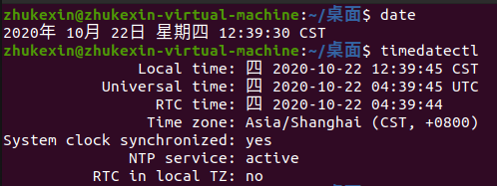

可通过以下命令更改时间

date命令将日期设置为2020年10月22日：

date -s 10/22/20

将时间设置为14点20分50秒：

date -s 14:20:50

将时间设置为2014年6月18日14点16分30秒（MMDDhhmmYYYY.ss）：

date 0618141614.30

1. Print your student ID and Name on the terminal window using proper command.

IMG_256

1. Print out your current working directory.

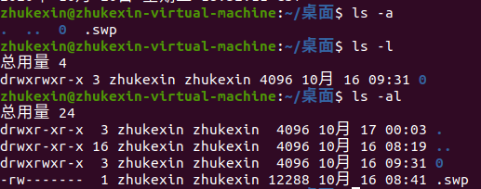

1. Run command “ls -l”, using one item of the outputs to explain the meaning of each field.

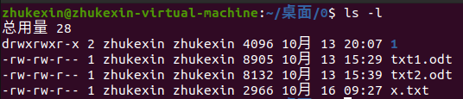

第1项含义：

第一个字符表示文件类型，d表示目录文件.

后面的9个字符每3个为一组，分别代表文件所有者、文件所有者所在用户组、其它用户对文件拥有的权限。每组中r、w、x三个字符分别代表读、写、执行的权限. 若没有其中的任何一个权限则用“-”表示. 执行的权限有两个字符可选，最常见的一个 是“x”代表可执行，另一个是“s”代表套接口文件.

紧接着的数字“2”为这个目录下的目录文件数目（=隐藏目录数目+普通目录数目）.（若只是一个普通文件，那“2”就代表这个文件有两个别名，这个文件被人创建了一个硬链接文件）

后面的zhukexin代表这个文件（目录）的属主（Owner）为用户zhukexin，一般情况下就是创建者.

再接下来的zhukexin代表这个文件（目录）所属的用户组（Group）为组zhukexin，一个用户组可以有很多用户 .

4096 代表文件的大小（字节数），目录的大小总是为 4096字节. 如果想看K或者M，前面加一个选项“-h”.

10月 13 20:07 代表文件（目录）的修改时间. 1 代表文件（目录）的名字.

1. Change directory as “Desktop”, then run command “cd”, “cd ~” and “cd -”. Using command “pwd” to compare the results of the three commands, and explain their differences.

IMG_256

IMG_256

IMG_256

IMG_256

IMG_256

pwd命令显示当前工作目录的绝对路径

cd **进入用户主目录**

cd ~ **进入用户主目录**

cd - **返回进入此目录之前所在目录**

1. Create a sub-directory named “subdir” in the home directory, and go to it.

IMG_256

IMG_256

**3.2 Manipulate files**

1. Verify that you are at “subdir”.

IMG_256

1. Run command “date > file”, and print out the contents of file using cat command.

IMG_256

1. Return to the parent-directory, run “cat subdir”, what will you see? Explain why you see that.

IMG_256

cat命令只能显示普通文件的内容，不可以查看目录

1. Compare the outputs of commands “man date” and “man date > file1”. Explain their corresponding functions and the differences of them.

“man date”:

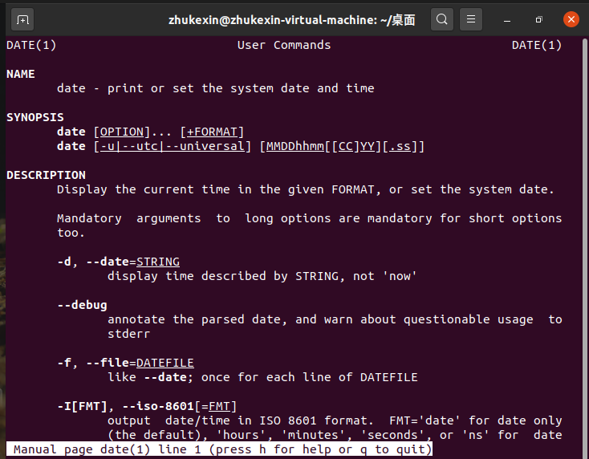

“man date > file1”:

IMG_256

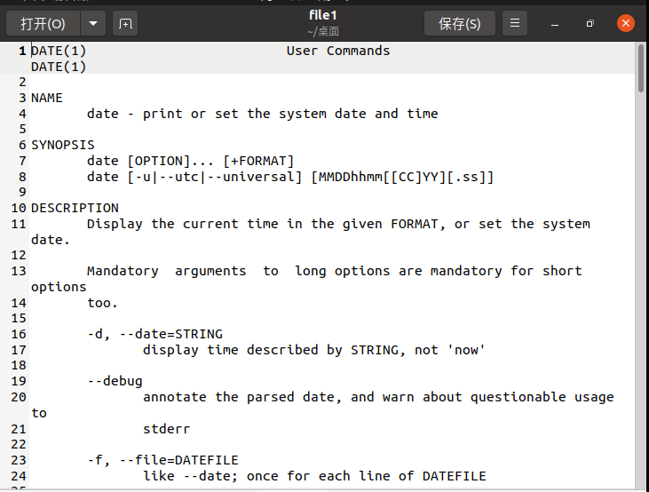

都是查看date命令的帮助信息：

man date 在终端查看

man date > file1 将查询到的帮助信息存入file1文件中

1. Print out the first and last 10 lines of file1.

IMG_256

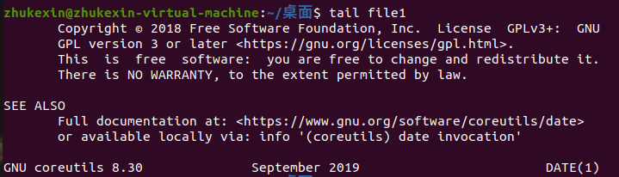

1. Edit file1 using the commands provided by vi, including cursor movement commands and text editing commands (delete, copy, paste, search, substitute/replace, etc.)

replace A with B A被B代替 永久

substitute A for B A代替B 暂时

1. Based on your understanding, try to figure out the commands that can be used to print out one line in file1.

IMG_256

打印file1中的第4行

1. Run command “cp file1 file2” and “cp file1”, and compare the results of them by command “ls -l”; explain their differences.

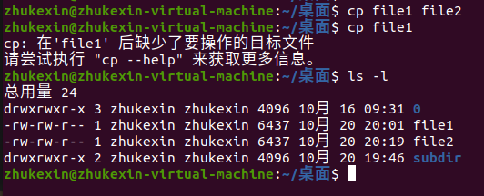

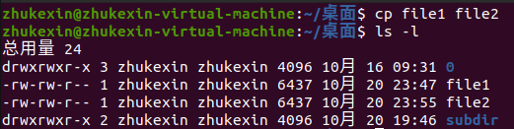

1. Run command “mv file2 file3”, and explain its meaning;

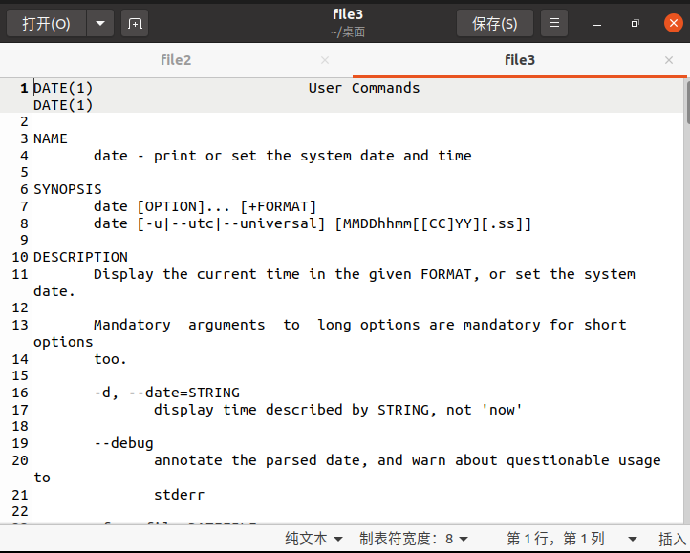

将文件file2重命名为file3

1. Run command “cat f\*”;

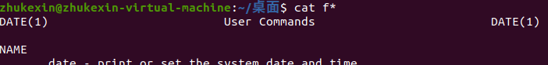

显示所有文件名是“f”开头的文件内容

1. File “/etc/passwd” records the information of every user. Using proper command to find out the line that corresponds to your login name.

IMG_256

1. Use different methods to change the permissions of file1 as follows: assign “execute” permission to all, then remove it from group and guest.

IMG_256

1. **确认你在“Subir”。**
2. **运行命令“日期>；文件”，并使用cat命令打印文件内容。**
3. **返回父目录，运行“cat子目录”，您将看到什么？ 解释你为什么看到这个。**
4. **比较命令“man日期”和“man日期>；file1”的输出”。 解释它们的相应功能及其差异。**
5. **打印出file1的第一行和最后10行。**
6. **使用vi提供的命令编辑file1，包括光标移动命令和文本编辑命令（删除、复制、粘贴、搜索、替换/替换等。）**
7. **根据您的理解，尝试找出可用于打印文件1中一行的命令。**
8. **运行命令“cp文件1文件2”和“cp文件1”，并通过命令“ls-l”比较它们的结果；解释它们的差异。**
9. **运行命令“mv文件2文件3”，并解释其含义；**
10. **运行命令“catf\*”；**
11. **file“/etc/passwd”记录每个用户的信息。 使用适当的命令查找对应于登录名的行。**
12. **使用不同的方法更改file1的权限如下：将“执行”权限分配给所有人，然后将其从组和来宾中删除。**

**3.3 Manage processes**

1. Display all of the processes in the Linux system, and explain the meaning of each field.

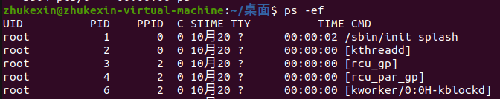

UID: 进程属主的用户ID号

PID: 进程标志号

PPID: 父进程的ID号

C：进程最近使用CPU的估算

STIME: 进程开始时间，以“小时：分”的形式给出

TTY: 该进程建立时所对应的终端，“？”表示该进程不占用端口

TIME: 报告进程累计使用的CPU时间（执行的时间）

CMD：执行进程的命令名，是COMMAND的缩写（所执行的指令）

1. Choose one process to kill it.

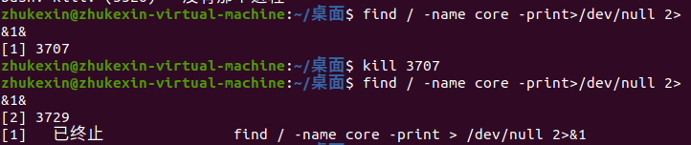

此时输入命令ps就找不到PID为3707的进程了

1. **Think about the following question and give your answer.**

CommandsList.txt is a plain text file, which records all the commands you typed. Change it to be an executable file. Think about how to execute it. Based on the results, think about how to use Linux commands to perform more complex tasks.

1. **Summary**

Linux命令很多，也是我们学习Linux的基本功，学习这些命令没有什么捷径，就是要做到：

1. 多用，熟能生巧，用着用着就记住了，至少常用命令要用熟；

2. 记好笔记，忘记了回来查查，笔记上没有的百度，多实验，多记录，积累经验。