Ex. No. 6 | PL/SQL - FUNCTIONS AND PROCEDURES
Date of Exercise | 09/09/2026

Aim
To create PL/SQL blocks, procedures and functions for various operations.
Description
A PL/SQL block combines SQL with procedural constructs such as variables, loops and conditional statements. The optional DECLARE section defines variables and constants; the mandatory BEGIN...END section holds the executable logic, including DML statements, loops and IF/CASE conditionals; and the optional EXCEPTION section handles run-time errors raised during execution. A PROCEDURE is a named, storable PL/SQL block invoked with CALL, while a FUNCTION is a named block that must RETURN a value and can be used directly inside a SQL expression.
1. Write a PL/SQL block to print first n natural numbers and their sum.
Sample Code:
DO $$
DECLARE
n INT := 10;
i INT := 1;
total INT := 0;
BEGIN
WHILE i <= n LOOP
RAISE NOTICE '%', i;
total := total + i;
i := i + 1;
END LOOP;
RAISE NOTICE 'Sum of first % natural numbers = %', n, total;
END $$;
Sample Output:
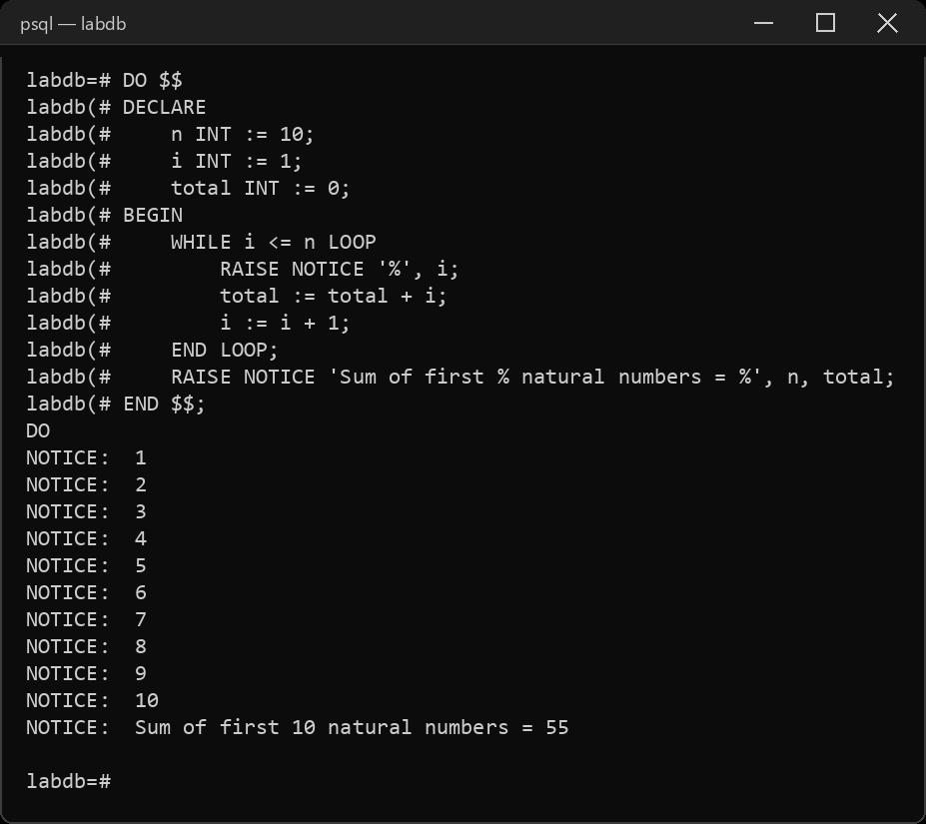
2. Write a PL/SQL block to find out sum of the digits of a given number.
Sample Code:
DO $$
DECLARE
num INT := 12345;
temp INT;
digit_sum INT := 0;
BEGIN
temp := num;
WHILE temp > 0 LOOP
digit_sum := digit_sum + (temp % 10);
temp := temp / 10;
END LOOP;
RAISE NOTICE 'Sum of digits of % = %', num, digit_sum;
END $$;
Sample Output:
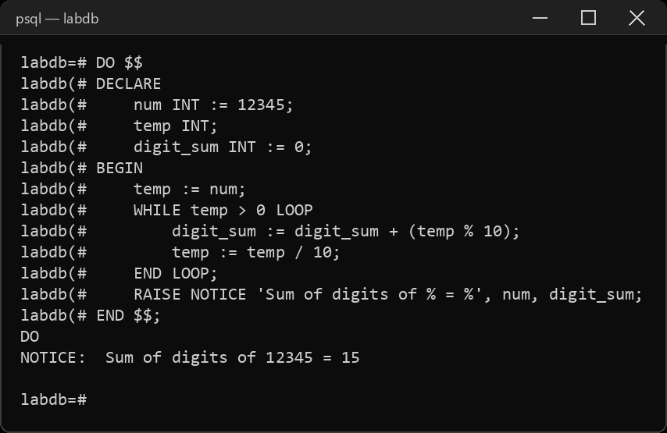
3. Write a PL/SQL block to generate a Fibonacci series.
Sample Code:
DO $$
DECLARE
n INT := 10;
a INT := 0;
b INT := 1;
nxt INT;
i INT;
BEGIN
RAISE NOTICE '%', a;
RAISE NOTICE '%', b;
FOR i IN 3..n LOOP
nxt := a + b;
RAISE NOTICE '%', nxt;
a := b;
b := nxt;
END LOOP;
END $$;
Sample Output:
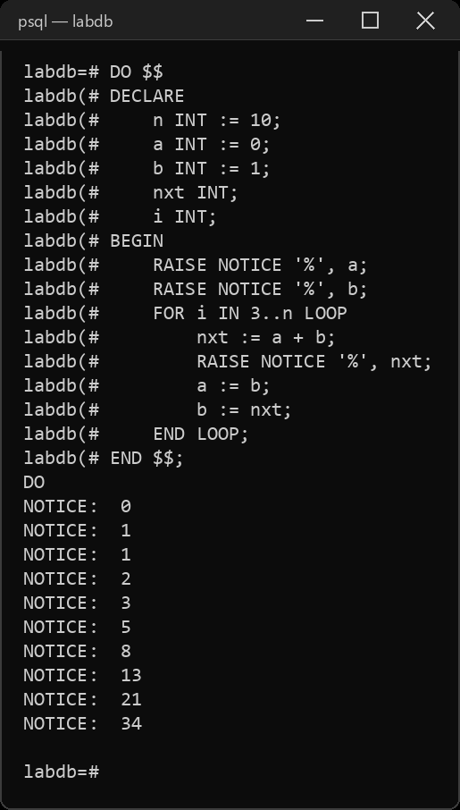
4. Write a PL/SQL script that traps ZERO_DIVIDE exceptions.
Sample Code:
DO $$
DECLARE
a INT := 10;
b INT := 0;
result INT;
BEGIN
result := a / b;
RAISE NOTICE 'Result = %', result;
EXCEPTION
WHEN division_by_zero THEN
RAISE NOTICE 'Error: division by zero is not allowed';
END $$;
Sample Output:
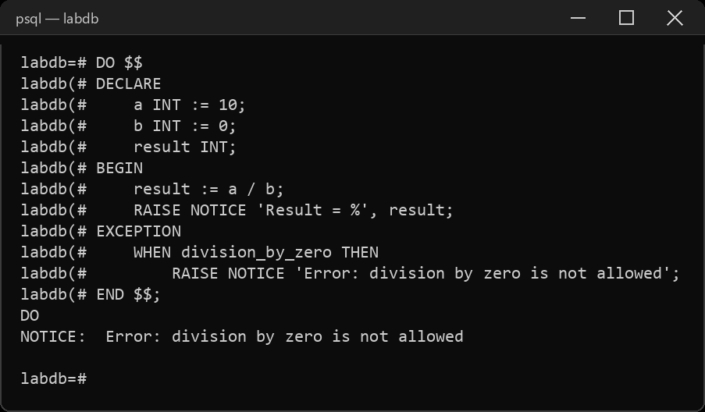
5. Write a PL/SQL block to illustrate functioning of IF_THEN_ELSIF by creating the equivalent of a four-function calculator.
Sample Code:
DO $$
DECLARE
num1 NUMERIC := 20;
num2 NUMERIC := 4;
op CHAR(1) := '*';
result NUMERIC;
BEGIN
IF op = '+' THEN
result := num1 + num2;
ELSIF op = '-' THEN
result := num1 - num2;
ELSIF op = '*' THEN
result := num1 * num2;
ELSIF op = '/' THEN
result := num1 / num2;
ELSE
RAISE NOTICE 'Invalid operator';
END IF;
RAISE NOTICE '% % % = %', num1, op, num2, result;
END $$;
Sample Output:
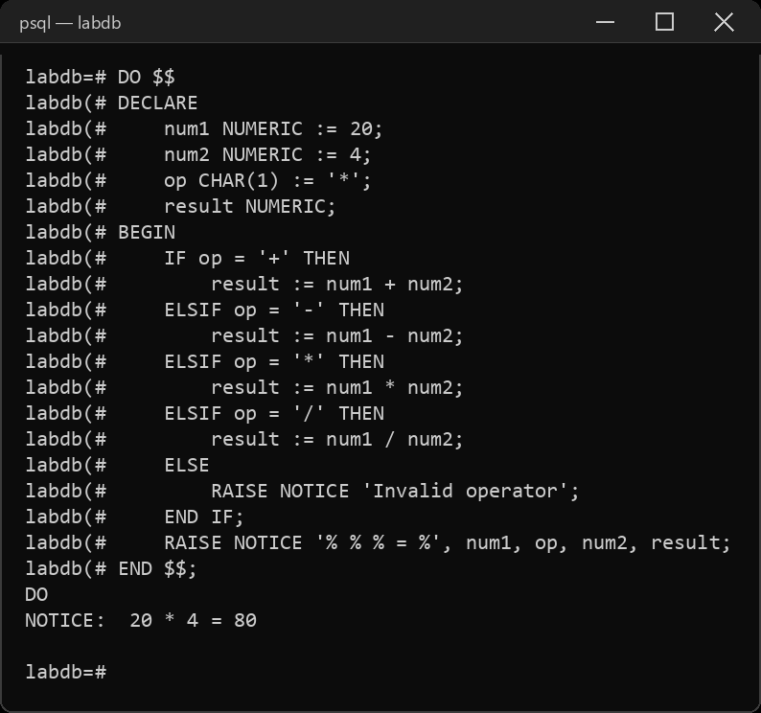
6. Write a PL/SQL Procedure to find the area of the circle.
Sample Code:
CREATE OR REPLACE PROCEDURE URK24CS1021_circle_area(radius NUMERIC)
LANGUAGE plpgsql AS $$
DECLARE
pi_val CONSTANT NUMERIC := 3.14159265358979;
area NUMERIC;
BEGIN
area := pi_val * radius * radius;
RAISE NOTICE 'Area of circle with radius % = %', radius, round(area, 2);
END;
$$;
CALL URK24CS1021_circle_area(7);
Sample Output:
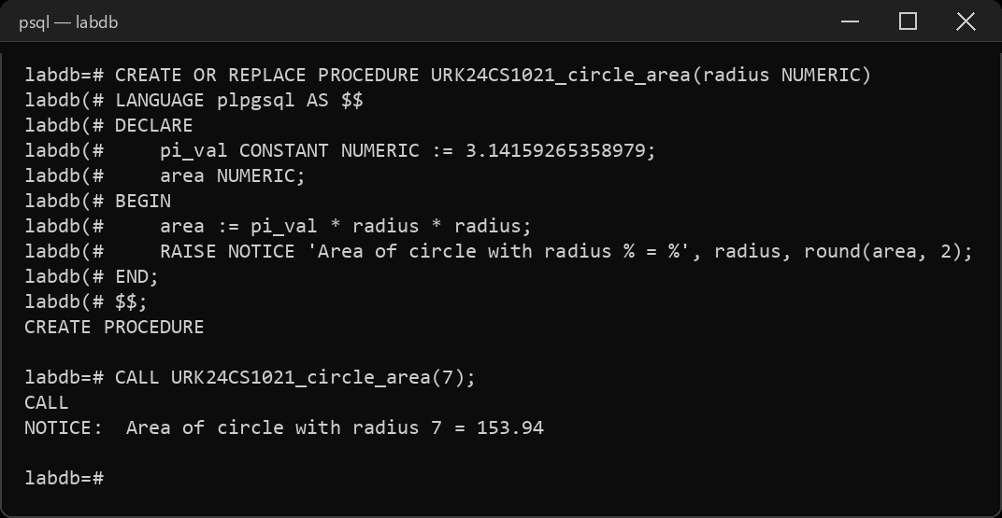
7. Write a PL/SQL Function to find the area of the rectangle.
Sample Code:
CREATE OR REPLACE FUNCTION URK24CS1021_rectangle_area(length NUMERIC, width NUMERIC)
RETURNS NUMERIC LANGUAGE plpgsql AS $$
DECLARE
area NUMERIC;
BEGIN
area := length * width;
RETURN area;
END;
$$;
SELECT URK24CS1021_rectangle_area(5, 10) AS rectangle_area;
Sample Output:
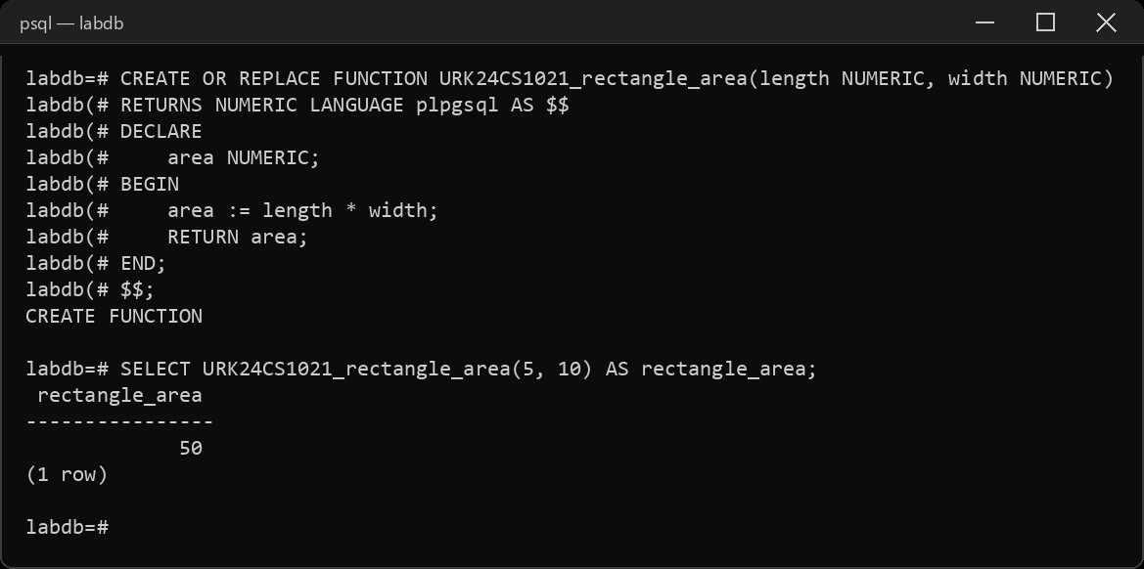
RESULT
The SQL queries were executed and the desired output was obtained.

