Ex. No. 4  Date: 19/08/2026 | SET OPERATIONS | URK24CS1021
Aim
To execute SET operators (UNION, INTERSECT, MINUS) and the IN operator to combine and compare results from multiple queries.
Description
Set operators combine the results of two or more SELECT queries that return the same number and type of columns. UNION returns the distinct rows from either query, while UNION ALL keeps duplicates. INTERSECT returns only the rows common to both queries, and MINUS (EXCEPT in PostgreSQL) returns the rows in the first query that are absent from the second. The IN operator tests whether a value matches any value returned by a subquery, and is often used as an alternative to a join.
Questions
1. Display the cities of the companies Acc and TATA.
SELECT city FROM URK24CS1021_company WHERE cname = 'Acc'
UNION
SELECT city FROM URK24CS1021_company WHERE cname = 'TATA';
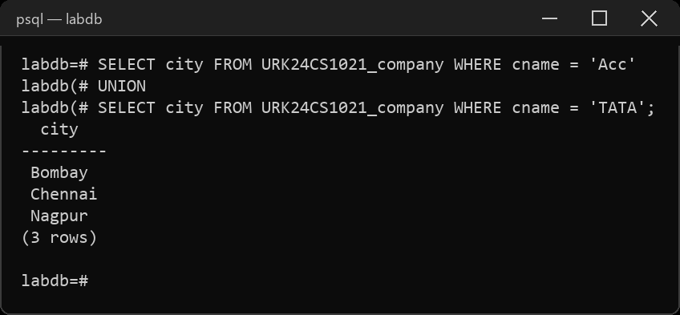
2. Display the names of the city that is common to companies Acc and TATA.
SELECT city FROM URK24CS1021_company WHERE cname = 'Acc'
INTERSECT
SELECT city FROM URK24CS1021_company WHERE cname = 'TATA';
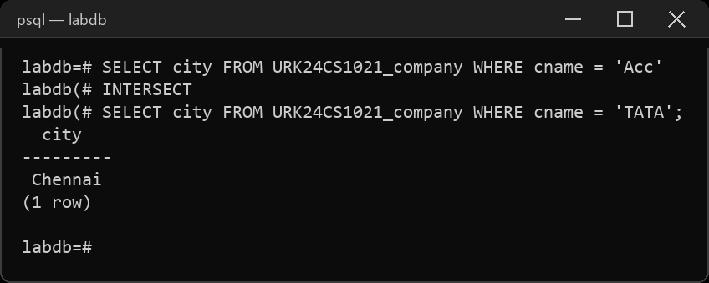
3. Find the cities where Acc is located, but not TATA.
SELECT city FROM URK24CS1021_company WHERE cname = 'Acc'
EXCEPT
SELECT city FROM URK24CS1021_company WHERE cname = 'TATA';
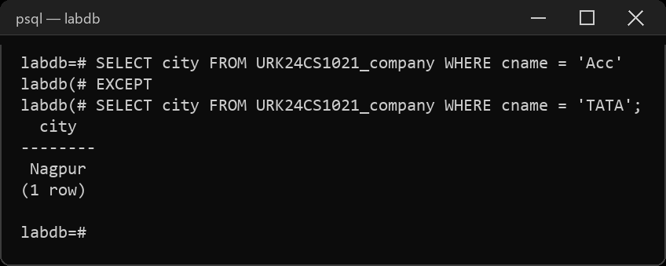
4. Display the names of employees living in Nagpur, and working with company Acc.
SELECT ename FROM URK24CS1021_employee WHERE city = 'Nagpur'
INTERSECT
SELECT ename FROM URK24CS1021_emp_company WHERE cname = 'Acc';
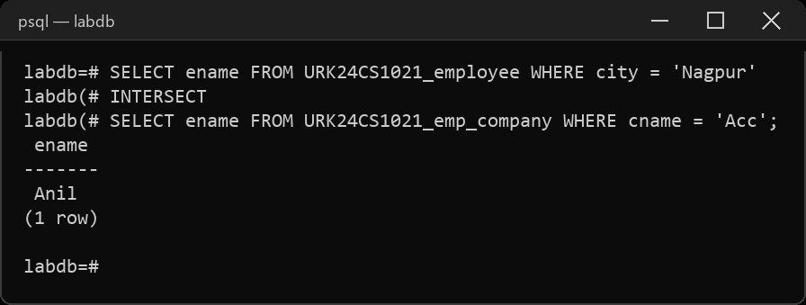
5. Display the names of employees living in Nagpur, but not working in company Acc.
SELECT ename FROM URK24CS1021_employee WHERE city = 'Nagpur'
EXCEPT
SELECT ename FROM URK24CS1021_emp_company WHERE cname = 'Acc';
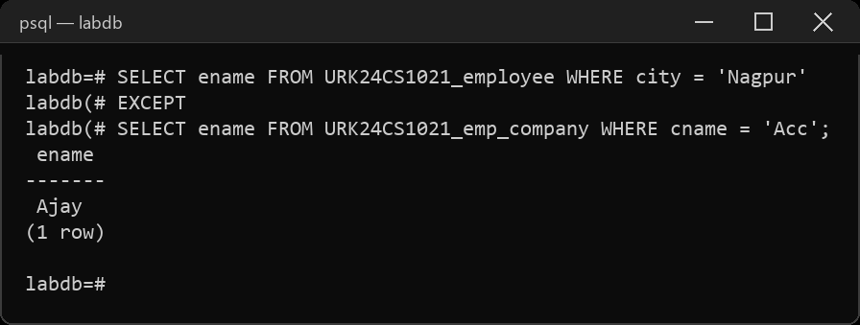
6. List the names of the employees living in city Bombay and having salary >1500
SELECT e.ename FROM URK24CS1021_employee e, URK24CS1021_emp_company c
WHERE e.ename = c.ename AND e.city = 'Bombay' AND c.salary > 1500;
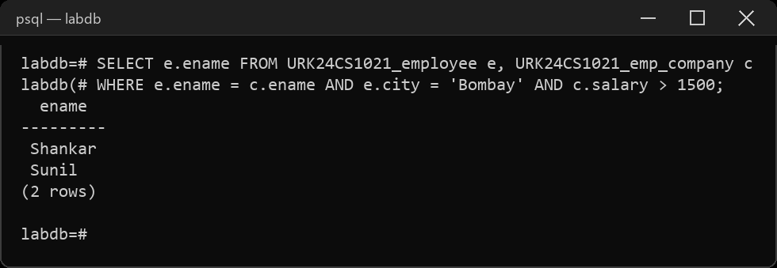
7. Display the names of the employees living in the city Chennai and working with the company CMC.
SELECT e.ename FROM URK24CS1021_employee e, URK24CS1021_emp_company c
WHERE e.ename = c.ename AND e.city = 'Chennai' AND c.cname = 'CMC';
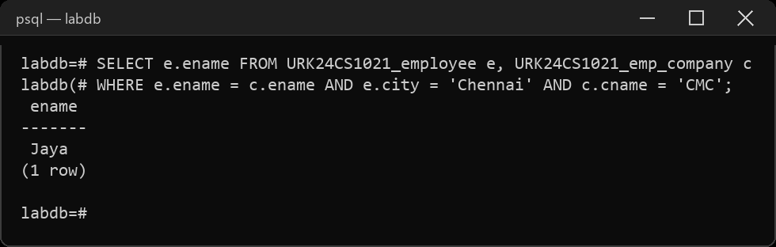
8. Display the names of the employees living in Nagpur, working in Acc, and having shift A.
SELECT ename FROM URK24CS1021_employee WHERE city = 'Nagpur'
INTERSECT
SELECT ename FROM URK24CS1021_emp_company WHERE cname = 'Acc'
INTERSECT
SELECT ename FROM URK24CS1021_emp_shift WHERE shift = 'A';
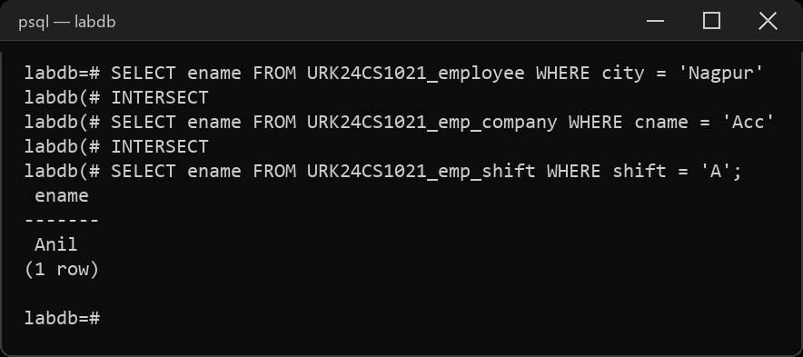
9. Display the names of the employees living in Nagpur, working in company Acc and not working in shift B.
SELECT ename FROM URK24CS1021_employee WHERE city = 'Nagpur'
INTERSECT
SELECT ename FROM URK24CS1021_emp_company WHERE cname = 'Acc'
EXCEPT
SELECT ename FROM URK24CS1021_emp_shift WHERE shift = 'B';
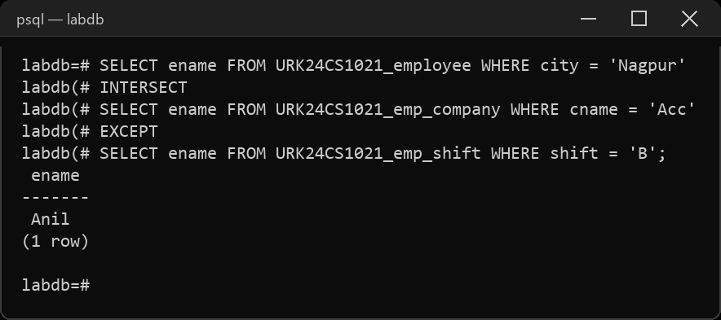
10. Display the names of employees who are living in Nagpur or Bombay.
SELECT ename FROM URK24CS1021_employee WHERE city = 'Nagpur'
UNION
SELECT ename FROM URK24CS1021_employee WHERE city = 'Bombay';
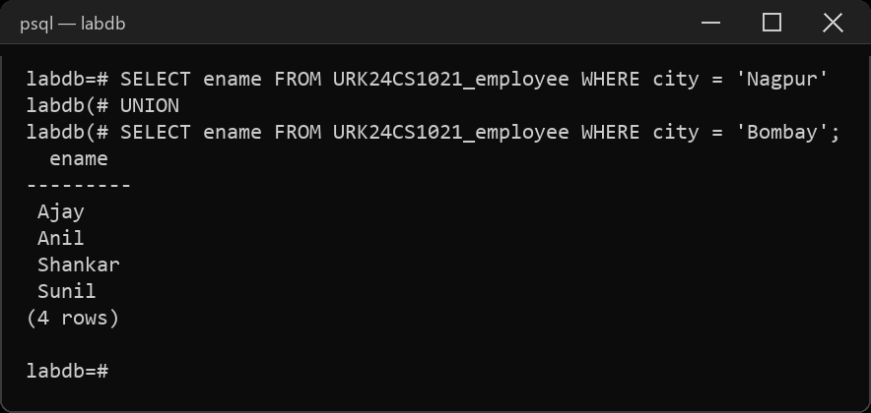
11. Display the employee names using union and union all operator.
SELECT ename FROM URK24CS1021_employee
UNION
SELECT ename FROM URK24CS1021_emp_company;
SELECT ename FROM URK24CS1021_employee
UNION ALL
SELECT ename FROM URK24CS1021_emp_company;
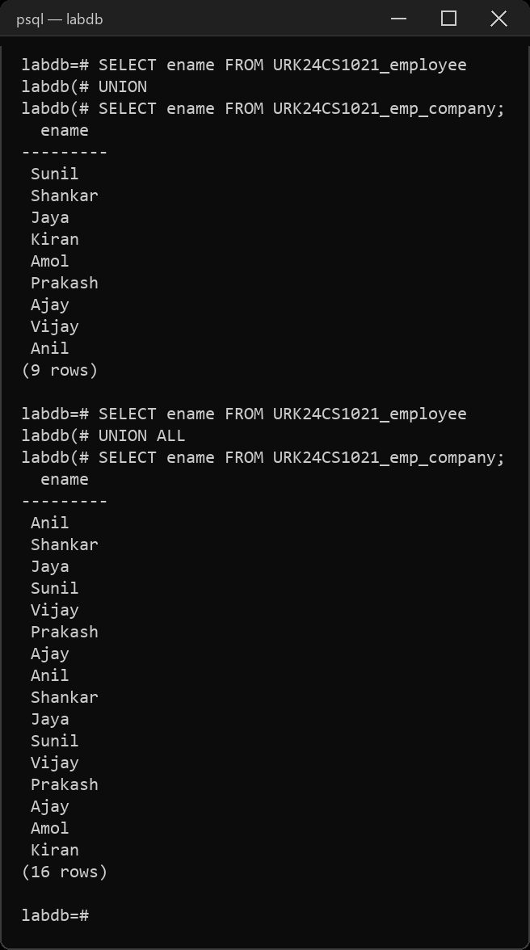
12. Display the employee's name whose joining date is 18-DEC-98 and whose working shift is 'E'.
SELECT ec.ename FROM URK24CS1021_emp_company ec, URK24CS1021_emp_shift s
WHERE ec.ename = s.ename AND ec.jdate = '1998-12-18' AND s.shift = 'E';
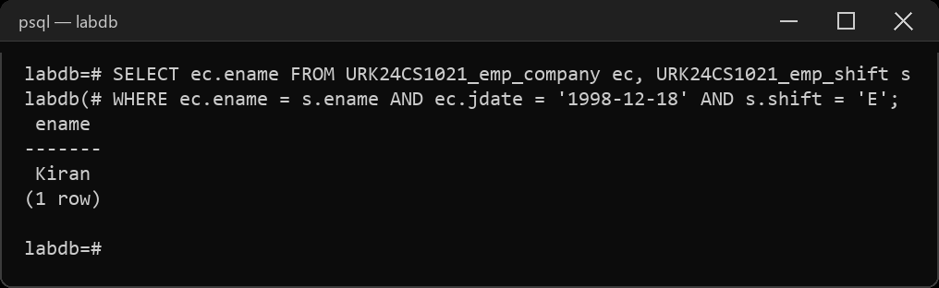
13. Use in operator to display the names of the employees living in the same city where Sunil is residing.
SELECT ename FROM URK24CS1021_employee
WHERE city IN (SELECT city FROM URK24CS1021_employee WHERE ename = 'Sunil');
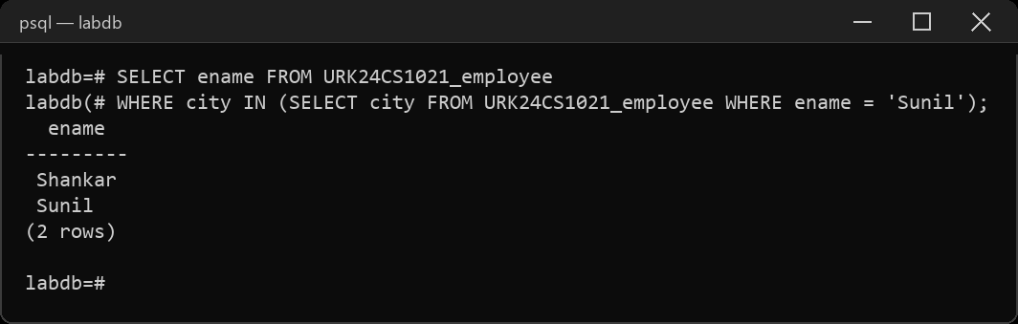
14. Use in operator to display the employees living in the city Bombay and having their company located in the city Delhi.
SELECT ename FROM URK24CS1021_employee
WHERE city = 'Bombay' AND ename IN
(SELECT ename FROM URK24CS1021_emp_company WHERE cname IN
(SELECT cname FROM URK24CS1021_company WHERE city = 'Delhi'));
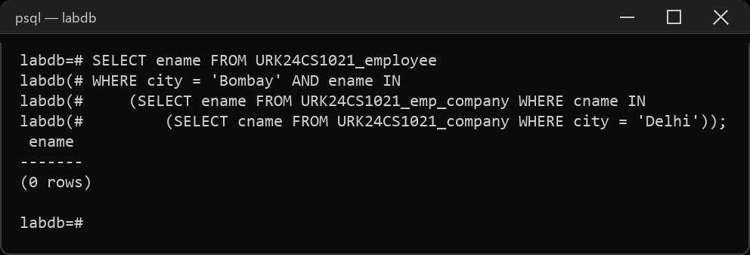
15. Display the names of the employees having same city as Ajay [Hint: Use IN operator]
SELECT ename FROM URK24CS1021_employee
WHERE city IN (SELECT city FROM URK24CS1021_employee WHERE ename = 'Ajay');
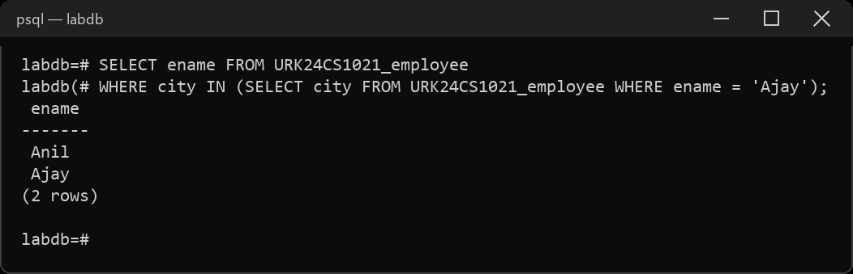
Result
The queries were executed and the desired output was obtained.

