Ex. No. 5  Date: 09/09/2026 | SUBQUERIES AND CORRELATED SUBQUERIES | URK24CS1021
Aim
To execute the given queries using the concept of subqueries and correlated subqueries.
Description
A subquery is a SELECT statement nested inside another SQL statement, typically in the WHERE clause, used when the value to search for isn't known in advance but can itself be produced by a query. A correlated subquery references a column from the outer query in its own WHERE clause, so it is re-evaluated once for every row the outer query processes -- unlike an ordinary subquery, which runs once and is reused for every outer row. EXISTS and NOT EXISTS test only whether a correlated subquery returns any rows at all.
Questions
1. Retrieve users who have reserved for a sports tournament.
SELECT name FROM URK24CS1021_users WHERE id IN
(SELECT userid FROM URK24CS1021_ticket WHERE eventid IN
(SELECT eventid FROM URK24CS1021_event WHERE name = 'Sports Tournament'));
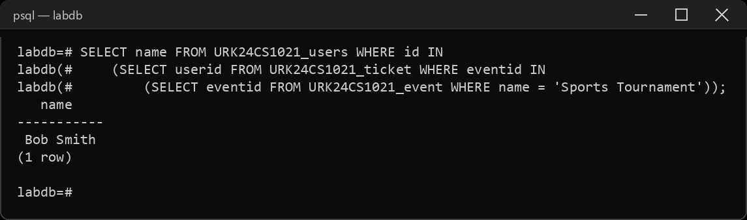
2. Find events hosted in London.
SELECT name FROM URK24CS1021_event WHERE venueid IN
(SELECT venueid FROM URK24CS1021_location WHERE city = 'London');
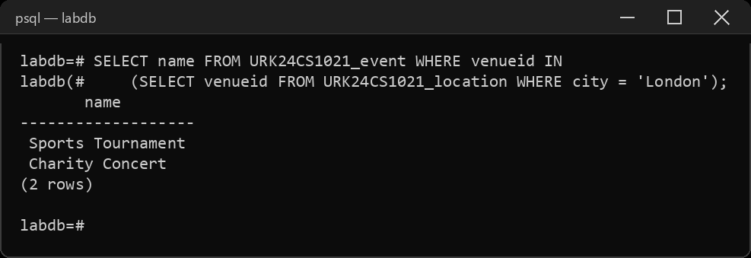
3. Calculate average ticket price for an event Art Exhibition.
SELECT AVG(price) AS avg_price FROM URK24CS1021_ticket WHERE eventid =
(SELECT eventid FROM URK24CS1021_event WHERE name = 'Art Exhibition');
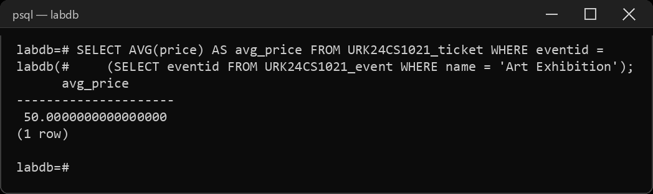
4. Retrieve users who haven't made any reservations.
SELECT name FROM URK24CS1021_users u WHERE NOT EXISTS
(SELECT 1 FROM URK24CS1021_ticket t WHERE t.userid = u.id);
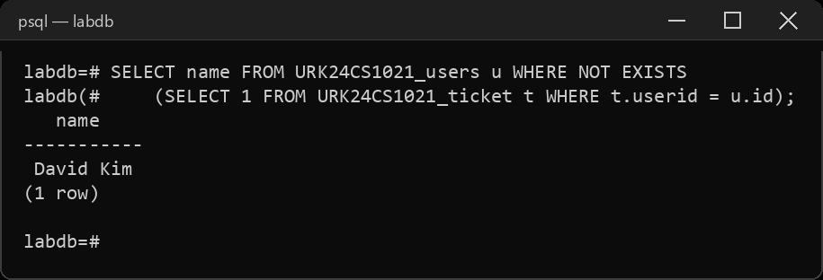
5. Calculate the maximum price among all events reserved by a user.
SELECT MAX(price) AS max_price FROM URK24CS1021_ticket WHERE userid =
(SELECT id FROM URK24CS1021_users WHERE name = 'Alice Johnson');
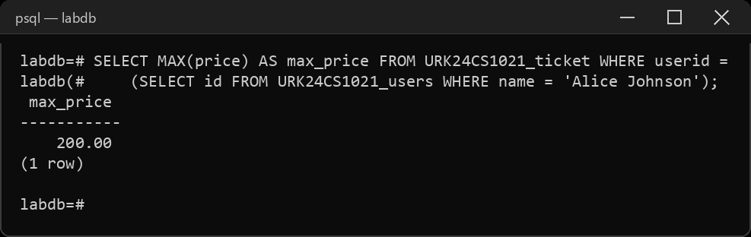
6. Find users who have reserved tickets for events on 20th July 2023.
SELECT DISTINCT u.name FROM URK24CS1021_users u WHERE u.id IN
(SELECT t.userid FROM URK24CS1021_ticket t WHERE t.eventid IN
(SELECT eventid FROM URK24CS1021_event WHERE eventdate = '2023-07-20'));
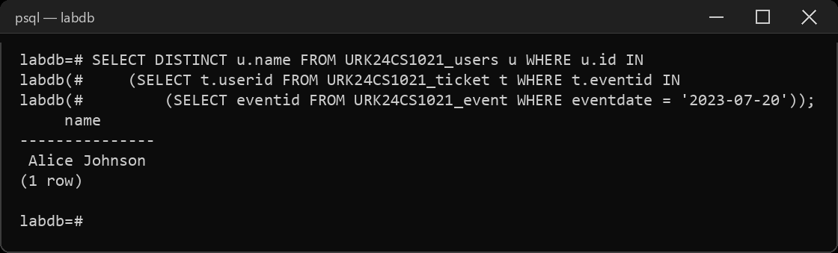
7. Find users who have reserved tickets for events at USA.
SELECT DISTINCT u.name FROM URK24CS1021_users u WHERE EXISTS
(SELECT 1 FROM URK24CS1021_ticket t, URK24CS1021_event e, URK24CS1021_location l
WHERE t.userid = u.id AND t.eventid = e.eventid
AND e.venueid = l.venueid AND l.country = 'USA');
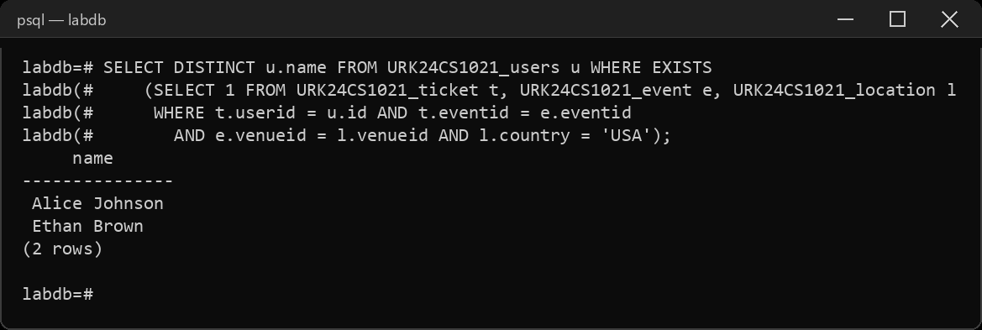
8. Retrieve events where the price of the events is less than $.30.
SELECT DISTINCT e.name FROM URK24CS1021_event e WHERE e.eventid IN
(SELECT eventid FROM URK24CS1021_ticket WHERE price < 30);
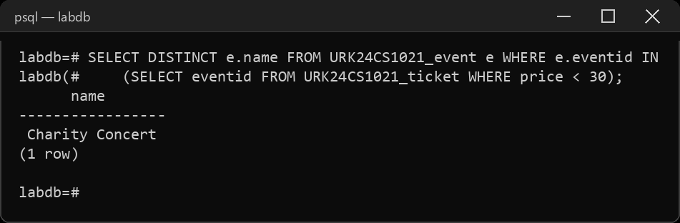
9. Calculate the total revenue generated by Ethan.
SELECT SUM(price) AS total_revenue FROM URK24CS1021_ticket WHERE userid =
(SELECT id FROM URK24CS1021_users WHERE name = 'Ethan Brown');
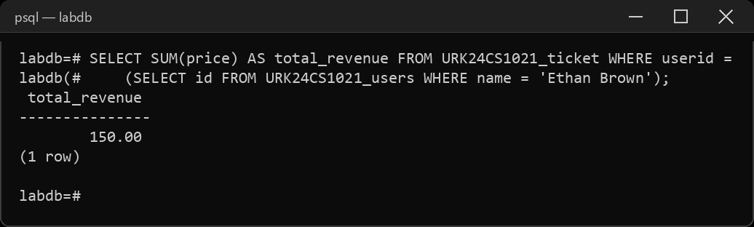
10. Find the events which have been conducted at the same venue.
SELECT name FROM URK24CS1021_event e WHERE EXISTS
(SELECT 1 FROM URK24CS1021_event e2
WHERE e2.venueid = e.venueid AND e2.eventid <> e.eventid)
ORDER BY name;
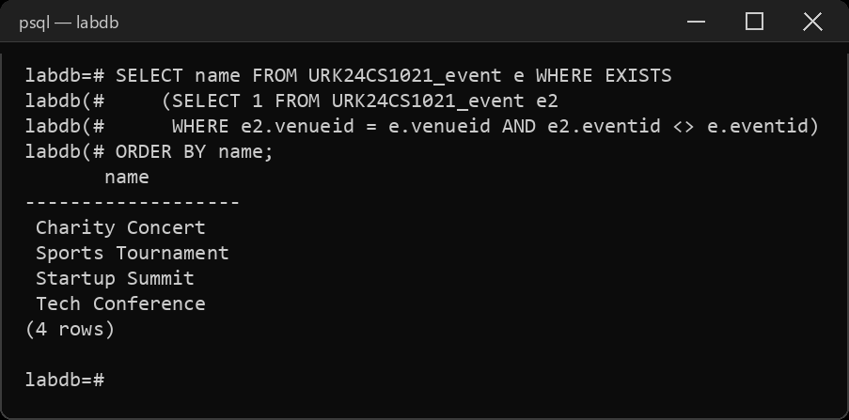
Result
The queries were executed and the desired output was obtained.

