Ex. No. 3 | DATA VISUALIZATION
Date of Exercise | 06/08/2026

Aim
To develop and implement Python programs that visualise real-world datasets from various industries such as HR, logistics, retail, finance, education and security using Matplotlib and Seaborn.
Description (About Matplotlib & Seaborn)
Matplotlib is Python's core plotting library and Seaborn is built on top of it with a shorter, dataset-aware interface. Together they turn a Pandas DataFrame into charts: scatter plots for the relationship between two numeric columns, box and violin plots for how a distribution differs between groups, bar plots for a summary value per category, and histograms for the shape of a single column. They show the patterns, spread and outliers that a table of numbers hides.
Question:
Dataset: University Admissions Dataset (admissions.csv)
Columns: Student_ID, GPA, SAT_Score, ACT_Score, Extracurriculars, Recommendation_Strength, Admitted
• Scatter Plot: SAT_Score vs. GPA (color by Admitted)
• Box Plot: ACT_Score distribution by Admitted status
• Bar Plot: Admission rate by Recommendation_Strength
• Histogram: Distribution of Extracurriculars
• Violin Plot: GPA distribution by Admitted status
Sample Code: Loading the dataset
df = pd.read_csv("admissions.csv")
print(df)
print("\nShape:", df.shape)
print("\nData types:")
print(df.dtypes)
Sample Output:
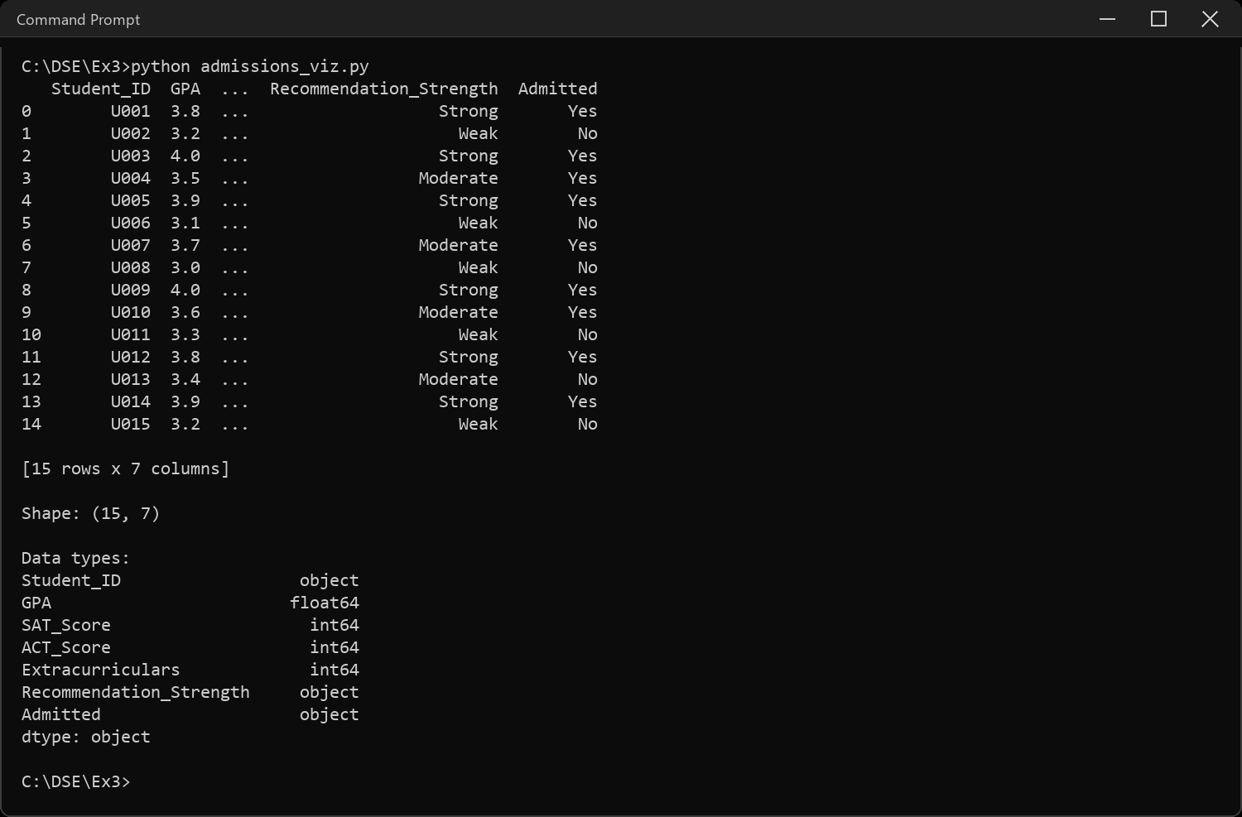
Sample Code: 1. Scatter Plot: SAT_Score vs. GPA (colour by Admitted)
sns.scatterplot(data=df, x="GPA", y="SAT_Score", hue="Admitted",
style="Admitted", s=120)
plt.title("SAT Score vs GPA, coloured by admission status")
plt.xlabel("GPA")
plt.ylabel("SAT Score")
plt.tight_layout()
plt.show()
Sample Output:
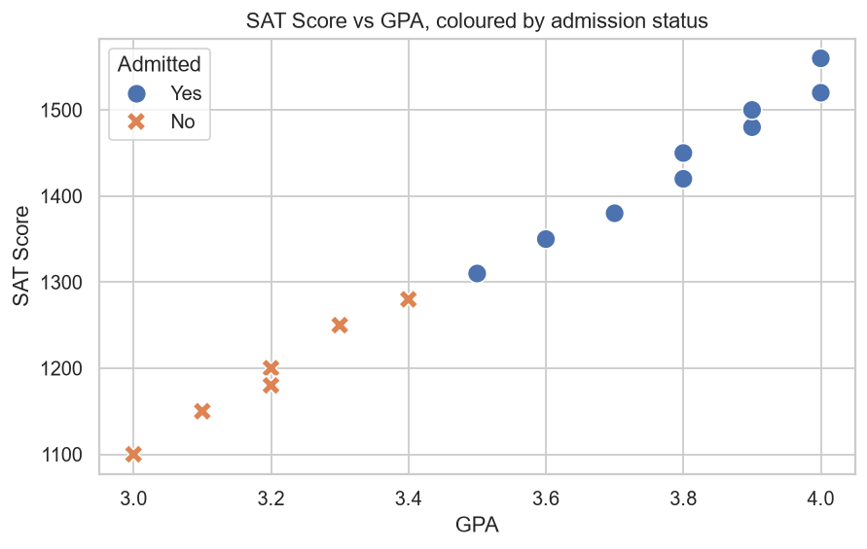
Sample Code: 2. Box Plot: ACT_Score distribution by Admitted status
sns.boxplot(data=df, x="Admitted", y="ACT_Score",
hue="Admitted", palette="Set2", legend=False)
plt.title("ACT Score distribution by admission status")
plt.xlabel("Admitted")
plt.ylabel("ACT Score")
plt.tight_layout()
plt.show()
Sample Output:
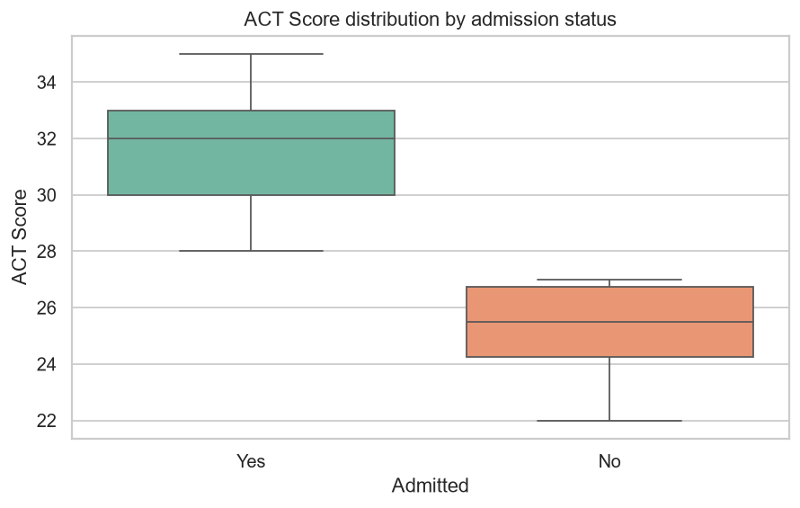
Sample Code: 3. Bar Plot: Admission rate by Recommendation_Strength
# Admitted is Yes/No, so the admission rate is the mean of (Admitted == "Yes")
rate = (df.groupby("Recommendation_Strength")["Admitted"]
.apply(lambda s: (s == "Yes").mean())
.reindex(["Weak", "Moderate", "Strong"]))
print("Admission rate:")
print(rate)
sns.barplot(x=rate.index, y=rate.values, hue=rate.index,
palette="Blues_d", legend=False)
plt.title("Admission rate by recommendation strength")
plt.xlabel("Recommendation Strength")
plt.ylabel("Admission rate")
plt.ylim(0, 1)
plt.tight_layout()
plt.show()
Sample Output:
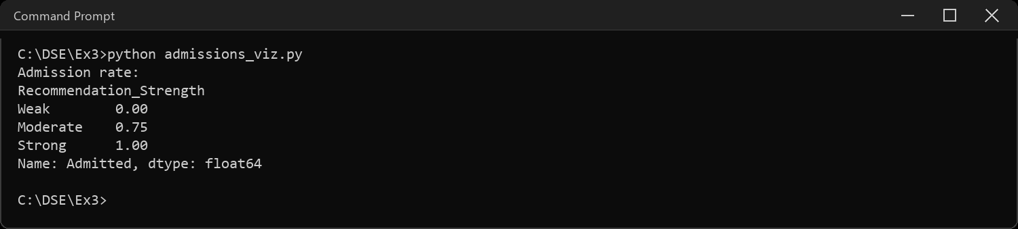
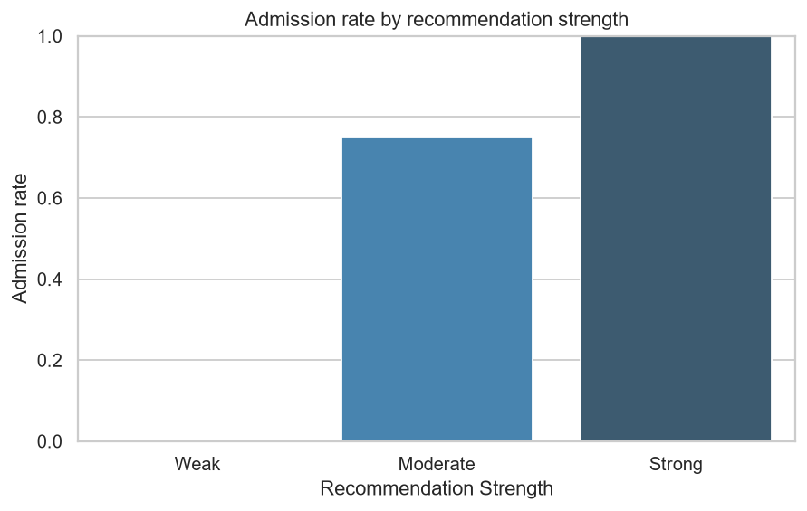
Sample Code: 4. Histogram: Distribution of Extracurriculars
# whole numbers 0-5, so give it explicit bins instead of the automatic ones
plt.hist(df["Extracurriculars"], bins=range(0, 7), edgecolor="black",
align="left", color="#4C72B0")
plt.xticks(range(0, 6))
plt.yticks(range(0, 6)) # counts are whole students, not 2.5 of one
plt.title("Distribution of extracurricular activities")
plt.xlabel("Number of extracurriculars")
plt.ylabel("Number of students")
plt.tight_layout()
plt.show()
Sample Output:
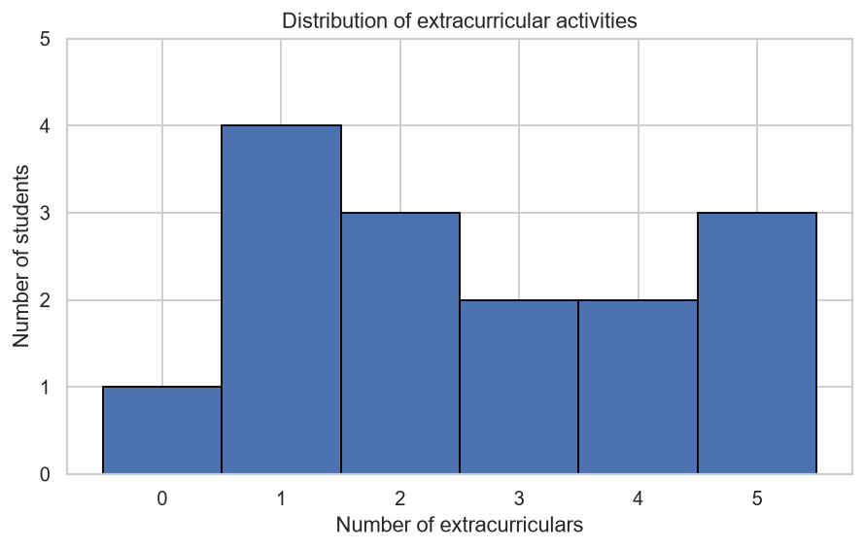
Sample Code: 5. Violin Plot: GPA distribution by Admitted status
sns.violinplot(data=df, x="Admitted", y="GPA", hue="Admitted",
palette="Set3", legend=False)
plt.title("GPA distribution by admission status")
plt.xlabel("Admitted")
plt.ylabel("GPA")
plt.tight_layout()
plt.show()
Sample Output:
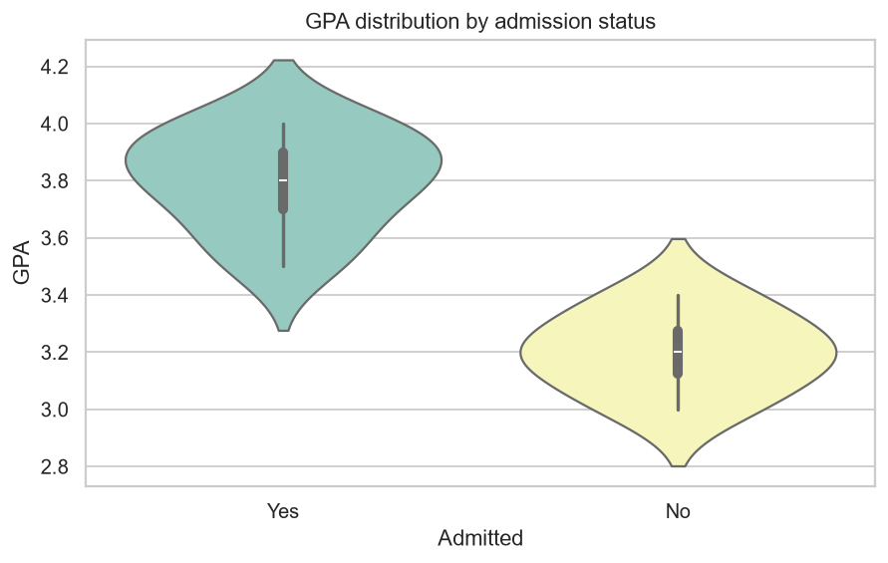
CODE EXPLANATION LINK:
(Youtube / Drive Link)
Preparation course certificate

RESULT
The exercise shown above has been successfully executed and the output has been verified.

