Ex. No. 4 | DESCRIPTIVE STATISTICS AND CORRELATION
Date of Exercise | 07/08/2026

Aim
To develop and implement Python programs that summarise real-world datasets using measures of central tendency, dispersion and correlation, and to visualise those relationships using Matplotlib and Seaborn.
Description (About Descriptive Statistics & Correlation)
Descriptive statistics reduce a column of numbers to a few values that describe it: the mean, median and mode say where the data sits, while the variance, standard deviation, range and inter-quartile range say how spread out it is. Correlation goes one step further and measures whether two columns move together — Pearson for a straight-line relationship and Spearman for rank order. Pandas computes all of these directly on a DataFrame, and Seaborn draws them as heatmaps, regression plots, box plots, histograms and pair plots.
Question:
Dataset: fanspeed.csv (https://dataset.karunya.edu/CSE/fanspeed.csv)
Columns: Temperature, Observed Fan Speed
• Calculate the mean (average) value for each numerical column in the dataset.
• Determine the median for each numerical column. How does it compare to the mean?
• Identify the mode(s) for categorical and numerical columns. Are there any columns with multiple modes?
• Compute the variance for each numerical column. Which column has the highest variability?
• Find the standard deviation for each numerical column. How does it relate to variance?
• Calculate the range (max - min) for each numerical column. Which column has the widest range?
• Determine the IQR for each numerical column. Are there any outliers based on the 1.5×IQR rule?
• Compute the correlation matrix for all numerical variables. Which pairs have the strongest correlations?
• Calculate the Pearson correlation coefficient between two selected numerical columns. Is the relationship positive, negative, or neutral?
• Compute the Spearman rank correlation for two selected columns. How does it compare to the Pearson correlation?
• Plot a heatmap of the correlation matrix. Which variables are most strongly correlated?
• Visualize the relationship between two numerical variables with a scatter plot and regression line. Does the trend match the correlation coefficient?
• Create a box plot for a numerical column. Are there any outliers?
• Plot a histogram for a numerical column. Is the distribution normal, skewed, or bimodal?
• Generate a pair plot for multiple numerical variables. What patterns do you observe?
Sample Code: Loading the dataset
df = pd.read_csv("fanspeed.csv")
print(df.head())
print("\nShape:", df.shape)
print("\nData types:")
print(df.dtypes)
Sample Output:
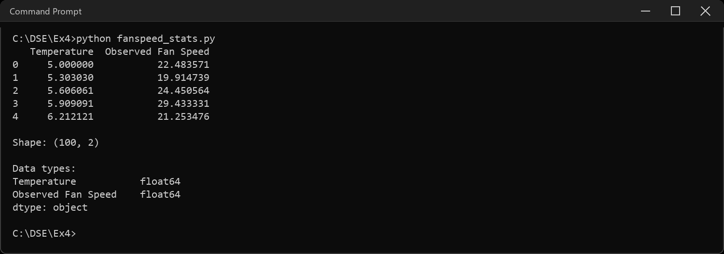
Sample Code: 1. Mean of each numerical column
print("Mean:")
print(df.mean(numeric_only=True))
Sample Output:
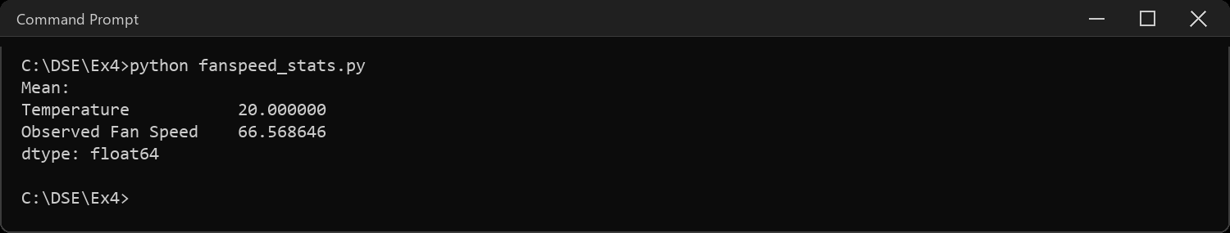
Sample Code: 2. Median of each numerical column, compared to the mean
print("Median:")
print(df.median(numeric_only=True))
compare = pd.DataFrame({"mean": df.mean(numeric_only=True),
"median": df.median(numeric_only=True)})
compare["difference"] = compare["mean"] - compare["median"]
print("\nMean vs median:")
print(compare)
Sample Output:
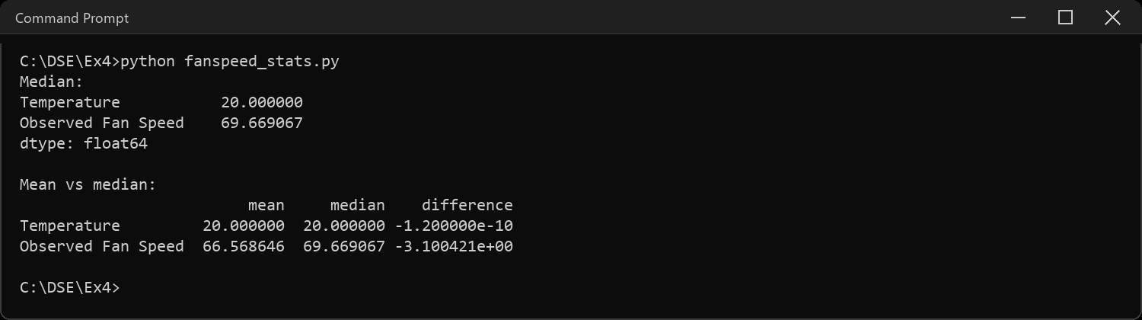
Sample Code: 3. Mode(s) for numerical and categorical columns
# every reading in this dataset is unique, so every value ties as a mode
for col in df.columns:
modes = df[col].mode()
print(col, "-> number of modes:", len(modes))
print(" first few:", list(modes.head(3)))
# the dataset has no categorical column, so derive one by binning temperature
df["Temp_Band"] = pd.cut(df["Temperature"], bins=[5, 15, 25, 35],
labels=["Low", "Mid", "High"], include_lowest=True)
print("\nCounts per band:")
print(df["Temp_Band"].value_counts())
print("\nMode of the categorical column:", list(df["Temp_Band"].mode()))
Sample Output:
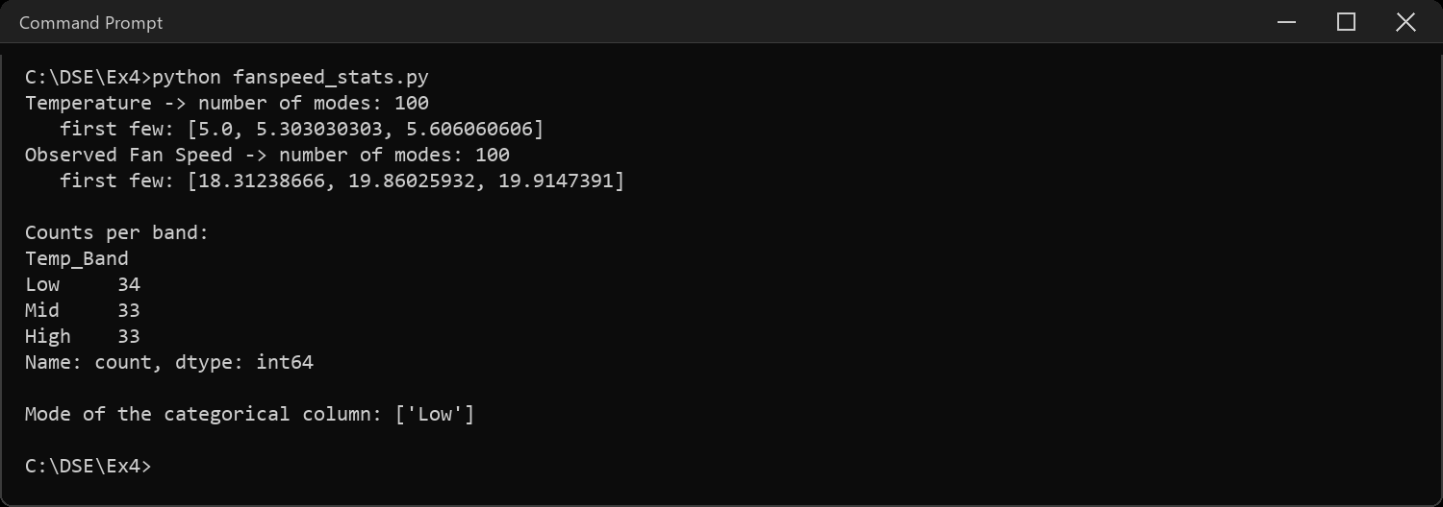
Sample Code: 4. Variance of each numerical column
print("Variance:")
print(df.var(numeric_only=True))
print("\nHighest variance:", df.var(numeric_only=True).idxmax())
Sample Output:
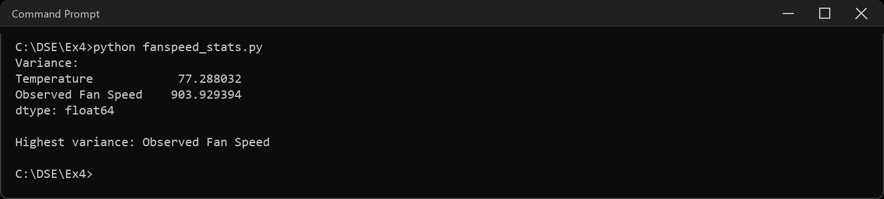
Sample Code: 5. Standard deviation, and how it relates to variance
print("Standard deviation:")
print(df.std(numeric_only=True))
check = pd.DataFrame({"variance": df.var(numeric_only=True),
"std": df.std(numeric_only=True)})
check["std squared"] = check["std"] ** 2
print("\nStd is the square root of variance:")
print(check)
Sample Output:
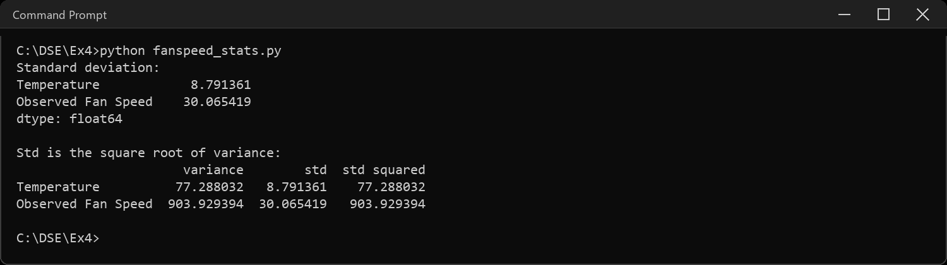
Sample Code: 6. Range (max - min) of each numerical column
nums = df.select_dtypes(include="number")
rng = pd.DataFrame({"min": nums.min(), "max": nums.max()})
rng["range"] = rng["max"] - rng["min"]
print(rng)
print("\nWidest range:", rng["range"].idxmax())
Sample Output:
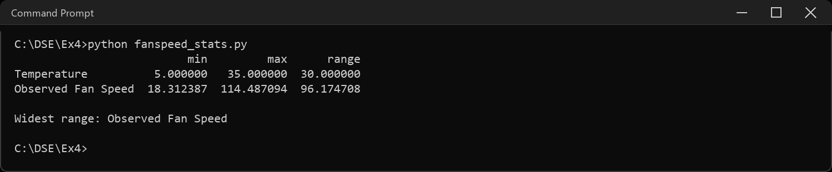
Sample Code: 7. Inter-quartile range and the 1.5xIQR outlier rule
q1 = nums.quantile(0.25)
q3 = nums.quantile(0.75)
iqr = q3 - q1
fences = pd.DataFrame({"Q1": q1, "Q3": q3, "IQR": iqr,
"lower fence": q1 - 1.5 * iqr,
"upper fence": q3 + 1.5 * iqr})
print(fences)
print("\nOutliers per column:")
for col in nums.columns:
low = q1[col] - 1.5 * iqr[col]
high = q3[col] + 1.5 * iqr[col]
out = nums[(nums[col] < low) | (nums[col] > high)]
print(" ", col, "->", len(out), "outliers")
Sample Output:
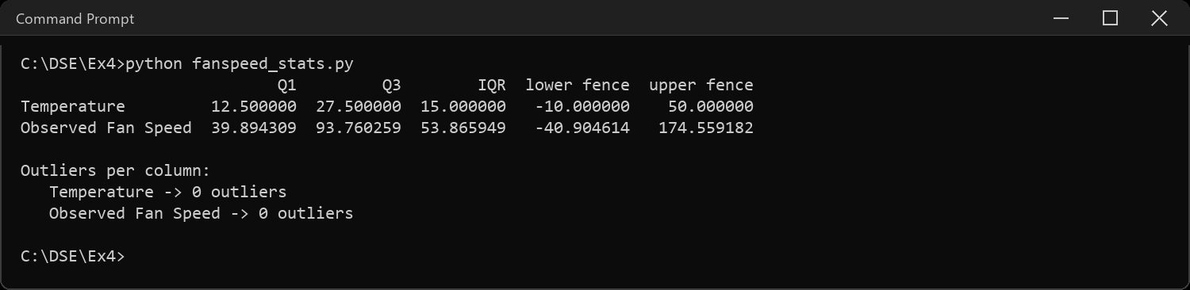
Sample Code: 8. Correlation matrix for all numerical variables
corr = nums.corr()
print(corr)
# only two numerical columns, so there is exactly one pair to compare
print("\nTemperature vs Observed Fan Speed:",
round(corr.loc["Temperature", "Observed Fan Speed"], 4))
Sample Output:
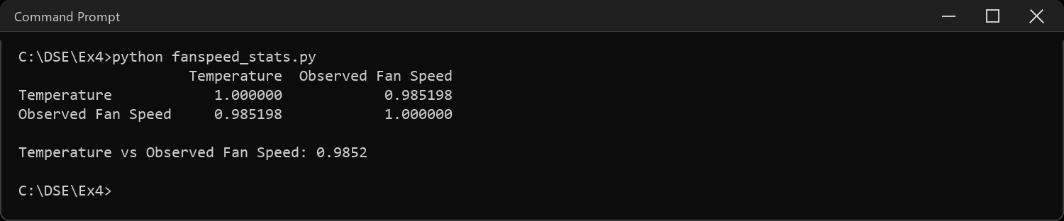
Sample Code: 9. Pearson correlation between two selected columns
pearson = df["Temperature"].corr(df["Observed Fan Speed"], method="pearson")
print("Pearson correlation:", round(pearson, 4))
print("Direction:", "positive" if pearson > 0 else
("negative" if pearson < 0 else "neutral"))
Sample Output:
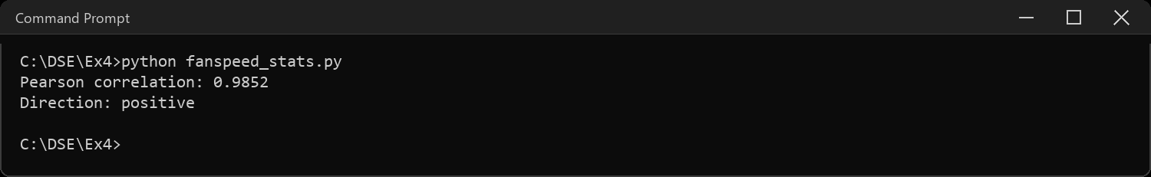
Sample Code: 10. Spearman rank correlation, compared to Pearson
spearman = df["Temperature"].corr(df["Observed Fan Speed"], method="spearman")
print("Spearman correlation:", round(spearman, 4))
print("Pearson correlation :", round(pearson, 4))
print("Difference :", round(pearson - spearman, 4))
Sample Output:
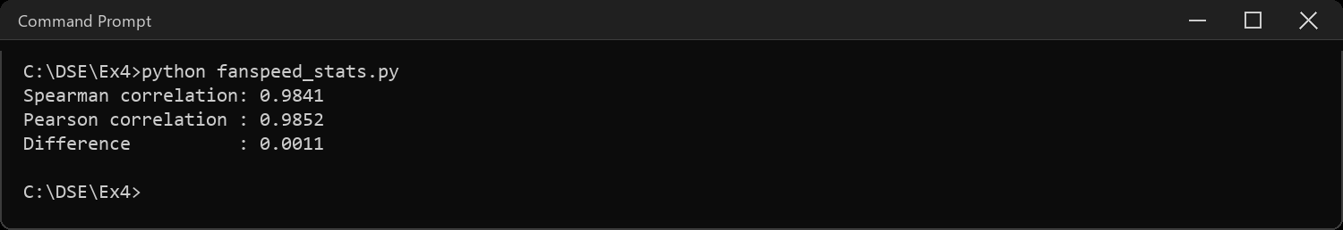
Sample Code: 11. Heatmap of the correlation matrix
sns.heatmap(corr, annot=True, fmt=".3f", cmap="coolwarm",
vmin=-1, vmax=1, square=True)
plt.title("Correlation matrix")
plt.tight_layout()
plt.show()
Sample Output:
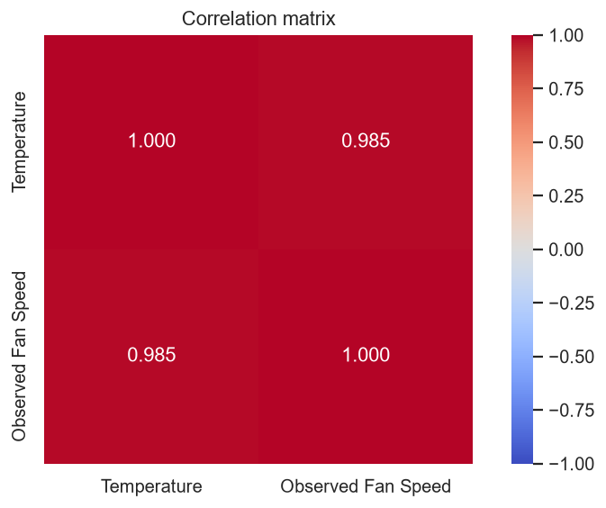
Sample Code: 12. Scatter plot with a regression line
sns.regplot(data=df, x="Temperature", y="Observed Fan Speed",
scatter_kws={"s": 30, "alpha": 0.7},
line_kws={"color": "red"})
plt.title("Observed Fan Speed vs Temperature, with regression line")
plt.tight_layout()
plt.show()
Sample Output:
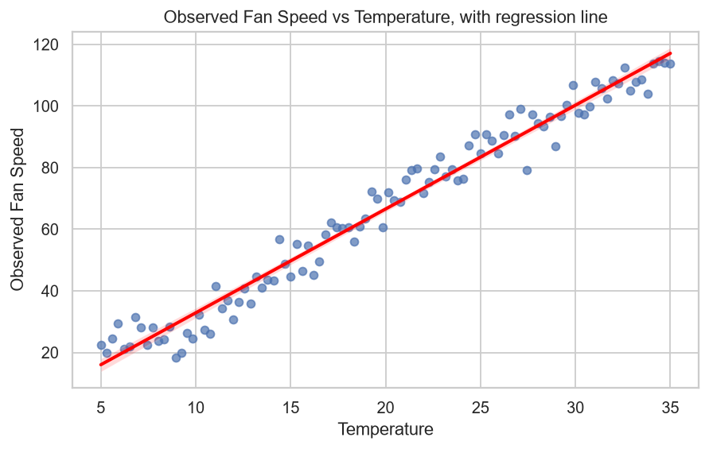
Sample Code: 13. Box plot for a numerical column
sns.boxplot(y=df["Observed Fan Speed"], color="#8FBC8F")
plt.title("Observed Fan Speed - box plot")
plt.tight_layout()
plt.show()
Sample Output:
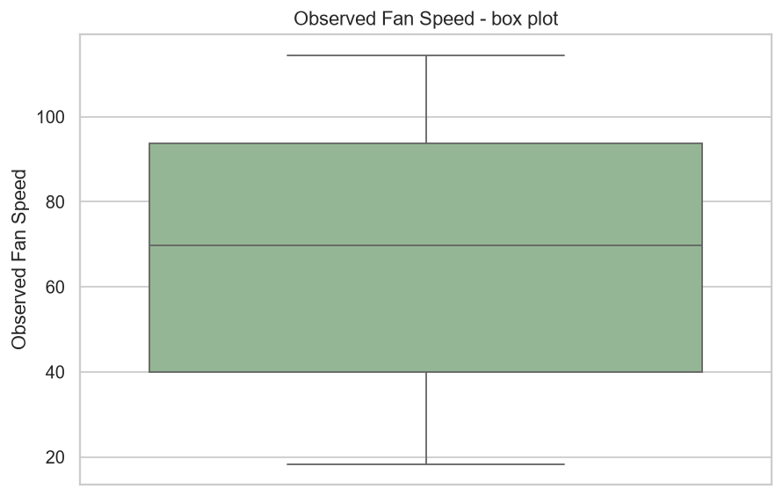
Sample Code: 14. Histogram for a numerical column
print("Skewness:", round(df["Observed Fan Speed"].skew(), 4))
sns.histplot(df["Observed Fan Speed"], bins=12, kde=True, color="#4C72B0")
plt.title("Distribution of Observed Fan Speed")
plt.xlabel("Observed Fan Speed")
plt.tight_layout()
plt.show()
Sample Output:
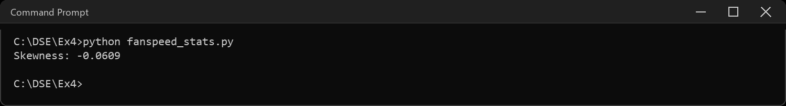
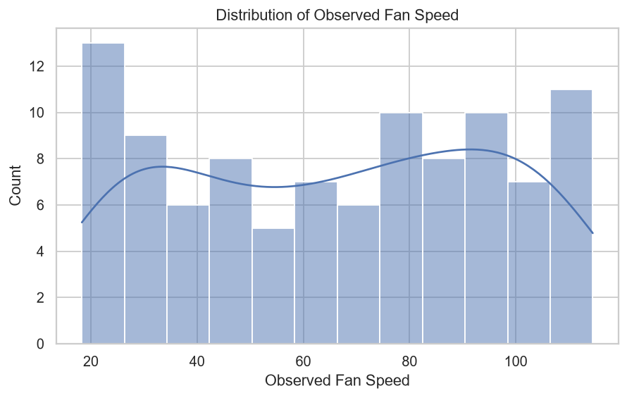
Sample Code: 15. Pair plot of the numerical variables
sns.pairplot(nums, diag_kind="hist", height=2.6)
plt.suptitle("Pair plot - Temperature and Observed Fan Speed", y=1.02)
plt.show()
Sample Output:
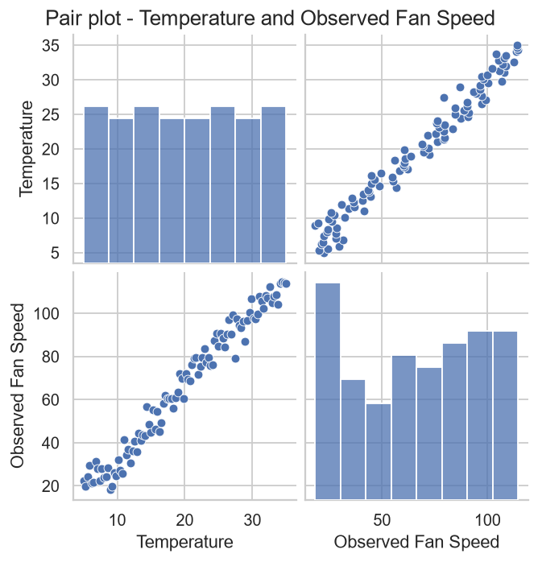
CODE EXPLANATION LINK:
(Youtube / Drive Link)
Preparation course certificate

RESULT
The exercise shown above has been successfully executed and the output has been verified.

