Ex. No. 5 | REGRESSION ANALYSIS
Date of Exercise | 11/09/2026

Aim
To build regression models in Python that predict a continuous target from a real-world dataset, and to compare simple linear, multiple linear, polynomial, Lasso and Ridge regression using the R² score and the root mean squared error.
Description (About Regression)
Regression fits a function to data so that a continuous value can be predicted from other measured values. Simple linear regression uses one predictor and fits a straight line; multiple linear regression uses several predictors and fits a plane. Polynomial regression adds squared and interaction terms so the fit can bend. Lasso and Ridge are the same linear fit with a penalty added to the size of the coefficients — Ridge shrinks them, Lasso can shrink them all the way to zero and so drops features outright. Two numbers judge the result: R², the share of the variation in the target that the model explains (1.0 is perfect, 0 is no better than always guessing the mean), and RMSE, the typical size of the error in the units of the target itself.
Question:
Dataset: India Rental House Price
(https://www.kaggle.com/datasets/bhavyadhingra00020/india-rental-house-price)
Target to Predict: Price per Square Foot
• Import the dataset.
• Display the first 10 rows of the dataset.
• Display the last 8 rows of the dataset.
• Display information about the dataset: information, column names, shape, statistical inferences, data types.
• Perform the following regression and measure the performance using r2 score and root mean squared error: Simple Linear Regression, Multiple Linear Regression, Polynomial Regression, Lasso Regression, Ridge Regression.
• Draw a comparative table of r2 score and root mean square of all the regression techniques.
• Document your interpretations.
Sample Code: 1. Import the dataset
# the kaggle download ships one csv per city; they share a schema, so I
# concatenated Delhi + Mumbai + Pune into one file before loading
df = pd.read_csv("rental.csv")
print("Rows loaded:", len(df))
print(df[["house_type", "house_size", "location", "city", "price"]].head())
Sample Output:
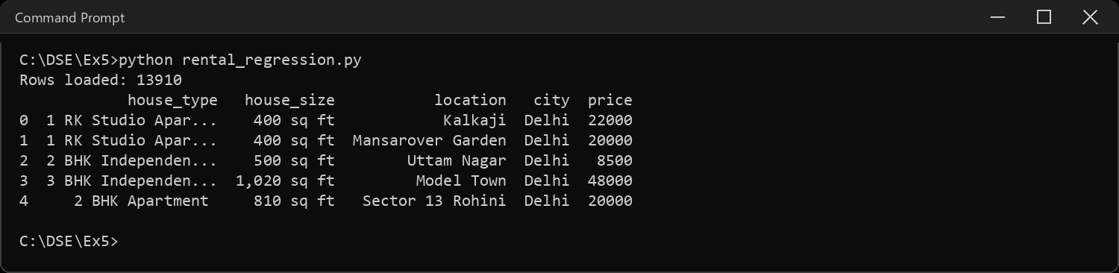
Sample Code: 2. Display the first 10 rows of the dataset
print(df.head(10))
Sample Output:
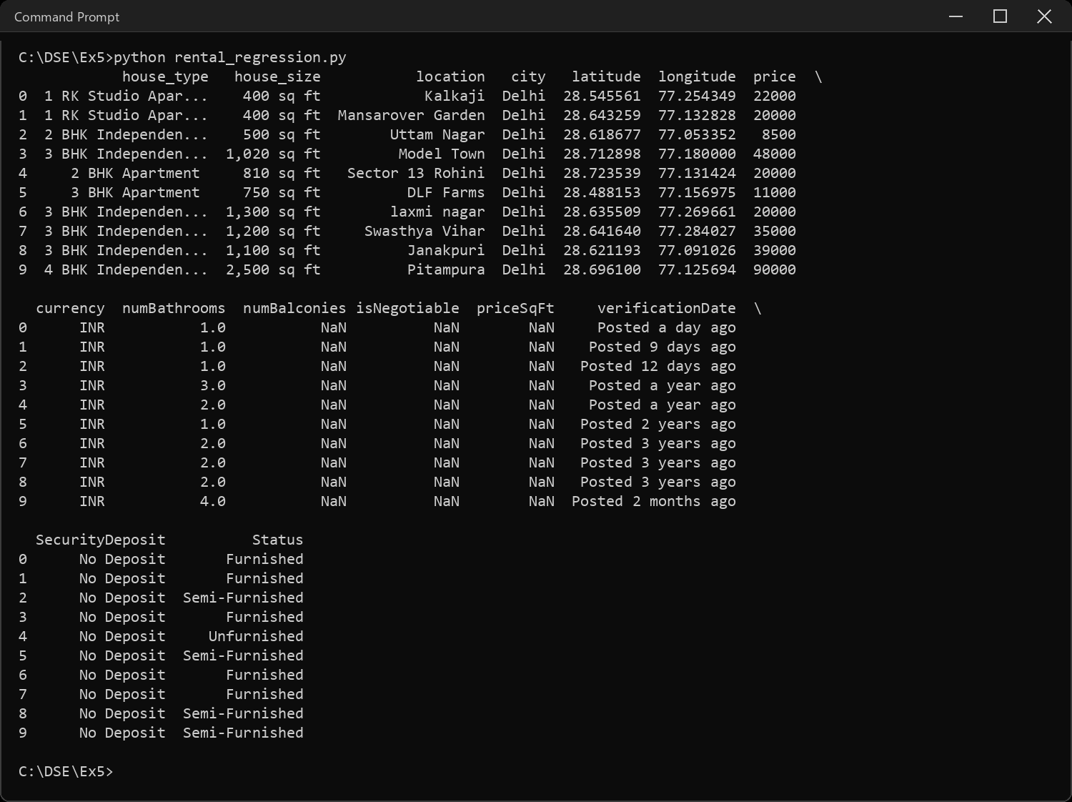
Sample Code: 3. Display the last 8 rows of the dataset
print(df.tail(8))
Sample Output:
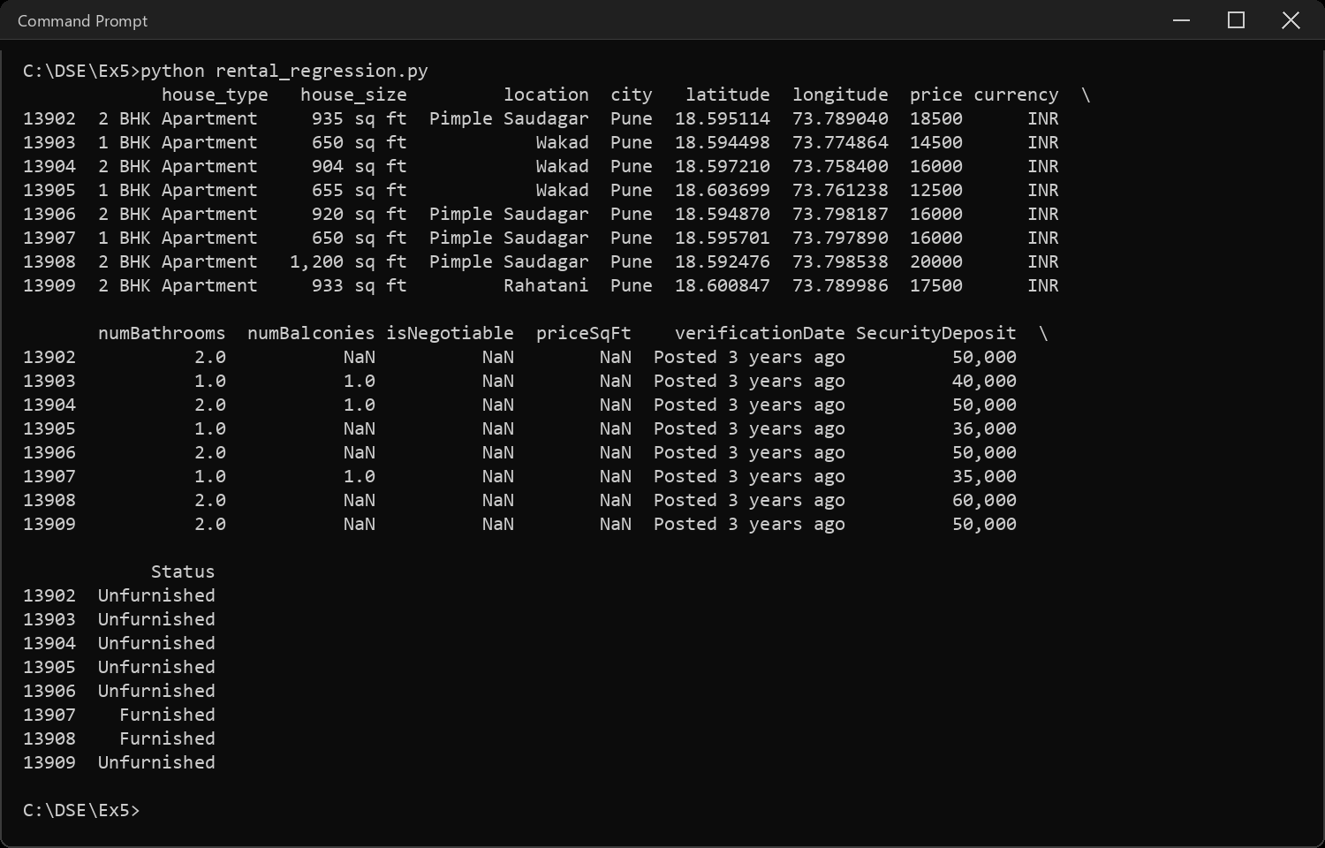
Sample Code: 4. Information about the dataset
df.info()
Sample Output:
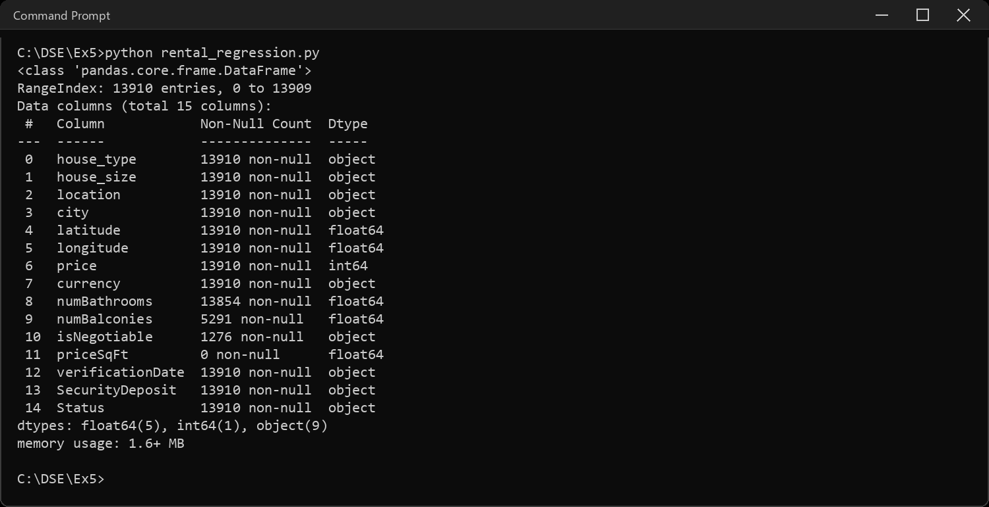
Sample Code: 5. Column names
print("Number of columns:", len(df.columns))
for i, col in enumerate(df.columns, 1):
print(i, col)
Sample Output:
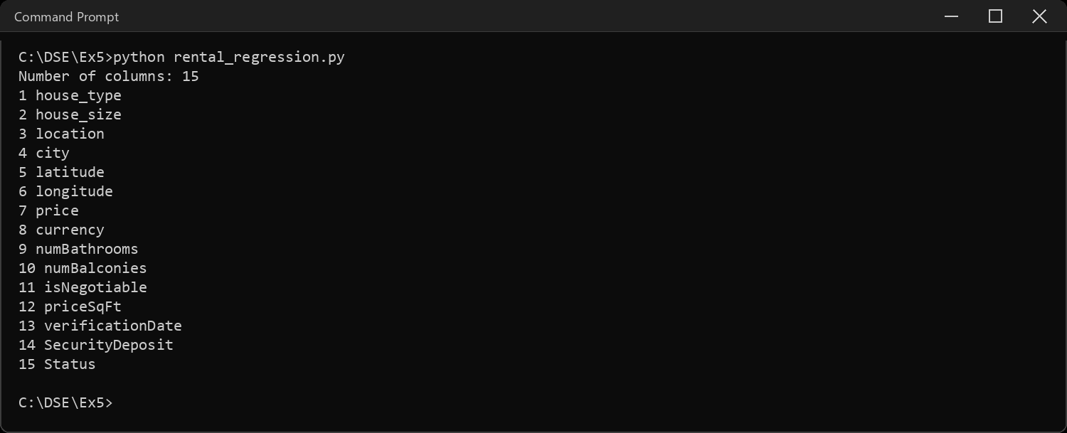
Sample Code: 6. Shape of the dataset
print("Shape (rows, columns):", df.shape)
print("Rows :", df.shape[0])
print("Columns:", df.shape[1])
print("\nRows per city:")
print(df["city"].value_counts())
Sample Output:
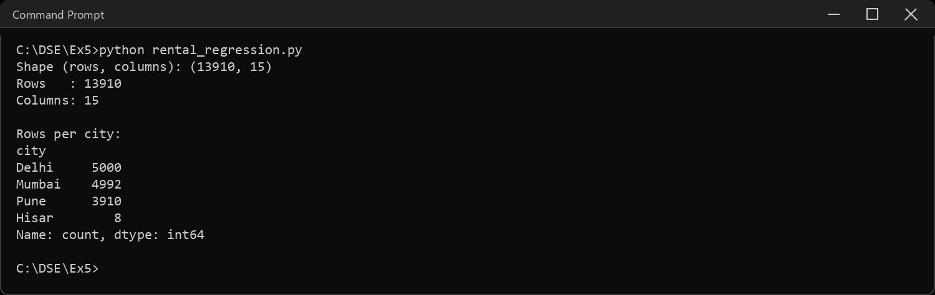
Sample Code: 7. Statistical inferences
print(df.describe())
print("\nMissing values per column:")
print(df.isnull().sum())
Sample Output:
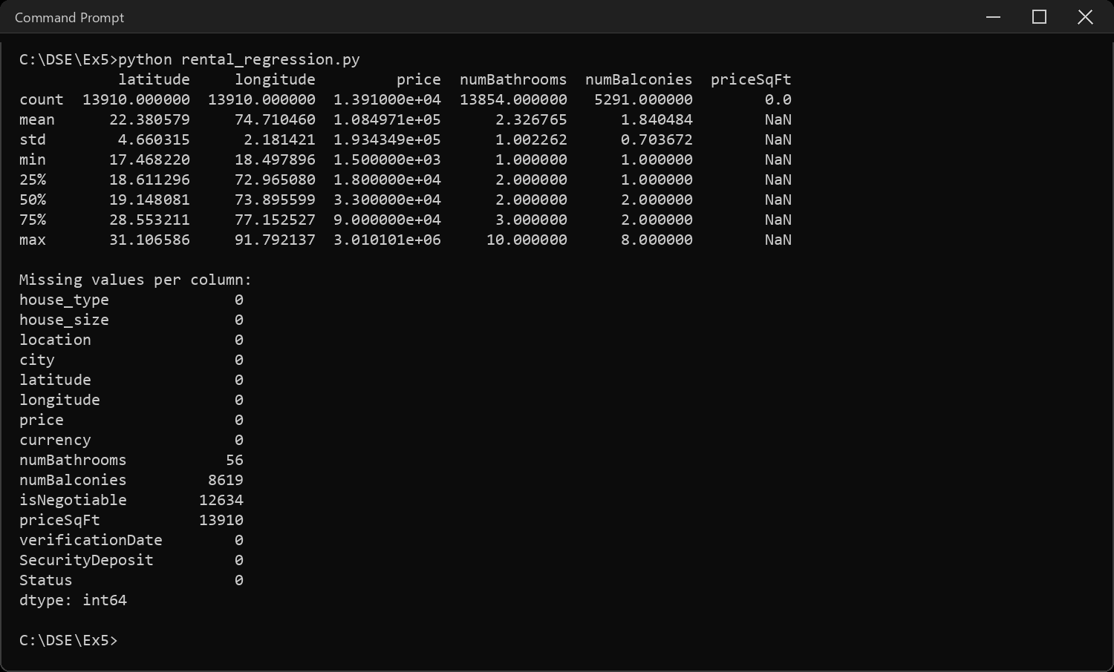
Sample Code: 8. Data types
print(df.dtypes)
print("\nNumeric columns :", list(df.select_dtypes(include="number").columns))
print("Categorical columns:", list(df.select_dtypes(include="object").columns))
Sample Output:
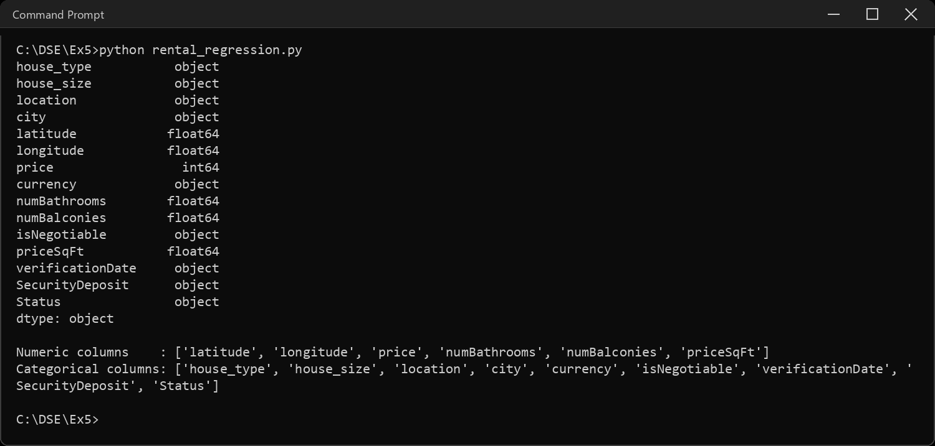
Sample Code: 9. Building the target column 'Price per Square Foot'
# the assigned target is Price per Square Foot. the dataset HAS a priceSqFt
# column but it is empty in all three city files, so the target has to be
# derived: monthly rent divided by the built-up area.
print("priceSqFt non-null values in the file:", df["priceSqFt"].notna().sum())
# house_size is text like "1,020 sq ft" -> strip it down to a number
df["size_sqft"] = pd.to_numeric(
df["house_size"].str.replace(" sq ft", "", regex=False).str.replace(",", "", regex=False),
errors="coerce")
df["price_per_sqft"] = df["price"] / df["size_sqft"]
print("\nTarget summary:")
print(df["price_per_sqft"].describe())
Sample Output:
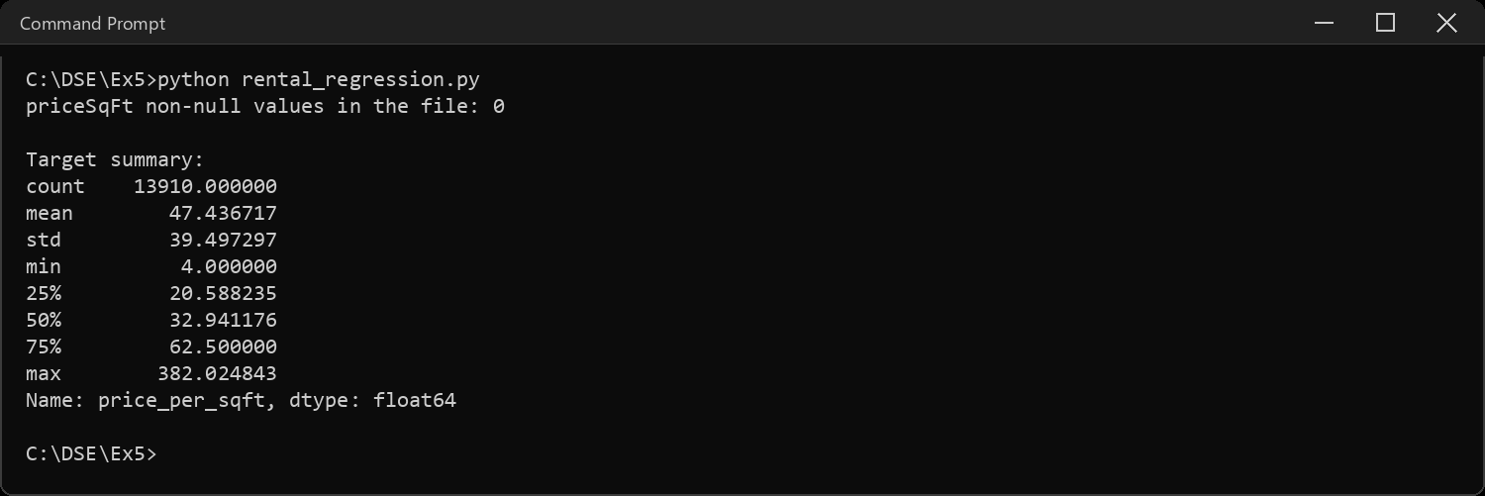
Sample Code: 10. Preparing the features and the train / test split
# bedrooms are hidden in the house_type text ("2 BHK Apartment" -> 2)
df["house_type"] = df["house_type"].str.strip()
df["bhk"] = df["house_type"].str.extract(r"^(\d+)").astype(float)
# fill the two numeric gaps: bathrooms with the median, balconies with 0
df["numBathrooms"] = df["numBathrooms"].fillna(df["numBathrooms"].median())
df["numBalconies"] = df["numBalconies"].fillna(0)
# 702 distinct localities is far too many to one-hot, so keep the 30
# commonest and bucket the rest as "Other"
top_loc = df["location"].value_counts().head(30).index
df["loc_grp"] = np.where(df["location"].isin(top_loc), df["location"], "Other")
# price is deliberately NOT a feature - the target is price/size, so price
# would leak the answer straight into the model
features = ["size_sqft", "bhk", "numBathrooms", "numBalconies",
"Status", "city", "loc_grp"]
X = pd.get_dummies(df[features], drop_first=True)
y = df["price_per_sqft"]
X_train, X_test, y_train, y_test = train_test_split(
X, y, test_size=0.2, random_state=SEED)
print("Feature matrix after one-hot encoding:", X.shape)
print("Training rows:", len(X_train), " Test rows:", len(X_test))
Sample Output:
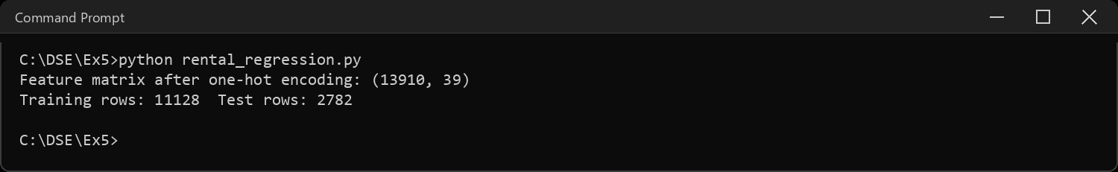
Sample Code: 11. Simple Linear Regression
# one predictor only - the size of the house
simple = LinearRegression()
simple.fit(X_train[["size_sqft"]], y_train)
pred = simple.predict(X_test[["size_sqft"]])
print("Intercept:", round(simple.intercept_, 4))
print("Slope :", round(simple.coef_[0], 6))
print("R2 score :", round(r2_score(y_test, pred), 4))
print("RMSE :", round(root_mean_squared_error(y_test, pred), 4))
results.append({"Technique": "Simple Linear",
"R2 Score": r2_score(y_test, pred),
"RMSE": root_mean_squared_error(y_test, pred)})
Sample Output:
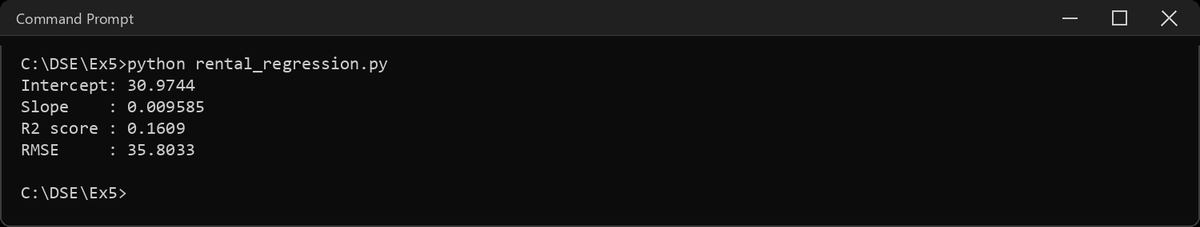
Sample Code: 12. Multiple Linear Regression
# all the features together
multi = LinearRegression()
multi.fit(X_train, y_train)
pred = multi.predict(X_test)
print("R2 score:", round(r2_score(y_test, pred), 4))
print("RMSE :", round(root_mean_squared_error(y_test, pred), 4))
results.append({"Technique": "Multiple Linear",
"R2 Score": r2_score(y_test, pred),
"RMSE": root_mean_squared_error(y_test, pred)})
coef = pd.Series(multi.coef_, index=X.columns).sort_values(key=abs, ascending=False)
print("\nFive strongest coefficients:")
print(coef.head(5))
Sample Output:
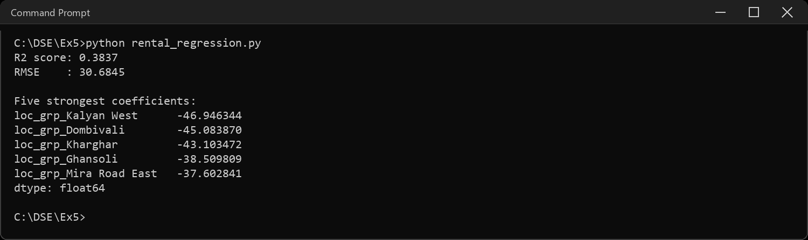
Sample Code: 13. Polynomial Regression
# degree 2 adds every squared term and every pairwise interaction
poly = make_pipeline(PolynomialFeatures(degree=2, include_bias=False),
LinearRegression())
poly.fit(X_train, y_train)
pred = poly.predict(X_test)
print("Features after expansion:",
poly.named_steps["polynomialfeatures"].n_output_features_)
print("R2 score:", round(r2_score(y_test, pred), 4))
print("RMSE :", round(root_mean_squared_error(y_test, pred), 4))
results.append({"Technique": "Polynomial (deg 2)",
"R2 Score": r2_score(y_test, pred),
"RMSE": root_mean_squared_error(y_test, pred)})
Sample Output:
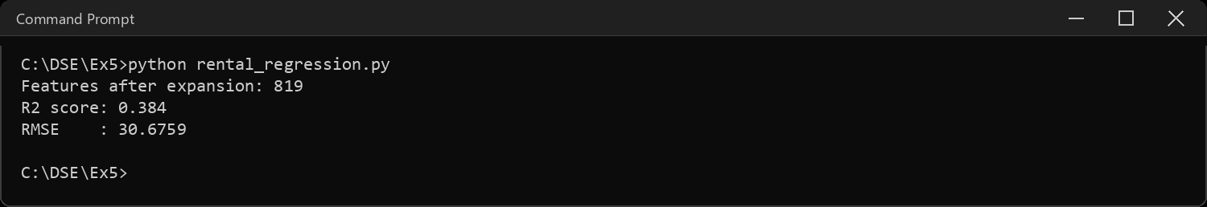
Sample Code: 14. Lasso Regression
# L1 penalty: it can push coefficients all the way to zero.
# scaling first, otherwise the penalty hits the big-valued columns hardest
lasso = make_pipeline(StandardScaler(), Lasso(alpha=0.1, max_iter=5000))
lasso.fit(X_train, y_train)
pred = lasso.predict(X_test)
print("R2 score:", round(r2_score(y_test, pred), 4))
print("RMSE :", round(root_mean_squared_error(y_test, pred), 4))
zeroed = (lasso.named_steps["lasso"].coef_ == 0).sum()
print("Coefficients driven to exactly zero:", zeroed, "of", X.shape[1])
results.append({"Technique": "Lasso",
"R2 Score": r2_score(y_test, pred),
"RMSE": root_mean_squared_error(y_test, pred)})
Sample Output:
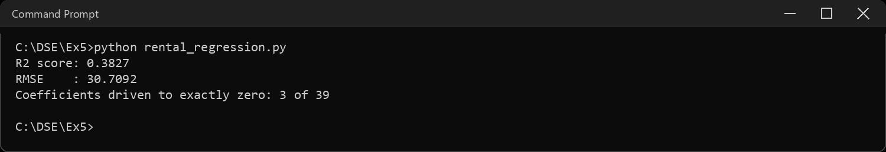
Sample Code: 15. Ridge Regression
# L2 penalty: it shrinks coefficients towards zero but never to zero
ridge = make_pipeline(StandardScaler(), Ridge(alpha=1.0))
ridge.fit(X_train, y_train)
pred = ridge.predict(X_test)
print("R2 score:", round(r2_score(y_test, pred), 4))
print("RMSE :", round(root_mean_squared_error(y_test, pred), 4))
zeroed = (ridge.named_steps["ridge"].coef_ == 0).sum()
print("Coefficients driven to exactly zero:", zeroed, "of", X.shape[1])
results.append({"Technique": "Ridge",
"R2 Score": r2_score(y_test, pred),
"RMSE": root_mean_squared_error(y_test, pred)})
Sample Output:
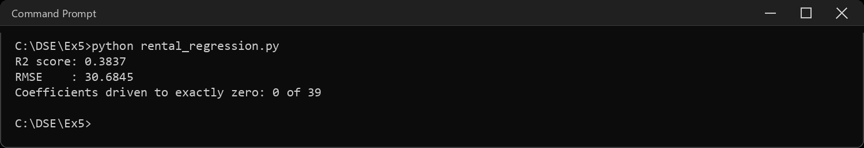
Sample Code: 16. Comparative table of R2 score and RMSE
table = pd.DataFrame(results).set_index("Technique").round(4)
print(table.to_string())
print("\nBest R2 :", table["R2 Score"].idxmax())
print("Lowest RMSE:", table["RMSE"].idxmin())
table["R2 Score"].plot(kind="bar", color="#4C72B0", rot=20)
plt.ylabel("R2 score")
plt.title("R2 by regression technique")
plt.tight_layout()
plt.show()
Sample Output:
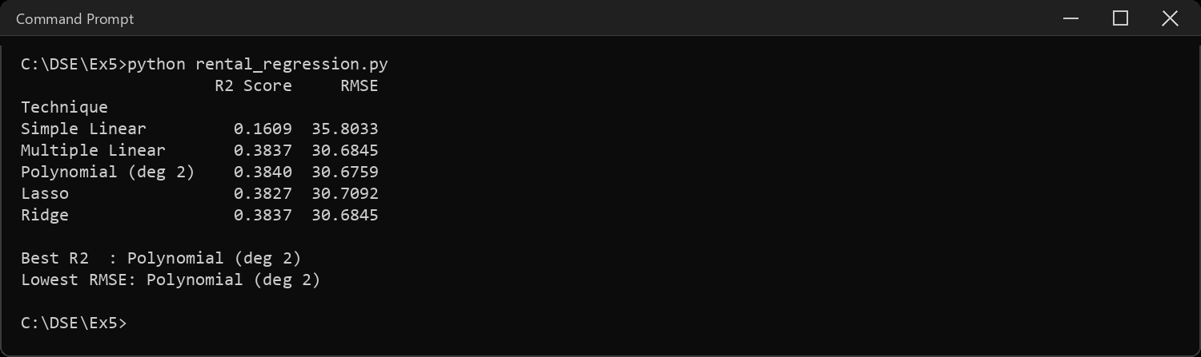
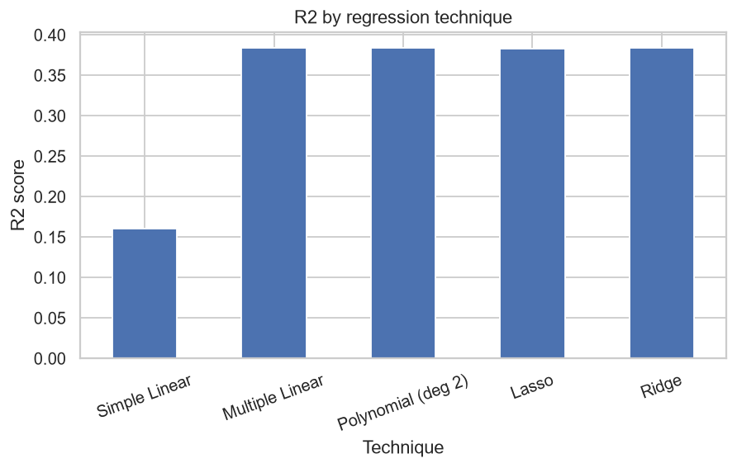
Sample Code: 17. Predicted vs actual for the multiple linear model
# polynomial edges it on R2 by 0.0003, which is noise - so the plot uses
# the plain multiple linear model, the simplest of the ones that tied
best = multi.predict(X_test)
plt.scatter(y_test, best, s=8, alpha=0.3, color="#4C72B0")
lims = [y_test.min(), y_test.max()]
plt.plot(lims, lims, color="red", linewidth=1.5)
plt.xlabel("Actual price per sq ft")
plt.ylabel("Predicted price per sq ft")
plt.title("Multiple linear regression - predicted vs actual")
plt.tight_layout()
plt.show()
Sample Output:
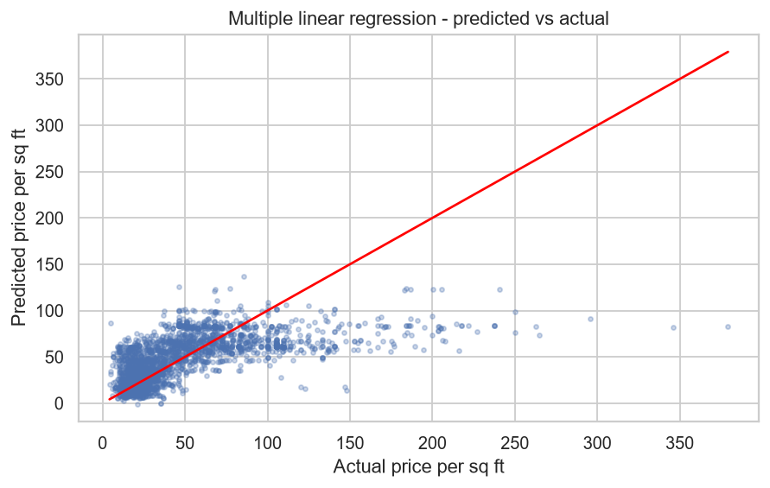
Sample Code: 18. Interpretations
print("INTERPRETATIONS")
print("-" * 62)
print("1. The assigned target, priceSqFt, is empty in every row of the")
print(" downloaded files, so it was derived as price / size_sqft.")
print("2. Size alone explains only", round(table.loc["Simple Linear", "R2 Score"], 4),
"of the variation. Rent per square")
print(" foot is mostly a question of WHERE the house is, not how big.")
print("3. Adding city, locality, furnishing and room counts more than")
print(" doubles R2 to", round(table.loc["Multiple Linear", "R2 Score"], 4),
"- location is doing most of that work.")
print("4. Degree-2 polynomial expands", X.shape[1], "features into",
poly.named_steps["polynomialfeatures"].n_output_features_, "but gains")
print(" almost nothing, so the relationship is close to linear already.")
print("5. Lasso and Ridge score the same as plain multiple regression.")
print(" With 11k training rows against", X.shape[1], "features there is no")
print(" overfitting for a penalty to fix.")
print("6. RMSE is around", round(table["RMSE"].min(), 1), "rupees per sq ft on a target whose")
print(" mean is", round(y.mean(), 1), "- the remaining error is the micro-location")
print(" detail lost when 702 localities were bucketed down to 30.")
Sample Output:
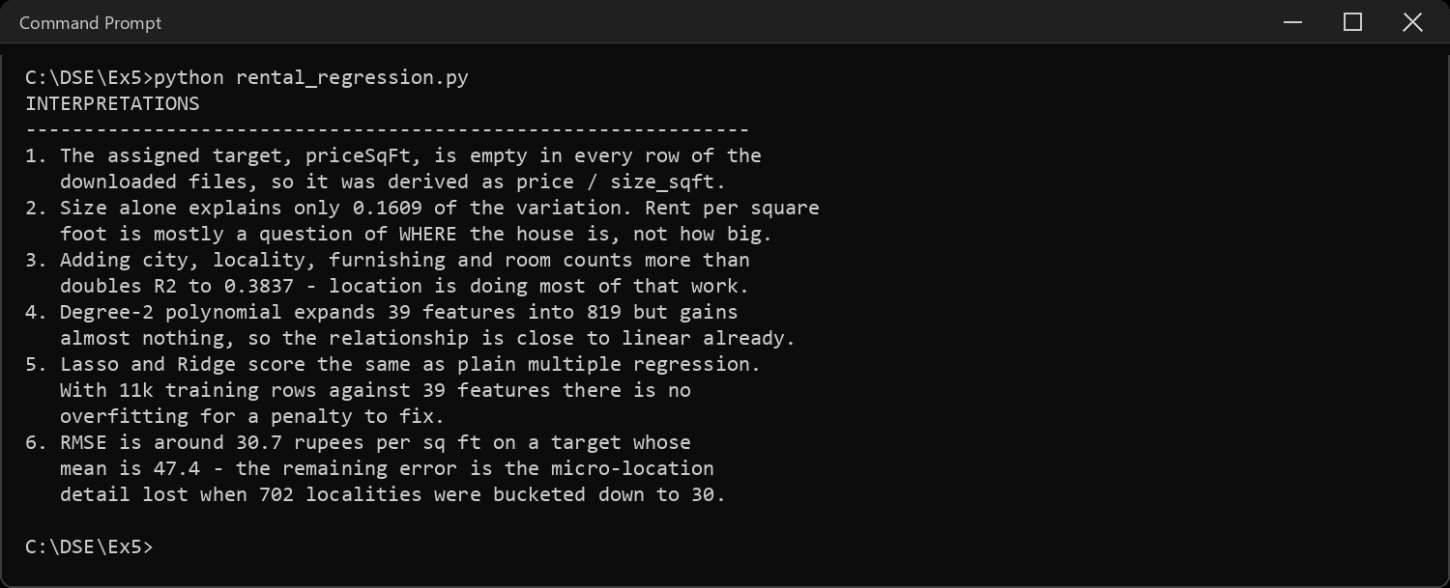
CODE EXPLANATION LINK:
(Youtube / Drive Link)
Preparation course certificate

RESULT
The exercise shown above has been successfully executed and the output has been verified.

