Ex. No. 6 | CLASSIFICATION TECHNIQUES
Date of Exercise | 11/09/2026

Aim
To build classification models in Python that predict a categorical label from a real-world dataset, and to compare KNN, decision trees, random forest, logistic regression and support vector machines using accuracy, the classification report and the confusion matrix.
Description (About Classification)
Classification predicts which class a record belongs to rather than a number. KNN stores the training set and labels a new point by majority vote of its nearest neighbours. A decision tree splits the data on one feature at a time until each leaf is close to pure. A random forest grows many trees on random subsets and lets them vote, which cancels out the quirks of any single tree. Logistic regression fits a linear boundary and reports a probability per class. A support vector machine looks for the boundary with the widest margin between classes. The results are judged by accuracy, by the classification report — precision, recall and F1 for each class — and by the confusion matrix, which shows exactly which classes are being mistaken for which.
Question:
Dataset: Music Genre Classification
(https://www.kaggle.com/datasets/purumalgi/music-genre-classification)
• Import the dataset.
• Display the first 10 rows of the dataset.
• Display the last 8 rows of the dataset.
• Display information about the dataset: information, column names, shape, statistical inferences, data types.
• Perform the following classification and measure the performance: KNN Classification, Decision Trees, Random Forest, Logistic Regression, Support Vector Machine.
• Display the classification report and confusion matrix for all the classifications.
• Draw a comparative table of accuracy for all the classification techniques.
• Document your interpretations on classification, overfitting and underfitting.
Sample Code: 1. Import the dataset
# train.csv from the kaggle download - the only file with labels
df = pd.read_csv("music_genre.csv")
print("Rows loaded:", len(df))
print(df[["Artist Name", "Track Name", "Popularity", "Class"]].head())
Sample Output:
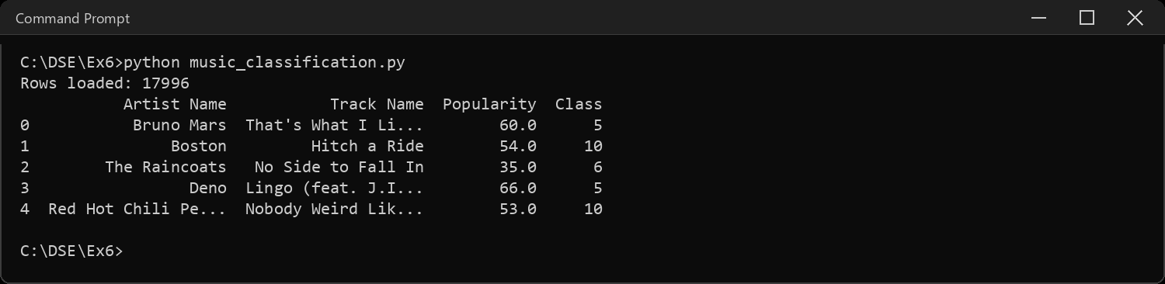
Sample Code: 2. Display the first 10 rows of the dataset
print(df.head(10))
Sample Output:
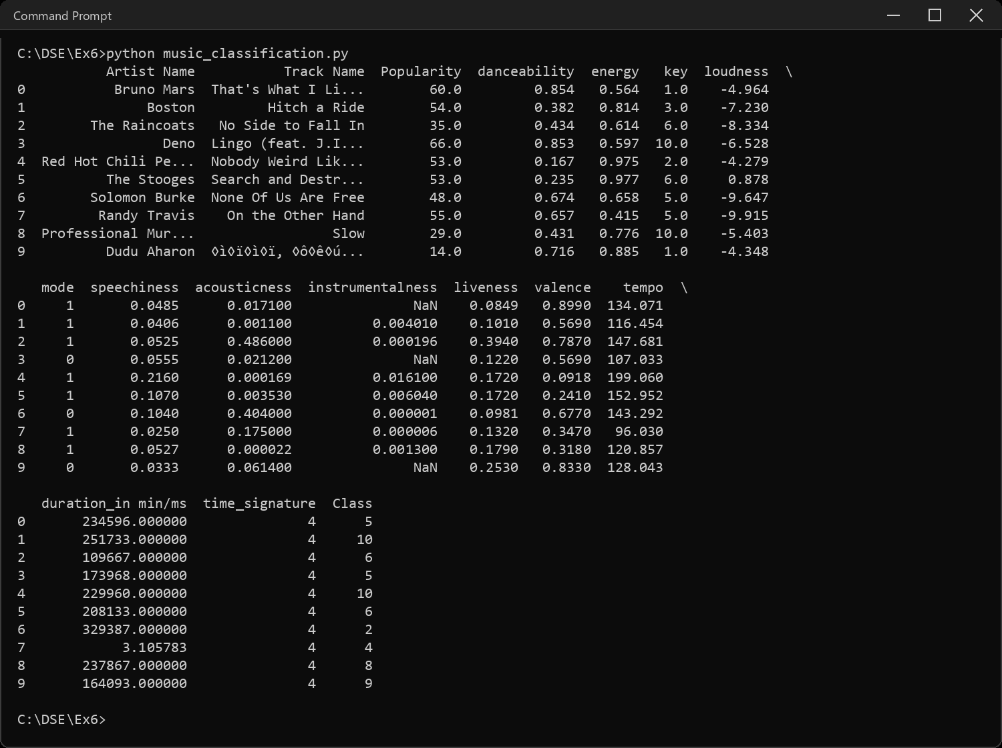
Sample Code: 3. Display the last 8 rows of the dataset
print(df.tail(8))
Sample Output:
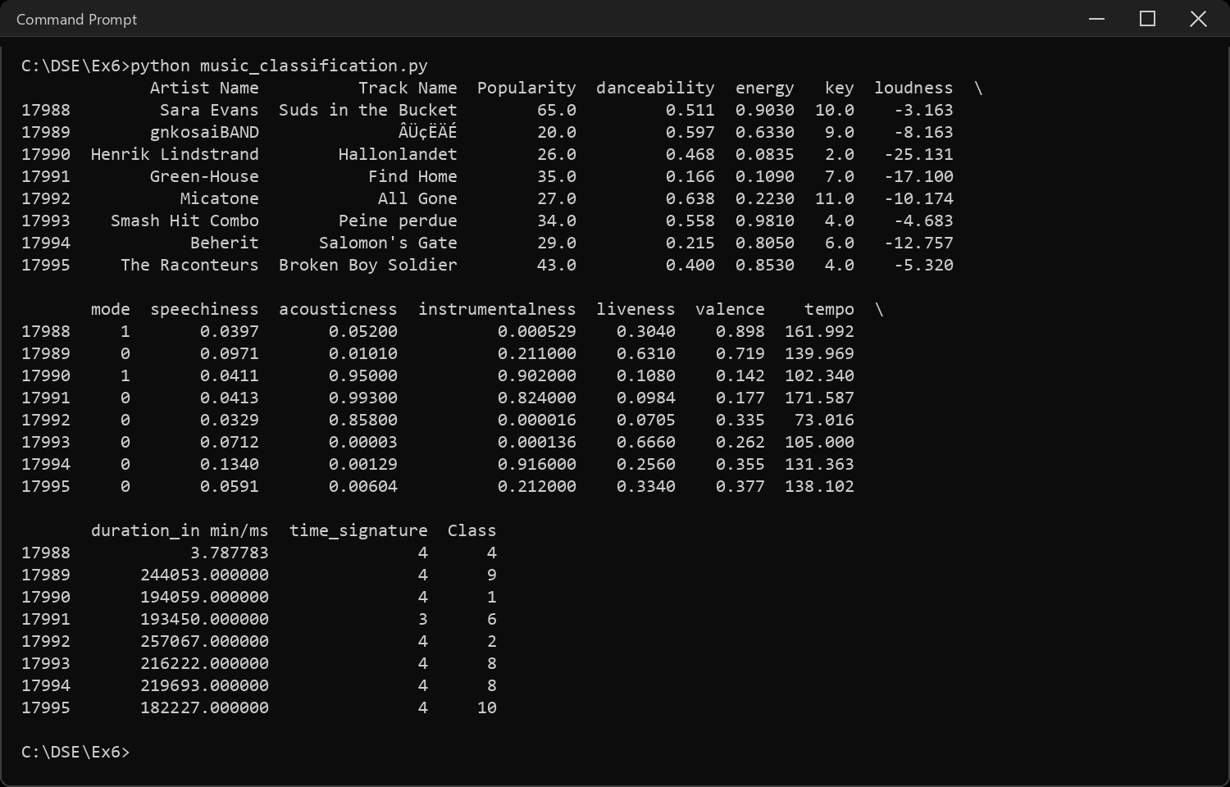
Sample Code: 4. Information about the dataset
df.info()
Sample Output:
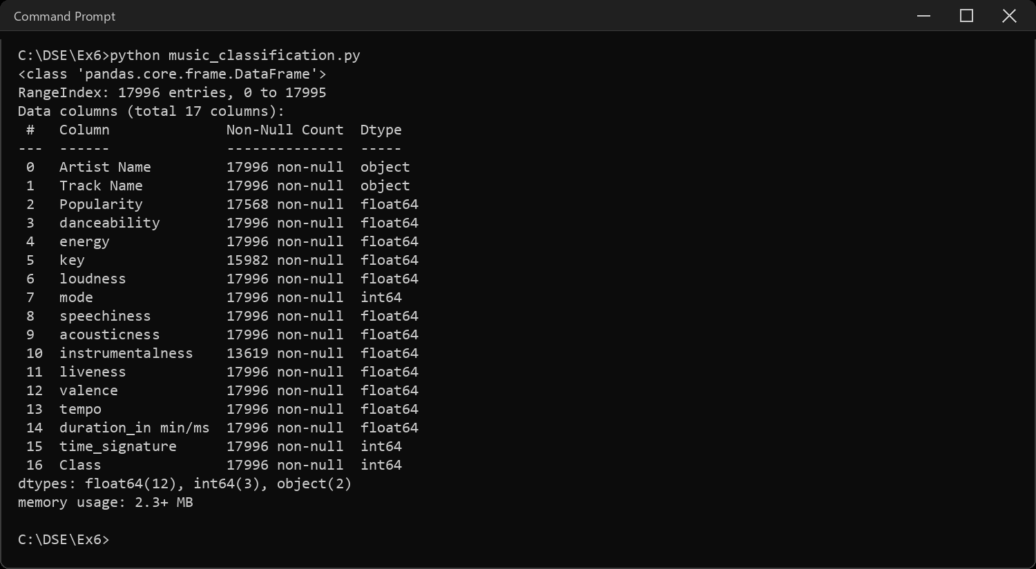
Sample Code: 5. Column names
print("Number of columns:", len(df.columns))
for i, col in enumerate(df.columns, 1):
print(i, col)
Sample Output:
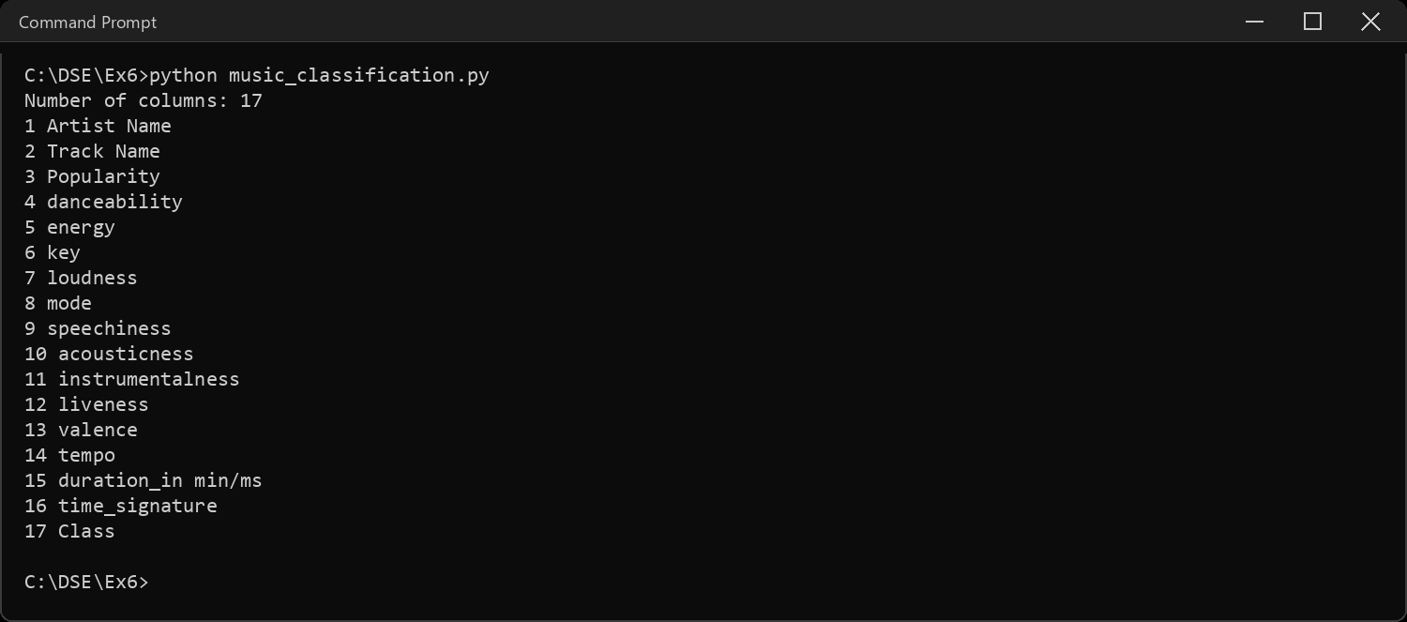
Sample Code: 6. Shape of the dataset and the class balance
print("Shape (rows, columns):", df.shape)
print("\nRows per class:")
print(df["Class"].value_counts().sort_index())
print("\nNumber of classes:", df["Class"].nunique())
print("Largest class share:", round(df["Class"].value_counts(normalize=True).max(), 4))
Sample Output:
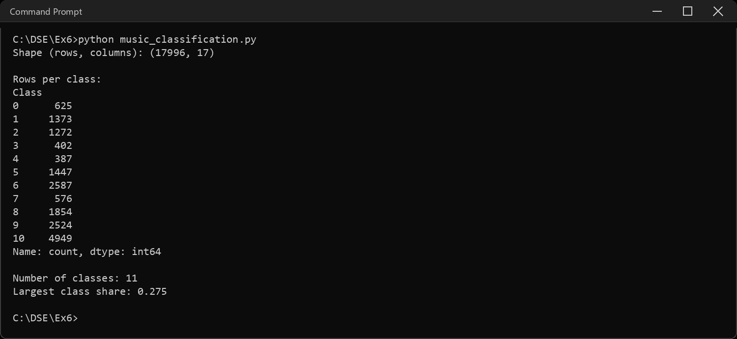
Sample Code: 7. Statistical inferences
print(df.describe())
Sample Output:
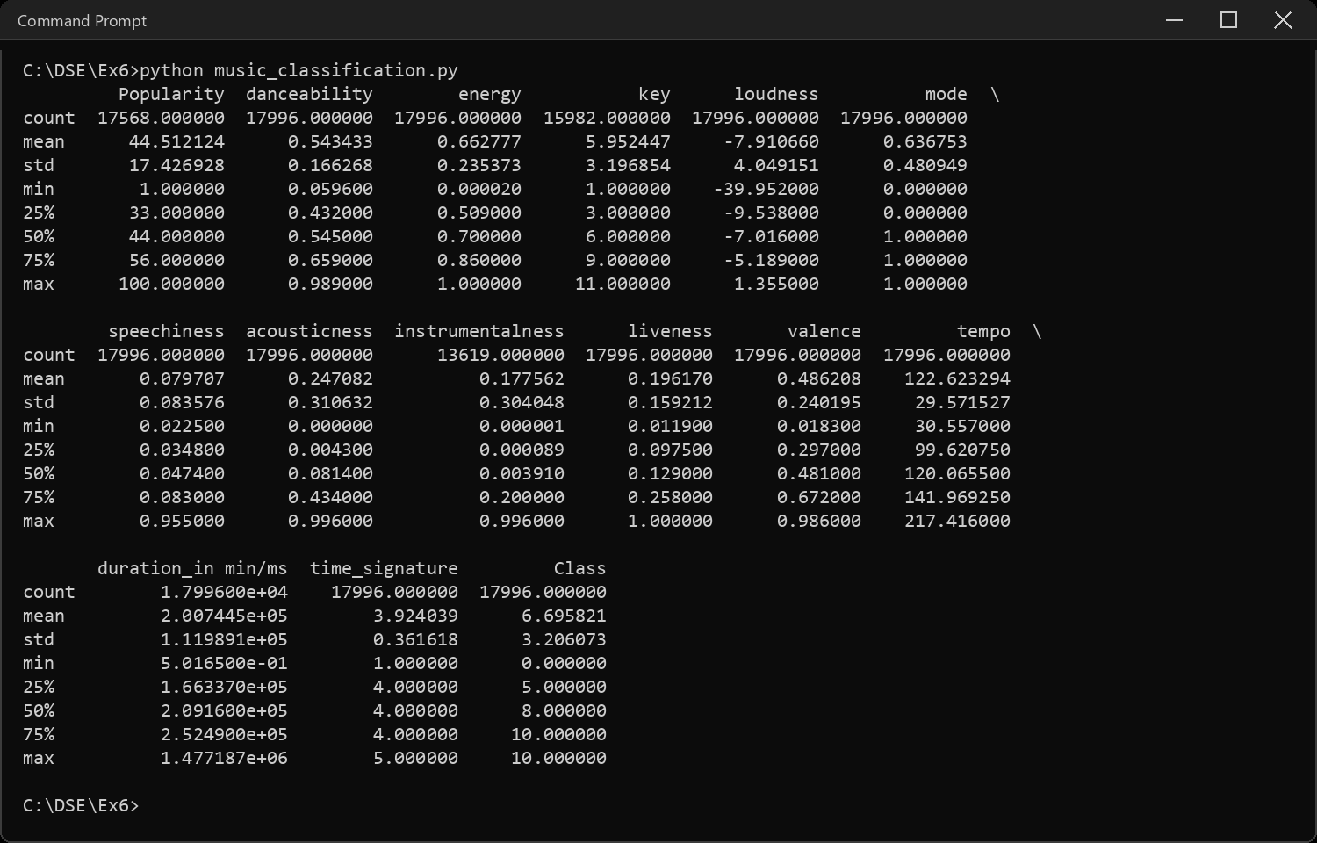
Sample Code: 8. Data types
print(df.dtypes)
print("\nMissing values per column:")
print(df.isnull().sum()[df.isnull().sum() > 0])
Sample Output:
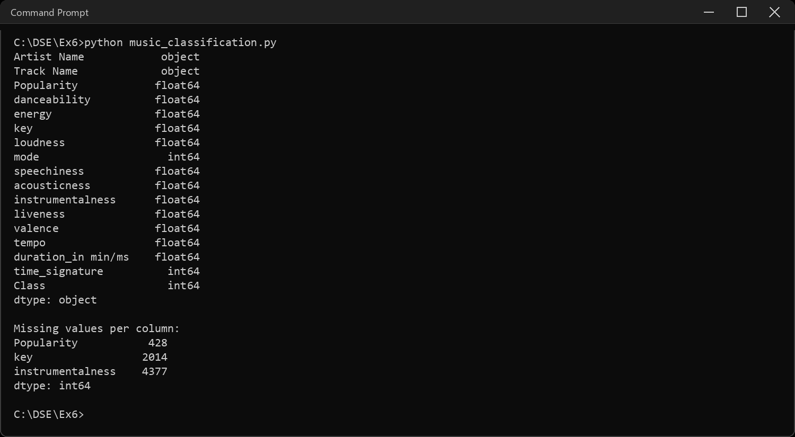
Sample Code: 9. Cleaning: the mixed-unit duration column
# "duration_in min/ms" is exactly what the name warns about - some rows are
# in minutes and some in milliseconds, in the same column
dur = df["duration_in min/ms"]
print("Rows that look like minutes (< 100):", (dur < 100).sum())
print("Rows that look like milliseconds :", (dur >= 100).sum())
# put everything on one scale - minutes
df["duration_min"] = np.where(dur < 100, dur, dur / 60000)
print("\nAfter conversion:")
print(df["duration_min"].describe())
Sample Output:
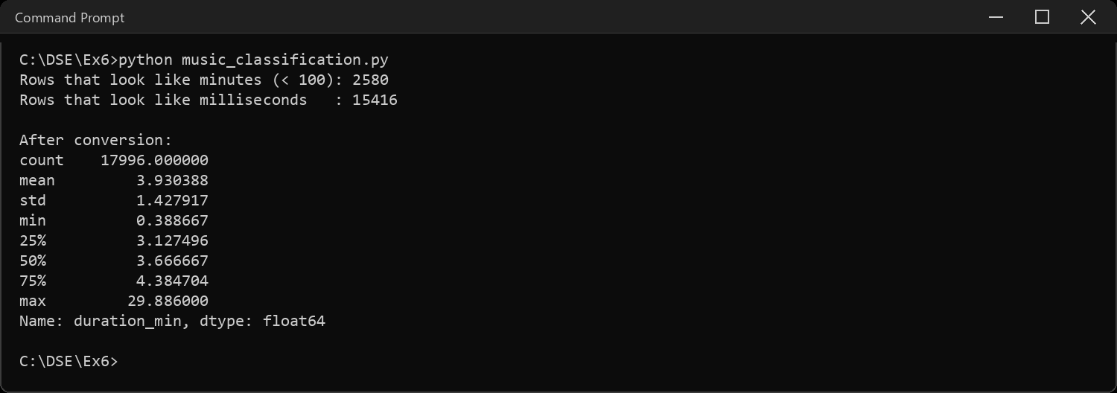
Sample Code: 10. Cleaning: imputing the missing values
# three columns have real gaps, so fill each with its own median
for col in ["Popularity", "key", "instrumentalness"]:
before = df[col].isnull().sum()
df[col] = df[col].fillna(df[col].median())
print(f"{col:<18} filled {before} missing values with the median")
print("\nMissing values left:", df.isnull().sum().sum())
Sample Output:
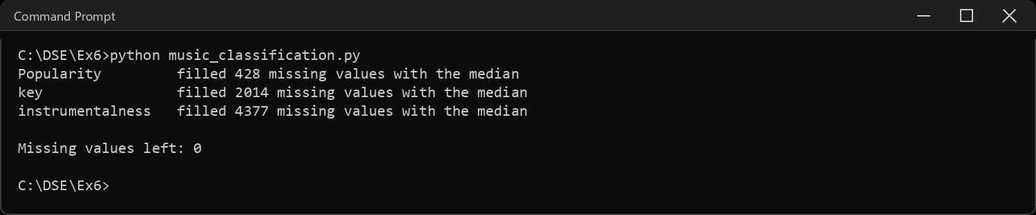
Sample Code: 11. Features, target and the train / test split
# artist and track name are free text and unique to almost every row, so
# they carry no pattern a classifier can generalise from
X = df.drop(columns=["Artist Name", "Track Name", "Class",
"duration_in min/ms", "duration_min"])
X["duration_min"] = df["duration_min"]
y = df["Class"]
# SVM is O(n^2) in the number of rows, so all five run on the same 5000-row
# sample - otherwise the comparison would not be like for like
idx = df.sample(n=5000, random_state=SEED).index
X, y = X.loc[idx], y.loc[idx]
# stratify keeps the class proportions identical in train and test
X_train, X_test, y_train, y_test = train_test_split(
X, y, test_size=0.2, random_state=SEED, stratify=y)
print("Features:", list(X.columns))
print("\nTraining rows:", len(X_train), " Test rows:", len(X_test))
Sample Output:
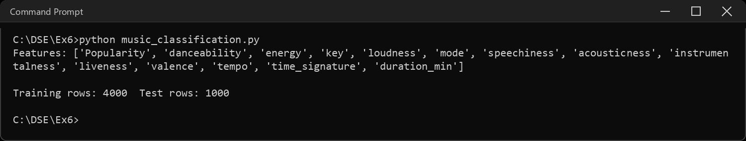
Sample Code: 12. KNN Classification
# KNN measures distance, so the features must be scaled first or
# tempo (values near 120) would drown out danceability (0 to 1)
knn = make_pipeline(StandardScaler(), KNeighborsClassifier(n_neighbors=5))
knn.fit(X_train, y_train)
pred = knn.predict(X_test)
train_acc = accuracy_score(y_train, knn.predict(X_train))
test_acc = accuracy_score(y_test, pred)
print("Training accuracy:", round(train_acc, 4))
print("Test accuracy :", round(test_acc, 4))
print("\nClassification report:")
print(classification_report(y_test, pred, zero_division=0))
print("Confusion matrix:")
print(confusion_matrix(y_test, pred))
results.append({"Technique": "KNN", "Train Accuracy": train_acc,
"Test Accuracy": test_acc})
sns.heatmap(confusion_matrix(y_test, pred), annot=True, fmt="d",
cmap="Blues", cbar=False)
plt.title("KNN - confusion matrix")
plt.xlabel("Predicted class")
plt.ylabel("Actual class")
plt.tight_layout()
plt.show()
Sample Output:
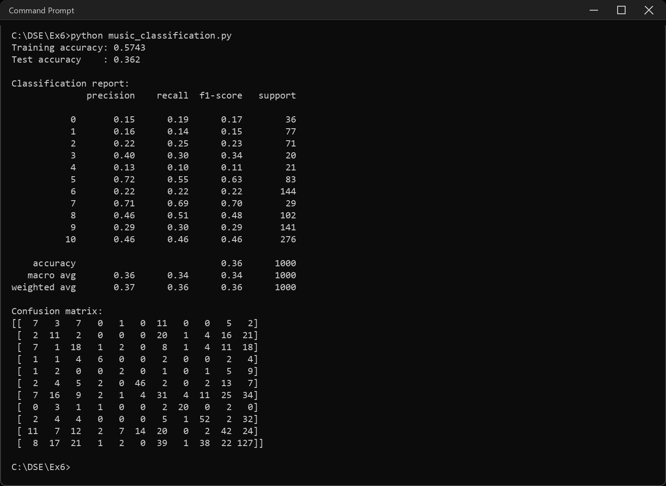
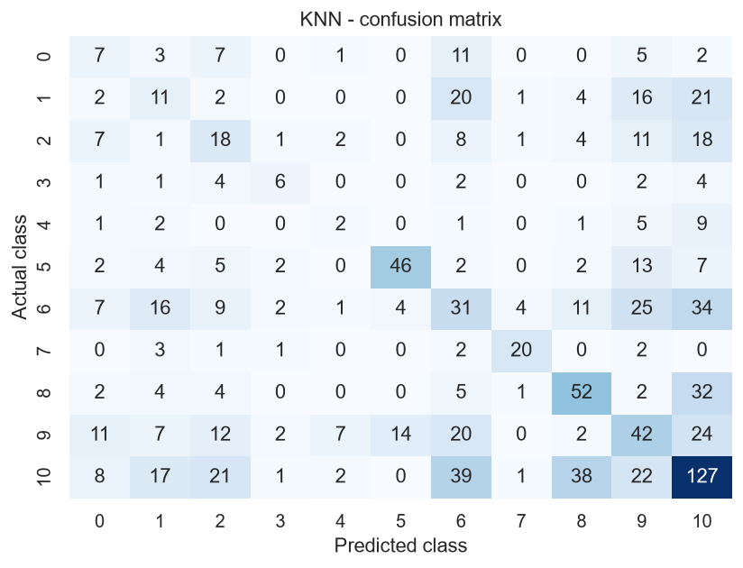
Sample Code: 13. Decision Tree
# a tree splits on thresholds, so scaling makes no difference to it.
# max_depth caps the growth - an unlimited tree memorises the training set
tree = DecisionTreeClassifier(max_depth=10, random_state=SEED)
tree.fit(X_train, y_train)
pred = tree.predict(X_test)
train_acc = accuracy_score(y_train, tree.predict(X_train))
test_acc = accuracy_score(y_test, pred)
print("Training accuracy:", round(train_acc, 4))
print("Test accuracy :", round(test_acc, 4))
print("\nClassification report:")
print(classification_report(y_test, pred, zero_division=0))
print("Confusion matrix:")
print(confusion_matrix(y_test, pred))
results.append({"Technique": "Decision Tree", "Train Accuracy": train_acc,
"Test Accuracy": test_acc})
sns.heatmap(confusion_matrix(y_test, pred), annot=True, fmt="d",
cmap="Blues", cbar=False)
plt.title("Decision Tree - confusion matrix")
plt.xlabel("Predicted class")
plt.ylabel("Actual class")
plt.tight_layout()
plt.show()
Sample Output:
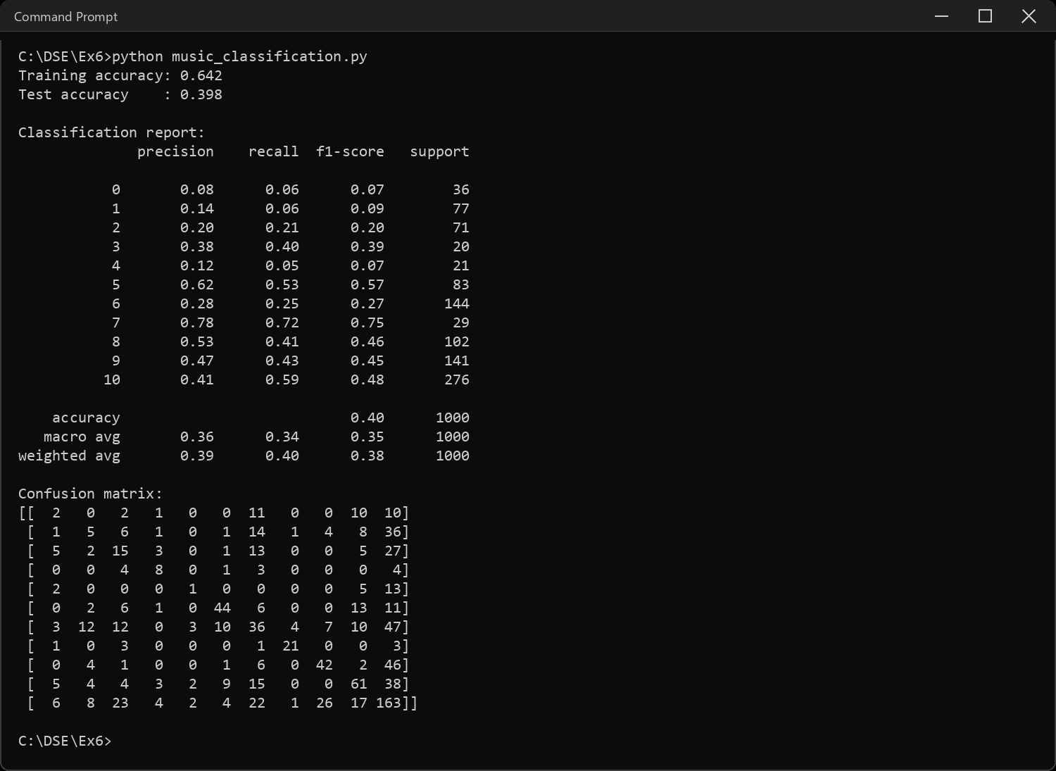
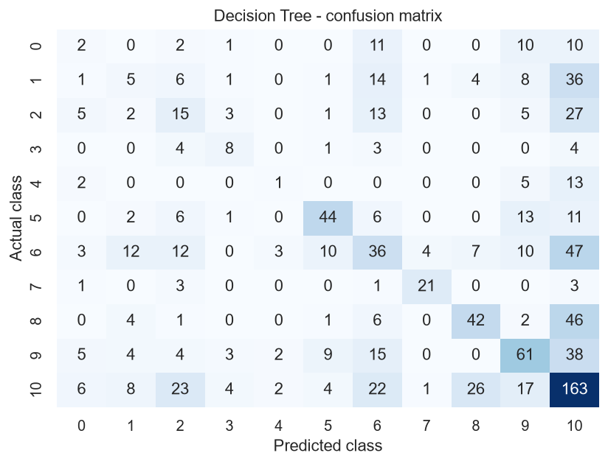
Sample Code: 14. Random Forest
# 200 trees, each on a random subset of rows and features, then a vote
forest = RandomForestClassifier(n_estimators=200, random_state=SEED)
forest.fit(X_train, y_train)
pred = forest.predict(X_test)
train_acc = accuracy_score(y_train, forest.predict(X_train))
test_acc = accuracy_score(y_test, pred)
print("Training accuracy:", round(train_acc, 4))
print("Test accuracy :", round(test_acc, 4))
print("\nClassification report:")
print(classification_report(y_test, pred, zero_division=0))
print("Confusion matrix:")
print(confusion_matrix(y_test, pred))
results.append({"Technique": "Random Forest", "Train Accuracy": train_acc,
"Test Accuracy": test_acc})
sns.heatmap(confusion_matrix(y_test, pred), annot=True, fmt="d",
cmap="Blues", cbar=False)
plt.title("Random Forest - confusion matrix")
plt.xlabel("Predicted class")
plt.ylabel("Actual class")
plt.tight_layout()
plt.show()
Sample Output:
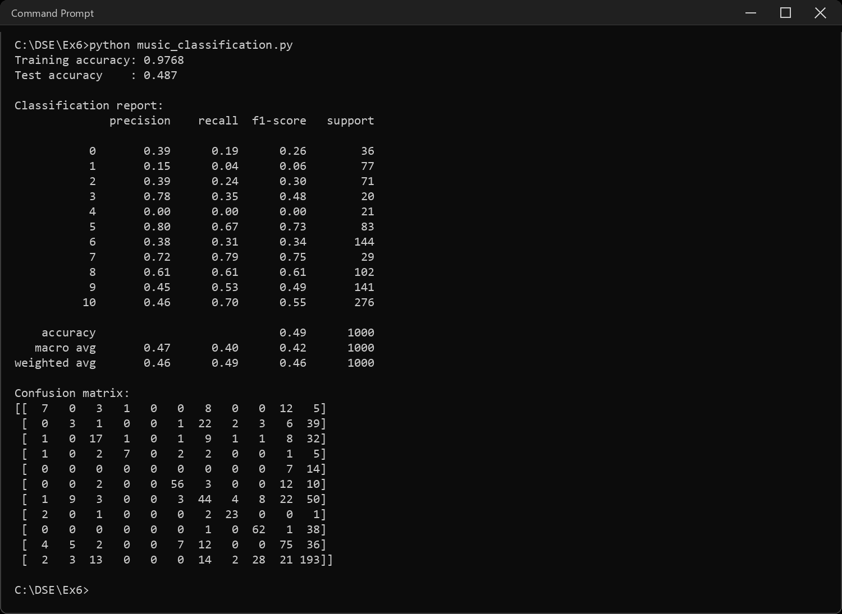
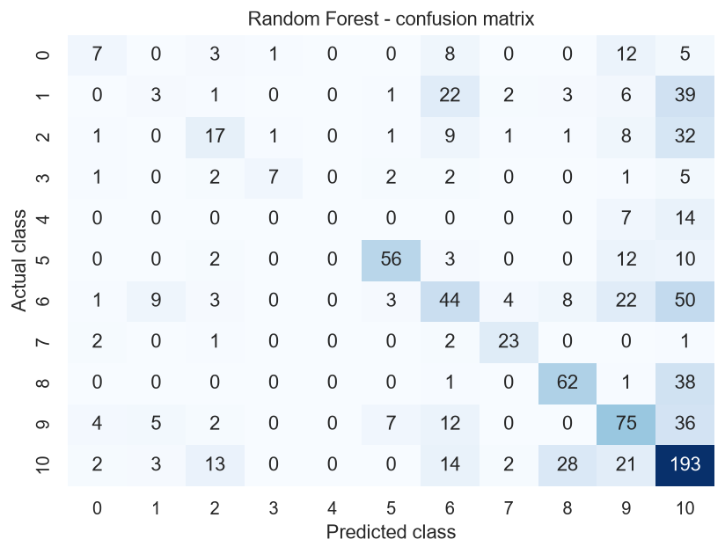
Sample Code: 15. Logistic Regression
# a linear boundary per class - the simplest model in the comparison
logreg = make_pipeline(StandardScaler(),
LogisticRegression(max_iter=2000, random_state=SEED))
logreg.fit(X_train, y_train)
pred = logreg.predict(X_test)
train_acc = accuracy_score(y_train, logreg.predict(X_train))
test_acc = accuracy_score(y_test, pred)
print("Training accuracy:", round(train_acc, 4))
print("Test accuracy :", round(test_acc, 4))
print("\nClassification report:")
print(classification_report(y_test, pred, zero_division=0))
print("Confusion matrix:")
print(confusion_matrix(y_test, pred))
results.append({"Technique": "Logistic Regression", "Train Accuracy": train_acc,
"Test Accuracy": test_acc})
sns.heatmap(confusion_matrix(y_test, pred), annot=True, fmt="d",
cmap="Blues", cbar=False)
plt.title("Logistic Regression - confusion matrix")
plt.xlabel("Predicted class")
plt.ylabel("Actual class")
plt.tight_layout()
plt.show()
Sample Output:
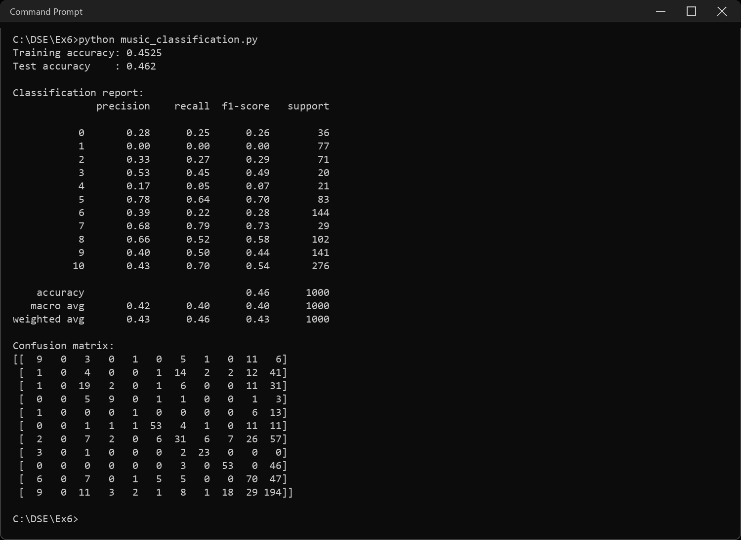
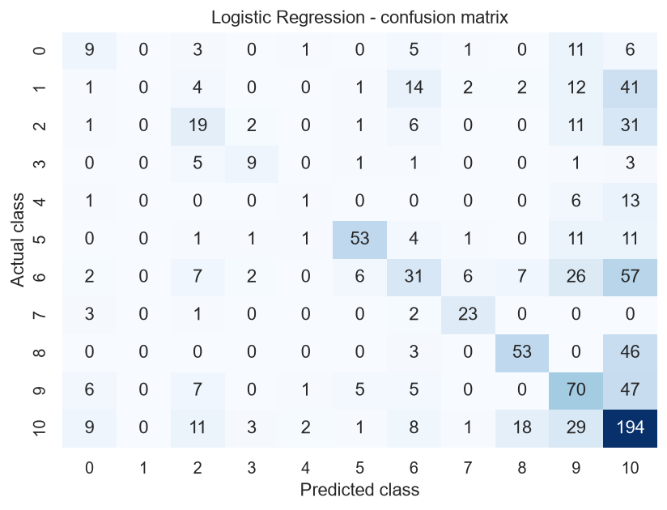
Sample Code: 16. Support Vector Machine
# rbf kernel, so the boundary can curve. distance based again, so scaled
svm = make_pipeline(StandardScaler(), SVC(kernel="rbf", random_state=SEED))
svm.fit(X_train, y_train)
pred = svm.predict(X_test)
train_acc = accuracy_score(y_train, svm.predict(X_train))
test_acc = accuracy_score(y_test, pred)
print("Training accuracy:", round(train_acc, 4))
print("Test accuracy :", round(test_acc, 4))
print("\nClassification report:")
print(classification_report(y_test, pred, zero_division=0))
print("Confusion matrix:")
print(confusion_matrix(y_test, pred))
results.append({"Technique": "SVM", "Train Accuracy": train_acc,
"Test Accuracy": test_acc})
sns.heatmap(confusion_matrix(y_test, pred), annot=True, fmt="d",
cmap="Blues", cbar=False)
plt.title("SVM - confusion matrix")
plt.xlabel("Predicted class")
plt.ylabel("Actual class")
plt.tight_layout()
plt.show()
Sample Output:
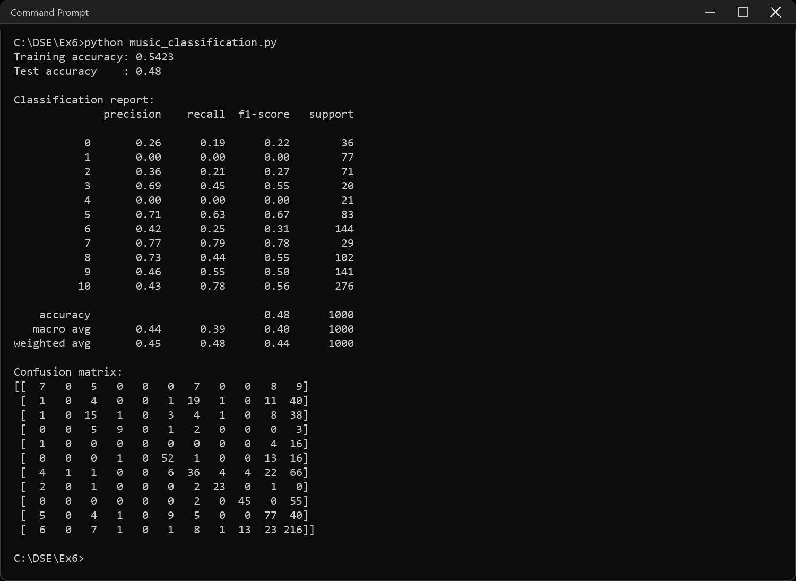
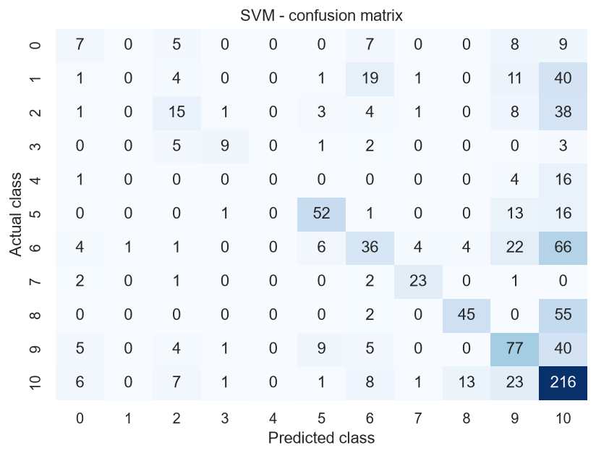
Sample Code: 17. Comparative table of accuracy
table = pd.DataFrame(results).set_index("Technique").round(4)
table["Gap (overfit)"] = (table["Train Accuracy"] - table["Test Accuracy"]).round(4)
print(table.to_string())
print("\nBest test accuracy:", table["Test Accuracy"].idxmax(),
"->", round(table["Test Accuracy"].max(), 4))
print("Widest train-test gap:", table["Gap (overfit)"].idxmax(),
"->", round(table["Gap (overfit)"].max(), 4))
table[["Train Accuracy", "Test Accuracy"]].plot(kind="bar", rot=20,
color=["#B0B0B0", "#4C72B0"])
plt.ylabel("Accuracy")
plt.title("Training vs test accuracy by classifier")
plt.tight_layout()
plt.show()
Sample Output:
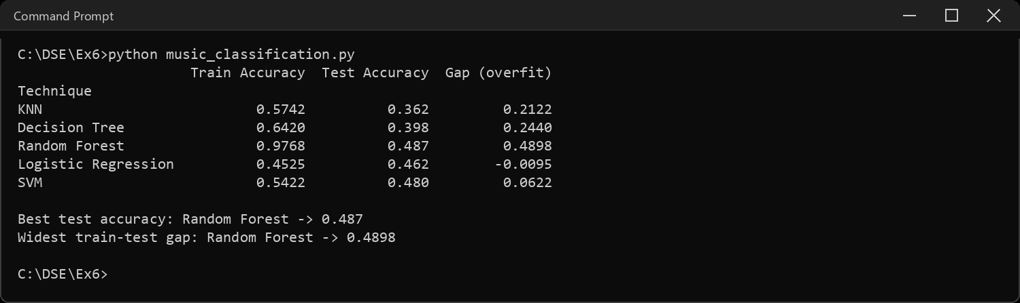
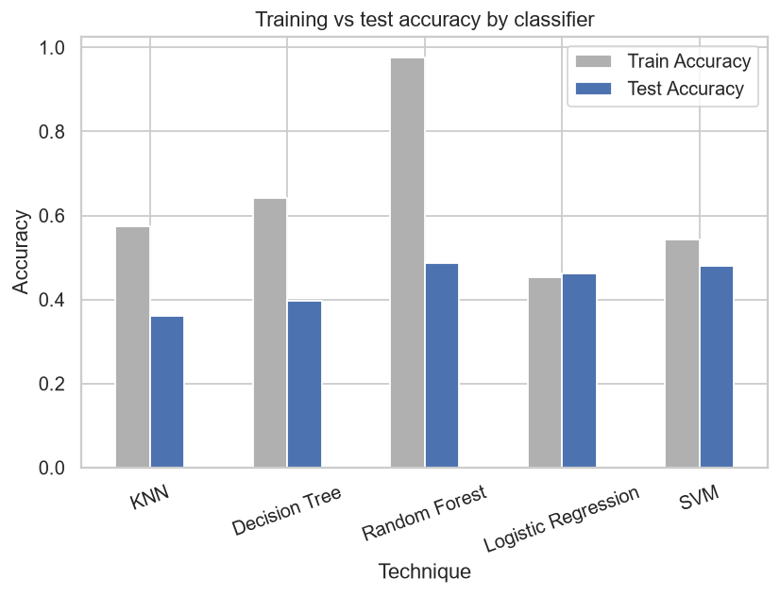
Sample Code: 18. Interpretations on classification, overfitting and underfitting
baseline = y_test.value_counts(normalize=True).max()
print("INTERPRETATIONS")
print("-" * 64)
print("1. This is an 11-class problem and the classes are not balanced.")
print(" Always guessing the largest class would already score",
round(baseline, 4), "-")
print(" that is the number every classifier here has to beat.")
print("2. Best test accuracy:", table["Test Accuracy"].idxmax(), "at",
round(table["Test Accuracy"].max(), 4), "- roughly double the")
print(" baseline, so the audio features do carry real genre signal.")
print("3. OVERFITTING - Random Forest scores",
round(table.loc["Random Forest", "Train Accuracy"], 4), "on training data")
print(" and", round(table.loc["Random Forest", "Test Accuracy"], 4),
"on unseen data, a gap of",
round(table.loc["Random Forest", "Gap (overfit)"], 4))
print(" Fully grown trees memorise every training row, so the forest")
print(" knows the training set far better than it knows music.")
print("4. UNDERFITTING - Logistic Regression scores",
round(table.loc["Logistic Regression", "Train Accuracy"], 4), "on training")
print(" data and", round(table.loc["Logistic Regression", "Test Accuracy"], 4),
"on test - no better on rows it has already seen.")
print(" It is not memorising anything, it simply cannot fit the data:")
print(" one straight boundary per class is too rigid for 11 genres")
print(" that overlap.")
print("5. The healthy middle is the small gap, not the high training score.")
print(" SVM sits closest to it and generalises about as well as the")
print(" forest while learning far less of the noise.")
print("6. The confusion matrices show the errors are not spread evenly -")
print(" the large classes absorb predictions from the small ones, which")
print(" is exactly what imbalance does to a classifier.")
Sample Output:
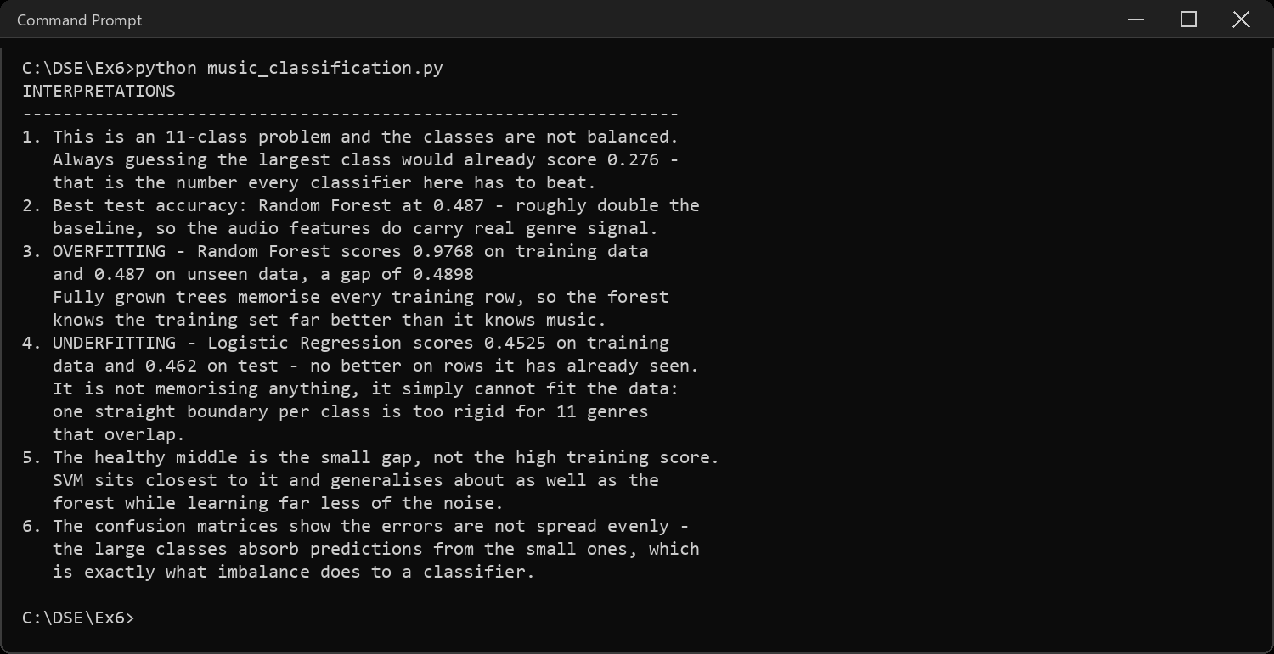
CODE EXPLANATION LINK:
(Youtube / Drive Link)
Preparation course certificate

RESULT
The exercise shown above has been successfully executed and the output has been verified.

