Ex. No. 3 | Responsive Website using HTML5 and CSS3
Date of Exercise | 17/08/2026
GitHub Host Link | https://kukyos.github.io/WebTechLab/Ex3/index.html

Aim
To design and implement a responsive website using HTML5 and CSS3, so that the same page adapts its layout across desktop, tablet and mobile screen sizes, applied to the online gaming community theme.
Description
Responsiveness here comes from CSS3 Flexbox and media queries, not separate pages for each device. The nav bar and the card grid both use display:flex so they can reflow instead of overflowing. The sidebar-plus-content section uses a flex container with each side sized in percentages, and every image uses max-width:100% so it never grows past its container. Three @media screen and (max-width: ...) blocks then override those percentage widths and flex directions at three breakpoints: 992px (tablet, sidebar and content stack full-width), 768px (mobile, the nav links and the game cards switch to a single column) and 480px (small mobile, heading font sizes shrink and buttons go full-width). A <meta name="viewport" content="width=device-width, initial-scale=1.0"> tag is required for any of this to take effect on an actual phone, since without it mobile browsers render at a fake desktop-sized viewport and zoom out instead of reflowing.
Procedure:
1. Reused the Ex1/Ex2 Respawn Point site and its orange-and-green color variables, this time moving every color and layout rule out of inline style attributes and into a single internal <style> block so media queries would actually have something to override.
2. Added the viewport meta tag, without which the responsive rules would be ignored on a real phone.
3. Restructured the page into <header>, <nav>, a <section class="hero">, and a .container holding a .sidebar (community roles) and .content (about, games, roles detail, join, rules, contact), followed by <footer> -- the same section content as Ex1, laid out with Flexbox instead of stacked <div>s.
4. Turned the featured-games table into a flex .cards grid, one card per game with a name, a short stat line and a button, so there would be a grid that visibly reflows at each breakpoint.
5. Wrote the tablet breakpoint (max-width: 992px): the sidebar+content flex row switches to flex-direction:column and both go to 100% width.
6. Wrote the mobile breakpoint (max-width: 768px): the nav list and the card grid switch to flex-direction:column so links and cards stack.
7. Wrote the small-mobile breakpoint (max-width: 480px): heading font sizes shrink and buttons stretch to full width for easier tapping.
8. Tested the page at three widths using the browser (desktop, tablet, mobile) and confirmed the nav, sidebar/content and card grid actually reflow at each one before taking the output screenshots.
Program

<!DOCTYPE html>
<html lang="en">
<head>
<meta charset="UTF-8">
<meta name="viewport" content="width=device-width, initial-scale=1.0">
<title>Respawn Point - Online Gaming Community</title>
<style>
* {
margin: 0;
padding: 0;
box-sizing: border-box;
}
body {
font-family: Arial, sans-serif;
background: #1c1b18;
color: #eae6df;
line-height: 1.6;
}
/* Header */
header {
background: #242220;
padding: 20px;
text-align: center;
}
header h1 { color: #e8792c; }
header p { color: #b7b1a4; }
/* Navigation */
nav { background: #151412; }
nav ul {
display: flex;
justify-content: center;
list-style: none;
flex-wrap: wrap;
}
nav li { padding: 15px; }
nav a { color: #eae6df; text-decoration: none; }
nav li:hover { background: #e8792c; }
nav li:hover a { color: #1c1b18; }
/* Hero */
.hero {
background: #242220;
padding: 50px;
text-align: center;
}
.hero h2 { color: #e8792c; }
.hero p { color: #b7b1a4; margin-top: 10px; }
.banner-link img {
display: block;
max-width: 100%;
height: auto;
margin: 0 auto;
}
/* Main container: sidebar + content, side by side until it doesn't fit */
.container {
display: flex;
padding: 20px;
gap: 20px;
}
.sidebar {
width: 25%;
background: #242220;
padding: 20px;
border-radius: 10px;
height: fit-content;
}
.sidebar h3 { color: #f3a15c; }
.sidebar ul { list-style: none; margin-top: 10px; }
.sidebar li {
padding: 10px;
border-bottom: 1px solid #3a372f;
color: #7fae5a;
}
.content { width: 75%; }
.content h2 { color: #f3a15c; margin-bottom: 10px; }
.content h3 { color: #7fae5a; margin-top: 15px; }
.content section { margin-bottom: 30px; }
table { width: 100%; border-collapse: collapse; margin-top: 10px; }
th, td { border: 1px solid #3a372f; padding: 8px; text-align: left; }
th { background: #242220; color: #e8792c; }
/* Cards */
.cards {
display: flex;
gap: 20px;
margin-top: 20px;
flex-wrap: wrap;
}
.card {
flex: 1;
min-width: 200px;
background: #242220;
padding: 20px;
border-radius: 10px;
text-align: center;
border-top: 3px solid #e8792c;
}
.card h3 { color: #e8792c; margin-top: 0; }
.card p { color: #b7b1a4; margin: 8px 0; }
button {
background: #e8792c;
color: #1c1b18;
padding: 10px 20px;
border: none;
border-radius: 4px;
margin-top: 10px;
font-weight: bold;
cursor: pointer;
}
button:hover { background: #f3a15c; }
/* Footer */
footer {
background: #242220;
color: #b7b1a4;
padding: 20px;
text-align: center;
margin-top: 20px;
}
footer a { color: #e8792c; }
/* Tablet */
@media screen and (max-width: 992px) {
.container { flex-direction: column; }
.sidebar, .content { width: 100%; }
.card { min-width: 45%; }
}
/* Mobile */
@media screen and (max-width: 768px) {
nav ul { flex-direction: column; align-items: center; }
.cards { flex-direction: column; }
.card { width: 100%; }
.hero { padding: 30px; }
}
/* Small mobile */
@media screen and (max-width: 480px) {
header h1 { font-size: 24px; }
.hero h2 { font-size: 22px; }
button { width: 100%; }
}
</style>
</head>
<body>
<header>
<h1>Respawn Point</h1>
<p>a place to find your next squad, not just your next game</p>
</header>
<nav>
<ul>
<li><a href="#about">About</a></li>
<li><a href="#games">Games</a></li>
<li><a href="#roles">Roles</a></li>
<li><a href="#join">Join</a></li>
<li><a href="#rules">Rules</a></li>
<li><a href="#contact">Contact</a></li>
</ul>
</nav>
<section class="hero">
<h2>Squad Up, Respawn Together</h2>
<p>This page now resizes itself for phones, tablets and desktops -- try shrinking the window and watch the layout fold.</p>
</section>
<a class="banner-link" href="#games">
<img src="banner.png" alt="Respawn Point community banner artwork">
</a>
<div class="container">
<div class="sidebar">
<h3>Community Roles</h3>
<ul>
<li>Member</li>
<li>Moderator</li>
<li>Admin</li>
</ul>
</div>
<div class="content">
<section id="about">
<h2>About the Community</h2>
<p>
Respawn Point started in 2023 as a small Discord server for a few of us
who kept getting split into different lobbies. It has grown into a
community of a few thousand people across battle royale, racing, MMORPG
and FPS games who mostly just want to play with people who won't rage
quit on them.
</p>
<h3>Why we exist</h3>
<p>
Public matchmaking is fine until your teammate disconnects at the worst
possible moment. We're here so that doesn't have to happen every single
match.
</p>
</section>
<section id="games">
<h2>Featured Games</h2>
<div class="cards">
<div class="card">
<h3>Nightfall Arena</h3>
<p>Battle Royale &middot; 1,204 online &middot; Bronze - Diamond</p>
<button>Find a Squad</button>
</div>
<div class="card">
<h3>Circuit Breakers</h3>
<p>Racing &middot; 386 online &middot; Open to all</p>
<button>Find a Squad</button>
</div>
<div class="card">
<h3>Warden's Keep</h3>
<p>MMORPG &middot; 2,891 online &middot; Level 5+</p>
<button>Find a Squad</button>
</div>
<div class="card">
<h3>Clutch City</h3>
<p>FPS &middot; 977 online &middot; Silver and up</p>
<button>Find a Squad</button>
</div>
</div>
</section>
<section id="roles">
<h2>Community Roles</h2>
<dl>
<dt><b style="color: #7fae5a">Member</b></dt>
<dd>Default role once you join. Access to general chat and the game-specific channels.</dd>
<dt><b style="color: #7fae5a">Moderator</b></dt>
<dd>Keeps the chat civil, handles reports, can mute or kick when needed.</dd>
<dt><b style="color: #7fae5a">Admin</b></dt>
<dd>Runs events, manages roles, and is who you complain to about the ping tax on Warden's Keep servers.</dd>
</dl>
</section>
<section id="join">
<h2>How to Join</h2>
<ol>
<li>Read the rules pinned in #welcome</li>
<li>Pick your main game(s):
<ol type="a">
<li>Battle royale squad</li>
<li>Racing crew</li>
<li>MMORPG guild</li>
</ol>
</li>
<li>Introduce yourself in #introductions</li>
<li>Grab your game roles from the reaction board</li>
</ol>
</section>
<section id="rules">
<h2>Ground Rules</h2>
<ul>
<li>Be respectful, no harassment or hate speech
<ul>
<li>this includes chat, voice channels and in-game lobbies</li>
</ul>
</li>
<li>No spamming or unsolicited DMs</li>
<li>Keep NSFW content out of every channel</li>
<li>Follow game-specific etiquette:
<ul>
<li>no griefing teammates</li>
<li>no smurfing in ranked lobbies</li>
</ul>
</li>
</ul>
</section>
<section id="contact">
<h2>Get In Touch</h2>
<p>Email: <a href="mailto:hello@respawnpoint.gg" style="color: #7fae5a">hello@respawnpoint.gg</a></p>
<p>Call the community desk: <a href="tel:+919876543210" style="color: #7fae5a">+91 98765 43210</a></p>
<p>
New to competitive gaming? Wikipedia has a solid
<a href="https://en.wikipedia.org/wiki/Esports" target="_blank" style="color: #7fae5a">overview of esports</a>
to get you started.
</p>
<p><a href="../Ex2/index.html" style="color: #7fae5a">Registration form (Ex2)</a></p>
</section>
</div>
</div>
<footer>
<p><small>&copy; 2026 Respawn Point. Made for URK24CS1021's Web Tech lab, not an actual gaming company.</small></p>
</footer>
</body>
</html>
Output

Desktop width (1200px): sidebar and content side by side, four-card row
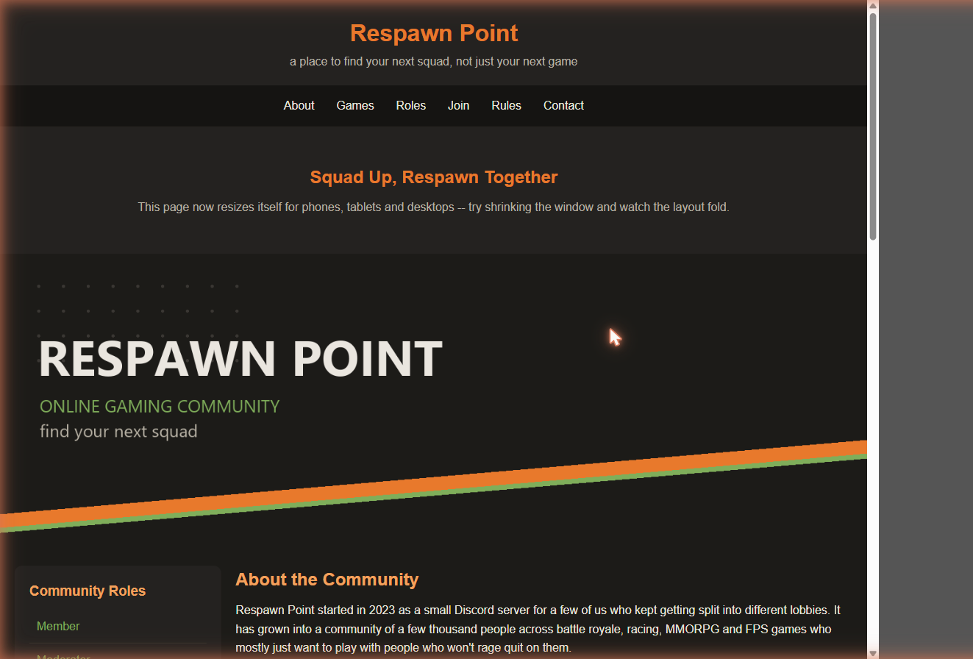
Tablet breakpoint (900px, <=992px): sidebar stacks full-width above content
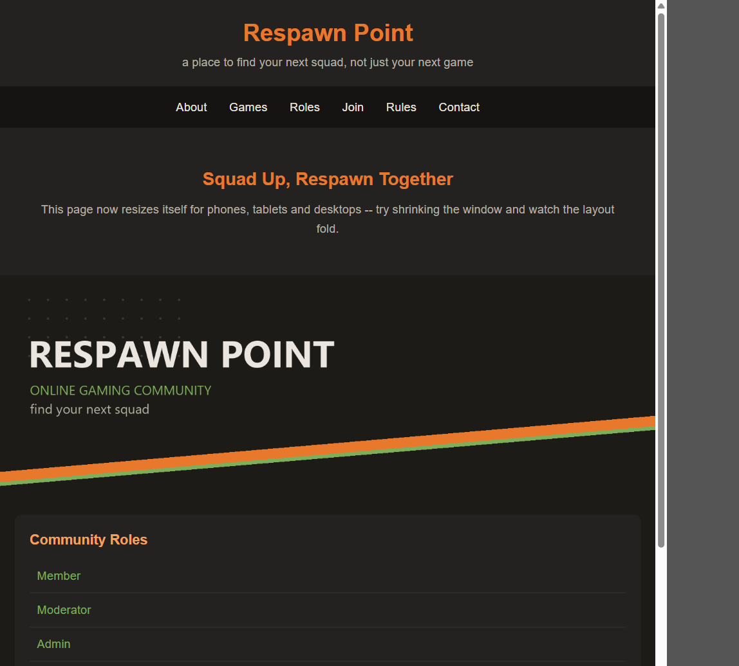
Mobile breakpoint (400px, <=768px): nav links stack into a single column
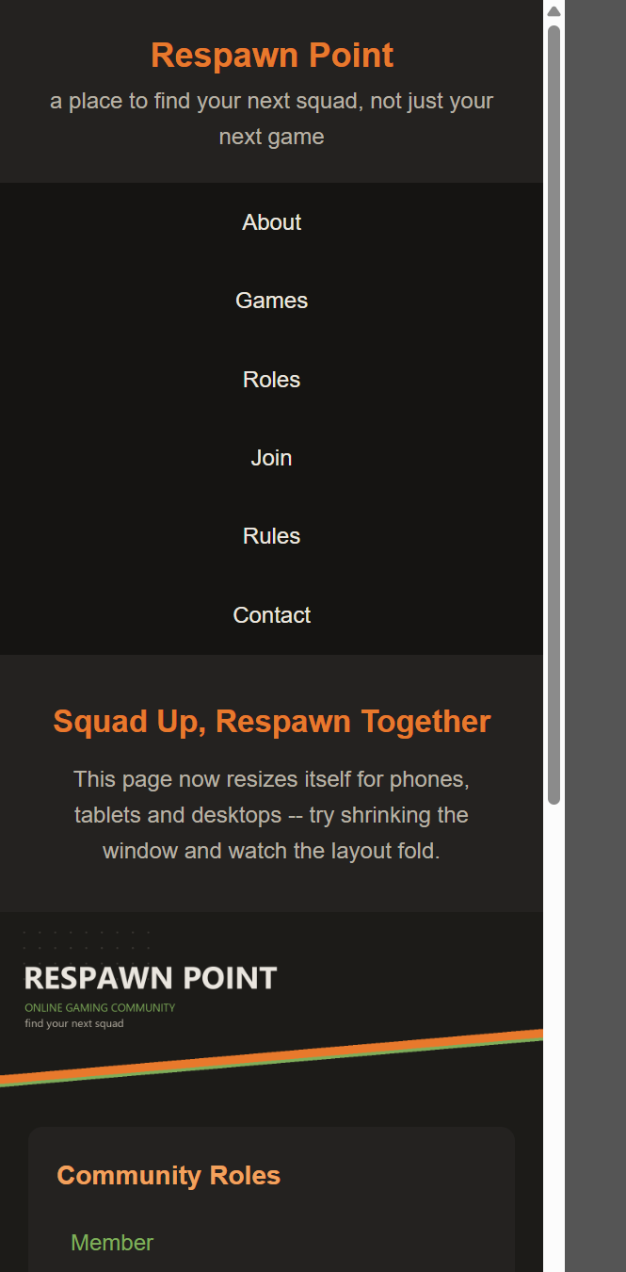
Mobile breakpoint (400px): game cards stack full-width, one per row
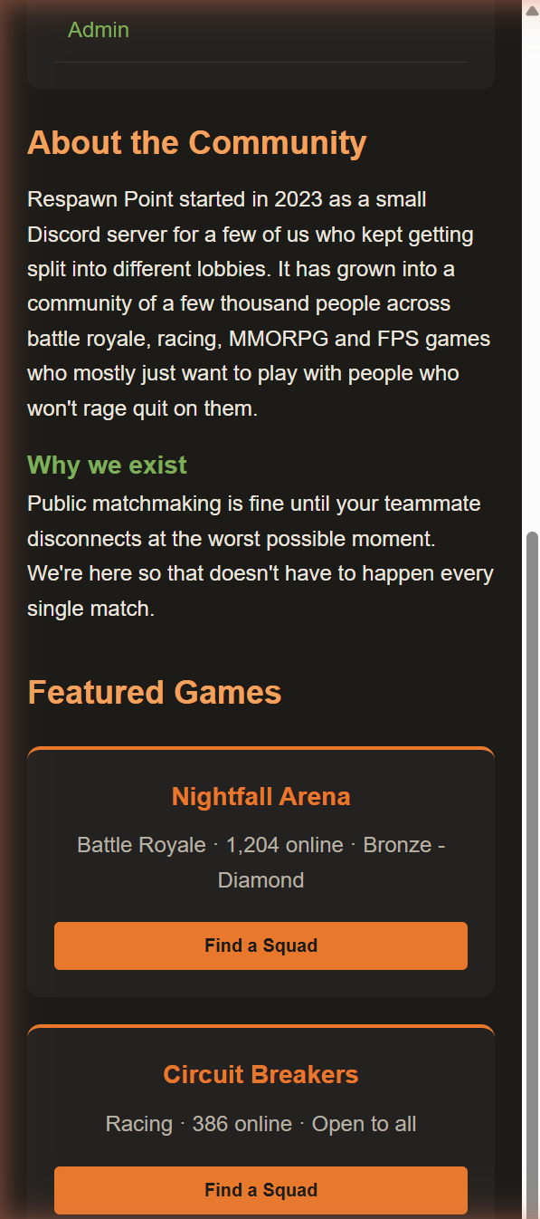
Result
The responsive website was successfully designed and implemented using HTML5 and CSS3 Flexbox with media queries. The layout adapted correctly across desktop, tablet and mobile screen widths, matching the expected output.

