Ex. No. 4 | Webpage Design Using Advanced CSS3
Date of Exercise | 24/08/2026
GitHub Host Link | https://kukyos.github.io/WebTechLab/Ex4/index.html

Aim
To design a webpage that demonstrates advanced CSS3 styling and selector features -- rounded corners, border images, multiple backgrounds, background sizing, pseudo-classes, the adjacent sibling selector and nth-child() -- applied to the online gaming community theme.
Description
Seven CSS3 features are demonstrated as one page, each in its own themed section. border-radius rounds the corner of four rank badges, from a single value up to four independent corners and a 50% circle. border-image replaces a plain border with a sliced, repeated PNG frame on a notice board. Two comma-separated background-image layers stack a crest emblem (no-repeat, bottom right) over a repeating stripe pattern on a guild banner. The same banner image is shown twice at a fixed box size with background-size: cover and contain, to compare cropping against letterboxing. A quick-join form uses :focus, :required and input[type=email]:valid/:invalid to react live to what is typed. The adjacent sibling combinator (.item-name:hover + .item-img) fades a loadout icon in only when the item name right before it is hovered. Finally tr:nth-child(odd/even) stripes a leaderboard table and a plain :hover rule highlights whichever row the cursor is over.
Procedure:
1. Generated the local image assets needed for the demo with PIL (generate_assets.py): a border-image frame tile, a crest emblem and a stripe-pattern tile for the layered background, and three small item icons -- no images were pulled from the network.
2. Built the Rank Badges section: four badges with border-radius set to one value, a different single value, four separate corner values, and 50% to make a circle.
3. Built the Event Notice Board section: a transparent-bordered box styled with border-image: url(border_deco.png) 20 round.
4. Built the Guild Banner section: background-image given two comma-separated url()s, with background-position and background-repeat also given one value per layer so the emblem sits still while the pattern behind it tiles.
5. Built the Banner Preview section: the same banner.png shown in two identically sized boxes, one with background-size: cover and one with contain, to compare how each handles an image that doesn't match the box's aspect ratio.
6. Built the Quick Join form: text and email inputs styled with :focus (active field), :required (mandatory field) and input[type=email]:valid / :invalid (live email-format feedback), checking the cascade order so :focus visibly wins over :required when a field is both.
7. Built the Loadout section: an item name next to an icon image, with .item-img given opacity 0.2 and .item-name:hover + .item-img given opacity 1 plus a transition, so hovering the name reveals the icon beside it.
8. Built the Server Leaderboard table: tr:nth-child(odd) and tr:nth-child(even) given different background colors to stripe the rows, plus a tr:hover rule on top for the highlight.
9. Served the page locally and tested every feature for real in the browser -- typed into the join form to see :focus/:invalid react, hovered a loadout item and a leaderboard row -- before taking the output screenshots.
Program

<!DOCTYPE html>
<html lang="en">
<head>
<meta charset="UTF-8">
<meta name="viewport" content="width=device-width, initial-scale=1.0">
<title>Respawn Point - Interface Lab</title>
<style>
* {
margin: 0;
padding: 0;
box-sizing: border-box;
}
body {
font-family: Arial, sans-serif;
background: #1c1b18;
color: #eae6df;
line-height: 1.6;
}
header {
background: #242220;
padding: 20px;
text-align: center;
}
header h1 { color: #e8792c; }
header p { color: #b7b1a4; }
nav { background: #151412; }
nav ul {
display: flex;
justify-content: center;
list-style: none;
flex-wrap: wrap;
}
nav li { padding: 15px; }
nav a { color: #eae6df; text-decoration: none; }
nav li:hover { background: #e8792c; }
nav li:hover a { color: #1c1b18; }
main { max-width: 900px; margin: 0 auto; padding: 20px; }
section { margin-bottom: 40px; }
section h2 { color: #f3a15c; margin-bottom: 6px; }
section > p.blurb { color: #b7b1a4; margin-bottom: 16px; }
/* 1. Rounded corners -- rank badges, one value vs four values */
.badges { display: flex; gap: 16px; flex-wrap: wrap; }
.badge {
background: #242220;
border: 2px solid #7fae5a;
padding: 14px 20px;
text-align: center;
min-width: 110px;
}
.badge span { display: block; color: #e8792c; font-weight: bold; }
.badge.bronze { border-radius: 8px; }
.badge.silver { border-radius: 20px; }
.badge.gold { border-radius: 15px 50px 30px 5px; }
.badge.diamond { border-radius: 50%; }
/* 2. Border image -- event notice board frame */
.notice {
border: 25px solid transparent;
border-image: url(border_deco.png) 20 round;
padding: 20px;
background: #242220;
}
.notice h3 { color: #e8792c; }
/* 3. Multiple backgrounds -- guild crest over a tiled pattern */
.guild-banner {
height: 180px;
background-image: url(bg_emblem.png), url(bg_pattern.png);
background-position: right bottom, left top;
background-repeat: no-repeat, repeat;
background-color: #242220;
border-radius: 10px;
display: flex;
align-items: center;
padding: 0 24px;
}
.guild-banner p { max-width: 60%; color: #eae6df; }
/* 4. background-size: cover vs contain */
.size-demo { display: flex; gap: 20px; flex-wrap: wrap; }
.size-box {
width: 260px;
height: 150px;
background-image: url(banner.png);
background-repeat: no-repeat;
border-radius: 6px;
border: 1px solid #3a372f;
position: relative;
}
.size-box span {
position: absolute;
bottom: 4px; left: 6px;
background: rgba(0,0,0,.6);
padding: 2px 6px;
font-size: 12px;
}
.size-box.cover { background-size: cover; }
.size-box.contain { background-size: contain; }
/* 5. Pseudo-classes -- quick join form */
.join-form { background: #242220; padding: 20px; border-radius: 10px; max-width: 360px; }
.join-form label { display: block; margin-top: 12px; color: #b7b1a4; }
.join-form input {
width: 100%;
padding: 8px;
margin-top: 4px;
border: 3px solid #3a372f;
border-radius: 4px;
background: #1c1b18;
color: #eae6df;
}
.join-form input:required {
border-color: #7fae5a;
}
.join-form input:focus {
border-color: #e8792c;
background-color: #2a271f;
outline: none;
}
.join-form input[type="email"]:invalid { color: #d9534f; }
.join-form input[type="email"]:valid { color: #7fae5a; }
.join-form button {
margin-top: 16px;
background: #e8792c;
color: #1c1b18;
border: none;
padding: 10px 18px;
border-radius: 4px;
font-weight: bold;
cursor: pointer;
}
.join-form button:hover { background: #f3a15c; }
/* 6. Adjacent sibling selector -- loadout hover reveal */
.loadout { list-style: none; }
.loadout li { display: flex; align-items: center; gap: 16px; padding: 10px 0; border-bottom: 1px solid #3a372f; }
.item-name { width: 140px; cursor: default; color: #eae6df; }
.item-img { opacity: 0.2; transition: opacity 0.3s ease; }
.item-name:hover + .item-img { opacity: 1; }
/* 7. nth-child -- server leaderboard striping */
table.leaderboard { width: 100%; border-collapse: collapse; }
table.leaderboard th, table.leaderboard td { padding: 10px; border: 1px solid #3a372f; text-align: left; }
table.leaderboard th { background: #242220; color: #e8792c; }
table.leaderboard tr:nth-child(odd) { background-color: #242220; }
table.leaderboard tr:nth-child(even) { background-color: #1f1e1b; }
table.leaderboard tr:hover { background-color: #3a372f; }
footer {
background: #242220;
color: #b7b1a4;
padding: 20px;
text-align: center;
margin-top: 20px;
}
footer a { color: #e8792c; }
@media screen and (max-width: 600px) {
.badges, .size-demo { flex-direction: column; }
.size-box { width: 100%; }
.guild-banner p { max-width: 100%; }
}
</style>
</head>
<body>
<header>
<h1>Respawn Point</h1>
<p>Interface Lab &mdash; CSS3 building blocks used across the site</p>
</header>
<nav>
<ul>
<li><a href="#corners">Rounded Corners</a></li>
<li><a href="#border">Border Image</a></li>
<li><a href="#backgrounds">Backgrounds</a></li>
<li><a href="#size">Background Size</a></li>
<li><a href="#join">Quick Join</a></li>
<li><a href="#loadout">Loadout</a></li>
<li><a href="#leaderboard">Leaderboard</a></li>
<li><a href="../Ex1/index.html">Back to Home</a></li>
</ul>
</nav>
<main>
<section id="corners">
<h2>Rank Badges</h2>
<p class="blurb">border-radius, from a single rounded value up to four independent corners.</p>
<div class="badges">
<div class="badge bronze"><span>Bronze</span>8px all round</div>
<div class="badge silver"><span>Silver</span>20px all round</div>
<div class="badge gold"><span>Gold</span>15px 50px 30px 5px</div>
<div class="badge diamond"><span>Diamond</span>50% (circle)</div>
</div>
</section>
<section id="border">
<h2>Event Notice Board</h2>
<p class="blurb">border-image swaps the plain border line for a sliced, repeated image frame.</p>
<div class="notice">
<h3>Season 4 Tournament</h3>
<p>Sign-ups close Friday. Framed with border-image: url(border_deco.png) 20 round.</p>
</div>
</section>
<section id="backgrounds">
<h2>Guild Banner</h2>
<p class="blurb">Two comma-separated background-image layers: the crest sits no-repeat over a repeating stripe pattern.</p>
<div class="guild-banner">
<p>Two backgrounds, one element: crest emblem on top, tiled pattern behind it.</p>
</div>
</section>
<section id="size">
<h2>Banner Preview: cover vs. contain</h2>
<p class="blurb">Same image, same box size, two background-size keywords.</p>
<div class="size-demo">
<div class="size-box cover"><span>cover</span></div>
<div class="size-box contain"><span>contain</span></div>
</div>
</section>
<section id="join">
<h2>Quick Join</h2>
<p class="blurb">:focus highlights the active field, :required marks mandatory fields, :valid/:invalid react to the email format live.</p>
<form class="join-form" onsubmit="return false;">
<label for="tag">Squad tag (required)</label>
<input id="tag" type="text" required placeholder="e.g. NightOwl">
<label for="mail">Contact email</label>
<input id="mail" type="email" required placeholder="you@example.com">
<button type="submit">Request Invite</button>
</form>
</section>
<section id="loadout">
<h2>Loadout</h2>
<p class="blurb">Adjacent sibling selector: hover an item name, the icon next to it fades in.</p>
<ul class="loadout">
<li><span class="item-name">Blade of Dawn</span><img class="item-img" src="icon_blade.png" width="48" alt="blade icon"></li>
<li><span class="item-name">Warden's Shield</span><img class="item-img" src="icon_shield.png" width="48" alt="shield icon"></li>
<li><span class="item-name">Ember Potion</span><img class="item-img" src="icon_potion.png" width="48" alt="potion icon"></li>
</ul>
</section>
<section id="leaderboard">
<h2>Server Leaderboard</h2>
<p class="blurb">nth-child(odd/even) stripes the rows, a plain hover rule highlights whichever one the cursor is over.</p>
<table class="leaderboard">
<tr><th>Rank</th><th>Player</th><th>Score</th></tr>
<tr><td>1</td><td>ashfall_v</td><td>18,420</td></tr>
<tr><td>2</td><td>quietstorm</td><td>17,955</td></tr>
<tr><td>3</td><td>rk_owlbear</td><td>16,880</td></tr>
<tr><td>4</td><td>duskrunner</td><td>16,210</td></tr>
<tr><td>5</td><td>ninth_lantern</td><td>15,730</td></tr>
</table>
</section>
</main>
<footer>
<p><small>&copy; 2026 Respawn Point. Made for URK24CS1021's Web Tech lab, not an actual gaming company.</small></p>
</footer>
</body>
</html>
Output

Rank badges (border-radius) and the Event Notice Board (border-image)
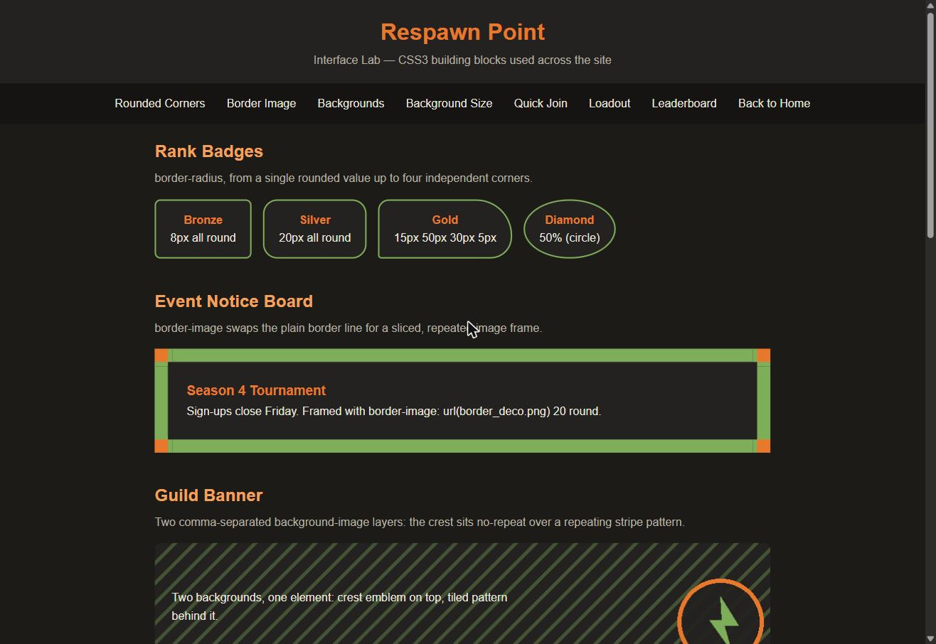
Guild Banner (layered backgrounds) and Banner Preview (background-size: cover vs contain)
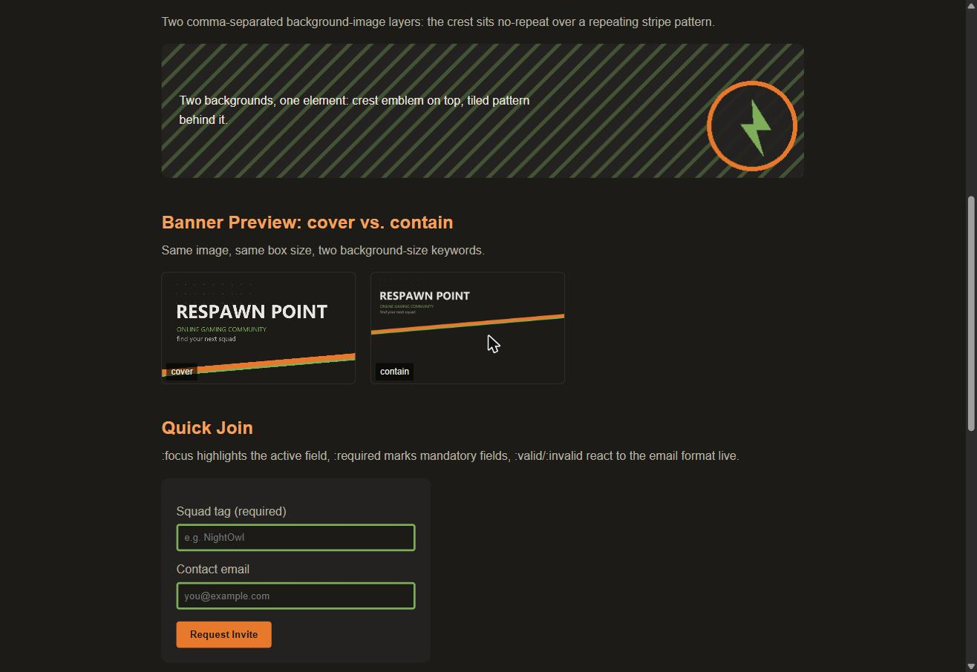
Quick Join form: :focus (orange border) and a live :invalid email (red text)
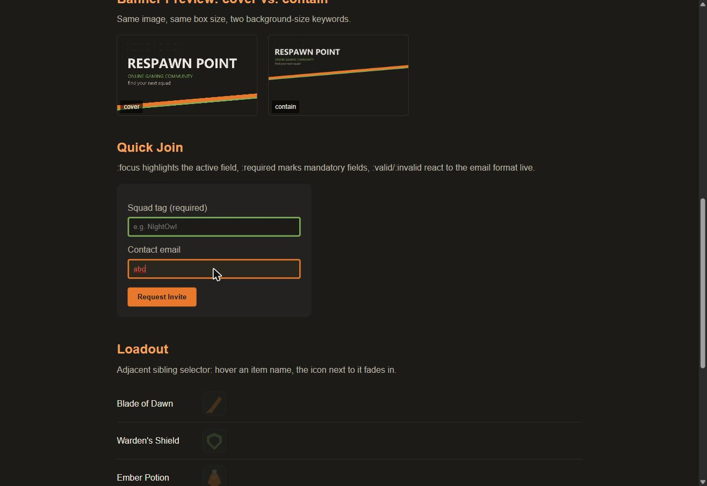
Loadout icons revealed via adjacent sibling hover, and the striped leaderboard with row 3 hovered
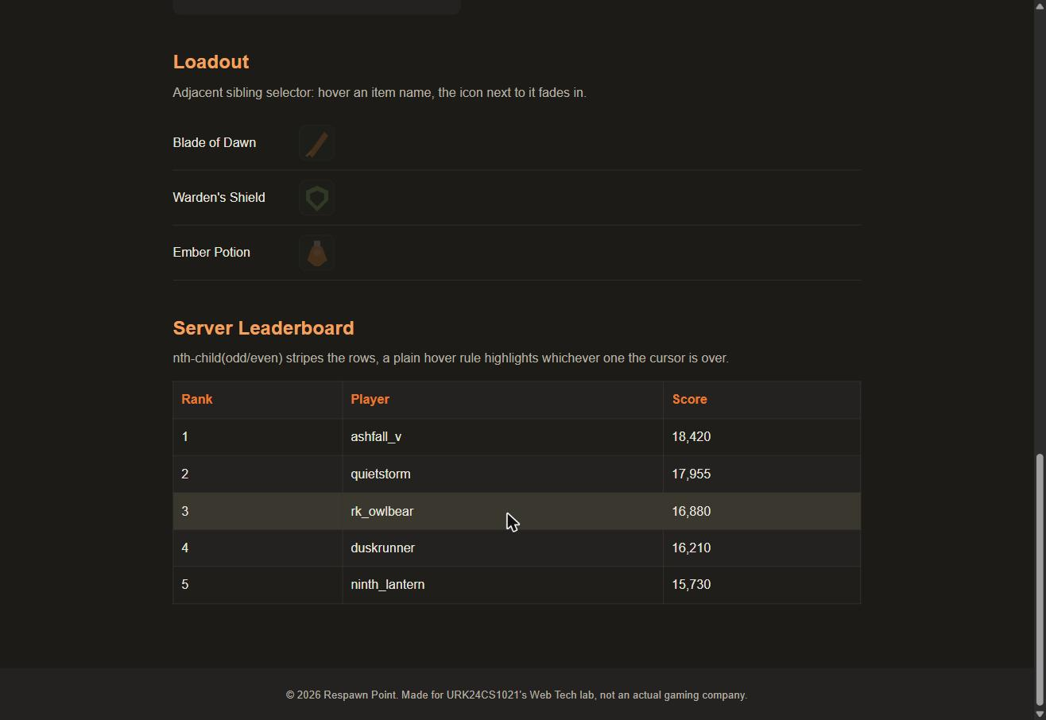
Result
The webpage was successfully designed using advanced CSS3 features. Rounded corners, a border image, layered backgrounds, background sizing, pseudo-classes, the adjacent sibling selector and nth-child() all rendered and behaved as expected in the browser.

