Ex. No. 2 | Registration Form - Join Respawn Point
Date of Exercise | 27/07/2026
GitHub Host Link | https://kukyos.github.io/WebTechLab/Ex2/index.html

Aim
To design and implement an HTML5 registration form using the various form input elements and controls, applied to the online gaming community theme.
Description
HTML5 introduced several new <input> types beyond plain text, each giving the browser its own built-in validation/UI: email (checks for an @ address), password (masks input), number (spinner + min/max), date (a date picker), range (a slider between min/max), and color (a color picker). Radio buttons let the user pick exactly one option from a group sharing the same name; checkboxes allow multiple. A <select> gives a fixed dropdown of options, while a <datalist> attached to a text input via the list attribute gives suggestions the user can still type past. Each <label>'s for attribute ties it to its input's id, and the fields are separated with <br> tags, the same way as in the sample form. The background and text colors are set with inline CSS, carried over from the Ex1 page.
Procedure:
1. Reused the sample registration form as a reference for which input types were required (text, email, password, number, date, radio, checkbox, select, datalist, range, color).
2. Reskinned every field to the Respawn Point gaming theme instead of the generic student-registration wording (Gamer Tag instead of Full Name, Main Platform instead of Gender, Games You're Into instead of Skills, and so on).
3. Laid the fields out the same way as the sample form: a <label> with a for attribute, a <br>, the input, then <br><br> before the next field, with an HTML comment naming the input type above each one.
4. Used the same background and text colors as the Ex1 page, applied with inline CSS on the <body> tag and on the labels, so this page looks like part of the same site.
5. Added a link at the top back to the Ex1 homepage.
6. Opened the page in the browser and filled in every field (typed the text fields, entered a date, picked a radio button and two checkboxes, chose a dropdown option, typed a datalist suggestion and moved the range slider) to confirm they all actually work, then took the output screenshots of the empty and the filled-in form.
Program

<!DOCTYPE html>
<html lang="en">
<head>
<meta charset="UTF-8">
<title>Join Respawn Point - Registration</title>
</head>
<body style="background-color: #1c1b18; color: #eae6df">
<!-- link back to the Ex1 homepage so the two pages are one site -->
<div style="background-color: #242220">
<p><b><a href="../Ex1/index.html" style="color: #e8792c">Back to Respawn Point</a></b></p>
</div>
<hr style="color: #e8792c">
<h1 style="color: #e8792c">Join the Squad</h1>
<p style="color: #b7b1a4">
<i>fill this in and you're one step closer to not solo queuing anymore</i>
</p>
<form action="#" method="post">
<!-- Text Input -->
<label for="gamertag" style="color: #7fae5a">Gamer Tag:</label><br>
<input type="text" id="gamertag" name="gamertag" placeholder="how people will see you" required><br><br>
<!-- Email Input -->
<label for="email" style="color: #7fae5a">Email:</label><br>
<input type="email" id="email" name="email" placeholder="you@example.com" required><br><br>
<!-- Password -->
<label for="password" style="color: #7fae5a">Password:</label><br>
<input type="password" id="password" name="password" required><br><br>
<!-- Number -->
<label for="age" style="color: #7fae5a">Age:</label><br>
<input type="number" id="age" name="age" min="13" max="99"><br><br>
<!-- Date -->
<label for="dob" style="color: #7fae5a">Date of Birth:</label><br>
<input type="date" id="dob" name="dob"><br><br>
<!-- Radio Buttons -->
<label style="color: #7fae5a">Main Platform:</label><br>
<input type="radio" name="platform" value="pc"> PC
<input type="radio" name="platform" value="console"> Console
<input type="radio" name="platform" value="mobile"> Mobile<br><br>
<!-- Checkbox -->
<label style="color: #7fae5a">Games You Play:</label><br>
<input type="checkbox" name="games" value="battle-royale"> Battle Royale
<input type="checkbox" name="games" value="racing"> Racing
<input type="checkbox" name="games" value="mmorpg"> MMORPG
<input type="checkbox" name="games" value="fps"> FPS<br><br>
<!-- Dropdown -->
<label for="heard" style="color: #7fae5a">How Did You Hear About Us:</label><br>
<select id="heard" name="heard">
<option value="friend">A friend told me</option>
<option value="youtube">YouTube</option>
<option value="reddit">Reddit</option>
<option value="discord">Another Discord server</option>
</select><br><br>
<!-- Datalist -->
<label for="region" style="color: #7fae5a">Closest Server Region:</label><br>
<input list="regions" name="region" id="region">
<datalist id="regions">
<option value="Mumbai">
<option value="Chennai">
<option value="Bangalore">
<option value="Singapore">
</datalist><br><br>
<!-- Range -->
<label for="rating" style="color: #7fae5a">Rate Your Skill Level:</label><br>
<input type="range" id="rating" name="rating" min="1" max="10"><br><br>
<!-- Color -->
<label for="accent" style="color: #7fae5a">Profile Accent Color:</label><br>
<input type="color" id="accent" name="accent" value="#e8792c"><br><br>
<!-- Submit -->
<button type="submit">Create Account</button>
</form>
<hr style="color: #e8792c">
<!-- footer -->
<div style="color: #b7b1a4">
<p><small>&copy; 2026 Respawn Point. Made for URK24CS1021's Web Tech lab, not an actual gaming company.</small></p>
</div>
</body>
</html>
Output

The empty form, showing every input type
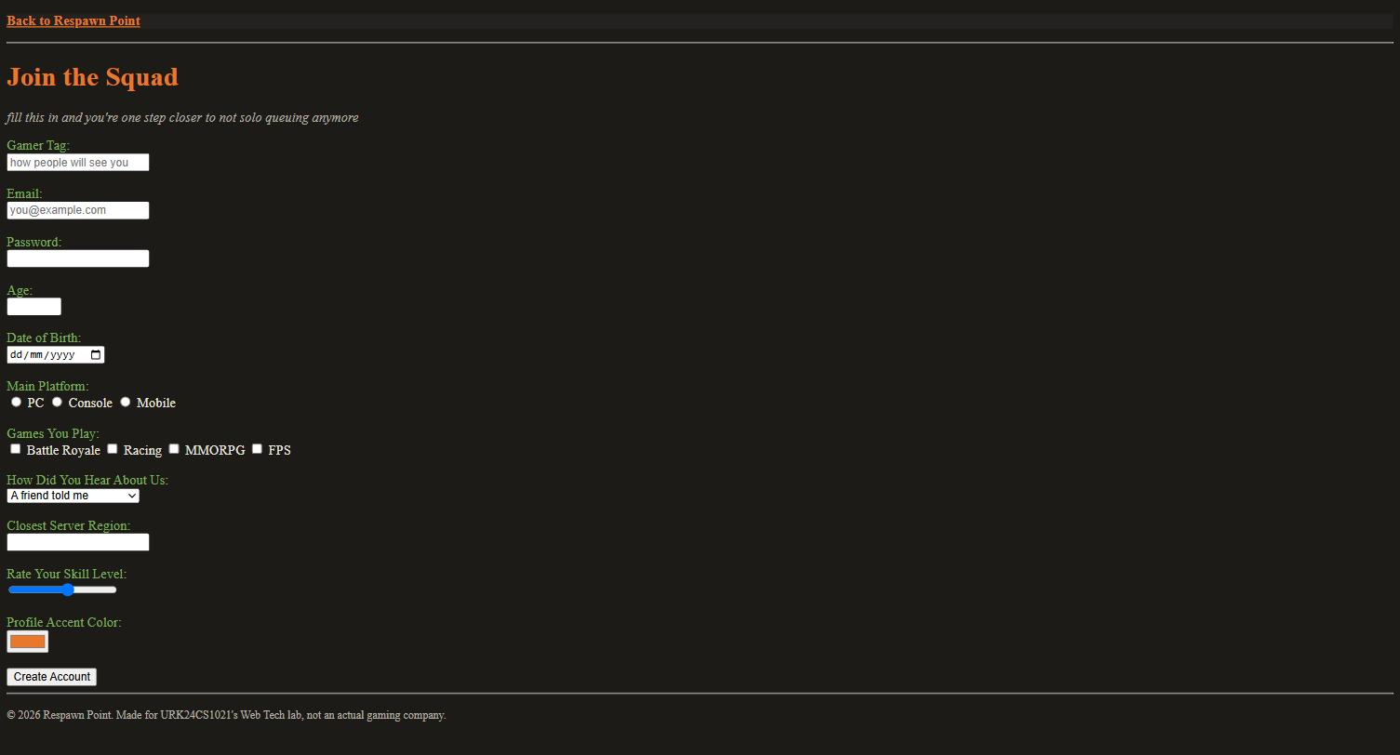
The same form after filling it in and using each control
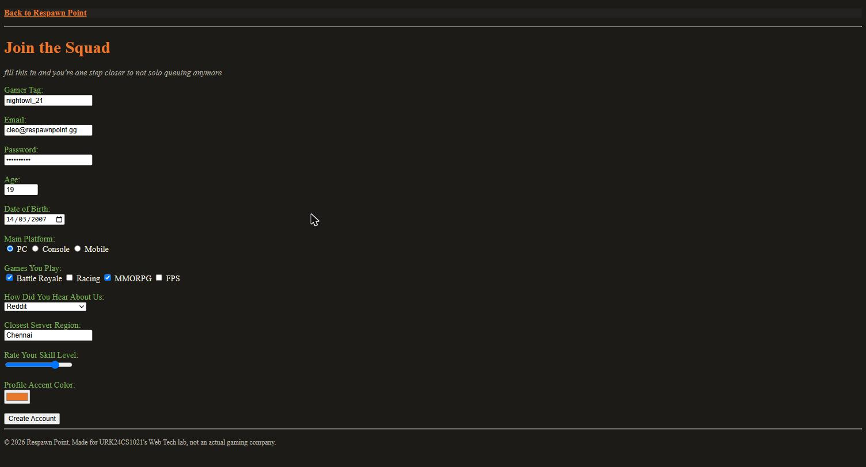
Result
The HTML5 registration form was successfully designed and executed using the required input elements and controls. The output matched the expected layout and content.

