Ex. No. 1 | WORKING WITH NUMPY AND PANDAS
Date of Exercise | 23/07/2026

Aim
To develop and implement Python programs that solves real-world problems in various industries such as HR, logistics, retail, finance, and security using Numpy and Pandas.
Description (About Numpy & Pandas)
NumPy (Numerical Python) is a library for efficient numerical computing. It provides the ndarray, an n-dimensional array object, together with vectorized operations for indexing, slicing, reshaping and mathematical computation that are much faster than native Python lists. Pandas is built on top of NumPy and provides two main data structures — the Series (a one-dimensional labelled array) and the DataFrame (a two-dimensional labelled table) — for handling and analysing structured, tabular data.
Question:
Manufacturing Quality Control
Analyze hourly defect rates (%) for 24-hour production:
• Create array of defects (random 0.1-5.0)
• Get rate at hour 12 (indexing)
• Slice night shift (20-6)
• Reshape into (3,8) for shift analysis
• Iterate to find problem hours (>3%)
• Join with temp/humidity array (random 24 values)
• Split into 3 shifts
• Find critical defects (>4%)
• Sort defects in ascending order
• Filter acceptable range (0.5-1.5%)
Pandas:
• Convert list of products ["Widget A", "Widget B", "Gadget"] to Series
• Convert {"Product": ["Tool X", "Tool Y"], "Tolerance": [0.1, 0.2]} to DataFrame
Sample Code:
# Ex 1 - Manufacturing Quality Control (NumPy)
# URK24CS1021
import numpy as np
np.random.seed(1021) # keep the run reproducible
# 1. hourly defect rates (%) for 24-hour production, random 0.1 - 5.0
defects = np.round(np.random.uniform(0.1, 5.0, 24), 2)
print("Hourly defect rates (%):")
print(defects)
# 2. defect rate at hour 12 (indexing)
print("\nDefect rate at hour 12:", defects[12], "%")
# 3. night shift 20:00 - 06:00 (slicing across midnight)
night = np.concatenate((defects[20:], defects[:7]))
print("\nNight shift (20:00 to 06:00):")
print(night)
# 4. reshape into (3, 8) for shift analysis
shifts = defects.reshape(3, 8)
print("\nReshaped into 3 shifts x 8 hours:")
print(shifts)
# 5. iterate to find problem hours (> 3%)
print("\nProblem hours (defect rate > 3%):")
for hour, rate in enumerate(defects):
if rate > 3:
print(" Hour", hour, "->", rate, "%")
# 6. join with a temperature array (random 24 values)
temp = np.round(np.random.uniform(18, 30, 24), 1)
combined = np.vstack((defects, temp))
print("\nDefects joined with temperature (2 x 24):")
print(combined)
# 7. split into 3 shifts
shift1, shift2, shift3 = np.split(defects, 3)
print("\nSplit into three shifts:")
print("Shift 1:", shift1)
print("Shift 2:", shift2)
print("Shift 3:", shift3)
# 8. critical defects (> 4%)
print("\nCritical defects (> 4%):", defects[defects > 4])
# 9. sort defects in ascending order
print("\nSorted (ascending):")
print(np.sort(defects))
# 10. filter acceptable range (0.5 - 1.5%)
acceptable = defects[(defects >= 0.5) & (defects <= 1.5)]
print("\nAcceptable range (0.5 - 1.5%):", acceptable)
Sample Output:
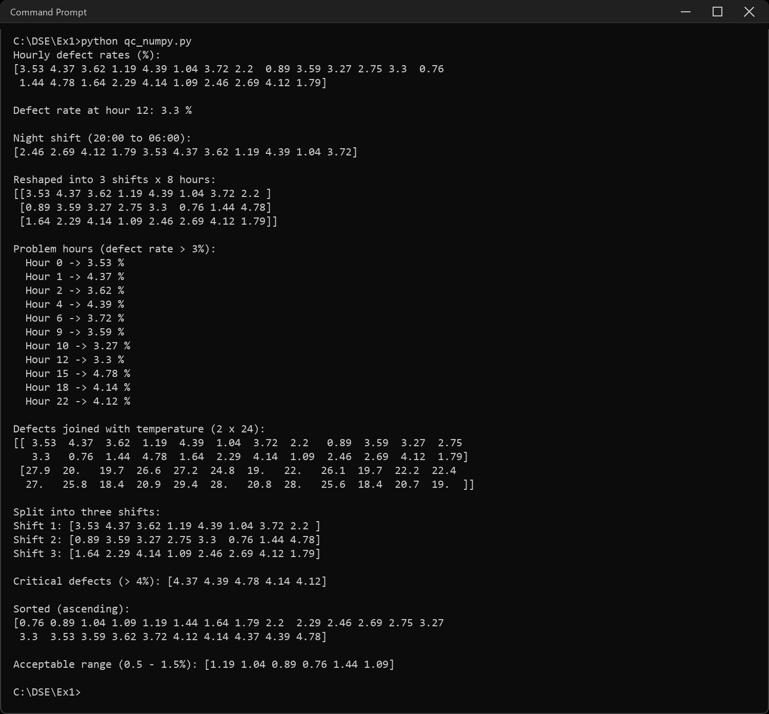
Sample Code:
# Ex 1 - Manufacturing Quality Control (Pandas)
# URK24CS1021
import pandas as pd
# 1. convert a list of products to a Series
products = ["Widget A", "Widget B", "Gadget"]
product_series = pd.Series(products)
print("Products Series:")
print(product_series)
# 2. convert a dictionary to a DataFrame
data = {"Product": ["Tool X", "Tool Y"], "Tolerance": [0.1, 0.2]}
df = pd.DataFrame(data)
print("\nProducts DataFrame:")
print(df)
Sample Output:
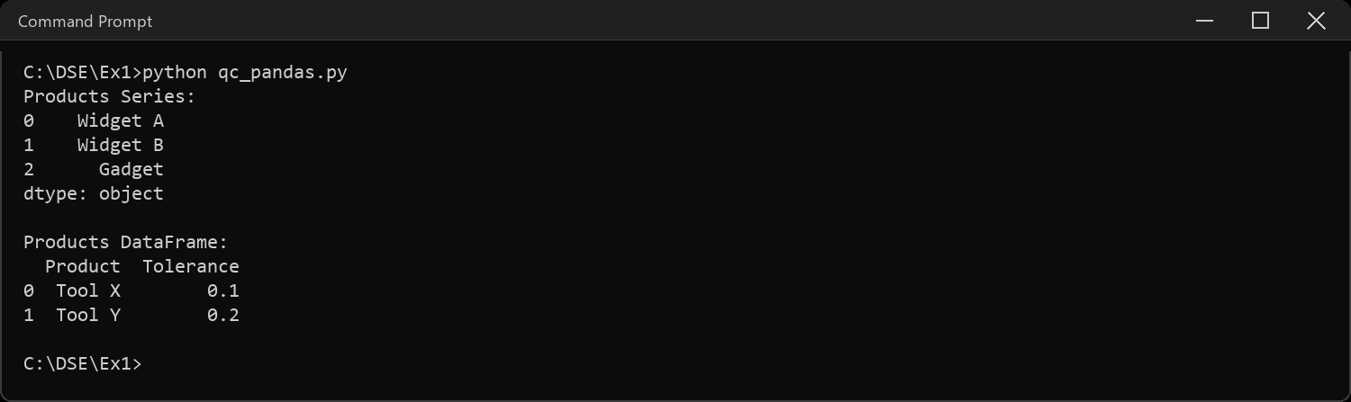
CODE EXPLANATION LINK:
(Youtube / Drive Link)
Preparation course certificate

RESULT
The exercise shown above has been successfully executed and the output has been verified.

