Ex. No. 1B  Date: 24/07/2026 | MANAGING TABLES USING DML, DCL AND TCL COMMANDS | URK24CS1021
Aim
To execute all commands of Data Manipulation Language, Data Control Language, and Transaction Control Language to get the desired output.
Description
DML statements (INSERT/UPDATE/DELETE) manipulate row data. DCL statements (GRANT/REVOKE) control access privileges on database objects for specific roles. TCL statements (COMMIT/ROLLBACK/SAVEPOINT) control transaction boundaries — COMMIT makes changes permanent, SAVEPOINT marks a point to roll back to within an open transaction, and ROLLBACK TO undoes work back to that point without discarding the whole transaction.
Questions
1. Insert a new user into the "User" table.
INSERT INTO URK24CS1021_users (id, name, email, password, phone)
VALUES (103, 'Nina Patel', 'nina@mail.com', 'pass3', '9000000012');
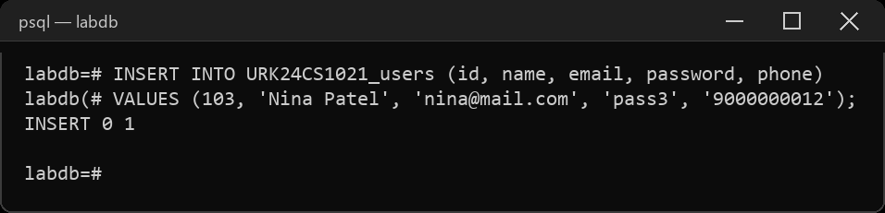
2. Update the email address of a user with UserID 102.
UPDATE URK24CS1021_users SET email = 'mary.ann.new@mail.com' WHERE id = 102;
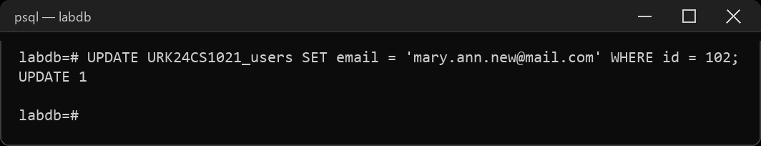
3. Delete a user with the email "example@example.com".
INSERT INTO URK24CS1021_users (id, name, email, password, phone)
VALUES (104, 'Temp User', 'example@example.com', 'pass4', '9000000013');
DELETE FROM URK24CS1021_users WHERE email = 'example@example.com';
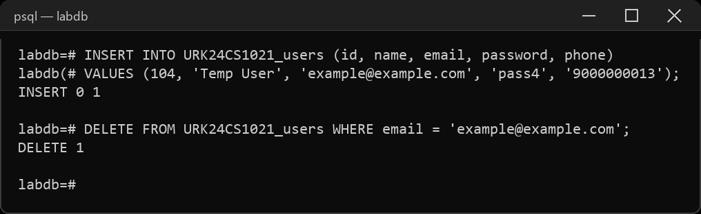
4. Insert a new event into the "Event" table.
INSERT INTO URK24CS1021_event (eventid, name, eventdate, eventtime, venueid, description)
VALUES (402, 'Food Festival', '2023-11-05', '2023-11-05 12:00:00', 1, 'Street food festival');
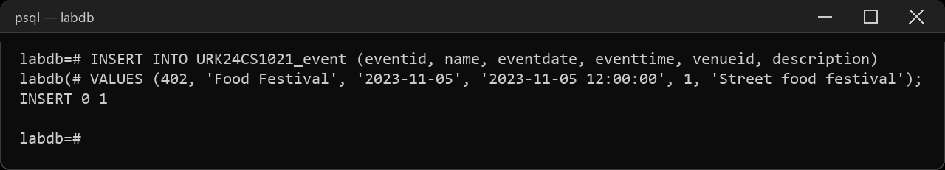
5. Update the description of an event with EventID 401.
UPDATE URK24CS1021_event SET description = 'Annual comic convention, now with a cosplay contest'
WHERE eventid = 401;
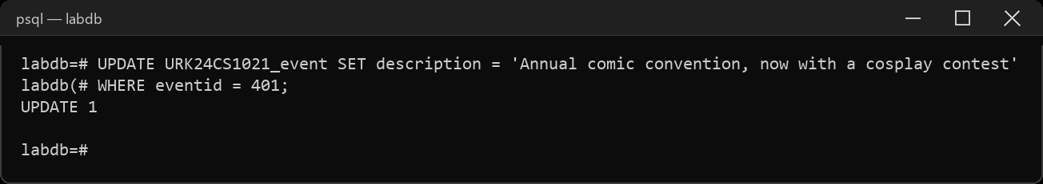
6. Grant SELECT privileges on the "User" table to a user named "john".
CREATE ROLE john LOGIN;
GRANT SELECT ON URK24CS1021_users TO john;
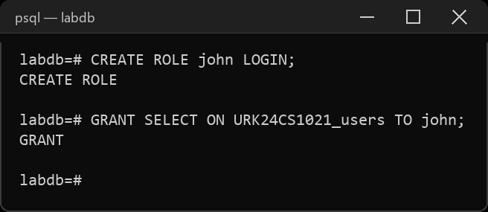
7. Revoke INSERT privileges on the "Event" table from a user named "mary".
CREATE ROLE mary LOGIN;
GRANT INSERT ON URK24CS1021_event TO mary;
REVOKE INSERT ON URK24CS1021_event FROM mary;
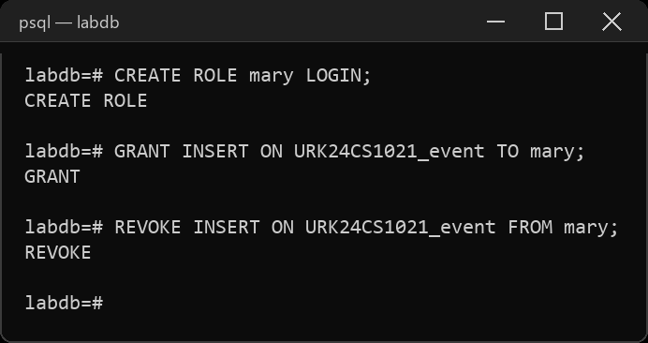
8. Create a new user with the username "jane" and grant them all privileges on the "Ticket" table.
CREATE ROLE jane LOGIN;
GRANT ALL PRIVILEGES ON URK24CS1021_ticket TO jane;
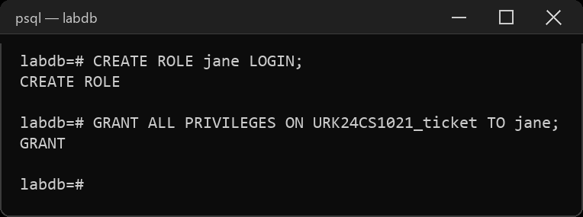
9. Grant EXECUTE privileges on a stored procedure to a role named "admin".
CREATE ROLE admin;
CREATE OR REPLACE PROCEDURE URK24CS1021_ticket_count() LANGUAGE sql AS $$ SELECT 1; $$;
GRANT EXECUTE ON PROCEDURE URK24CS1021_ticket_count() TO admin;
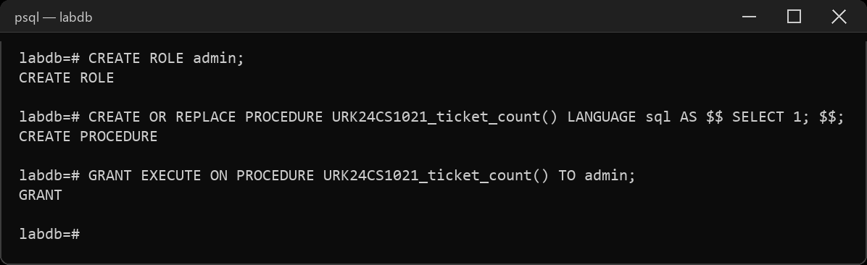
10. Revoke all privileges from a user named "guest" on all tables in the schema.
CREATE ROLE guest LOGIN;
REVOKE ALL PRIVILEGES ON ALL TABLES IN SCHEMA public FROM guest;
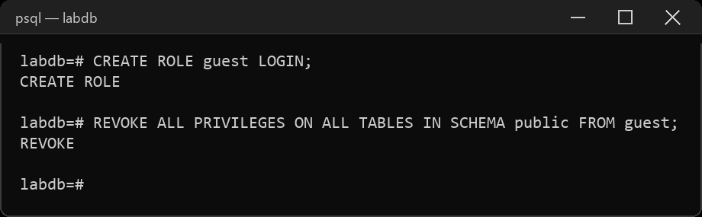
11. Perform commit a transaction in the database.
BEGIN;
INSERT INTO URK24CS1021_ticket (ticketid, eventid, userid, price, status, barcode)
VALUES (902, 401, 102, 80.00, 'confirmed', 'BCX002');
COMMIT;
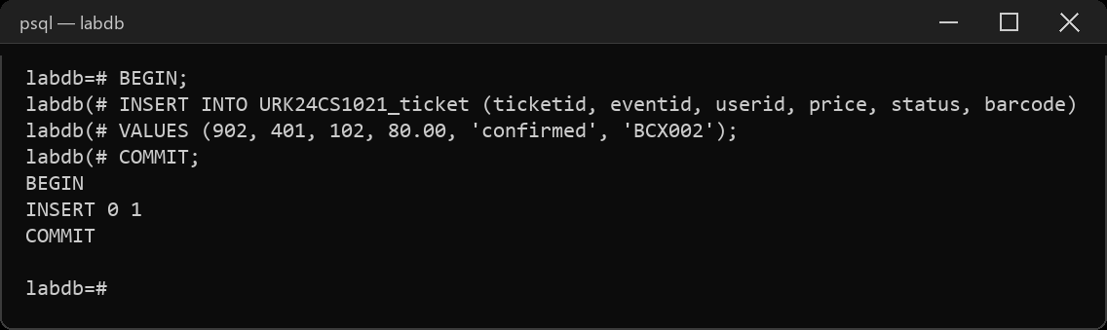
12. Perform roll back a transaction to a specific savepoint.
BEGIN;
INSERT INTO URK24CS1021_ticket (ticketid, eventid, userid, price, status, barcode)
VALUES (903, 401, 103, 95.00, 'confirmed', 'BCX003');
SAVEPOINT sp1;
INSERT INTO URK24CS1021_ticket (ticketid, eventid, userid, price, status, barcode)
VALUES (904, 401, 104, 95.00, 'confirmed', 'BCX004');
ROLLBACK TO SAVEPOINT sp1;
COMMIT;
SELECT ticketid FROM URK24CS1021_ticket WHERE ticketid IN (903, 904);
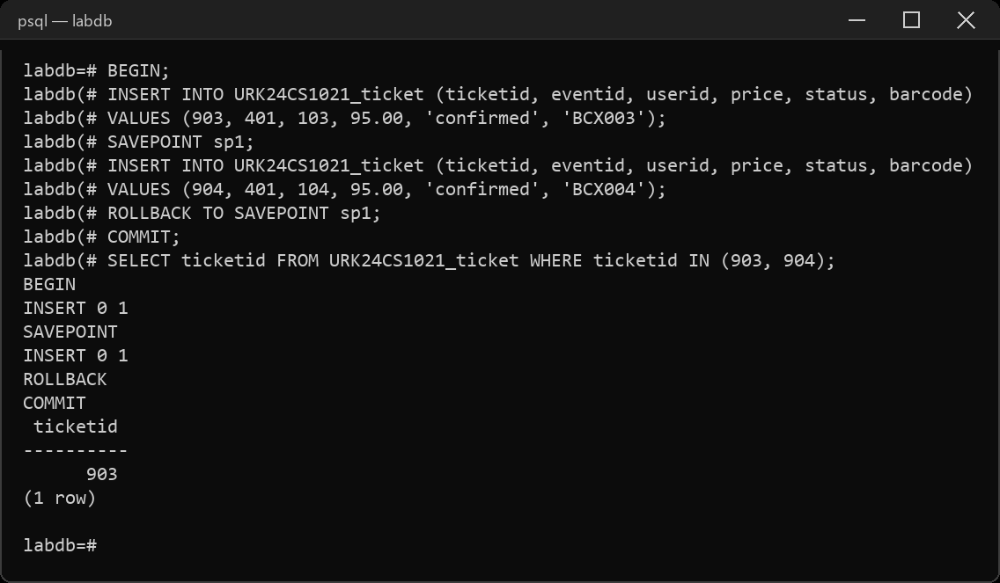
13. Perform set a savepoint within a transaction.
BEGIN;
INSERT INTO URK24CS1021_ticket (ticketid, eventid, userid, price, status, barcode)
VALUES (905, 401, 105, 70.00, 'confirmed', 'BCX005');
SAVEPOINT sp2;
SELECT COUNT(*) AS tickets_so_far FROM URK24CS1021_ticket;
COMMIT;
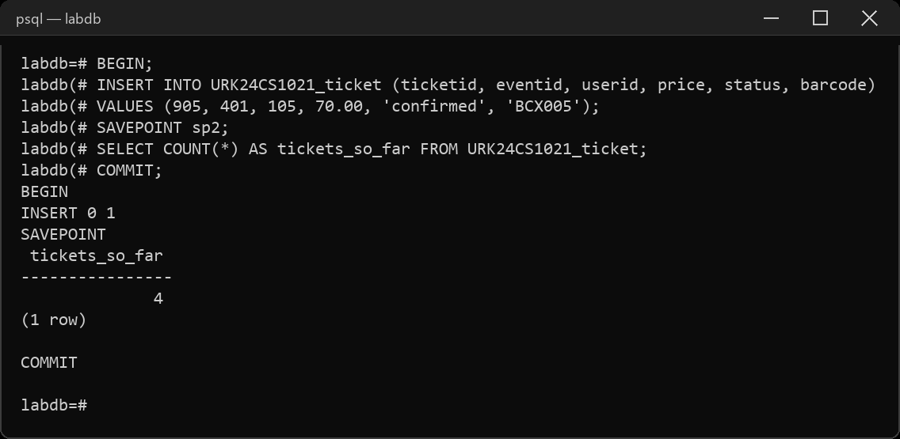
14. Enable autocommit mode in the database.
\set AUTOCOMMIT on
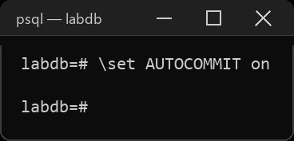
15. Disable autocommit mode in the database.
\set AUTOCOMMIT off
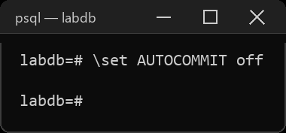
Result
The queries were executed and the desired output was obtained.

