Ex. No. 2  Date: 24/07/2026 | BASIC SQL | URK24CS1021
Aim
To execute the given basic SQL queries.
Description
DML (Data Manipulation Language) statements manipulate the data held within tables: INSERT adds rows, UPDATE changes existing rows, DELETE removes rows, and SELECT retrieves rows, optionally filtered with a WHERE clause (comparison, AND/OR, IS NULL, IN, LIKE, BETWEEN), grouped with GROUP BY, and ordered with ORDER BY.
Questions
1. Insert all the fields given in the ticket reservation schema.
INSERT INTO URK24CS1021_users (id, name, email, password, phone) VALUES
(101, 'Alice Johnson', 'alice@mail.com', 'pass1', '9000000001'),
(102, 'Bob Smith', 'bob@mail.com', 'pass2', '9000000002'),
(103, 'Carol Lee', 'carol@mail.com', 'pass3', '9000000003'),
(104, 'David Kim', 'david@mail.com', 'pass4', '9000000004'),
(105, 'Emma Watson', 'emma@mail.com', 'pass5', '9000000005');
INSERT INTO URK24CS1021_location (venueid, name, address, city, state, country) VALUES
(1, 'Madison Square Garden', '4 Pennsylvania Plaza', 'New York', 'NY', 'USA'),
(2, 'Wembley Stadium', 'Wembley', 'London', 'England', 'UK'),
(3, 'Marina Bay Sands', '10 Bayfront Ave', 'Singapore', 'Singapore', 'Singapore');
INSERT INTO URK24CS1021_event (eventid, name, eventdate, eventtime, venueid, description) VALUES
(1, 'Rock Fest', '2023-08-15', '2023-08-15 19:00:00', 1, 'Outdoor rock concert'),
(2, 'Tech Conference', '2023-07-20', '2023-07-20 09:00:00', 2, 'Annual tech meetup'),
(3, 'Jazz Night', '2023-09-05', '2023-09-05 20:00:00', 3, 'Live jazz performance'),
(4, 'Startup Summit', '2023-06-10', '2023-06-10 10:00:00', 1, 'Startup pitch day');
INSERT INTO URK24CS1021_ticket (ticketid, eventid, userid, price, status, barcode) VALUES
(1, 1, 101, 150.00, 'confirmed', 'BC1001'),
(2, 1, 102, 150.00, 'confirmed', 'BC1002'),
(3, 2, 103, 200.00, 'cancelled', 'BC1003'),
(4, 3, 104, 120.00, 'confirmed', 'BC1004'),
(5, 3, 105, 120.00, 'confirmed', 'BC1005'),
(6, 4, 101, 90.00, 'cancelled', 'BC1006'),
(7, 2, 102, 200.00, 'confirmed', 'BC1007');
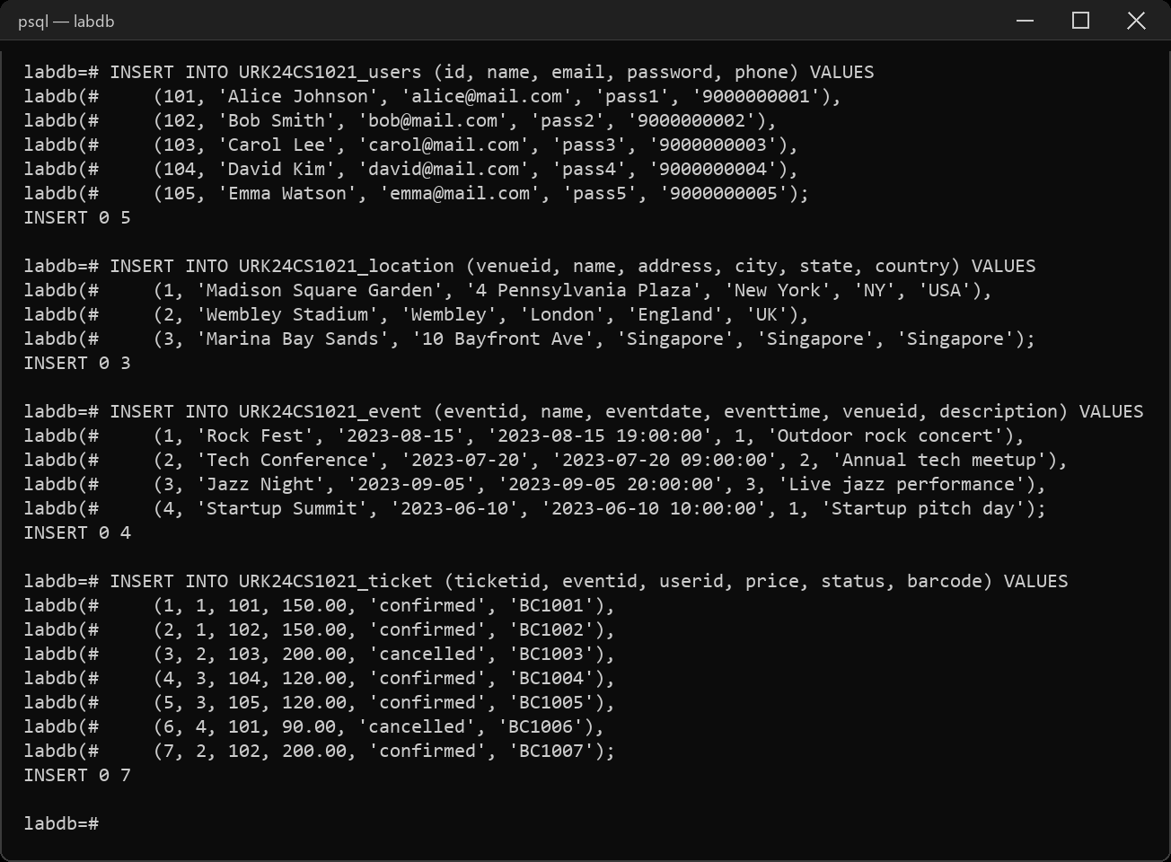
2. Display all the fields in User, Events, Venue and Ticket tables.
SELECT * FROM URK24CS1021_users;
SELECT * FROM URK24CS1021_event;
SELECT * FROM URK24CS1021_location;
SELECT * FROM URK24CS1021_ticket;
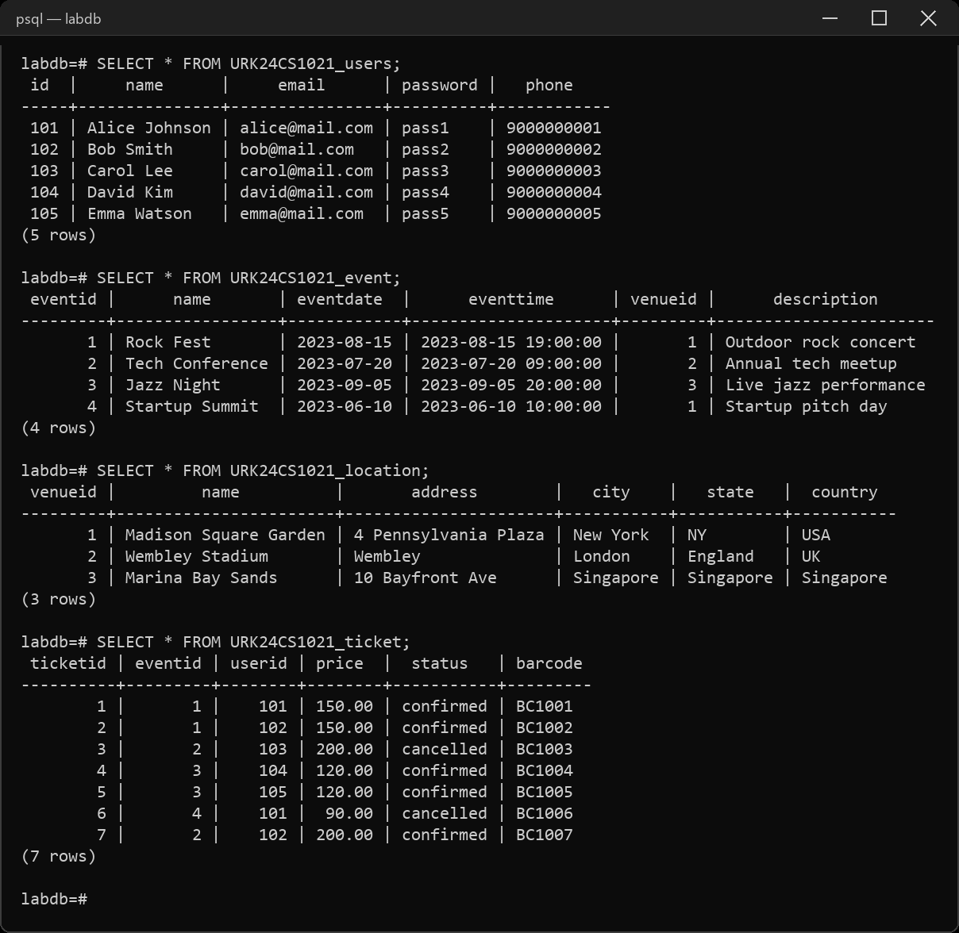
3. Retrieve all venues ordered by city and then by country.
SELECT * FROM URK24CS1021_location ORDER BY city, country;
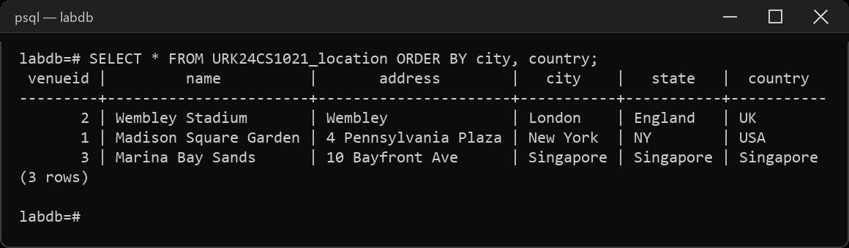
4. Retrieve total number of users.
SELECT COUNT(*) AS total_users FROM URK24CS1021_users;
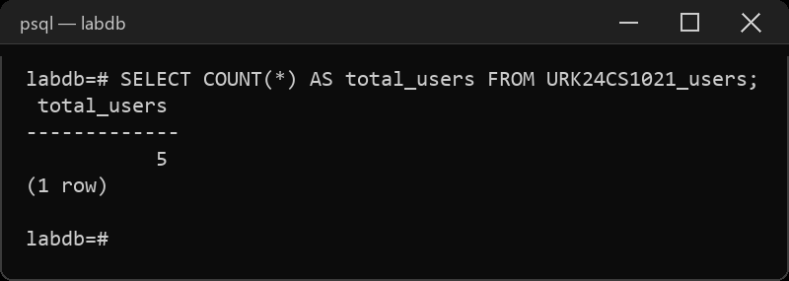
5. Retrieve all events ordered by date and time in descending order.
SELECT * FROM URK24CS1021_event ORDER BY eventdate DESC, eventtime DESC;
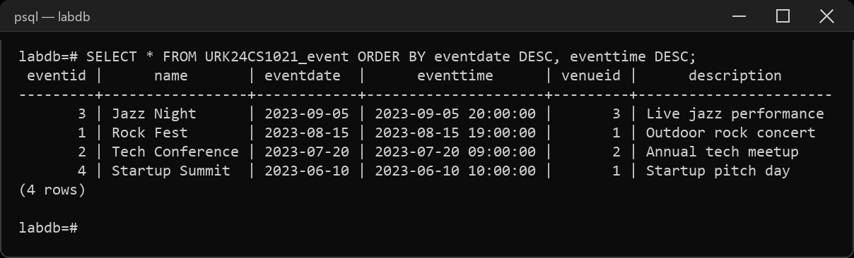
6. Get the average price of tickets for each event.
SELECT eventid, AVG(price) AS avg_price
FROM URK24CS1021_ticket GROUP BY eventid;
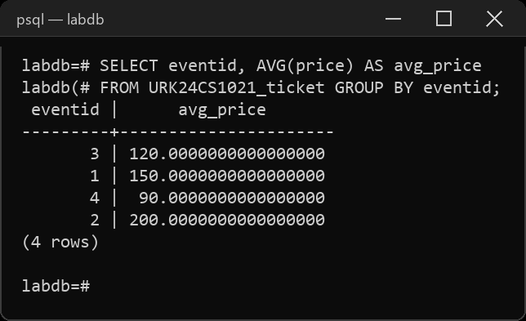
7. Get the total price and count of tickets for each event.
SELECT eventid, SUM(price) AS total_price, COUNT(*) AS ticket_count
FROM URK24CS1021_ticket GROUP BY eventid;
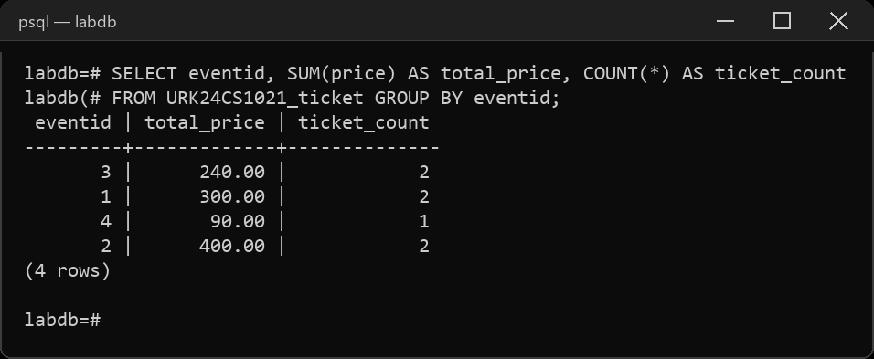
8. Count the number of tickets for each event.
SELECT eventid, COUNT(*) AS ticket_count
FROM URK24CS1021_ticket GROUP BY eventid;
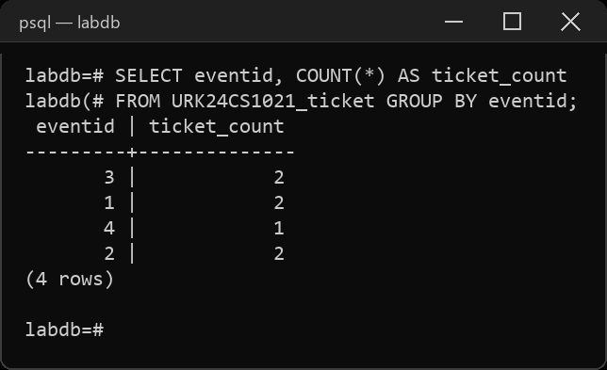
9. Retrieve a distinct number of users.
SELECT COUNT(DISTINCT id) AS distinct_users FROM URK24CS1021_users;
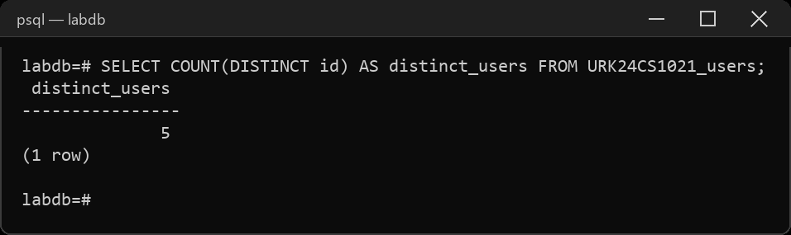
10. Retrieve the events conducted after 30/07/2023.
SELECT * FROM URK24CS1021_event WHERE eventdate > '2023-07-30';
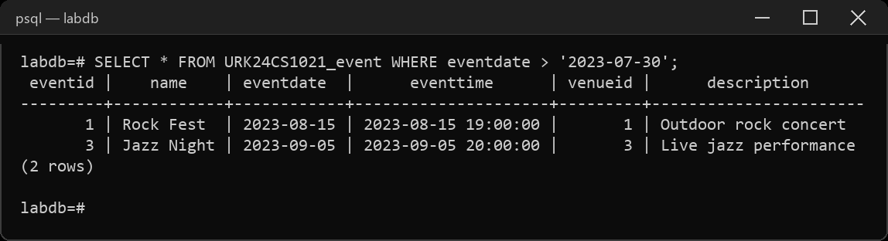
11. Calculate the sum of prices for all confirmed tickets.
SELECT SUM(price) AS confirmed_total
FROM URK24CS1021_ticket WHERE status = 'confirmed';
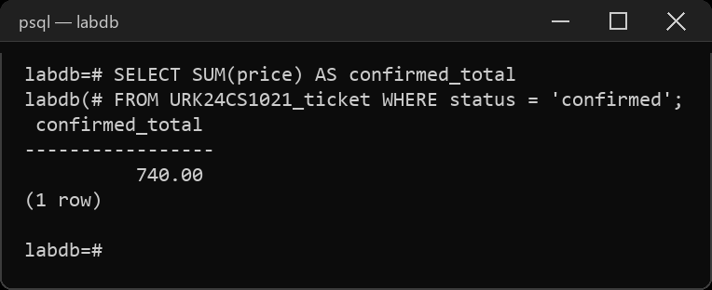
12. Concatenate the user's name and email for display.
SELECT name || ' <' || email || '>' AS display FROM URK24CS1021_users;
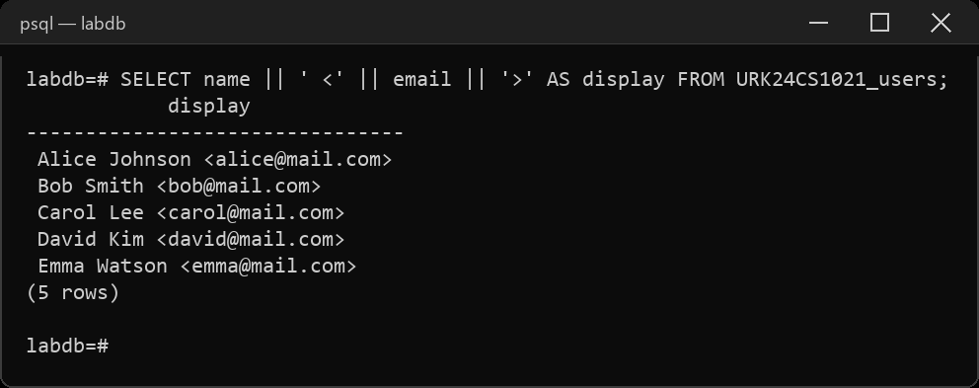
13. Retrieve the venue from the city New York and country USA.
SELECT * FROM URK24CS1021_location
WHERE city = 'New York' AND country = 'USA';
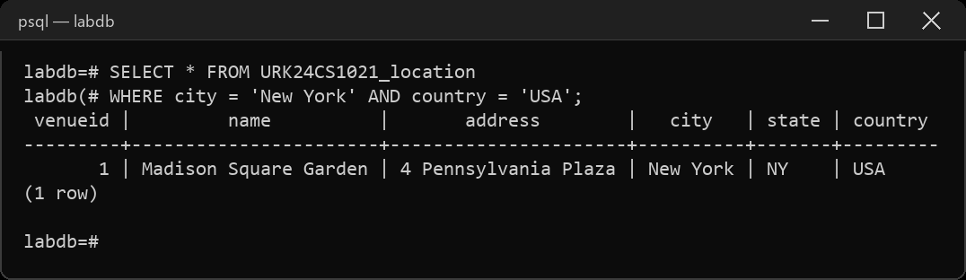
14. Retrieve all cities ordered by Country in ascending order.
SELECT city, country FROM URK24CS1021_location ORDER BY country ASC;
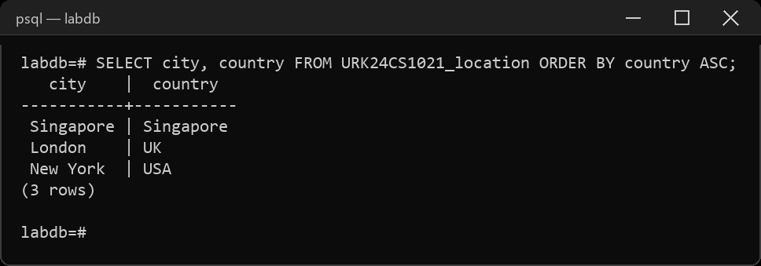
15. Delete the cancelled ticket in the ticket table.
DELETE FROM URK24CS1021_ticket WHERE status = 'cancelled';
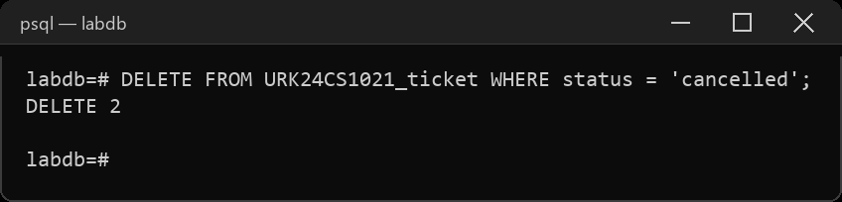
Result
The queries were executed and the desired output was obtained.

