Data Type
Column

Ex. No. 1(a) – Creating and Managing Tables
Date: 08/07/2026
Aim
To execute DDL commands and get the desired output.

Description
DDL refers to "Data Definition Language", a subset of SQL statements that change the structure of the database schema in some way, typically by creating, deleting, or modifying schema objects such as databases, tables, and views. Most Impala DDL statements start with the keywords CREATE , DROP , or ALTER .
In this schema, we have four main tables: User, Event, Venue, and Ticket.
User table:
Column | Data Type
UserID | NUMBER(10)
Name | VARCHAR2(255)
Email | VARCHAR2(255)
Password | VARCHAR2(255)
Phone | VARCHAR2(20)
Event table:
Column | Data Type
EventID | NUMBER(10)
Name | VARCHAR2(255)
Date | DATE
Time | TIMESTAMP
VenueID | NUMBER(10) (Foreign key)
Description | VARCHAR2(500)
Venue table:
Column | Data Type
VenueID | NUMBER(10)
Name | VARCHAR2(255)
Address | VARCHAR2(255)
City | VARCHAR2(255)
State | VARCHAR2(255)
Country | VARCHAR2(255)
Ticket table:

TicketID | NUMBER(10)
EventID | NUMBER(10) (Foreign key)
UserID | NUMBER(10)
SeatNumber | VARCHAR2(20)
Price | NUMBER(10, 2)
Status | VARCHAR2(50)

Queries(DDL Commands)
- Create User, Event, Venue, and ticket tables based on the given schema.
CREATE TABLE URK24CS1021_users (
userid numeric(10) PRIMARY KEY,
name varchar(255),
email varchar(255),
password varchar(255),
phone varchar(20)
);
CREATE TABLE URK24CS1021_venue (
venueid numeric(10) PRIMARY KEY,
name varchar(255),
address varchar(255),
city varchar(255),
state varchar(255),
country varchar(255)
);
CREATE TABLE URK24CS1021_event (
eventid numeric(10) PRIMARY KEY,
name varchar(255),
eventdate date,
eventtime timestamp,
venueid numeric(10),
description varchar(500)
);
CREATE TABLE URK24CS1021_ticket (
ticketid numeric(10) PRIMARY KEY,
eventid numeric(10) REFERENCES URK24CS1021_event(eventid),
userid numeric(10),
seatnumber varchar(20),
price numeric(10,2),
status varchar(50)
);
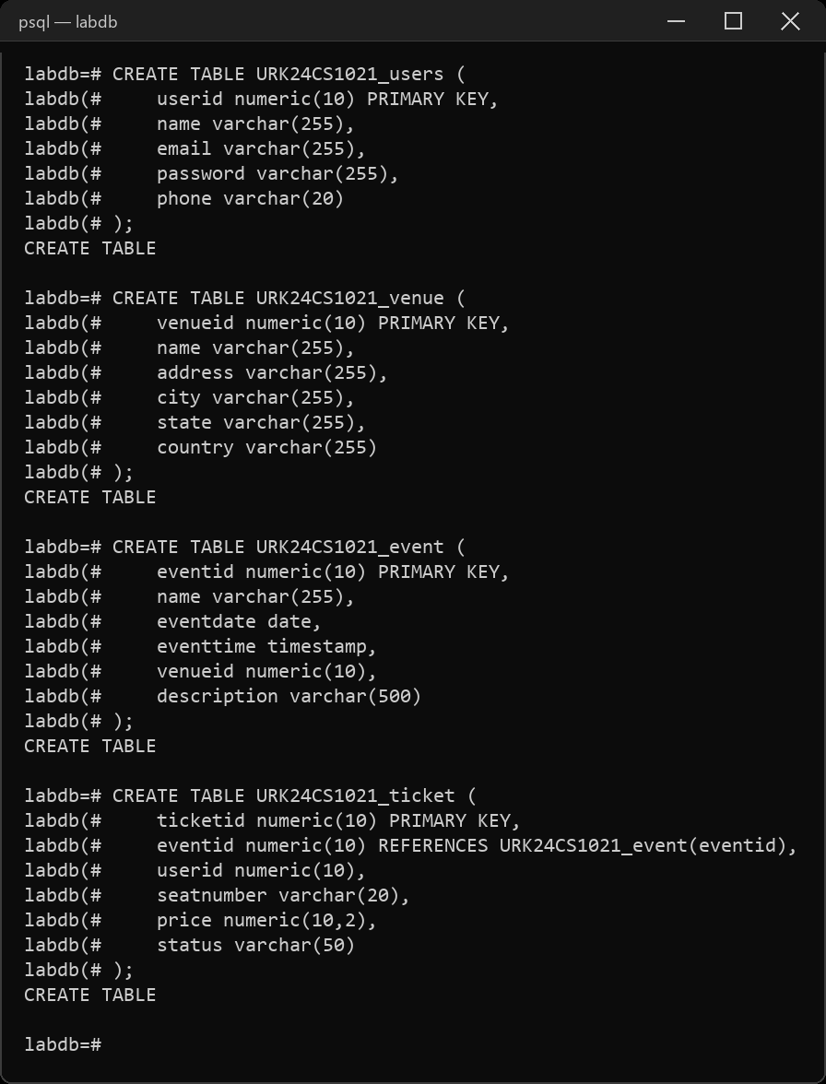
- Describe the tables.
\d URK24CS1021_users
\d URK24CS1021_event
\d URK24CS1021_venue
\d URK24CS1021_ticket
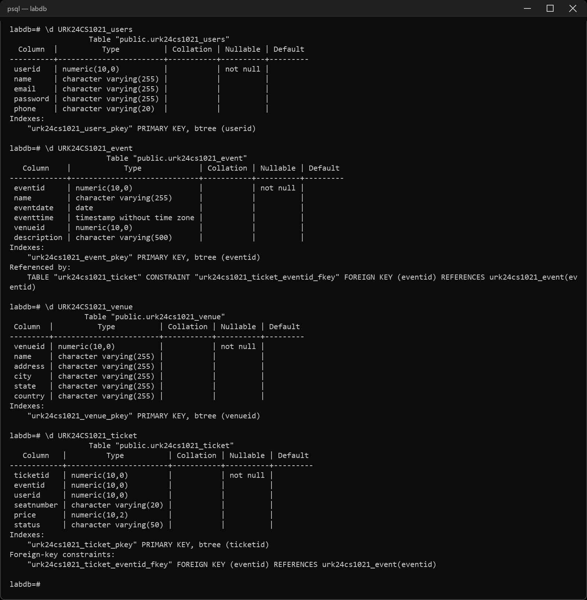
- Alter the User table to add a new column Age.
ALTER TABLE URK24CS1021_users ADD COLUMN age numeric(3);
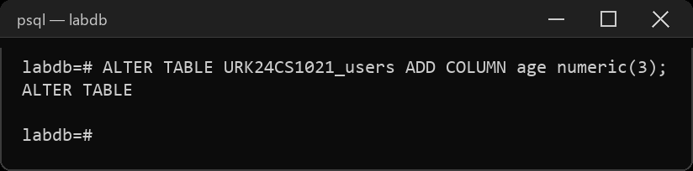
- Drop the newly added column Age.
ALTER TABLE URK24CS1021_users DROP COLUMN age;
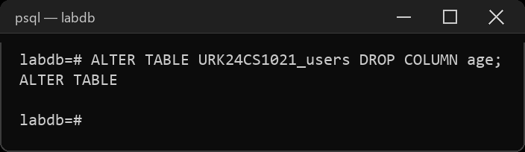
- Rename the Venue table to Location
ALTER TABLE URK24CS1021_venue RENAME TO URK24CS1021_location;
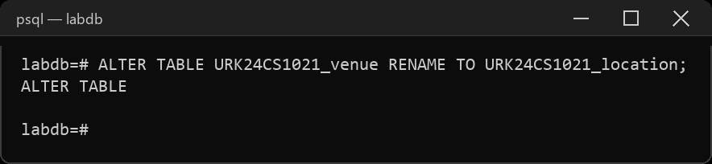
- Modify the size of the Event table's Description column to 1000.
ALTER TABLE URK24CS1021_event ALTER COLUMN description TYPE varchar(1000);
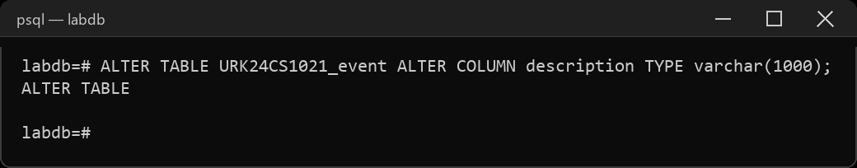
- Drop the SeatNumber column from the Ticket table
ALTER TABLE URK24CS1021_ticket DROP COLUMN seatnumber;
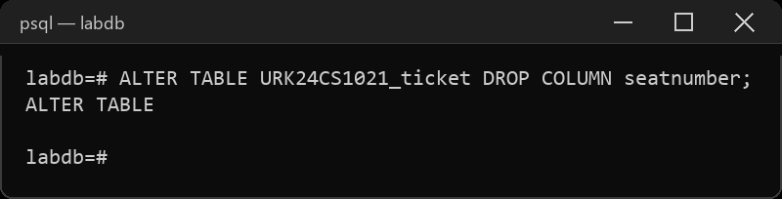
- Add a unique constraint on the Email column in the User table
ALTER TABLE URK24CS1021_users ADD CONSTRAINT users_email_uq UNIQUE (email);
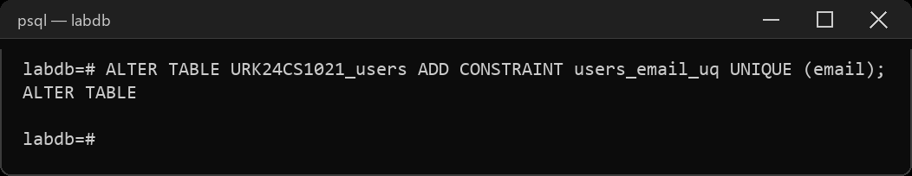
- Rename the UserID column in the User table to ID
ALTER TABLE URK24CS1021_users RENAME COLUMN userid TO id;
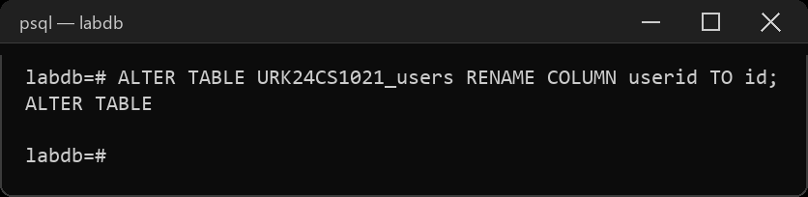
- Modify the Ticket table to add a column named "Barcode" with a data type of VARCHAR2(50).
ALTER TABLE URK24CS1021_ticket ADD COLUMN barcode varchar(50);
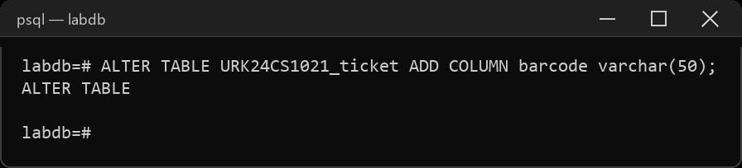
- Modify the Name column in the Venue table to increase its maximum length to VARCHAR2(300)
ALTER TABLE URK24CS1021_location ALTER COLUMN name TYPE varchar(300);
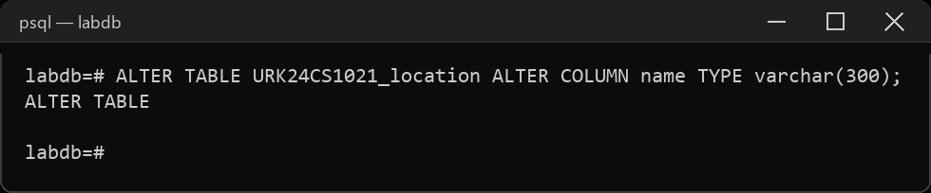
- Add a foreign key constraint on the VenueID column in the Event table, referencing the Venue table.
ALTER TABLE URK24CS1021_event ADD CONSTRAINT event_venue_fk
FOREIGN KEY (venueid) REFERENCES URK24CS1021_location(venueid);
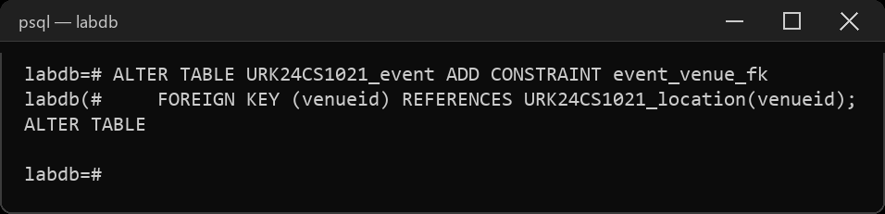
- Add a CHECK constraint to check whether the UserID is between 101 and 105
ALTER TABLE URK24CS1021_users ADD CONSTRAINT users_id_chk CHECK (id BETWEEN 101 AND 105);
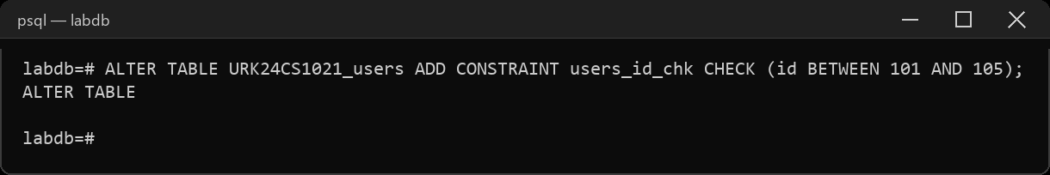
- Add a unique constraint to Phone column of the User table.
ALTER TABLE URK24CS1021_users ADD CONSTRAINT users_phone_uq UNIQUE (phone);
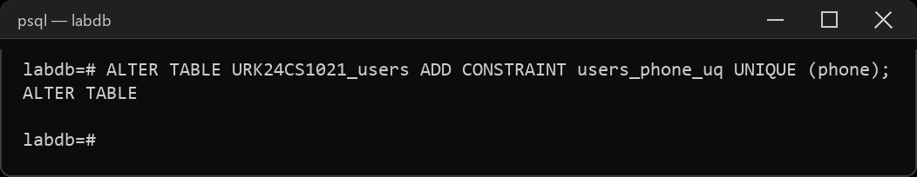

- Truncate the user table.
TRUNCATE TABLE URK24CS1021_users;
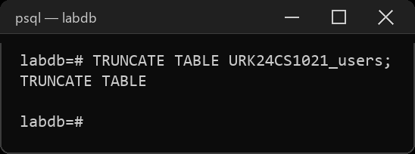
Result:
The DDL commands were executed and the desired output was obtained.

