Data Type
Column

Ex. No. 1(a) – Creating and Managing Tables
Aim
To execute DDL commands and get the desired output.

Description
DDL refers to "Data Definition Language", a subset of SQL statements that change the structure of the database schema in some way, typically by creating, deleting, or modifying schema objects such as databases, tables, and views. Most Impala DDL statements start with the keywords CREATE , DROP , or ALTER .
In this schema, we have four main tables: User, Event, Venue, and Ticket.

User table:
Column | Data Type
UserID | NUMBER(10)
Name | VARCHAR2(255)
Email | VARCHAR2(255)
Password | VARCHAR2(255)
Phone | VARCHAR2(20)

Event table:
Column | Data Type
EventID | NUMBER(10)
Name | VARCHAR2(255)
Date | DATE
Time | TIMESTAMP
VenueID | NUMBER(10) (Foreign key)
Description | VARCHAR2(500)
Venue table:
Column | Data Type
VenueID | NUMBER(10)
Name | VARCHAR2(255)
Address | VARCHAR2(255)
City | VARCHAR2(255)
State | VARCHAR2(255)
Country | VARCHAR2(255)
Ticket table:

TicketID | NUMBER(10)
EventID | NUMBER(10) (Foreign key)
UserID | NUMBER(10)
SeatNumber | VARCHAR2(20)
Price | NUMBER(10, 2)
Status | VARCHAR2(50)

Queries(DDL Commands)
- Create User, Event, Venue, and ticket tables based on the given schema.
CREATE TABLE User_1030 (
UserID INT PRIMARY KEY,
Name VARCHAR(255),
Email VARCHAR(255),
Password VARCHAR(255),
Phone VARCHAR(20)
);
CREATE TABLE Venue_1030 (
VenueID INT PRIMARY KEY,
Name VARCHAR(255),
Address VARCHAR(255),
City VARCHAR(255),
State VARCHAR(255),
Country VARCHAR(255)
);
CREATE TABLE Event_1030 (
EventID INT PRIMARY KEY,
Name VARCHAR(255),
Date DATE,
Time TIMESTAMP,
VenueID INT,

Description VARCHAR(500)
);
CREATE TABLE Ticket_1030 (
TicketID INT PRIMARY KEY,
EventID INT,
UserID INT,
SeatNumber VARCHAR(20),
Price DECIMAL(10, 2),
Status VARCHAR(50),
FOREIGN KEY (EventID) REFERENCES Event_1030(EventID),
FOREIGN KEY (UserID) REFERENCES User_1030(UserID)
);
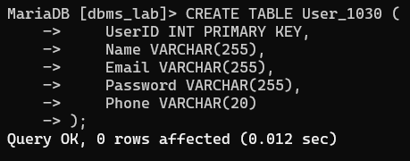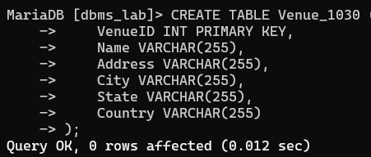

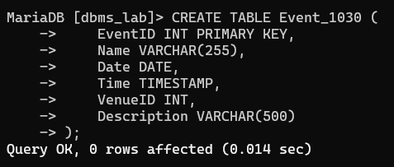
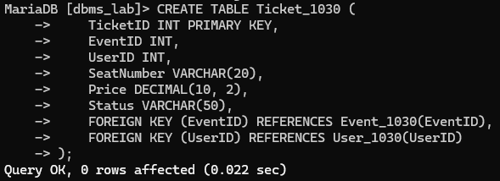
- Describe the tables.
DESCRIBE User_1030;
DESCRIBE Event_1030;
DESCRIBE Venue_1030;
DESCRIBE Ticket_1030;

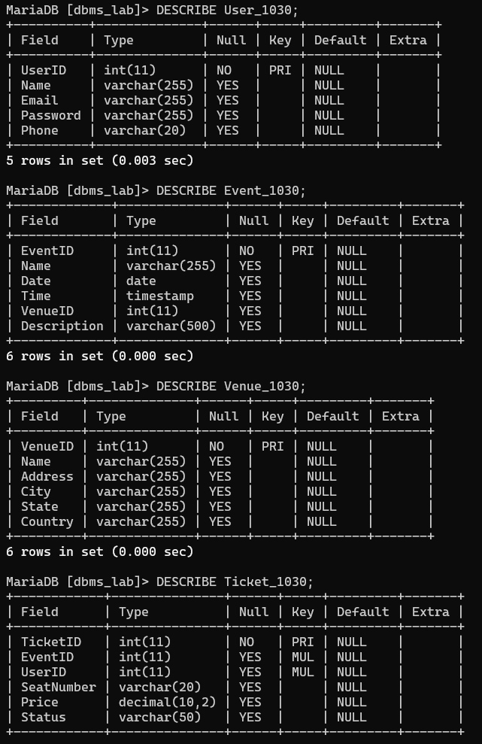

- Alter the User table to add a new column Age.
ALTER TABLE User_1030 ADD Age INT;
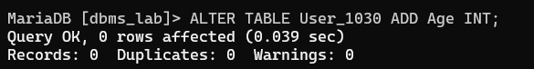
- Drop the newly added column Age.
ALTER TABLE User_1030 DROP COLUMN Age;
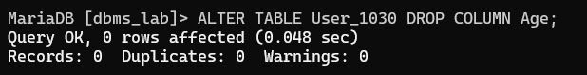
- Rename the Venue table to Location
RENAME TABLE Venue_1030 TO Location_1030;
- Modify the size of the Event table's Description column to 1000.
ALTER TABLE Event_1030 MODIFY Description VARCHAR(1000);
- Drop the SeatNumber column from the Ticket table
ALTER TABLE Ticket_1030 DROP COLUMN SeatNumber;
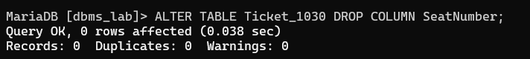
- Add a unique constraint on the Email column in the User table
ALTER TABLE User_1030 ADD CONSTRAINT uq_email UNIQUE (Email);

- Rename the UserID column in the User table to ID
ALTER TABLE User_1030 RENAME COLUMN UserID TO ID;
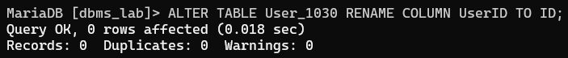
- Modify the Ticket table to add a column named "Barcode" with a data type of VARCHAR2(50).
ALTER TABLE Ticket_1030 ADD Barcode VARCHAR(50);
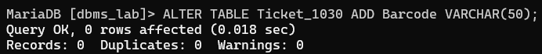
- Modify the Name column in the Venue table to increase its maximum length to VARCHAR2(300)
ALTER TABLE Location_1030 MODIFY Name VARCHAR(300);
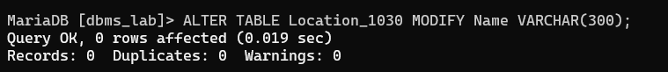
- Add a foreign key constraint on the VenueID column in the Event table, referencing the Venue table.
ALTER TABLE Event_1030 ADD CONSTRAINT fk_venue FOREIGN KEY (VenueID) REFERENCES Location_1030(VenueID);
- Add a CHECK constraint to check whether the UserID is between 101 and 105
ALTER TABLE User_1030 ADD CONSTRAINT chk_userid CHECK (ID BETWEEN 101 AND 105);

- Add a unique constraint to Phone column of the User table.
ALTER TABLE User_1030 ADD CONSTRAINT uq_phone UNIQUE (Phone);
- Truncate the user table.
TRUNCATE TABLE User_1030;
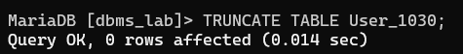

Result:
Thus, the various DDL commands to create, alter, drop, and manage the database tables were successfully executed, and the desired output was obtained.

