Data Type
Column

Ex. No. 1(a) – Creating and Managing Tables
Date: 08/07/2026
Aim
To execute DDL commands and get the desired output.

Description
DDL refers to "Data Definition Language", a subset of SQL statements that change the structure of the database schema in some way, typically by creating, deleting, or modifying schema objects such as databases, tables, and views. Most Impala DDL statements start with the keywords CREATE , DROP , or ALTER .
In this schema, we have four main tables: User, Event, Venue, and Ticket.
User table:
Column | Data Type
UserID | NUMBER(10)
Name | VARCHAR2(255)
Email | VARCHAR2(255)
Password | VARCHAR2(255)
Phone | VARCHAR2(20)
Event table:
Column | Data Type
EventID | NUMBER(10)
Name | VARCHAR2(255)
Date | DATE
Time | TIMESTAMP
VenueID | NUMBER(10) (Foreign key)
Description | VARCHAR2(500)
Venue table:
Column | Data Type
VenueID | NUMBER(10)
Name | VARCHAR2(255)
Address | VARCHAR2(255)
City | VARCHAR2(255)
State | VARCHAR2(255)
Country | VARCHAR2(255)
Ticket table:

TicketID | NUMBER(10)
EventID | NUMBER(10) (Foreign key)
UserID | NUMBER(10)
SeatNumber | VARCHAR2(20)
Price | NUMBER(10, 2)
Status | VARCHAR2(50)

Queries(DDL Commands)
- Create User, Event, Venue, and ticket tables based on the given schema.
CREATE TABLE users (
UserID NUMBER(10) PRIMARY KEY,
Name VARCHAR2(255),
Email VARCHAR2(255),
Password VARCHAR2(255),
Phone VARCHAR2(20)
);
CREATE TABLE venue (
VenueID NUMBER(10) PRIMARY KEY,
Name VARCHAR2(255),
Address VARCHAR2(255),
City VARCHAR2(255),
State VARCHAR2(255),
Country VARCHAR2(255)
);
CREATE TABLE event (
EventID NUMBER(10) PRIMARY KEY,
Name VARCHAR2(255),
EventDate DATE,
EventTime TIMESTAMP,
VenueID NUMBER(10),
Description VARCHAR2(500)
);
CREATE TABLE ticket (
TicketID NUMBER(10) PRIMARY KEY,
EventID NUMBER(10) REFERENCES event(EventID),
UserID NUMBER(10),
SeatNumber VARCHAR2(20),
Price NUMBER(10,2),
Status VARCHAR2(50)
);
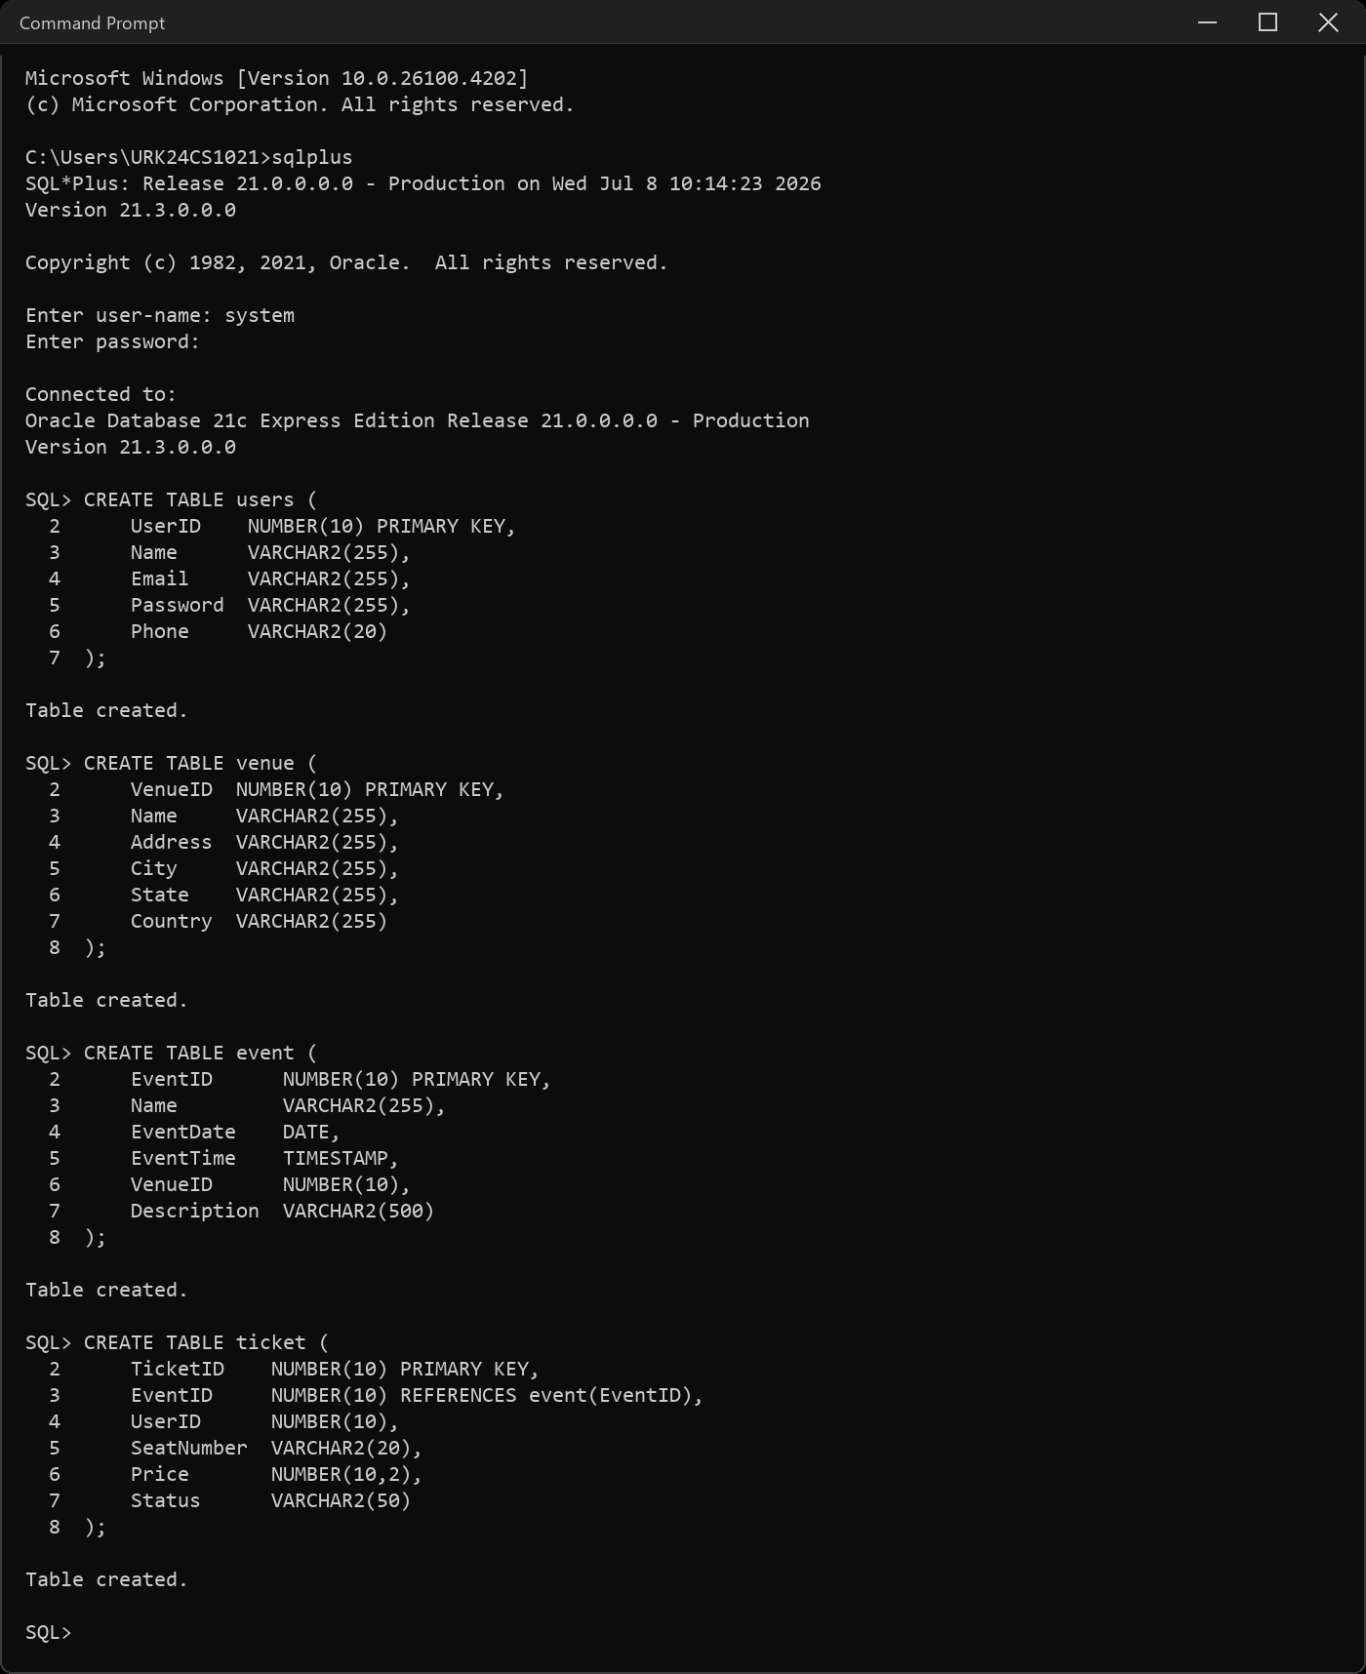
- Describe the tables.
DESC users
DESC event
DESC venue
DESC ticket
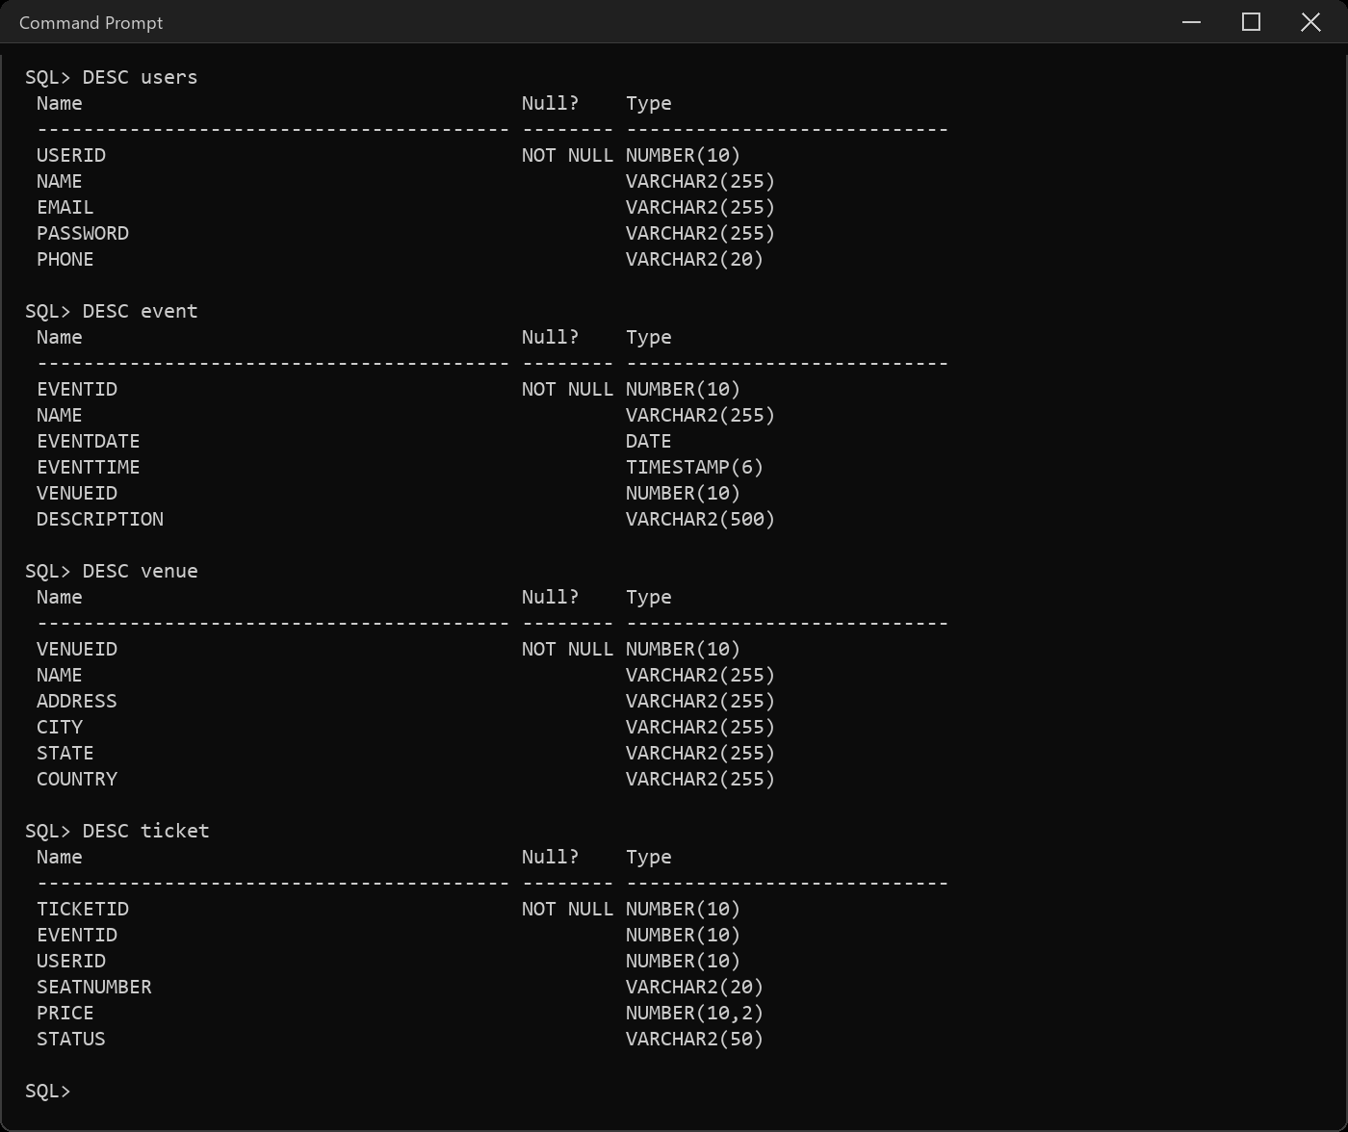
- Alter the User table to add a new column Age.
ALTER TABLE users ADD Age NUMBER(3);
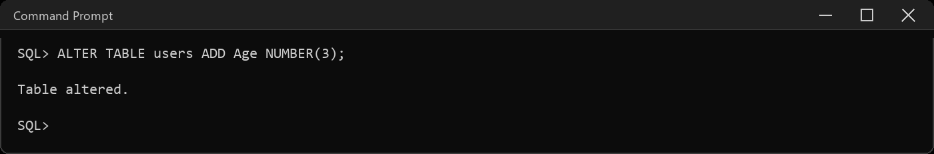
- Drop the newly added column Age.
ALTER TABLE users DROP COLUMN Age;
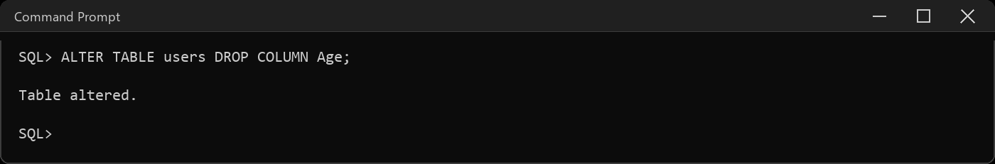
- Rename the Venue table to Location
RENAME venue TO location;
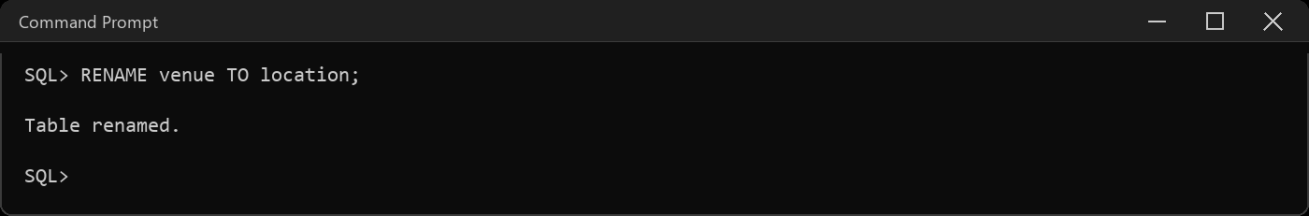
- Modify the size of the Event table's Description column to 1000.
ALTER TABLE event MODIFY Description VARCHAR2(1000);
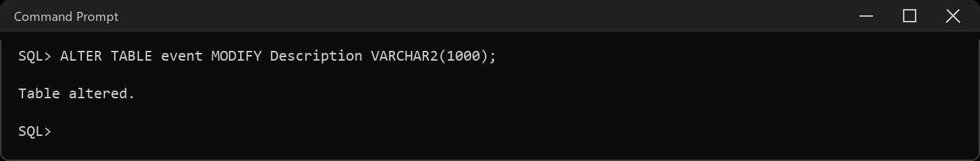
- Drop the SeatNumber column from the Ticket table
ALTER TABLE ticket DROP COLUMN SeatNumber;
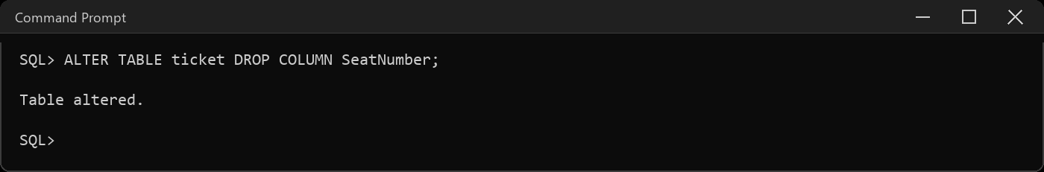
- Add a unique constraint on the Email column in the User table
ALTER TABLE users ADD CONSTRAINT users_email_uq UNIQUE (Email);
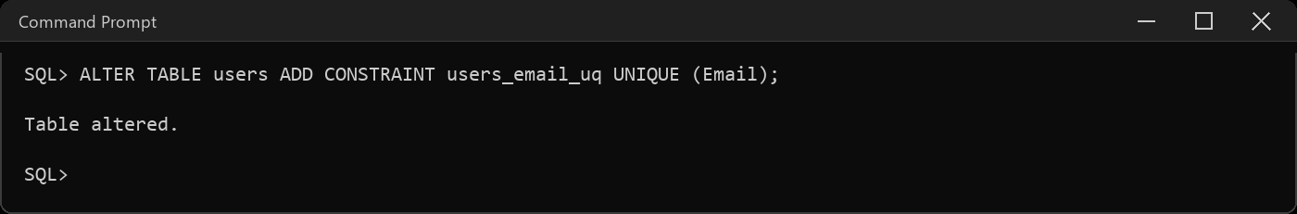
- Rename the UserID column in the User table to ID
ALTER TABLE users RENAME COLUMN UserID TO ID;
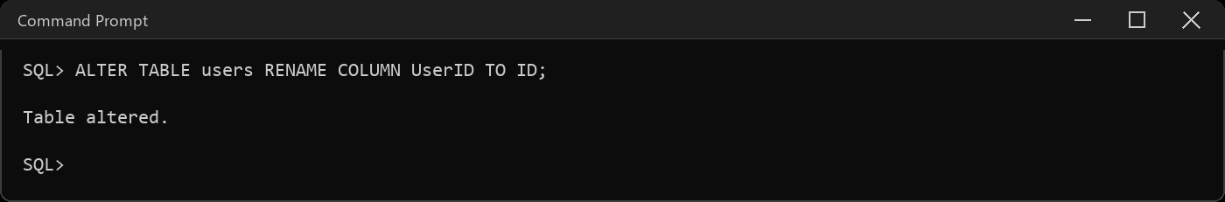
- Modify the Ticket table to add a column named "Barcode" with a data type of VARCHAR2(50).
ALTER TABLE ticket ADD Barcode VARCHAR2(50);
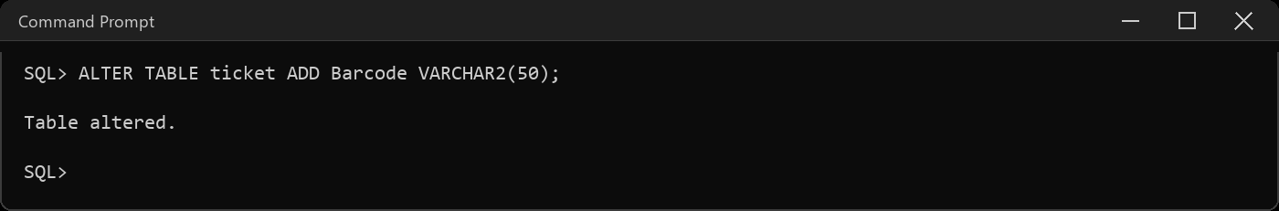
- Modify the Name column in the Venue table to increase its maximum length to VARCHAR2(300)
ALTER TABLE location MODIFY Name VARCHAR2(300);
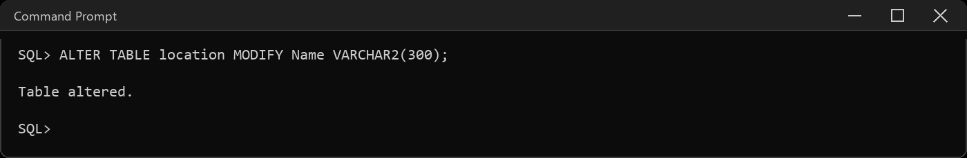
- Add a foreign key constraint on the VenueID column in the Event table, referencing the Venue table.
ALTER TABLE event ADD CONSTRAINT event_venue_fk FOREIGN KEY (VenueID) REFERENCES location(VenueID);
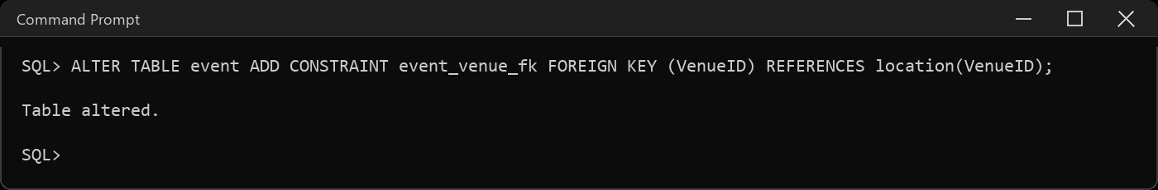
- Add a CHECK constraint to check whether the UserID is between 101 and 105
ALTER TABLE users ADD CONSTRAINT users_id_chk CHECK (ID BETWEEN 101 AND 105);
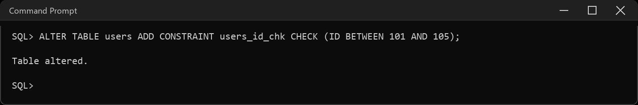
- Add a unique constraint to Phone column of the User table.
ALTER TABLE users ADD CONSTRAINT users_phone_uq UNIQUE (Phone);
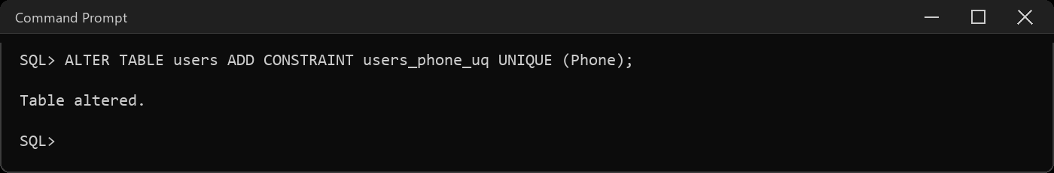

- Truncate the user table.
TRUNCATE TABLE users;
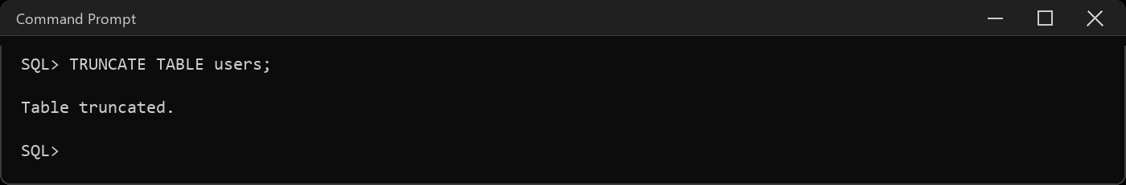
Result:
The DDL commands were executed and the desired output was obtained.

