Ex. No. 1 | Online Gaming Community Website
Date of Exercise | 27/07/2026
GitHub Host Link | https://kukyos.github.io/WebTechLab/Ex1/index.html

Aim
To design and develop a structured HTML5 website for an online gaming community, using semantic elements and formatting techniques to demonstrate a clear understanding of HTML5 fundamentals.
Description
The page uses the standard HTML5 structure (doctype, head with meta/title, body split into sections using <div>). It covers headings (h1-h3), multiple paragraphs, all six required link types (external with target="_blank", internal id-based navigation, a bookmark back-to-top link, a mailto: link, a tel: link, and a clickable image link), a descriptive <img>, a data table, a description list (dl/dt/dd), a nested ordered list and a nested unordered list, and an HTML comment above every section. The background and text colors are applied with inline CSS on the body and on individual headings, links and table cells; no external or internal stylesheet is used.
Procedure:
1. Picked the theme: an online gaming community site ("Respawn Point"), similar in spirit to a Discord community page.
2. Created index.html with the <!DOCTYPE html> declaration and the html/head/meta/title/body skeleton.
3. Built the nav bar as a <div> with internal links (#about, #games, #roles, #join, #rules, #contact) to each section further down the page.
4. Added the hero section with the h1 site name and a tagline paragraph.
5. Wrote the About section (h2 + h3 + paragraphs) and generated a banner image, wrapped it in an <a> tag so it's a clickable image link too.
6. Added a table listing the featured games, a description list for the community roles, a nested ordered list for the join steps, and a nested unordered list for the rules.
7. Added the contact section with a mailto: link, a tel: link, an external Wikipedia link (target="_blank"), and a bookmark link back to the top of the page.
8. Wrote an HTML comment above every section explaining what it is.
9. Set the page background color and the text color with inline CSS on the <body> tag, and used the same inline style attribute on the headings, links and table header cells to give them the orange and green accent colors.
10. Opened the page in the browser to check every section renders and every link/id target actually works, then took the output screenshots.
Program

<!DOCTYPE html>
<html lang="en">
<head>
<meta charset="UTF-8">
<title>Respawn Point - Online Gaming Community</title>
</head>
<body style="background-color: #1c1b18; color: #eae6df">
<!-- bookmark target for the "back to top" link at the bottom -->
<div id="top"></div>
<!-- nav bar: internal links to each section further down the page -->
<div style="background-color: #242220">
<p>
<b>
<a href="#about" style="color: #e8792c">About</a> &nbsp;|&nbsp;
<a href="#games" style="color: #e8792c">Games</a> &nbsp;|&nbsp;
<a href="#roles" style="color: #e8792c">Roles</a> &nbsp;|&nbsp;
<a href="#join" style="color: #e8792c">Join</a> &nbsp;|&nbsp;
<a href="#rules" style="color: #e8792c">Rules</a> &nbsp;|&nbsp;
<a href="#contact" style="color: #e8792c">Contact</a>
</b>
</p>
</div>
<hr style="color: #e8792c">
<!-- hero / landing section -->
<div>
<h1 style="color: #e8792c">Respawn Point</h1>
<p style="color: #b7b1a4">
<i>a place to find your next squad, not just your next game</i>
</p>
</div>
<!-- about the community -->
<div id="about">
<h2 style="color: #f3a15c">About the Community</h2>
<p>
Respawn Point started in 2023 as a small Discord server for a few of us
who kept getting split into different lobbies. It has grown into a
community of a few thousand people across battle royale, racing, MMORPG
and FPS games who mostly just want to play with people who won't rage
quit on them.
</p>
<h3 style="color: #7fae5a">Why we exist</h3>
<p>
Public matchmaking is fine until your teammate disconnects at the worst
possible moment. We're here so that doesn't have to happen every single
match.
</p>
</div>
<!-- clickable image link: the banner jumps down to the games section -->
<div>
<a href="#games">
<img src="banner.png" alt="Respawn Point community banner artwork" width="700">
</a>
</div>
<!-- featured games table -->
<div id="games">
<h2 style="color: #f3a15c">Featured Games</h2>
<table border="1" cellpadding="8" cellspacing="0">
<tr style="background-color: #242220">
<th style="color: #e8792c">Game</th>
<th style="color: #e8792c">Genre</th>
<th style="color: #e8792c">Players Online</th>
<th style="color: #e8792c">Skill Tier</th>
</tr>
<tr>
<td>Nightfall Arena</td>
<td>Battle Royale</td>
<td>1,204</td>
<td>Bronze - Diamond</td>
</tr>
<tr>
<td>Circuit Breakers</td>
<td>Racing</td>
<td>386</td>
<td>Open to all</td>
</tr>
<tr>
<td>Warden's Keep</td>
<td>MMORPG</td>
<td>2,891</td>
<td>Level 5+</td>
</tr>
<tr>
<td>Clutch City</td>
<td>FPS</td>
<td>977</td>
<td>Silver and up</td>
</tr>
</table>
</div>
<!-- community roles, as a description list -->
<div id="roles">
<h2 style="color: #f3a15c">Community Roles</h2>
<dl>
<dt style="color: #7fae5a"><b>Member</b></dt>
<dd>Default role once you join. Access to general chat and the game-specific channels.</dd>
<dt style="color: #7fae5a"><b>Moderator</b></dt>
<dd>Keeps the chat civil, handles reports, can mute or kick when needed.</dd>
<dt style="color: #7fae5a"><b>Admin</b></dt>
<dd>Runs events, manages roles, and is who you complain to about the ping tax on Warden's Keep servers.</dd>
</dl>
</div>
<!-- how to join: nested ordered list -->
<div id="join">
<h2 style="color: #f3a15c">How to Join</h2>
<ol>
<li>Read the rules pinned in #welcome</li>
<li>Pick your main game(s):
<ol type="a">
<li>Battle royale squad</li>
<li>Racing crew</li>
<li>MMORPG guild</li>
</ol>
</li>
<li>Introduce yourself in #introductions</li>
<li>Grab your game roles from the reaction board</li>
</ol>
</div>
<!-- ground rules: nested unordered list -->
<div id="rules">
<h2 style="color: #f3a15c">Ground Rules</h2>
<ul>
<li>Be respectful, no harassment or hate speech
<ul>
<li>this includes chat, voice channels and in-game lobbies</li>
</ul>
</li>
<li>No spamming or unsolicited DMs</li>
<li>Keep NSFW content out of every channel</li>
<li>Follow game-specific etiquette:
<ul>
<li>no griefing teammates</li>
<li>no smurfing in ranked lobbies</li>
</ul>
</li>
</ul>
</div>
<!-- contact: email link, phone link, external link, bookmark link -->
<div id="contact">
<h2 style="color: #f3a15c">Get In Touch</h2>
<p>Email: <a href="mailto:hello@respawnpoint.gg" style="color: #7fae5a">hello@respawnpoint.gg</a></p>
<p>Call the community desk: <a href="tel:+919876543210" style="color: #7fae5a">+91 98765 43210</a></p>
<p>
New to competitive gaming? Wikipedia has a solid
<a href="https://en.wikipedia.org/wiki/Esports" target="_blank" style="color: #7fae5a">overview of esports</a>
to get you started.
</p>
<p><a href="#top" style="color: #7fae5a">Back to top</a></p>
</div>
<hr style="color: #e8792c">
<!-- footer -->
<div style="color: #b7b1a4">
<p><small>&copy; 2026 Respawn Point. Made for URK24CS1021's Web Tech lab, not an actual gaming company.</small></p>
</div>
</body>
</html>
Output

Nav bar, hero, about section, banner image and the games table
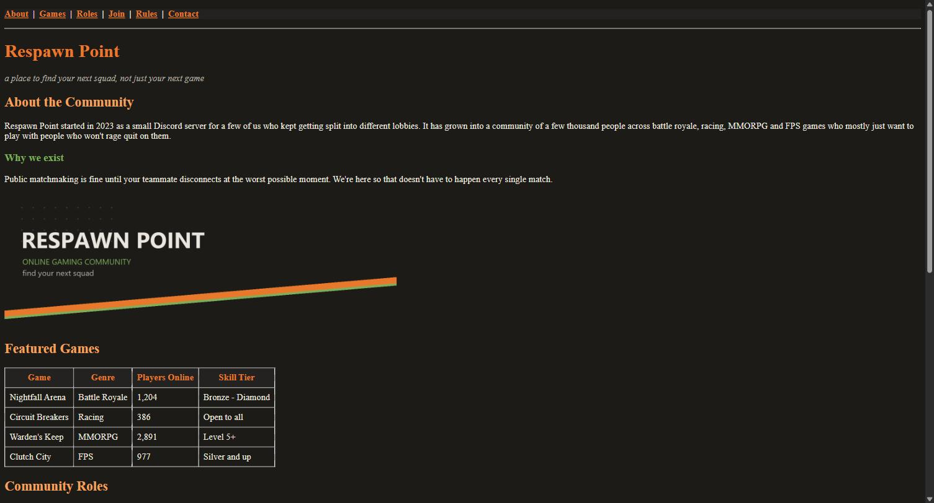
Community roles, join steps, ground rules and the contact section
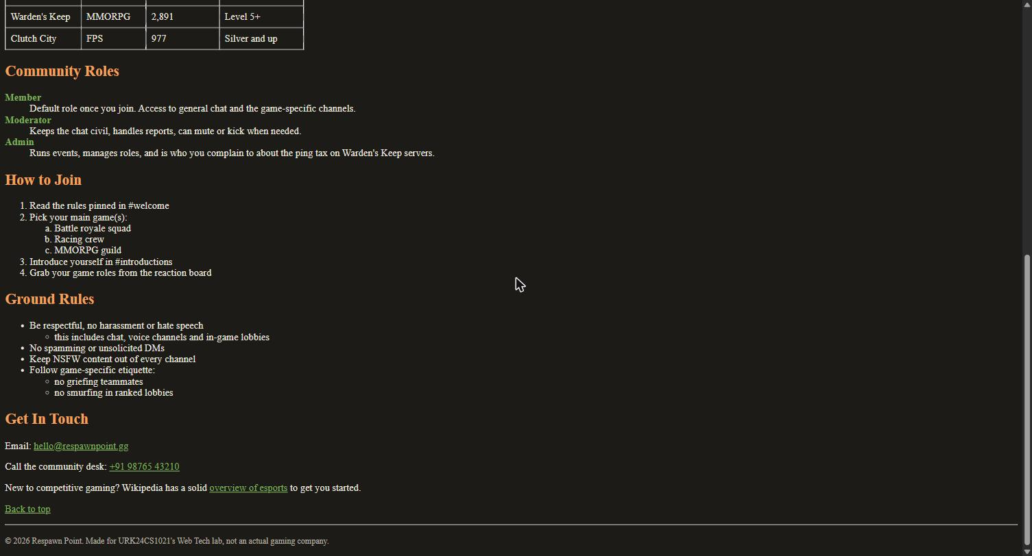
Result
The HTML5 web page for the online gaming community theme was successfully designed and executed using the required tags, formatting elements and structure. The output matched the expected layout and content.

