Ex. No. 2 | BASIC SQL
Date of Exercise | 29/07/2026

Aim
To execute the given basic SQL queries.
Description
DML (Data Manipulation Language) statements manipulate the data held within tables: INSERT adds rows, UPDATE changes existing rows, DELETE removes rows, and SELECT retrieves rows, optionally filtered with a WHERE clause (comparison, AND/OR, IS NULL, IN, LIKE, BETWEEN), grouped with GROUP BY, and ordered with ORDER BY.
1. Insert all the fields given in the ticket reservation schema.
Sample Code:
use dbmslab
INSERT INTO LocationURK24CS1006 (VenueID, Name, Address, City, State, Country)
VALUES (1, 'Madison Square Garden', '4 Pennsylvania Plaza', 'New York', 'New York', 'USA');
INSERT INTO UsersURK24CS1006 (ID, Name, Email, Password, Phone)
VALUES (101, 'John Doe', 'john@example.com', 'password123', '9876543210');
INSERT INTO EventURK24CS1006 (EventID, Name, EventDate, EventTime, VenueID, Description)
VALUES (201, 'Rock Concert', '2023-08-15', '2023-08-15 19:00:00', 1, 'Live Rock Music');
INSERT INTO TicketURK24CS1006 (TicketID, EventID, UserID, Price, Status, Barcode)
VALUES (301, 201, 101, 100.00, 'Confirmed', 'BC301');
Sample Output:
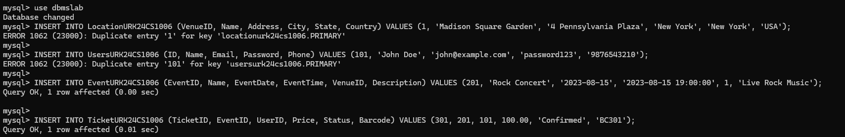
2. Display all the fields in User, Events, Venue and Ticket tables.
Sample Code:
SELECT * FROM TicketURK24CS1006;
SELECT * FROM UsersURK24CS1006;
SELECT * FROM EventURK24CS1006;
SELECT * FROM LocationURK24CS1006;
Sample Output:
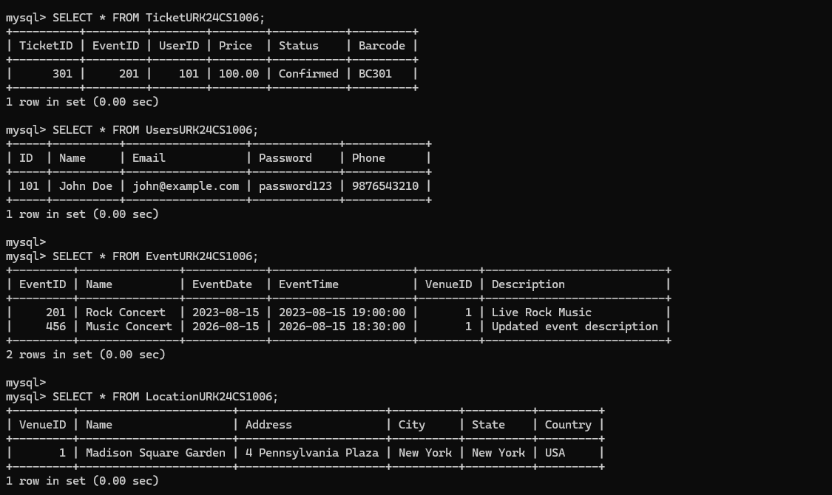
3. Retrieve all venues ordered by city and then by country.
Sample Code:
SELECT *
FROM LocationURK24CS1006
ORDER BY City ASC, Country ASC;
Sample Output:
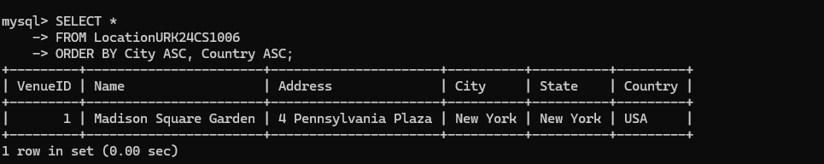
4. Retrieve total number of users.
Sample Code:
SELECT COUNT(*) AS TotalUsers
FROM UsersURK24CS1006;
Sample Output:
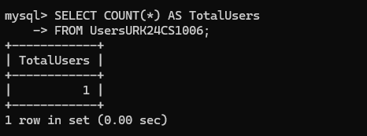
5. Retrieve all events ordered by date and time in descending order.
Sample Code:
SELECT *
FROM EventURK24CS1006
ORDER BY EventDate DESC, EventTime DESC;
Sample Output:
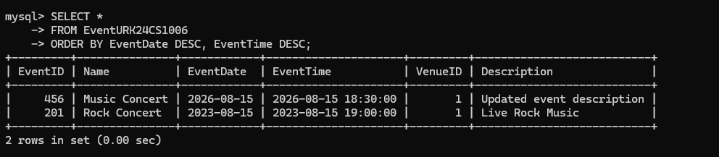
6. Get the average price of tickets for each event.
Sample Code:
SELECT EventID, AVG(Price) AS AveragePrice
FROM TicketURK24CS1006
GROUP BY EventID;
Sample Output:
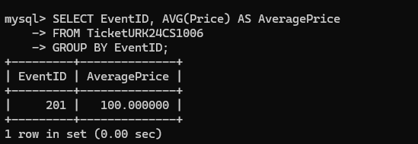
7. Get the total price and count of tickets for each event.
Sample Code:
SELECT EventID, SUM(Price) AS TotalPrice, COUNT(*) AS TicketCount
FROM TicketURK24CS1006
GROUP BY EventID;
Sample Output:
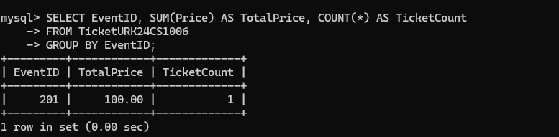
8. Count the number of tickets for each event.
Sample Code:
SELECT EventID, COUNT(*) AS NumberOfTickets
FROM TicketURK24CS1006
GROUP BY EventID;
Sample Output:
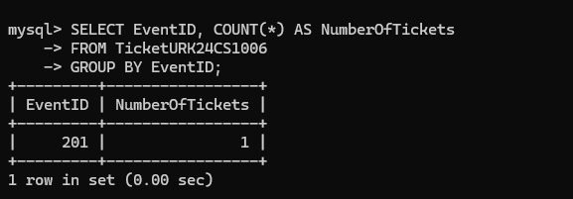
9. Retrieve a distinct number of users.
Sample Code:
SELECT DISTINCT *
FROM UsersURK24CS1006;
Sample Output:
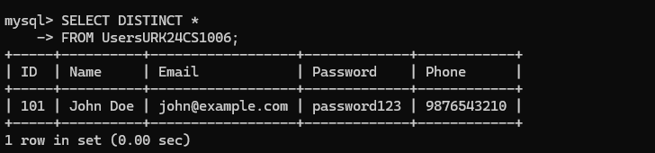
10. Retrieve the events conducted after 30/07/2023.
Sample Code:
SELECT *
FROM EventURK24CS1006
WHERE EventDate > '2023-07-30';
Sample Output:
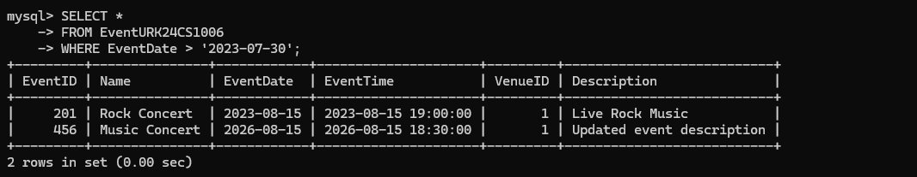
11. Calculate the sum of prices for all confirmed tickets.
Sample Code:
SELECT SUM(Price) AS TotalConfirmedPrice
FROM TicketURK24CS1006
WHERE Status = 'Confirmed';
Sample Output:
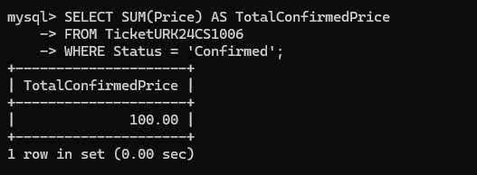
12. Concatenate the user's name and email for display.
Sample Code:
SELECT CONCAT(Name, ' - ', Email) AS UserDetails
FROM UsersURK24CS1006;
Sample Output:
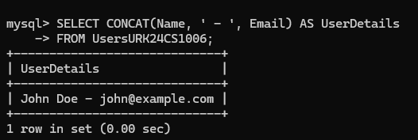
13. Retrieve the venue from the city New York and country USA.
Sample Code:
SELECT *
FROM LocationURK24CS1006
WHERE City = 'New York' AND Country = 'USA';
Sample Output:
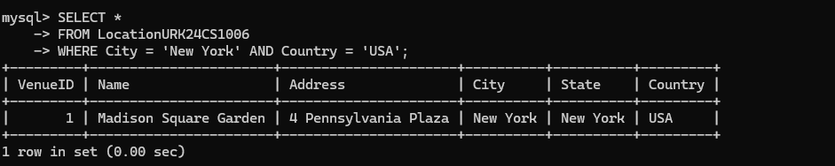
14. Retrieve all cities ordered by Country in ascending order.
Sample Code:
SELECT City, Country
FROM LocationURK24CS1006
ORDER BY Country ASC;
Sample Output:
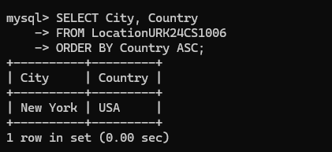
15. Delete the cancelled ticket in the ticket table.
Sample Code:
DELETE FROM TicketURK24CS1006
WHERE Status = 'Cancelled';
Sample Output:
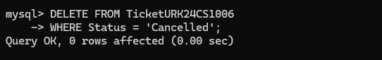
RESULT
The SQL queries were executed and the desired output was obtained.

