Ex. No. 1  Date: 29/07/2026 | CREATING AND MANAGING TABLES | URK24CS1006
Aim
(a) Creating and Managing Tables
To execute DDL commands and get the desired output.
(b) Managing Tables using DML, DCL and TCL Commands
To execute all commands of Data Manipulation Language, Data Control Language, and Transaction Control Language to get the desired output.
Description
(a) Creating and Managing Tables
DDL refers to "Data Definition Language", a subset of SQL statements that change the structure of the database schema in some way, typically by creating, deleting, or modifying schema objects such as databases, tables, and views. Most DDL statements start with the keywords CREATE, DROP, or ALTER.
(b) Managing Tables using DML, DCL and TCL Commands
DML statements (INSERT/UPDATE/DELETE) manipulate row data. DCL statements (GRANT/REVOKE) control access privileges on database objects for specific roles. TCL statements (COMMIT/ROLLBACK/SAVEPOINT) control transaction boundaries — COMMIT makes changes permanent, SAVEPOINT marks a point to roll back to within an open transaction, and ROLLBACK TO undoes work back to that point without discarding the whole transaction.
Questions
(a) Creating and Managing Tables
1. Create User, Event, Venue, and ticket tables based on the given schema.
CREATE TABLE VenueURK24CS1006 (
VenueID INT PRIMARY KEY,
Name VARCHAR(255),
Address VARCHAR(255),
City VARCHAR(255),
State VARCHAR(255),
Country VARCHAR(255)
);
CREATE TABLE UsersURK24CS1006 (
UserID INT PRIMARY KEY,
Name VARCHAR(255),
Email VARCHAR(255),
Password VARCHAR(255),
Phone VARCHAR(20)
);
CREATE TABLE EventURK24CS1006 (
EventID INT PRIMARY KEY,
Name VARCHAR(255),
EventDate DATE,
EventTime TIMESTAMP,
VenueID INT,
Description VARCHAR(500)
);
CREATE TABLE TicketURK24CS1006 (
TicketID INT PRIMARY KEY,
EventID INT,
UserID INT,
SeatNumber VARCHAR(20),
Price DECIMAL(10,2),
Status VARCHAR(50)
);
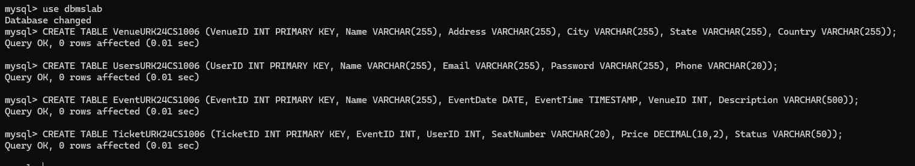
2. Describe the tables.
DESC UsersURK24CS1006;
DESC EventURK24CS1006;
DESC VenueURK24CS1006;
DESC TicketURK24CS1006;
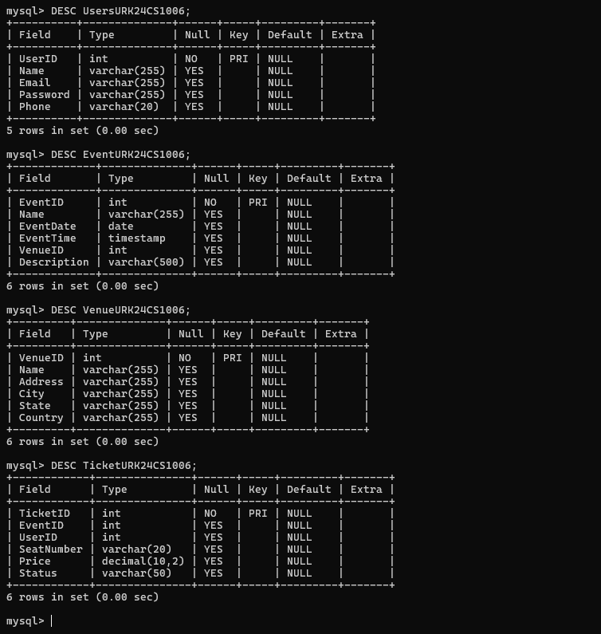
3. Alter the User table to add a new column Age.
ALTER TABLE UsersURK24CS1006 ADD Age INT;
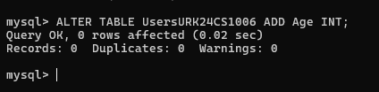
4. Drop the newly added column Age.
ALTER TABLE UsersURK24CS1006 DROP COLUMN Age;
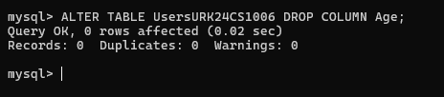
5. Rename the Venue table to Location.
RENAME TABLE VenueURK24CS1006 TO LocationURK24CS1006;
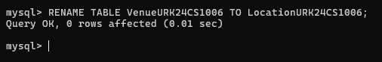
6. Modify the size of the Event table's Description column to 1000.
ALTER TABLE EventURK24CS1006 MODIFY Description VARCHAR(1000);
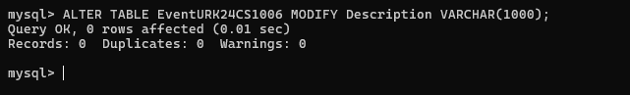
7. Drop the SeatNumber column from the Ticket table.
ALTER TABLE TicketURK24CS1006 DROP COLUMN SeatNumber;
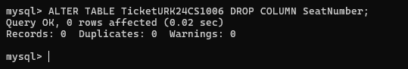
8. Add a unique constraint on the Email column in the User table.
ALTER TABLE UsersURK24CS1006 ADD CONSTRAINT unique_email UNIQUE (Email);
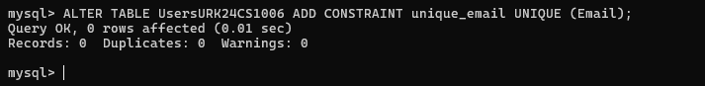
9. Rename the UserID column in the User table to ID.
ALTER TABLE UsersURK24CS1006 CHANGE UserID ID INT;
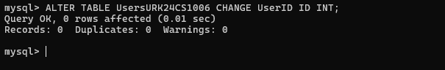
10. Modify the Ticket table to add a column named "Barcode" with a data type of VARCHAR(50).
ALTER TABLE TicketURK24CS1006 ADD Barcode VARCHAR(50);
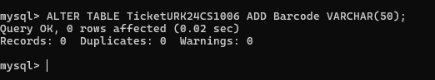
11. Modify the Name column in the Venue table to increase its maximum length to VARCHAR(300).
ALTER TABLE LocationURK24CS1006 MODIFY Name VARCHAR(300);
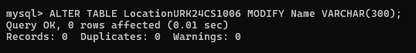
12. Add a foreign key constraint on the VenueID column in the Event table, referencing the Venue table.
ALTER TABLE EventURK24CS1006 ADD CONSTRAINT fk_event_venue
FOREIGN KEY (VenueID) REFERENCES LocationURK24CS1006(VenueID);
13. Add a CHECK constraint to check whether the UserID is between 101 and 105.
ALTER TABLE UsersURK24CS1006 ADD CONSTRAINT check_userid CHECK (ID BETWEEN 101 AND 105);
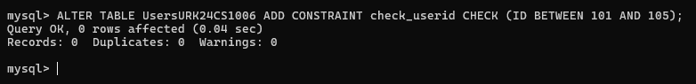
14. Add a unique constraint to Phone column of the User table.
ALTER TABLE UsersURK24CS1006 ADD CONSTRAINT unique_phone UNIQUE (Phone);
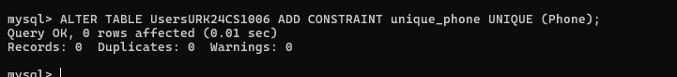
15. Truncate the user table.
TRUNCATE TABLE UsersURK24CS1006;
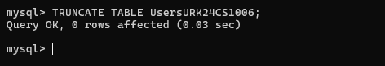
(b) Managing Tables using DML, DCL and TCL Commands
1. Insert a new user into the "User" table.
2. Update the email address of a user with UserID 102.
UPDATE UsersURK24CS1006 SET Email = 'newemail@example.com' WHERE ID = 123;
3. Delete a user with the email "example@example.com".
DELETE FROM UsersURK24CS1006 WHERE Email = 'example@example.com';
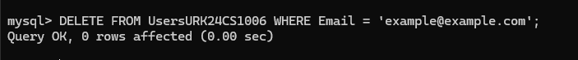
4. Insert a new event into the "Event" table.
INSERT INTO EventURK24CS1006 (EventID, Name, EventDate, EventTime, VenueID, Description)
VALUES (456, 'Music Concert', '2026-08-15', '2026-08-15 18:30:00', 1, 'Live music concert');
5. Update the description of an event with EventID 401.
UPDATE EventURK24CS1006 SET Description = 'Updated event description'
WHERE EventID = 456;
6. Grant SELECT privileges on the "User" table to a user named "john".
GRANT SELECT ON dbmslab.UsersURK24CS1006 TO 'john'@'localhost';
7. Revoke INSERT privileges on the "Event" table from a user named "mary".
REVOKE INSERT ON dbmslab.EventURK24CS1006 FROM 'mary'@'localhost';
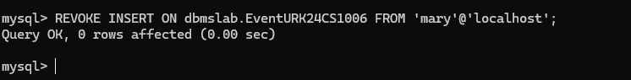
8. Create a new user with the username "jane" and grant them all privileges on the "Ticket" table.
GRANT ALL PRIVILEGES ON dbmslab.TicketURK24CS1006 TO 'jane'@'localhost';
9. Grant EXECUTE privileges on a stored procedure to a role named "admin".
GRANT SELECT ON dbmslab.* TO 'guest'@'localhost';
REVOKE ALL PRIVILEGES ON dbmslab.* FROM 'guest'@'localhost';
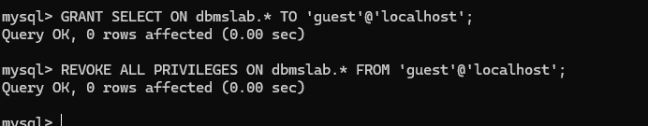
10. Revoke all privileges from a user named "guest" on all tables in the schema.
GRANT SELECT ON dbmslab.* TO 'guest'@'localhost';
REVOKE ALL PRIVILEGES ON dbmslab.* FROM 'guest'@'localhost';
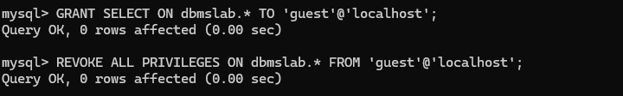
11. Perform commit a transaction in the database.
COMMIT;
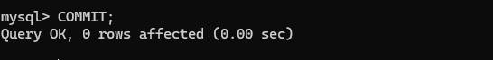
12. Perform roll back a transaction to a specific savepoint.
ROLLBACK TO SAVEPOINT sp1;
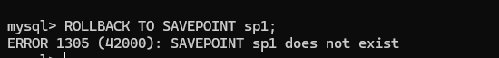
13. Perform set a savepoint within a transaction.
SAVEPOINT sp1;
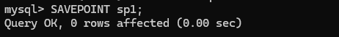
14. Enable autocommit mode in the database.
SET autocommit = 1;
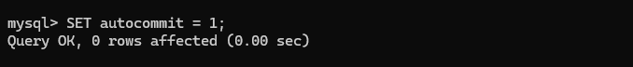
15. Disable autocommit mode in the database.
SET autocommit = 0;
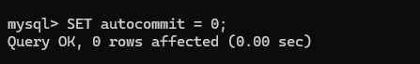
Result
The queries were executed and the desired output was obtained.

