Ex. No. 2  Date: 29/07/2026 | BASIC SQL | URK24CS1006
Aim
To execute the given basic SQL queries.
Description
DML (Data Manipulation Language) statements manipulate the data held within tables: INSERT adds rows, UPDATE changes existing rows, DELETE removes rows, and SELECT retrieves rows, optionally filtered with a WHERE clause (comparison, AND/OR, IS NULL, IN, LIKE, BETWEEN), grouped with GROUP BY, and ordered with ORDER BY.
Questions
1. Insert all the fields given in the ticket reservation schema.
use dbmslab
INSERT INTO LocationURK24CS1006 (VenueID, Name, Address, City, State, Country)
VALUES (1, 'Madison Square Garden', '4 Pennsylvania Plaza', 'New York', 'New York', 'USA');
INSERT INTO UsersURK24CS1006 (ID, Name, Email, Password, Phone)
VALUES (101, 'John Doe', 'john@example.com', 'password123', '9876543210');
INSERT INTO EventURK24CS1006 (EventID, Name, EventDate, EventTime, VenueID, Description)
VALUES (201, 'Rock Concert', '2023-08-15', '2023-08-15 19:00:00', 1, 'Live Rock Music');
INSERT INTO TicketURK24CS1006 (TicketID, EventID, UserID, Price, Status, Barcode)
VALUES (301, 201, 101, 100.00, 'Confirmed', 'BC301');
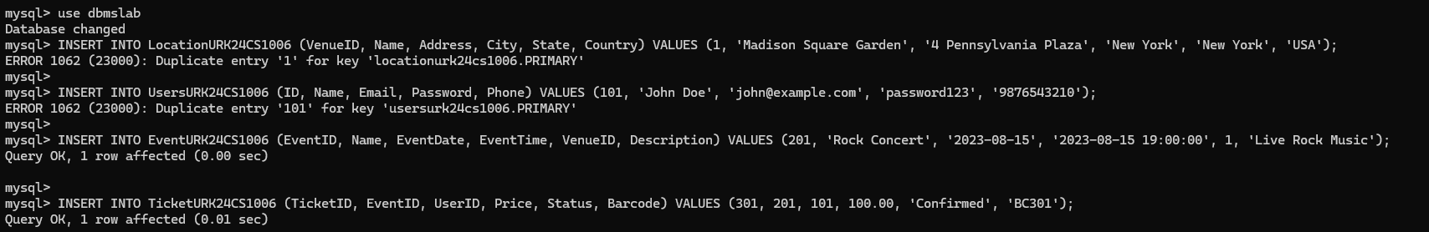
2. Display all the fields in User, Events, Venue and Ticket tables.
SELECT * FROM TicketURK24CS1006;
SELECT * FROM UsersURK24CS1006;
SELECT * FROM EventURK24CS1006;
SELECT * FROM LocationURK24CS1006;
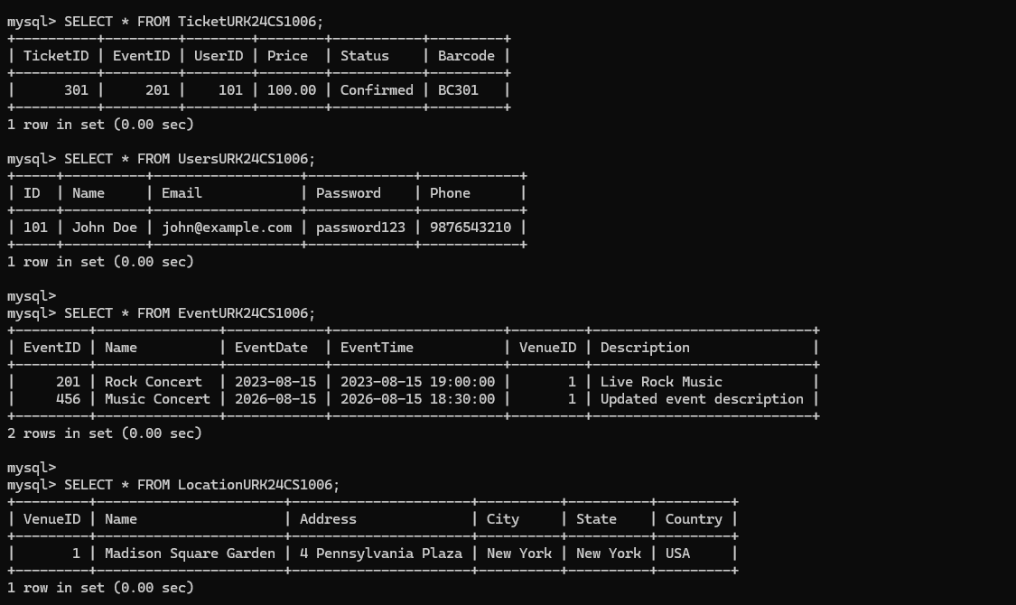
3. Retrieve all venues ordered by city and then by country.
SELECT *
FROM LocationURK24CS1006
ORDER BY City ASC, Country ASC;
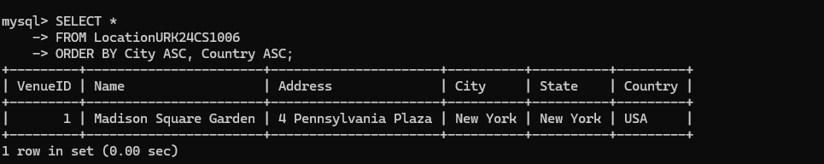
4. Retrieve total number of users.
SELECT COUNT(*) AS TotalUsers
FROM UsersURK24CS1006;
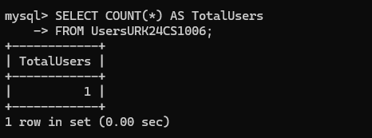
5. Retrieve all events ordered by date and time in descending order.
SELECT *
FROM EventURK24CS1006
ORDER BY EventDate DESC, EventTime DESC;
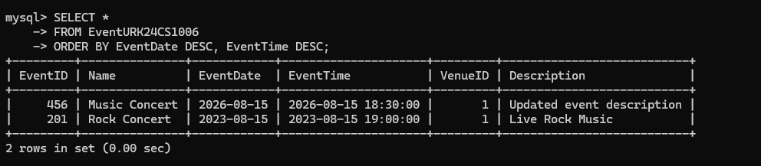
6. Get the average price of tickets for each event.
SELECT EventID, AVG(Price) AS AveragePrice
FROM TicketURK24CS1006
GROUP BY EventID;
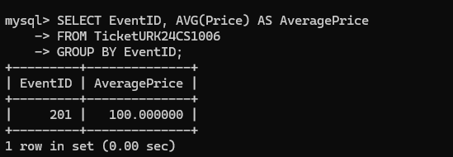
7. Get the total price and count of tickets for each event.
SELECT EventID, SUM(Price) AS TotalPrice, COUNT(*) AS TicketCount
FROM TicketURK24CS1006
GROUP BY EventID;
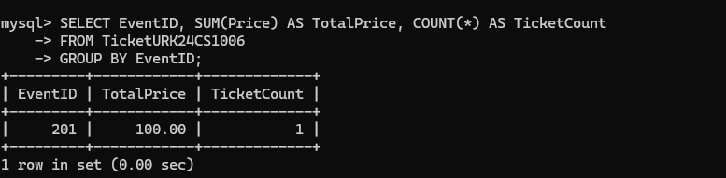
8. Count the number of tickets for each event.
SELECT EventID, COUNT(*) AS NumberOfTickets
FROM TicketURK24CS1006
GROUP BY EventID;
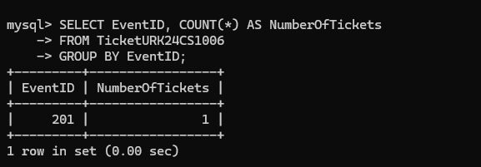
9. Retrieve a distinct number of users.
SELECT DISTINCT *
FROM UsersURK24CS1006;
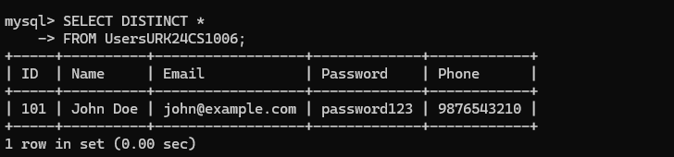
10. Retrieve the events conducted after 30/07/2023.
SELECT *
FROM EventURK24CS1006
WHERE EventDate > '2023-07-30';
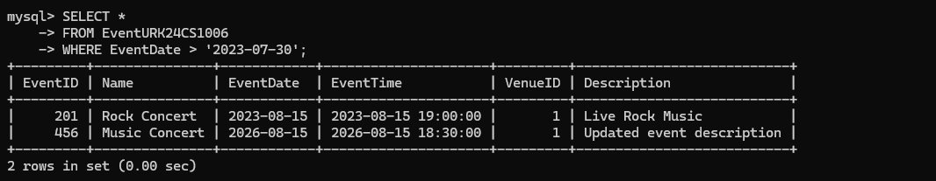
11. Calculate the sum of prices for all confirmed tickets.
SELECT SUM(Price) AS TotalConfirmedPrice
FROM TicketURK24CS1006
WHERE Status = 'Confirmed';
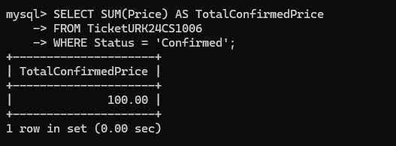
12. Concatenate the user's name and email for display.
SELECT CONCAT(Name, ' - ', Email) AS UserDetails
FROM UsersURK24CS1006;
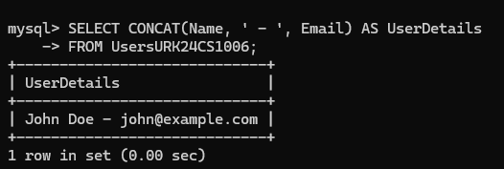
13. Retrieve the venue from the city New York and country USA.
SELECT *
FROM LocationURK24CS1006
WHERE City = 'New York' AND Country = 'USA';
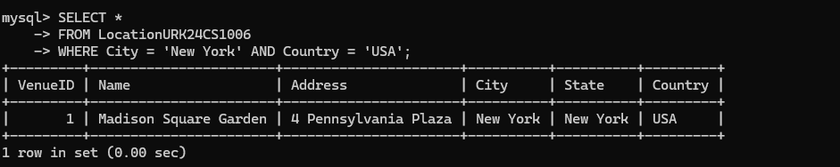
14. Retrieve all cities ordered by Country in ascending order.
SELECT City, Country
FROM LocationURK24CS1006
ORDER BY Country ASC;
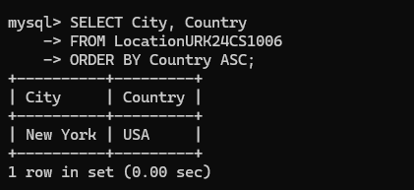
15. Delete the cancelled ticket in the ticket table.
DELETE FROM TicketURK24CS1006
WHERE Status = 'Cancelled';
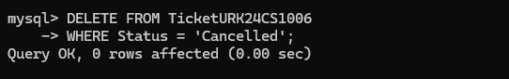
Result
The queries were executed and the desired output was obtained.

