Ex. No. 1  Date: 08/07/2026 | CREATING AND MANAGING TABLES | URK24CS1021
Aim
(a) Creating and Managing Tables
To execute DDL commands and get the desired output.
(b) Managing Tables using DML, DCL and TCL Commands
To execute all commands of Data Manipulation Language, Data Control Language, and Transaction Control Language to get the desired output.
Description
(a) Creating and Managing Tables
DDL refers to "Data Definition Language", a subset of SQL statements that change the structure of the database schema in some way, typically by creating, deleting, or modifying schema objects such as databases, tables, and views. Most DDL statements start with the keywords CREATE, DROP, or ALTER.
(b) Managing Tables using DML, DCL and TCL Commands
DML statements (INSERT/UPDATE/DELETE) manipulate row data. DCL statements (GRANT/REVOKE) control access privileges on database objects for specific roles. TCL statements (COMMIT/ROLLBACK/SAVEPOINT) control transaction boundaries — COMMIT makes changes permanent, SAVEPOINT marks a point to roll back to within an open transaction, and ROLLBACK TO undoes work back to that point without discarding the whole transaction.
Questions
(a) Creating and Managing Tables
1. Create User, Event, Venue, and ticket tables based on the given schema.
CREATE TABLE URK24CS1021_users (
userid numeric(10) PRIMARY KEY,
name varchar(255),
email varchar(255),
password varchar(255),
phone varchar(20)
);
CREATE TABLE URK24CS1021_venue (
venueid numeric(10) PRIMARY KEY,
name varchar(255),
address varchar(255),
city varchar(255),
state varchar(255),
country varchar(255)
);
CREATE TABLE URK24CS1021_event (
eventid numeric(10) PRIMARY KEY,
name varchar(255),
eventdate date,
eventtime timestamp,
venueid numeric(10),
description varchar(500)
);
CREATE TABLE URK24CS1021_ticket (
ticketid numeric(10) PRIMARY KEY,
eventid numeric(10) REFERENCES URK24CS1021_event(eventid),
userid numeric(10),
seatnumber varchar(20),
price numeric(10,2),
status varchar(50)
);
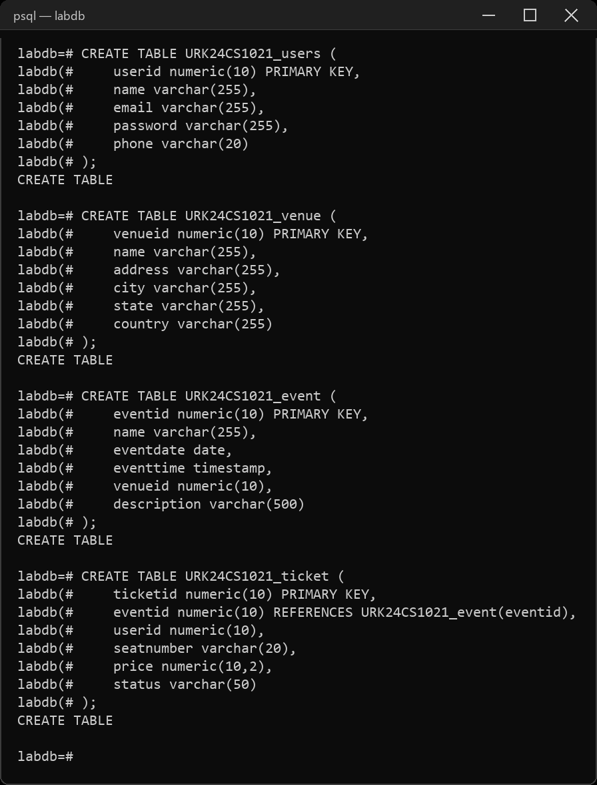
2. Describe the tables.
\d URK24CS1021_users
\d URK24CS1021_event
\d URK24CS1021_venue
\d URK24CS1021_ticket
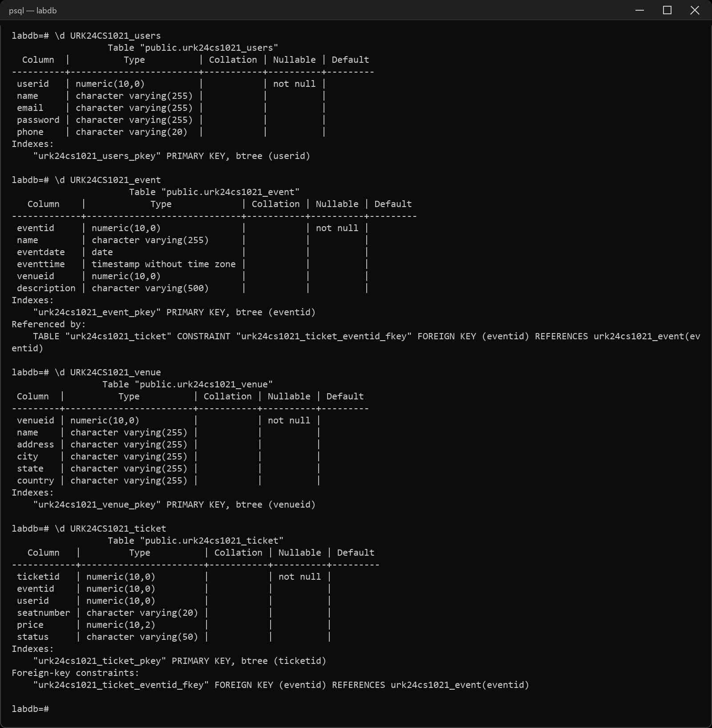
3. Alter the User table to add a new column Age.
ALTER TABLE URK24CS1021_users ADD COLUMN age numeric(3);
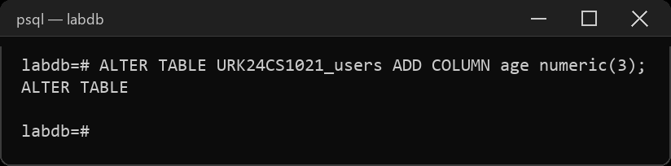
4. Drop the newly added column Age.
ALTER TABLE URK24CS1021_users DROP COLUMN age;
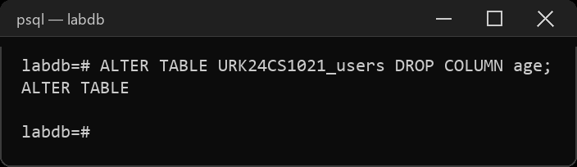
5. Rename the Venue table to Location.
ALTER TABLE URK24CS1021_venue RENAME TO URK24CS1021_location;
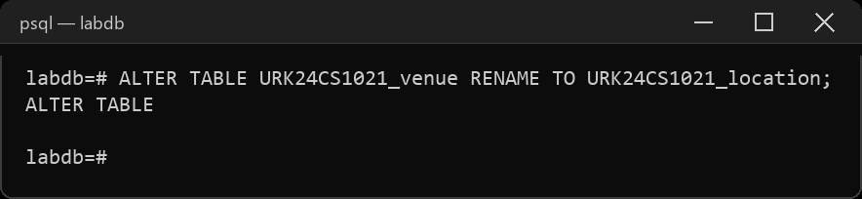
6. Modify the size of the Event table's Description column to 1000.
ALTER TABLE URK24CS1021_event ALTER COLUMN description TYPE varchar(1000);
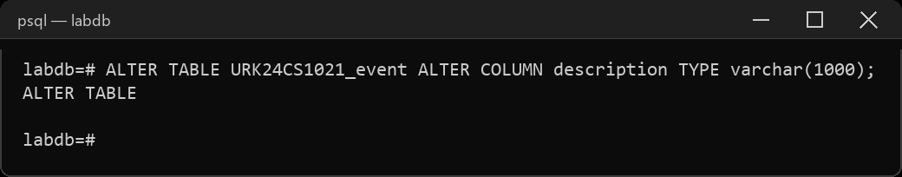
7. Drop the SeatNumber column from the Ticket table.
ALTER TABLE URK24CS1021_ticket DROP COLUMN seatnumber;
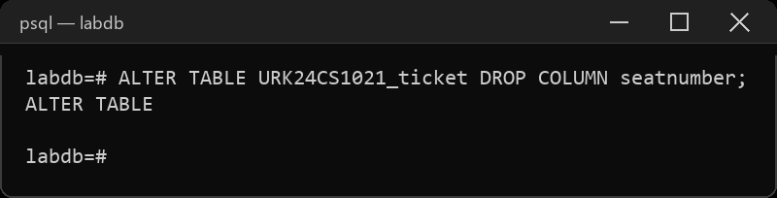
8. Add a unique constraint on the Email column in the User table.
ALTER TABLE URK24CS1021_users ADD CONSTRAINT users_email_uq UNIQUE (email);
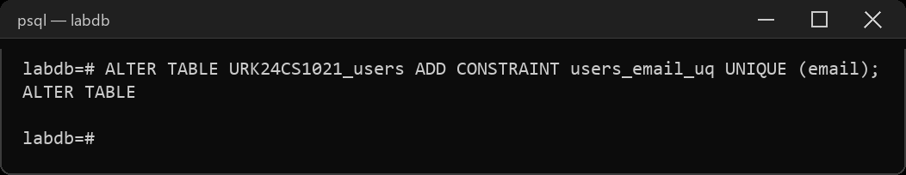
9. Rename the UserID column in the User table to ID.
ALTER TABLE URK24CS1021_users RENAME COLUMN userid TO id;
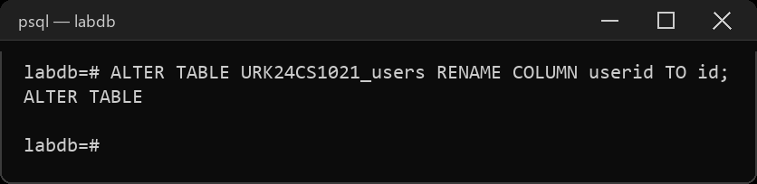
10. Modify the Ticket table to add a column named "Barcode" with a data type of VARCHAR(50).
ALTER TABLE URK24CS1021_ticket ADD COLUMN barcode varchar(50);
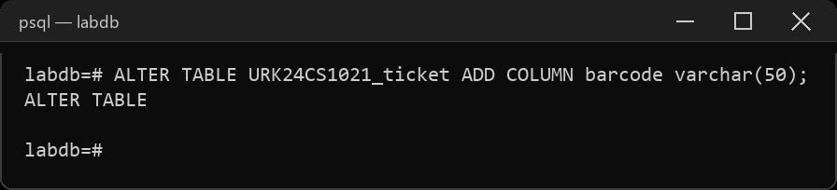
11. Modify the Name column in the Venue table to increase its maximum length to VARCHAR(300).
ALTER TABLE URK24CS1021_location ALTER COLUMN name TYPE varchar(300);
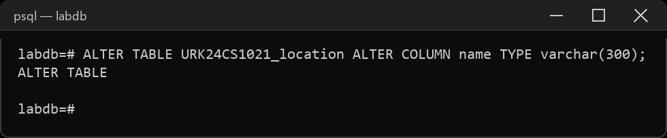
12. Add a foreign key constraint on the VenueID column in the Event table, referencing the Venue table.
ALTER TABLE URK24CS1021_event ADD CONSTRAINT event_venue_fk
FOREIGN KEY (venueid) REFERENCES URK24CS1021_location(venueid);
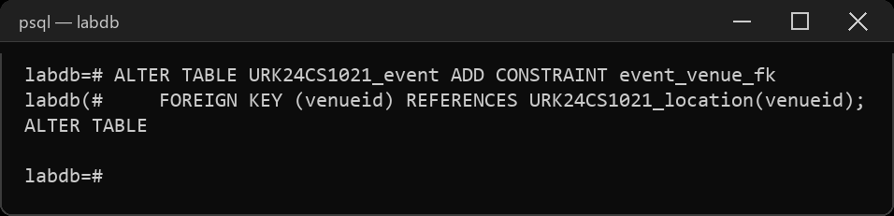
13. Add a CHECK constraint to check whether the UserID is between 101 and 105.
ALTER TABLE URK24CS1021_users ADD CONSTRAINT users_id_chk CHECK (id BETWEEN 101 AND 105);
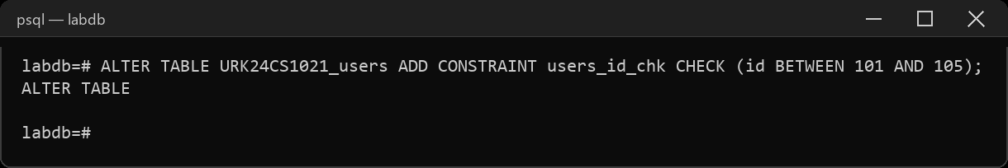
14. Add a unique constraint to Phone column of the User table.
ALTER TABLE URK24CS1021_users ADD CONSTRAINT users_phone_uq UNIQUE (phone);
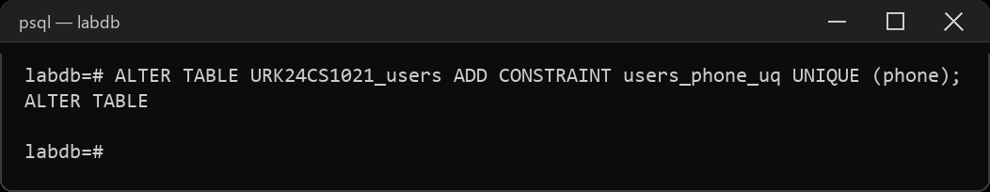
15. Truncate the user table.
TRUNCATE TABLE URK24CS1021_users;
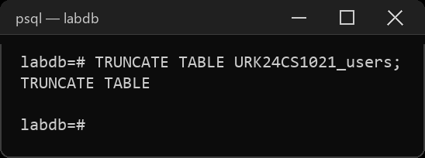
(b) Managing Tables using DML, DCL and TCL Commands
1. Insert a new user into the "User" table.
INSERT INTO URK24CS1021_users (id, name, email, password, phone)
VALUES (103, 'Nina Patel', 'nina@mail.com', 'pass3', '9000000012');
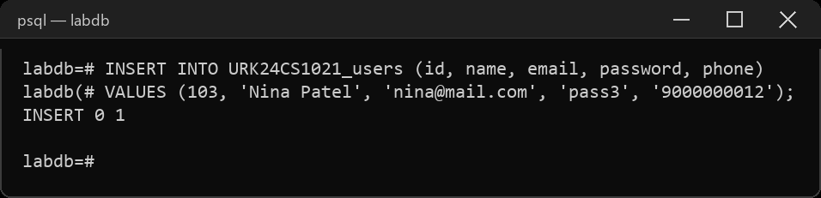
2. Update the email address of a user with UserID 102.
UPDATE URK24CS1021_users SET email = 'mary.ann.new@mail.com' WHERE id = 102;
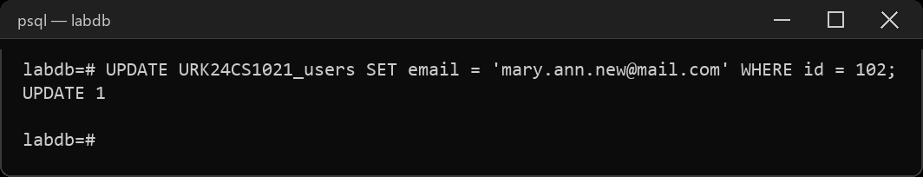
3. Delete a user with the email "example@example.com".
INSERT INTO URK24CS1021_users (id, name, email, password, phone)
VALUES (104, 'Temp User', 'example@example.com', 'pass4', '9000000013');
DELETE FROM URK24CS1021_users WHERE email = 'example@example.com';
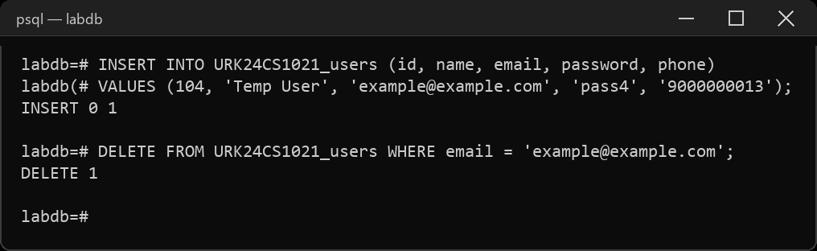
4. Insert a new event into the "Event" table.
INSERT INTO URK24CS1021_event (eventid, name, eventdate, eventtime, venueid, description)
VALUES (402, 'Food Festival', '2023-11-05', '2023-11-05 12:00:00', 1, 'Street food festival');
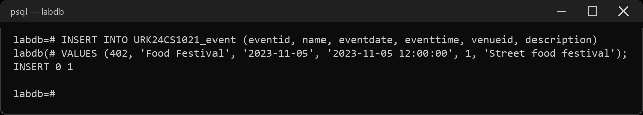
5. Update the description of an event with EventID 401.
UPDATE URK24CS1021_event SET description = 'Annual comic convention, now with a cosplay contest'
WHERE eventid = 401;
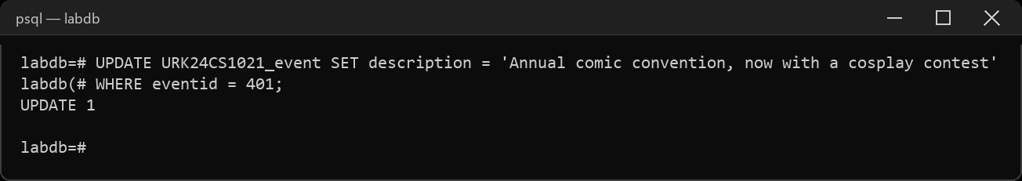
6. Grant SELECT privileges on the "User" table to a user named "john".
CREATE ROLE john LOGIN;
GRANT SELECT ON URK24CS1021_users TO john;
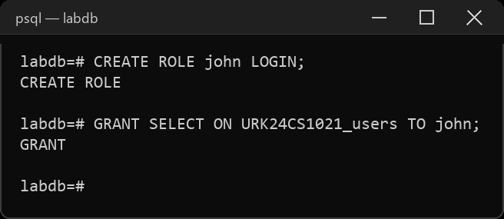
7. Revoke INSERT privileges on the "Event" table from a user named "mary".
CREATE ROLE mary LOGIN;
GRANT INSERT ON URK24CS1021_event TO mary;
REVOKE INSERT ON URK24CS1021_event FROM mary;
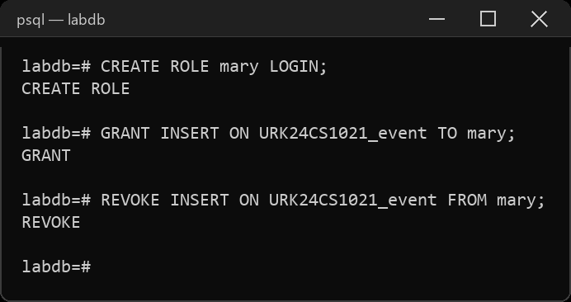
8. Create a new user with the username "jane" and grant them all privileges on the "Ticket" table.
CREATE ROLE jane LOGIN;
GRANT ALL PRIVILEGES ON URK24CS1021_ticket TO jane;
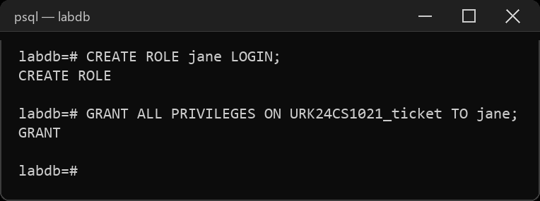
9. Grant EXECUTE privileges on a stored procedure to a role named "admin".
CREATE ROLE admin;
CREATE OR REPLACE PROCEDURE URK24CS1021_ticket_count() LANGUAGE sql AS $$ SELECT 1; $$;
GRANT EXECUTE ON PROCEDURE URK24CS1021_ticket_count() TO admin;
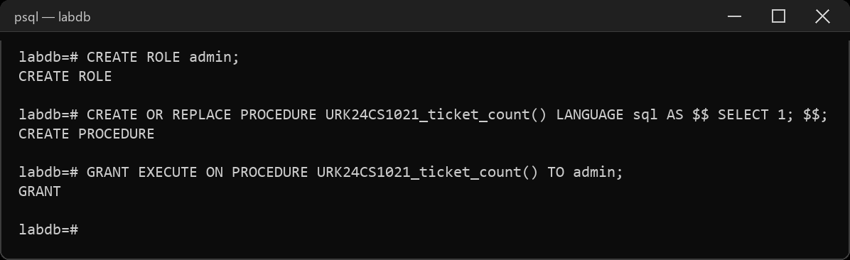
10. Revoke all privileges from a user named "guest" on all tables in the schema.
CREATE ROLE guest LOGIN;
REVOKE ALL PRIVILEGES ON ALL TABLES IN SCHEMA public FROM guest;
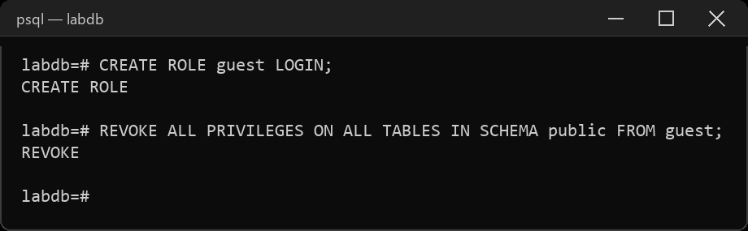
11. Perform commit a transaction in the database.
BEGIN;
INSERT INTO URK24CS1021_ticket (ticketid, eventid, userid, price, status, barcode)
VALUES (902, 401, 102, 80.00, 'confirmed', 'BCX002');
COMMIT;
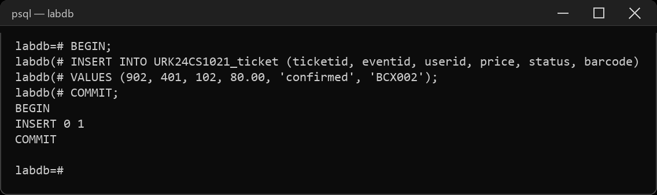
12. Perform roll back a transaction to a specific savepoint.
BEGIN;
INSERT INTO URK24CS1021_ticket (ticketid, eventid, userid, price, status, barcode)
VALUES (903, 401, 103, 95.00, 'confirmed', 'BCX003');
SAVEPOINT sp1;
INSERT INTO URK24CS1021_ticket (ticketid, eventid, userid, price, status, barcode)
VALUES (904, 401, 104, 95.00, 'confirmed', 'BCX004');
ROLLBACK TO SAVEPOINT sp1;
COMMIT;
SELECT ticketid FROM URK24CS1021_ticket WHERE ticketid IN (903, 904);
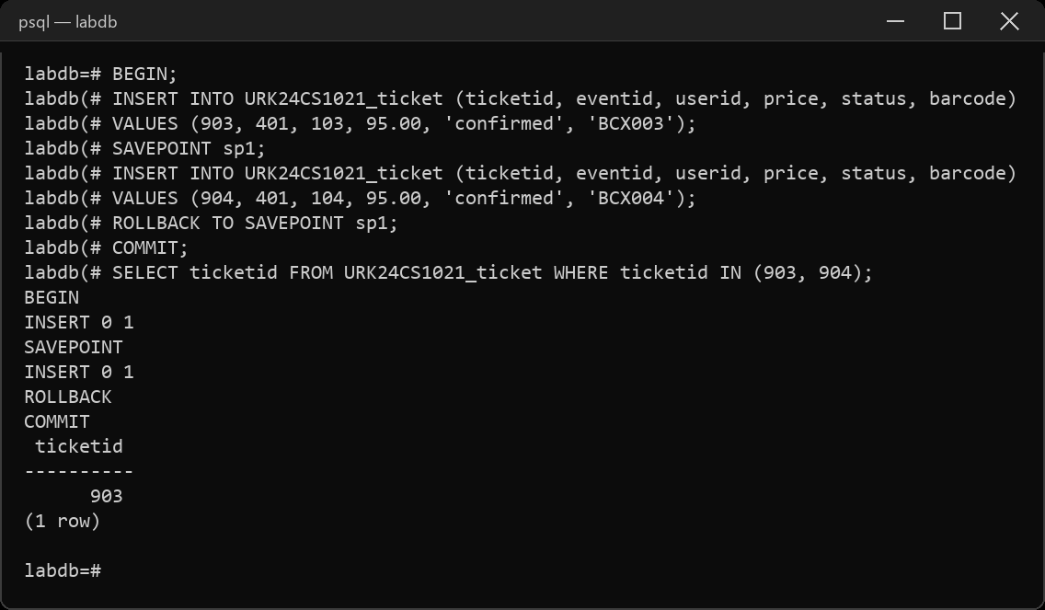
13. Perform set a savepoint within a transaction.
BEGIN;
INSERT INTO URK24CS1021_ticket (ticketid, eventid, userid, price, status, barcode)
VALUES (905, 401, 105, 70.00, 'confirmed', 'BCX005');
SAVEPOINT sp2;
SELECT COUNT(*) AS tickets_so_far FROM URK24CS1021_ticket;
COMMIT;
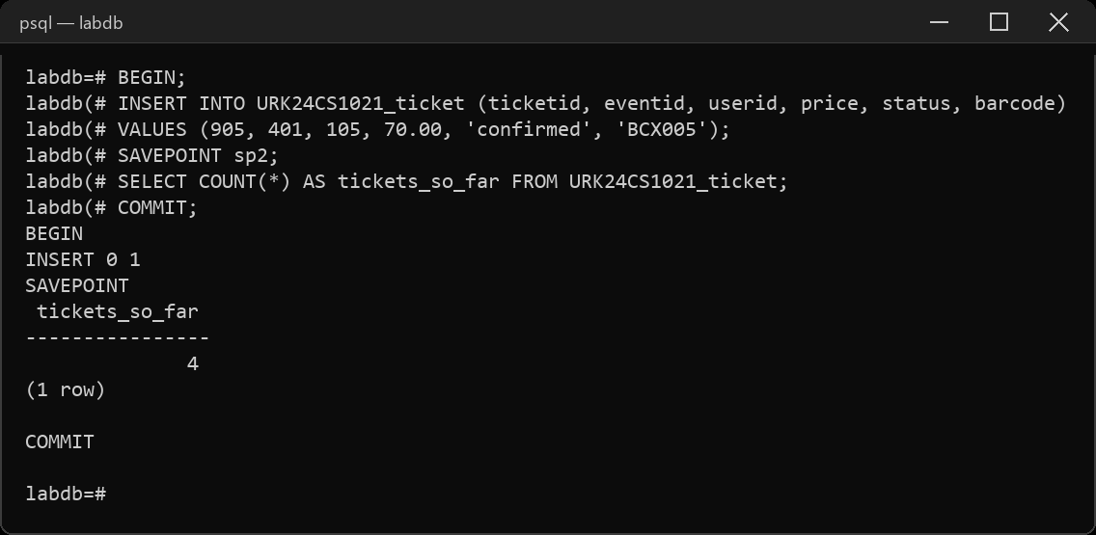
14. Enable autocommit mode in the database.
\set AUTOCOMMIT on
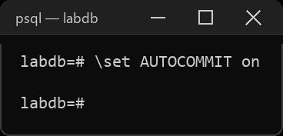
15. Disable autocommit mode in the database.
\set AUTOCOMMIT off
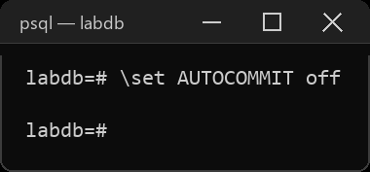
Result
The queries were executed and the desired output was obtained.

