Ex. No. 2 | BASIC SQL
Date of Exercise | 24/07/2026

Aim
To execute the given basic SQL queries.
Description
DML (Data Manipulation Language) statements manipulate the data held within tables: INSERT adds rows, UPDATE changes existing rows, DELETE removes rows, and SELECT retrieves rows, optionally filtered with a WHERE clause (comparison, AND/OR, IS NULL, IN, LIKE, BETWEEN), grouped with GROUP BY, and ordered with ORDER BY.
1. Insert all the fields given in the ticket reservation schema.
Sample Code:
INSERT INTO URK24CS1021_users (id, name, email, password, phone) VALUES
(101, 'Alice Johnson', 'alice@mail.com', 'pass1', '9000000001'),
(102, 'Bob Smith', 'bob@mail.com', 'pass2', '9000000002'),
(103, 'Carol Lee', 'carol@mail.com', 'pass3', '9000000003'),
(104, 'David Kim', 'david@mail.com', 'pass4', '9000000004'),
(105, 'Emma Watson', 'emma@mail.com', 'pass5', '9000000005');
INSERT INTO URK24CS1021_location (venueid, name, address, city, state, country) VALUES
(1, 'Madison Square Garden', '4 Pennsylvania Plaza', 'New York', 'NY', 'USA'),
(2, 'Wembley Stadium', 'Wembley', 'London', 'England', 'UK'),
(3, 'Marina Bay Sands', '10 Bayfront Ave', 'Singapore', 'Singapore', 'Singapore');
INSERT INTO URK24CS1021_event (eventid, name, eventdate, eventtime, venueid, description) VALUES
(1, 'Rock Fest', '2023-08-15', '2023-08-15 19:00:00', 1, 'Outdoor rock concert'),
(2, 'Tech Conference', '2023-07-20', '2023-07-20 09:00:00', 2, 'Annual tech meetup'),
(3, 'Jazz Night', '2023-09-05', '2023-09-05 20:00:00', 3, 'Live jazz performance'),
(4, 'Startup Summit', '2023-06-10', '2023-06-10 10:00:00', 1, 'Startup pitch day');
INSERT INTO URK24CS1021_ticket (ticketid, eventid, userid, price, status, barcode) VALUES
(1, 1, 101, 150.00, 'confirmed', 'BC1001'),
(2, 1, 102, 150.00, 'confirmed', 'BC1002'),
(3, 2, 103, 200.00, 'cancelled', 'BC1003'),
(4, 3, 104, 120.00, 'confirmed', 'BC1004'),
(5, 3, 105, 120.00, 'confirmed', 'BC1005'),
(6, 4, 101, 90.00, 'cancelled', 'BC1006'),
(7, 2, 102, 200.00, 'confirmed', 'BC1007');
Sample Output:
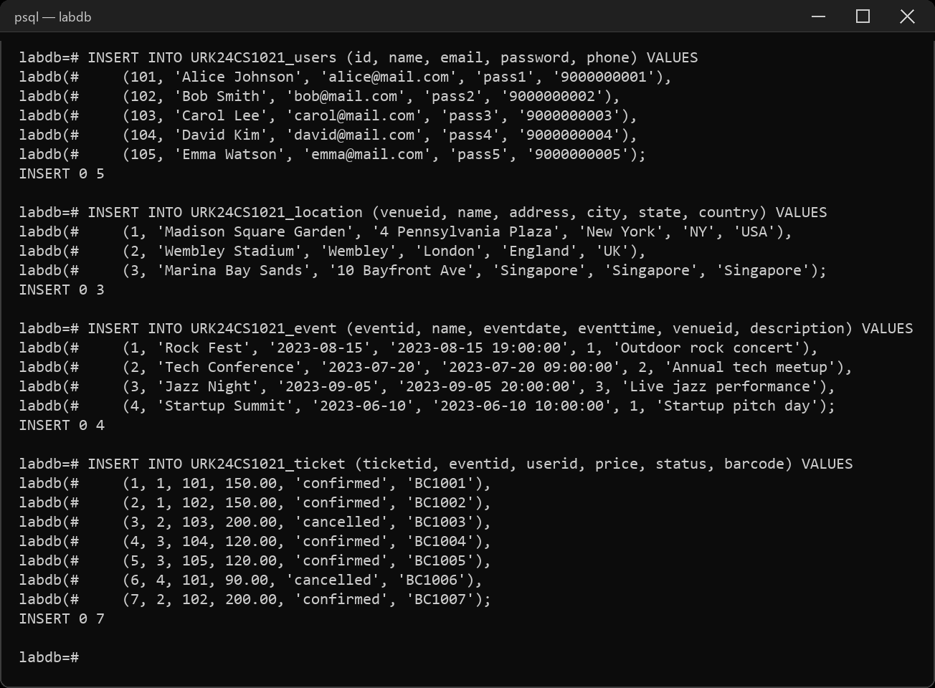
2. Display all the fields in User, Events, Venue and Ticket tables.
Sample Code:
SELECT * FROM URK24CS1021_users;
SELECT * FROM URK24CS1021_event;
SELECT * FROM URK24CS1021_location;
SELECT * FROM URK24CS1021_ticket;
Sample Output:
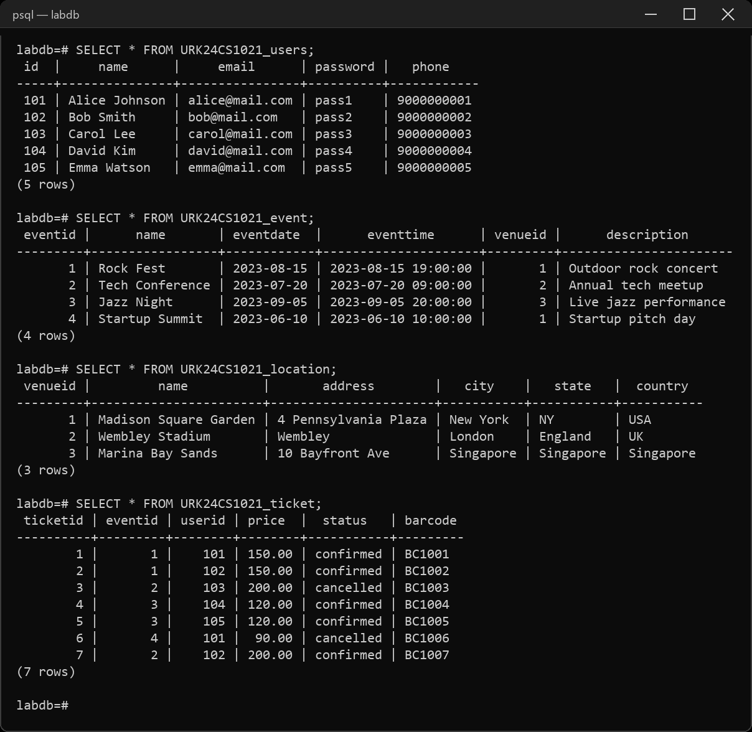
3. Retrieve all venues ordered by city and then by country.
Sample Code:
SELECT * FROM URK24CS1021_location ORDER BY city, country;
Sample Output:
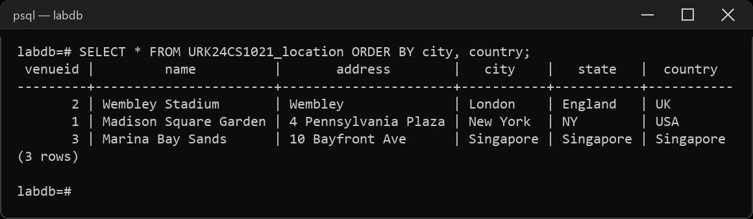
4. Retrieve total number of users.
Sample Code:
SELECT COUNT(*) AS total_users FROM URK24CS1021_users;
Sample Output:
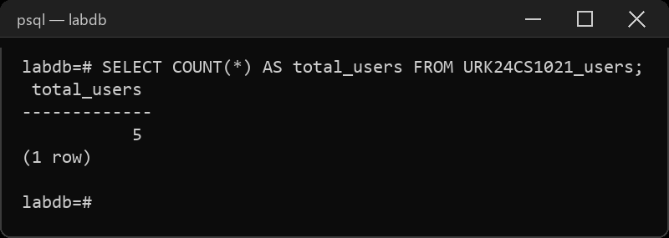
5. Retrieve all events ordered by date and time in descending order.
Sample Code:
SELECT * FROM URK24CS1021_event ORDER BY eventdate DESC, eventtime DESC;
Sample Output:
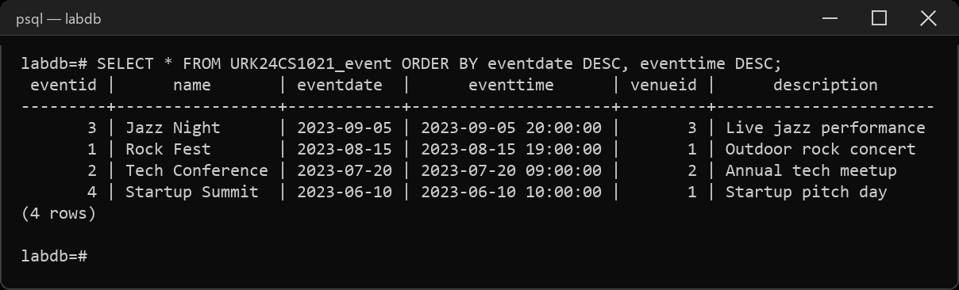
6. Get the average price of tickets for each event.
Sample Code:
SELECT eventid, AVG(price) AS avg_price
FROM URK24CS1021_ticket GROUP BY eventid;
Sample Output:
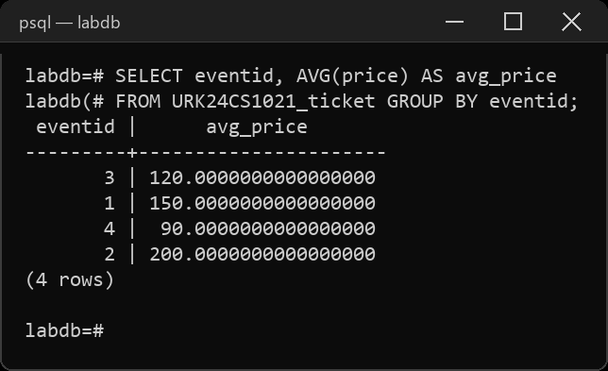
7. Get the total price and count of tickets for each event.
Sample Code:
SELECT eventid, SUM(price) AS total_price, COUNT(*) AS ticket_count
FROM URK24CS1021_ticket GROUP BY eventid;
Sample Output:
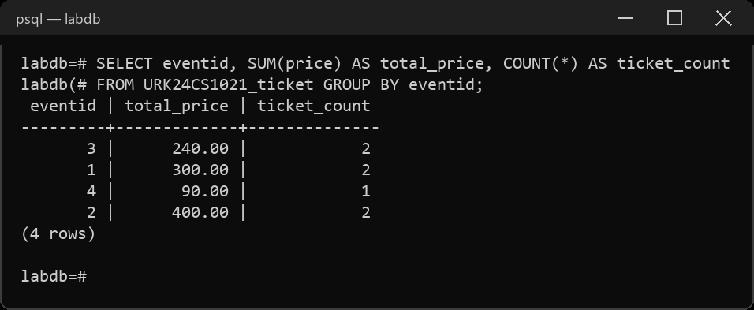
8. Count the number of tickets for each event.
Sample Code:
SELECT eventid, COUNT(*) AS ticket_count
FROM URK24CS1021_ticket GROUP BY eventid;
Sample Output:
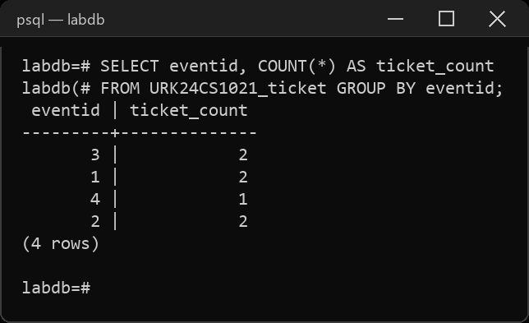
9. Retrieve a distinct number of users.
Sample Code:
SELECT COUNT(DISTINCT id) AS distinct_users FROM URK24CS1021_users;
Sample Output:
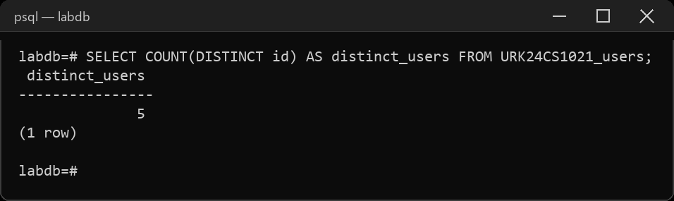
10. Retrieve the events conducted after 30/07/2023.
Sample Code:
SELECT * FROM URK24CS1021_event WHERE eventdate > '2023-07-30';
Sample Output:
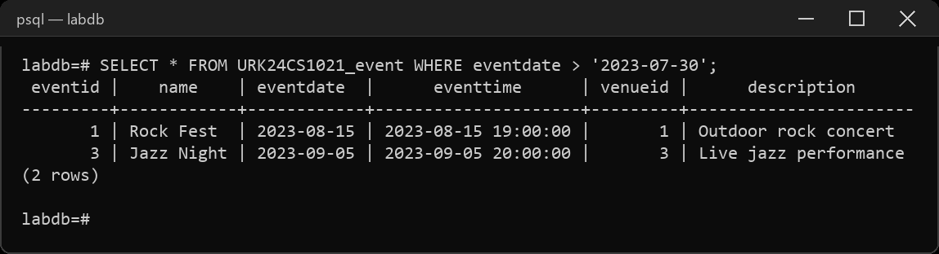
11. Calculate the sum of prices for all confirmed tickets.
Sample Code:
SELECT SUM(price) AS confirmed_total
FROM URK24CS1021_ticket WHERE status = 'confirmed';
Sample Output:
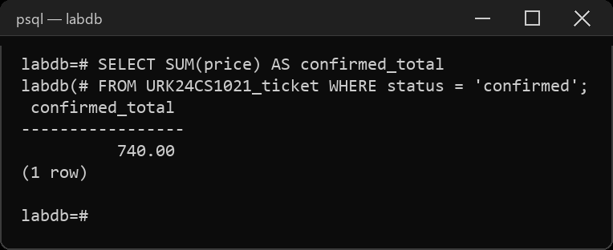
12. Concatenate the user's name and email for display.
Sample Code:
SELECT name || ' <' || email || '>' AS display FROM URK24CS1021_users;
Sample Output:
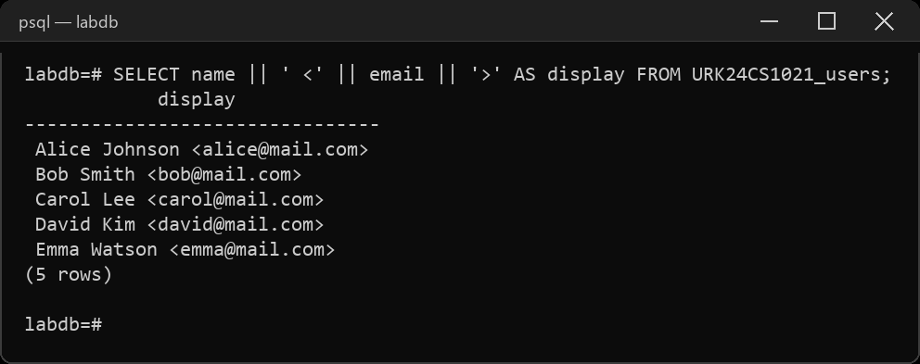
13. Retrieve the venue from the city New York and country USA.
Sample Code:
SELECT * FROM URK24CS1021_location
WHERE city = 'New York' AND country = 'USA';
Sample Output:
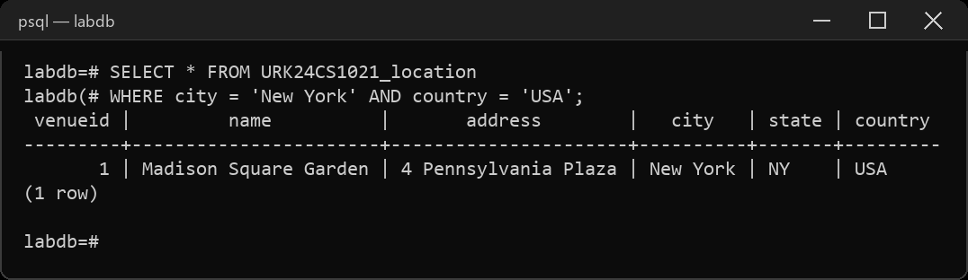
14. Retrieve all cities ordered by Country in ascending order.
Sample Code:
SELECT city, country FROM URK24CS1021_location ORDER BY country ASC;
Sample Output:
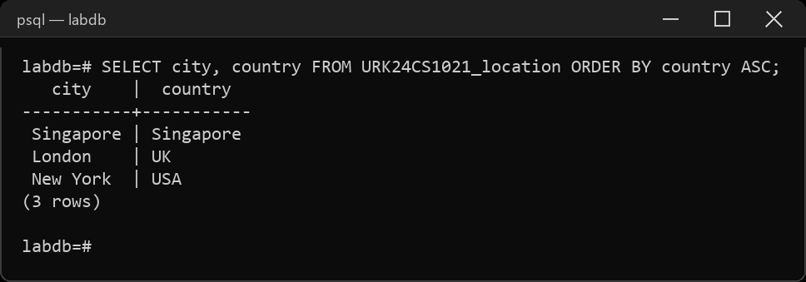
15. Delete the cancelled ticket in the ticket table.
Sample Code:
DELETE FROM URK24CS1021_ticket WHERE status = 'cancelled';
Sample Output:
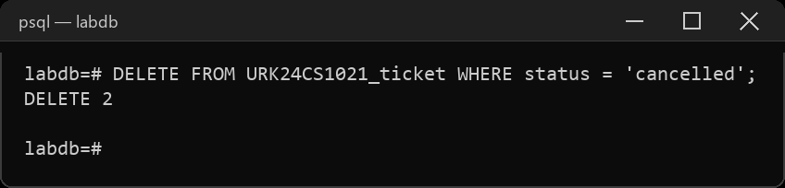
RESULT
The SQL queries were executed and the desired output was obtained.

