Ex. No. 2 | WORKING WITH PANDAS
Date of Exercise | 24/07/2026

Aim
To develop and implement Python programs that solves real-world problems in various industries such as HR, logistics, retail, finance, and security using Numpy and Pandas.
Description (About Pandas)
Pandas is a Python library built on top of NumPy for handling and analysing structured, tabular data. Its core structure, the DataFrame, is a two-dimensional labelled table that supports importing data from files, inspecting and cleaning it, slicing it by rows/columns/conditions, deriving new columns, sorting, grouping, building pivot tables, and ranking values — the standard steps of exploring any real-world dataset.
Question:
Dataset: fanspeed.csv (https://dataset.karunya.edu/CSE/fanspeed.csv)
Columns: Temperature, Observed Fan Speed
• Import the dataset
• Display the first 10 rows / last 8 rows
• Display information about the dataset (info, column names, shape, statistical inferences, data types)
• Examine the dataset for null values, display the null count per column, impute the null values with a suitable method
• Slicing: single/multiple column, single/multiple row, loc & iloc (single & multiple), conditional slicing
• Add a column to the end using a normal arithmetic operation, apply() with a custom function, apply() with an inbuilt function
• Add a row and delete it
• Sort the dataset in ascending and descending order
• Group the dataset using single and multiple conditions
• Create a pivot table for the dataset
• Create a ranking column using all the ranking methods
Sample Code: 1. Import the dataset
df = pd.read_csv("fanspeed.csv")
print(df)
Sample Output:
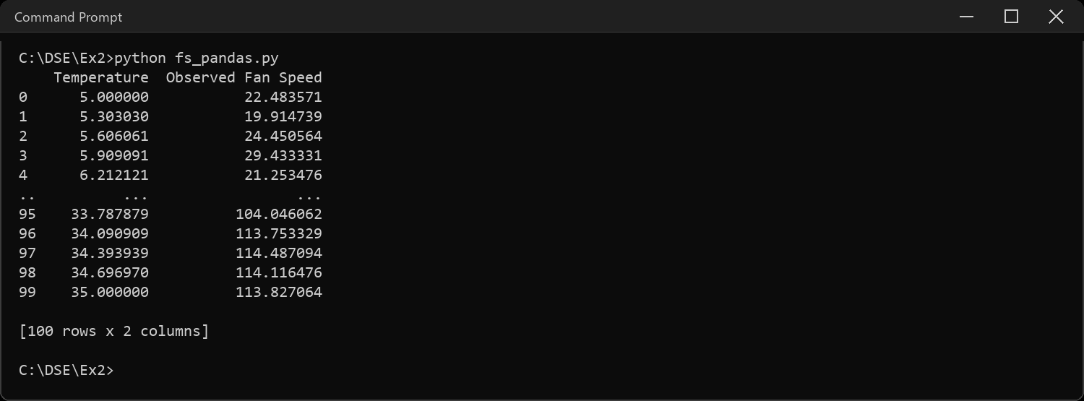
Sample Code: 2. Display the first 10 rows and last 8 rows
print("First 10 rows:")
print(df.head(10))
print("\nLast 8 rows:")
print(df.tail(8))
Sample Output:
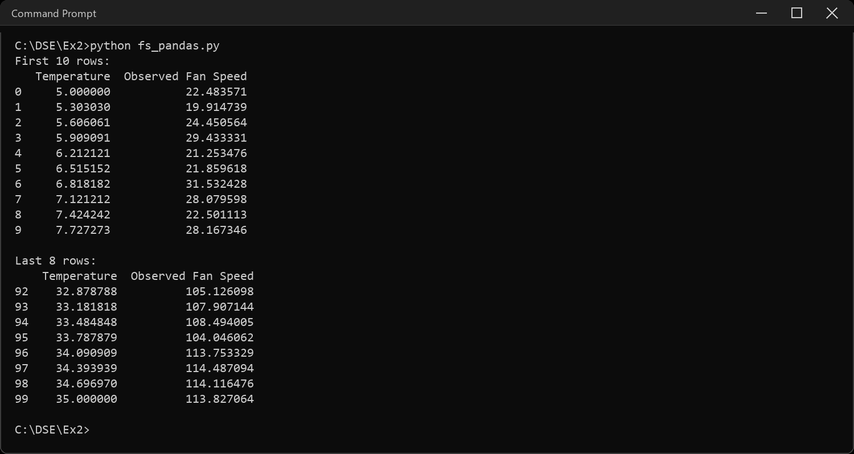
Sample Code: 3. Display information about the dataset
print("Column names:", list(df.columns))
print("\nShape:", df.shape)
print("\nStatistical inferences:")
print(df.describe())
print("\nData types:")
print(df.dtypes)
print("\nInfo:")
df.info()
Sample Output:
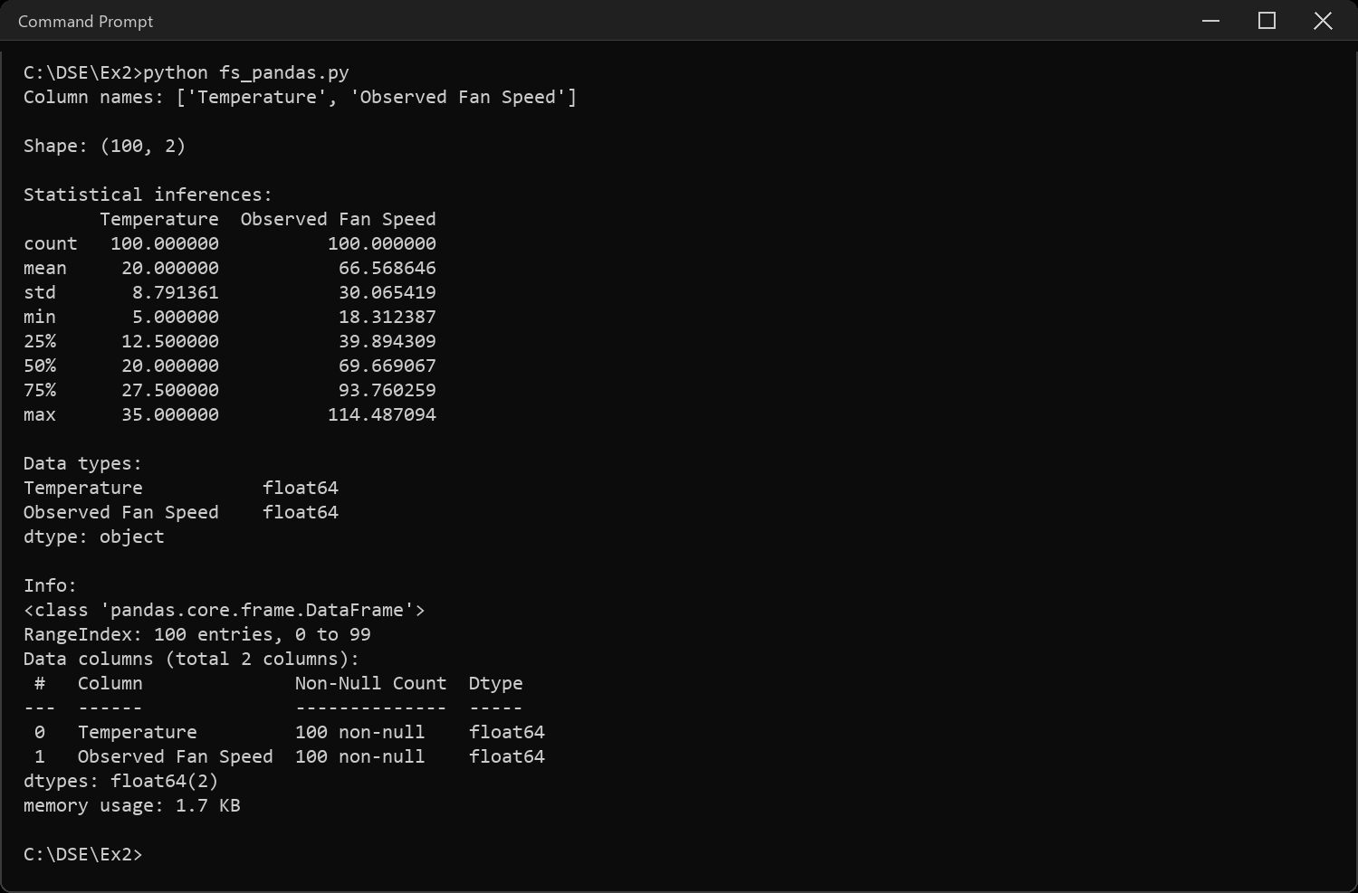
Sample Code: 4. Null values: examine, display, impute
# fanspeed.csv has no missing values as downloaded, so plant a few on a
# copy (fixed rows, reproducible) just to show detection + imputation
# -- the real df used from here on stays untouched
demo = df.copy()
demo.loc[[3, 27, 61], "Observed Fan Speed"] = None
print("Null values per column:")
print(demo.isnull().sum())
mean_speed = demo["Observed Fan Speed"].mean()
demo["Observed Fan Speed"] = demo["Observed Fan Speed"].fillna(mean_speed)
print("\nAfter imputing with the column mean:")
print(demo.isnull().sum())
Sample Output:
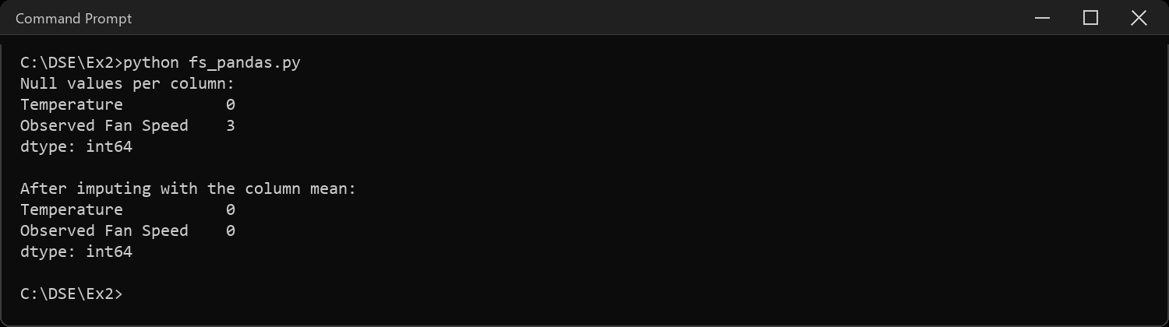
Sample Code: 5. Slicing the dataset
print("Single column:")
print(df["Temperature"].head())
print("\nMultiple columns:")
print(df[["Temperature", "Observed Fan Speed"]].head())
print("\nSingle row (loc):")
print(df.loc[5])
print("\nMultiple rows (loc):")
print(df.loc[5:8])
print("\nSingle row (iloc):")
print(df.iloc[5])
print("\nMultiple rows (iloc):")
print(df.iloc[5:8])
print("\nloc - rows + one column:")
print(df.loc[5:8, "Temperature"])
print("\niloc - rows + one column:")
print(df.iloc[5:8, 0])
print("\nConditional slicing (Temperature > 25):")
print(df[df["Temperature"] > 25].head())
Sample Output:
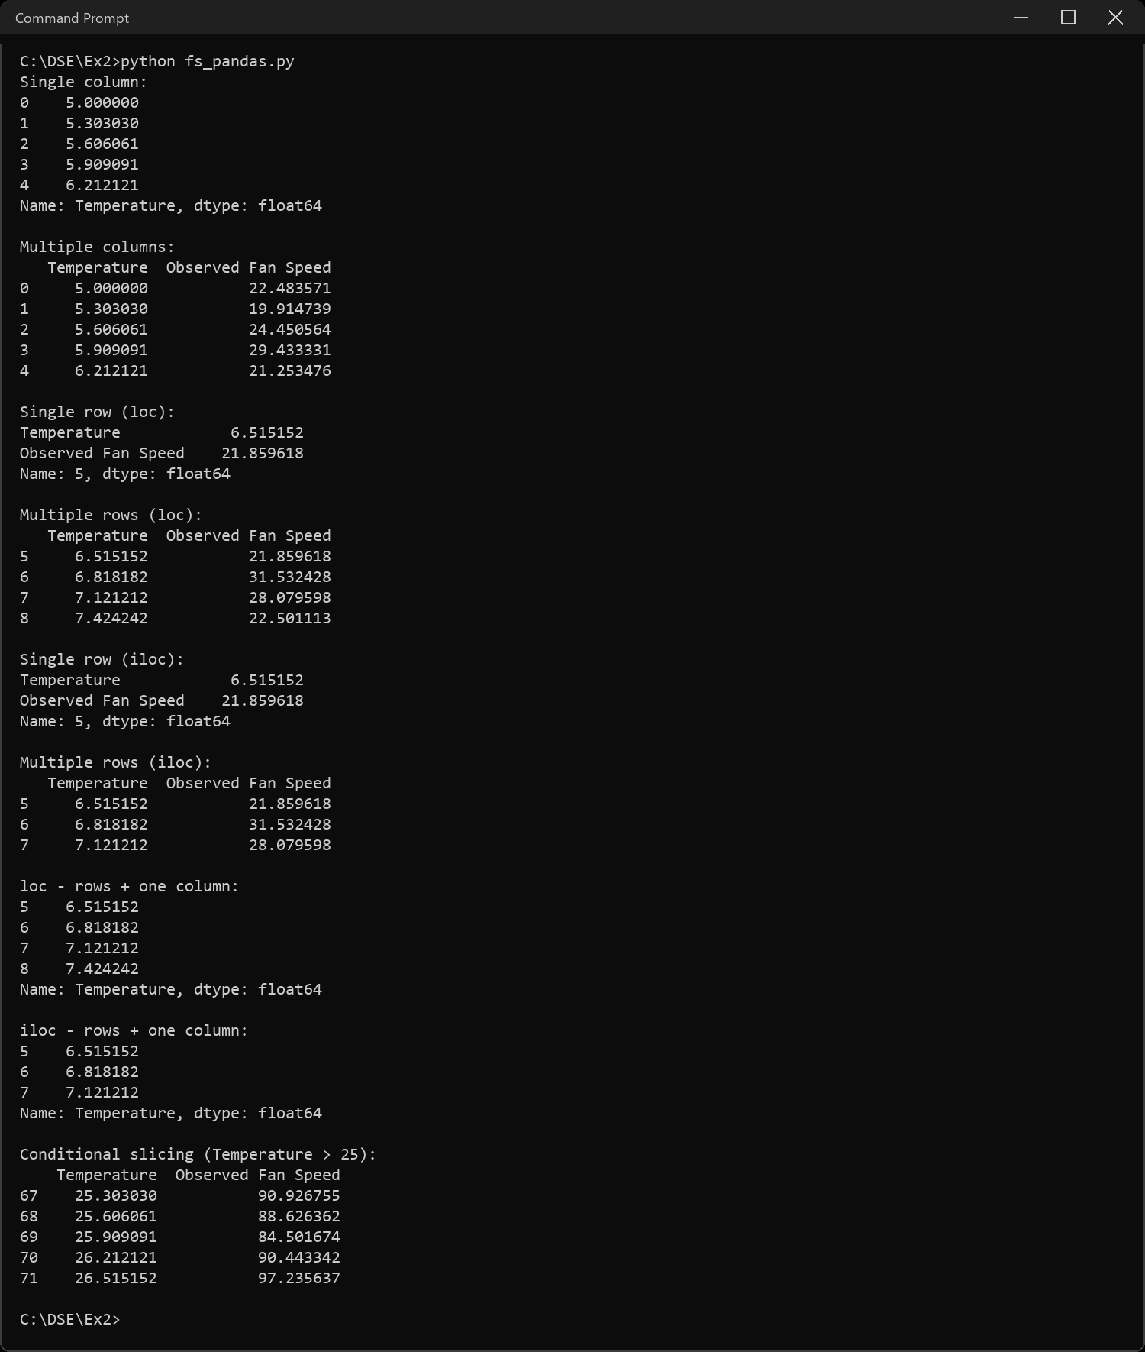
Sample Code: 6. Add a column to the end
# normal arithmetic operation
df["Speed_Per_Degree"] = df["Observed Fan Speed"] / df["Temperature"]
# apply() with a custom function
df["Speed_Level"] = df["Observed Fan Speed"].apply(lambda x: "High" if x > 60 else "Low")
# apply() with an inbuilt function
df["Speed_Rounded"] = df["Observed Fan Speed"].apply(round)
print(df.head())
Sample Output:
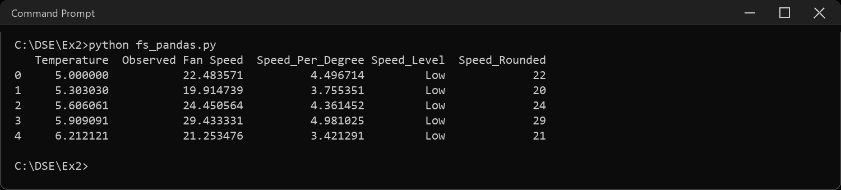
Sample Code: 7. Add a row and delete it
new_row = pd.DataFrame([{"Temperature": 40, "Observed Fan Speed": 120,
"Speed_Per_Degree": 3.0, "Speed_Level": "High",
"Speed_Rounded": 120}])
df = pd.concat([df, new_row], ignore_index=True)
print("After adding a row:")
print(df.tail(3))
df = df.drop(df.index[-1])
print("\nAfter deleting it:")
print(df.tail(3))
Sample Output:
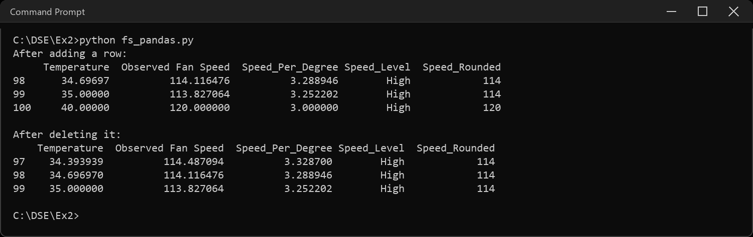
Sample Code: 8. Sort ascending and descending
print("Ascending by Observed Fan Speed:")
print(df.sort_values("Observed Fan Speed").head())
print("\nDescending by Observed Fan Speed:")
print(df.sort_values("Observed Fan Speed", ascending=False).head())
Sample Output:
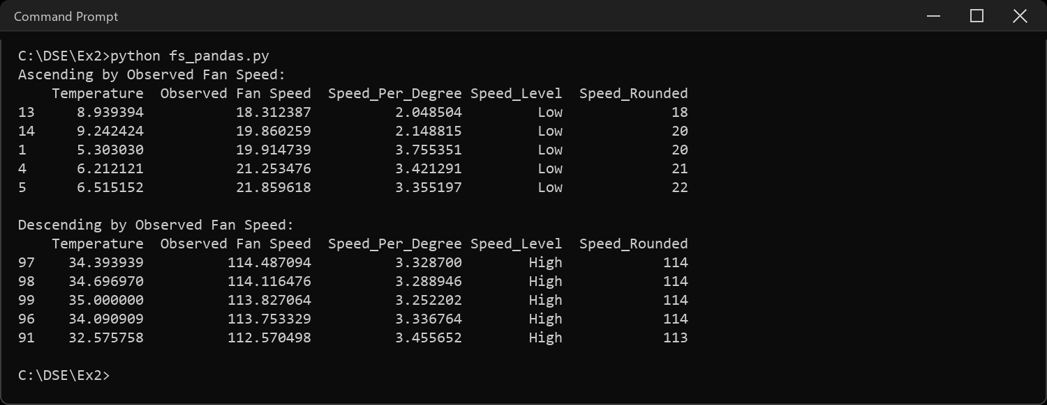
Sample Code: 9. Group by single and multiple conditions
print("Group by Speed_Level (single condition):")
print(df.groupby("Speed_Level")["Observed Fan Speed"].mean())
df["Temp_Band"] = df["Temperature"].apply(
lambda t: "Low" if t < 15 else ("Mid" if t < 25 else "High"))
print("\nGroup by Speed_Level & Temp_Band (multiple conditions):")
print(df.groupby(["Speed_Level", "Temp_Band"])["Observed Fan Speed"].mean())
Sample Output:
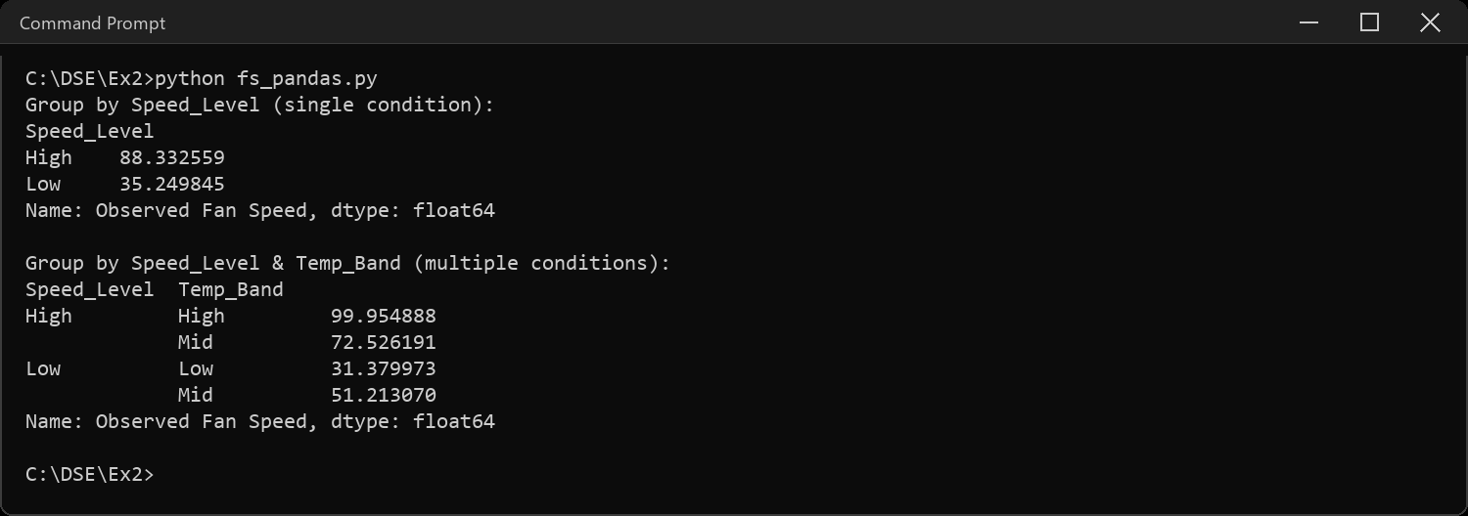
Sample Code: 10. Pivot table
print(pd.pivot_table(df, index="Temp_Band", columns="Speed_Level",
values="Observed Fan Speed", aggfunc="mean"))
Sample Output:
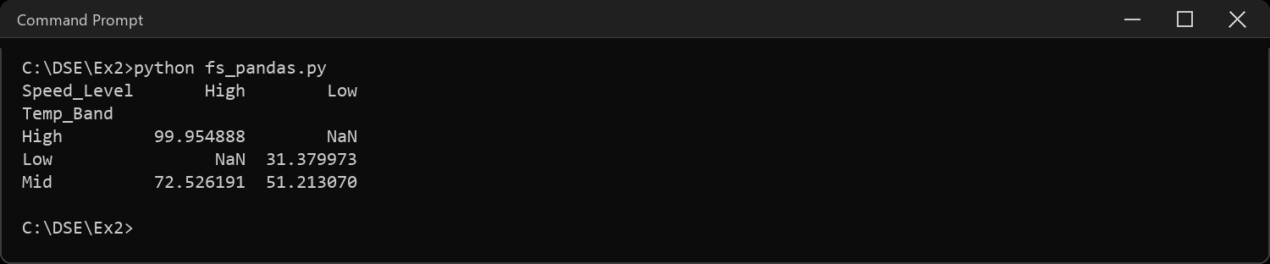
Sample Code: 11. Ranking column, all methods
df["Rank_average"] = df["Observed Fan Speed"].rank(method="average")
df["Rank_min"] = df["Observed Fan Speed"].rank(method="min")
df["Rank_max"] = df["Observed Fan Speed"].rank(method="max")
df["Rank_first"] = df["Observed Fan Speed"].rank(method="first")
df["Rank_dense"] = df["Observed Fan Speed"].rank(method="dense")
print(df[["Observed Fan Speed", "Rank_average", "Rank_min",
"Rank_max", "Rank_first", "Rank_dense"]].head())
Sample Output:
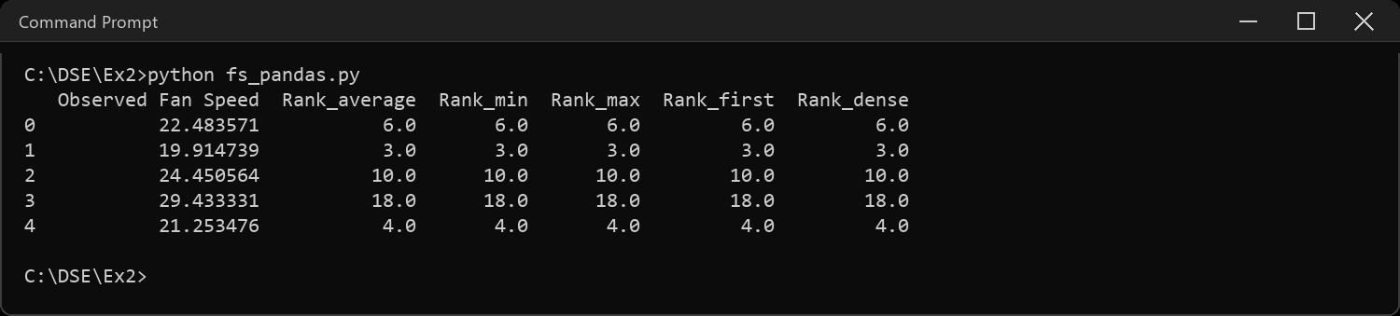
CODE EXPLANATION LINK:
(Youtube / Drive Link)
Preparation course certificate
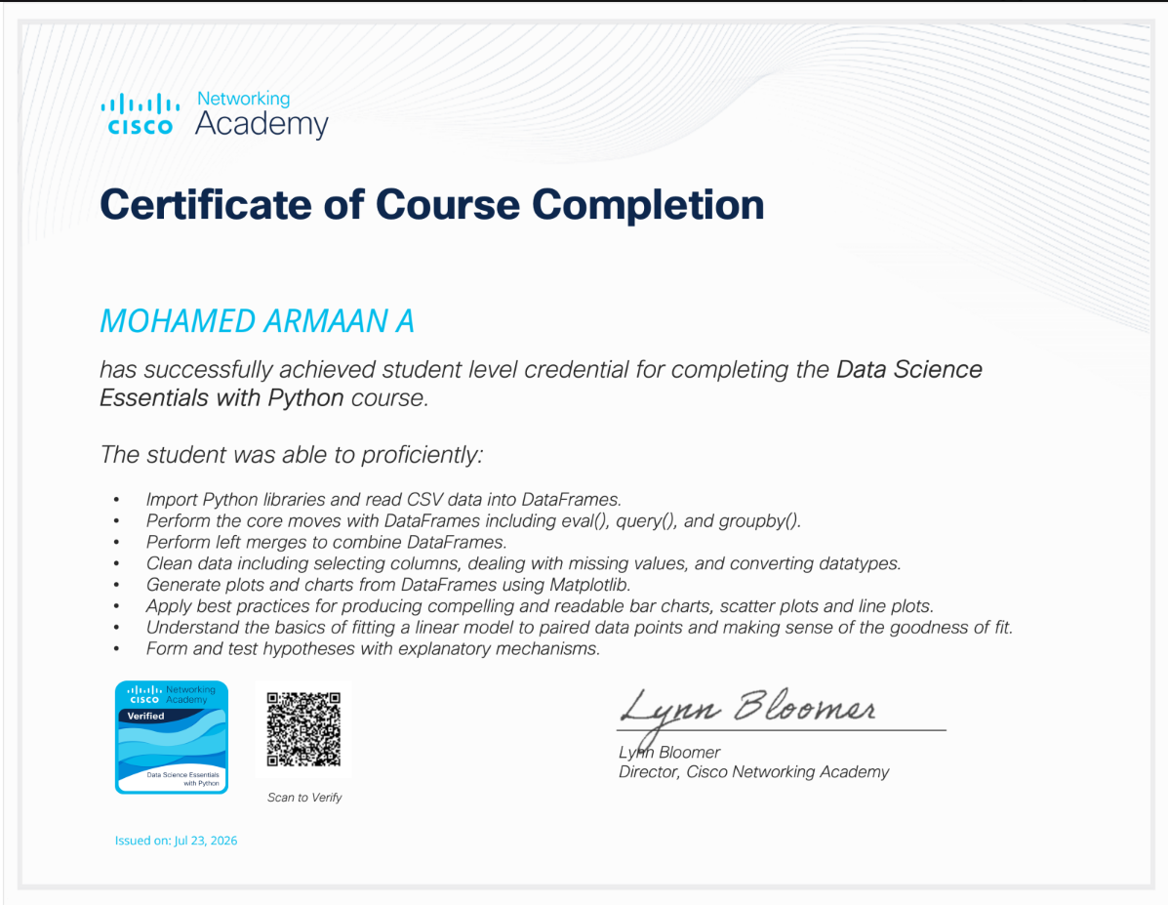
RESULT
The exercise shown above has been successfully executed and the output has been verified.

