Ex. No. 1B | MANAGING TABLES USING DML, DCL AND TCL COMMANDS
Date of Exercise | 29/07/2026

Aim
To execute all commands of Data Manipulation Language, Data Control Language, and Transaction Control Language to get the desired output.
Description
DML statements (INSERT/UPDATE/DELETE) manipulate row data. DCL statements (GRANT/REVOKE) control access privileges on database objects for specific roles. TCL statements (COMMIT/ROLLBACK/SAVEPOINT) control transaction boundaries — COMMIT makes changes permanent, SAVEPOINT marks a point to roll back to within an open transaction, and ROLLBACK TO undoes work back to that point without discarding the whole transaction.
1. Insert a new user into the "User" table.
2. Update the email address of a user with UserID 102.
Sample Code:
UPDATE UsersURK24CS1006 SET Email = 'newemail@example.com' WHERE ID = 123;
Sample Output:
3. Delete a user with the email "example@example.com".
Sample Code:
DELETE FROM UsersURK24CS1006 WHERE Email = 'example@example.com';
Sample Output:
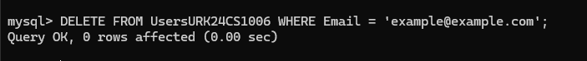
4. Insert a new event into the "Event" table.
Sample Code:
INSERT INTO EventURK24CS1006 (EventID, Name, EventDate, EventTime, VenueID, Description)
VALUES (456, 'Music Concert', '2026-08-15', '2026-08-15 18:30:00', 1, 'Live music concert');
Sample Output:
5. Update the description of an event with EventID 401.
Sample Code:
UPDATE EventURK24CS1006 SET Description = 'Updated event description'
WHERE EventID = 456;
Sample Output:
6. Grant SELECT privileges on the "User" table to a user named "john".
Sample Code:
GRANT SELECT ON dbmslab.UsersURK24CS1006 TO 'john'@'localhost';
Sample Output:
7. Revoke INSERT privileges on the "Event" table from a user named "mary".
Sample Code:
REVOKE INSERT ON dbmslab.EventURK24CS1006 FROM 'mary'@'localhost';
Sample Output:
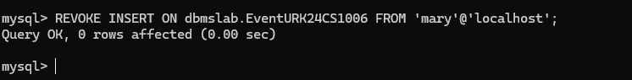
8. Create a new user with the username "jane" and grant them all privileges on the "Ticket" table.
Sample Code:
GRANT ALL PRIVILEGES ON dbmslab.TicketURK24CS1006 TO 'jane'@'localhost';
Sample Output:
9. Grant EXECUTE privileges on a stored procedure to a role named "admin".
Sample Code:
GRANT SELECT ON dbmslab.* TO 'guest'@'localhost';
REVOKE ALL PRIVILEGES ON dbmslab.* FROM 'guest'@'localhost';
Sample Output:
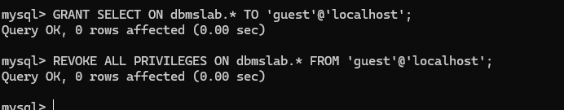
10. Revoke all privileges from a user named "guest" on all tables in the schema.
Sample Code:
GRANT SELECT ON dbmslab.* TO 'guest'@'localhost';
REVOKE ALL PRIVILEGES ON dbmslab.* FROM 'guest'@'localhost';
Sample Output:
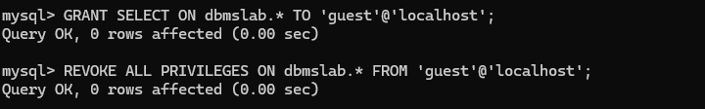
11. Perform commit a transaction in the database.
Sample Code:
COMMIT;
Sample Output:
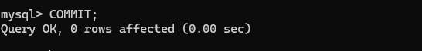
12. Perform roll back a transaction to a specific savepoint.
Sample Code:
ROLLBACK TO SAVEPOINT sp1;
Sample Output:
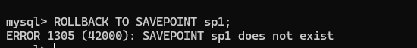
13. Perform set a savepoint within a transaction.
Sample Code:
SAVEPOINT sp1;
Sample Output:
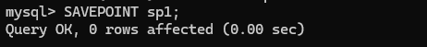
14. Enable autocommit mode in the database.
Sample Code:
SET autocommit = 1;
Sample Output:
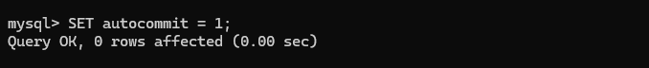
15. Disable autocommit mode in the database.
Sample Code:
SET autocommit = 0;
Sample Output:
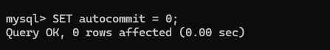
RESULT
The SQL queries were executed and the desired output was obtained.

