Ex. No. 3 | ADVANCED SQL
Date of Exercise | 05/08/2026

Aim
To execute the given commands making use of aggregate functions, group by clause and order by clause.
Description
Aggregate functions take a collection of values and return a single value as the result: SUM returns the total, AVG the average, COUNT the number of tuples, and MIN and MAX the smallest and largest value in the collection. SUM and AVG need numeric input, while COUNT, MIN and MAX also work on non-numeric types. The DISTINCT keyword inside an aggregate expression eliminates duplicates before the function is applied. The GROUP BY clause applies an aggregate function to groups of tuples — tuples sharing the same value on every attribute named in the clause are placed in one group — and the ORDER BY clause returns the result of a query in sorted order, ASC for ascending and DESC for descending.
1. List the number of users in the user table.
Sample Code:
SELECT COUNT(*) AS total_users FROM URK24CS1021_users;
Sample Output:
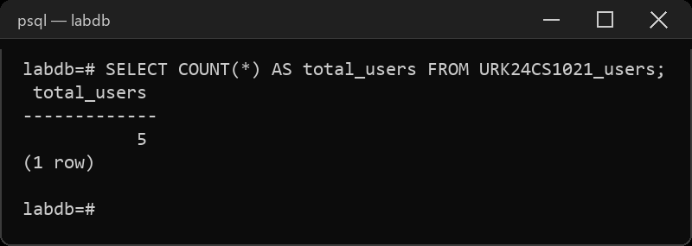
2. List the number of events conducted during 2023.
Sample Code:
SELECT COUNT(*) AS events_2023 FROM URK24CS1021_event
WHERE eventdate BETWEEN '2023-01-01' AND '2023-12-31';
Sample Output:
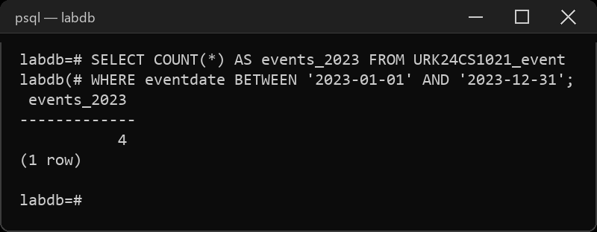
3. Calculate the total price for the confirmed tickets.
Sample Code:
SELECT SUM(price) AS confirmed_total FROM URK24CS1021_ticket
WHERE status = 'confirmed';
Sample Output:
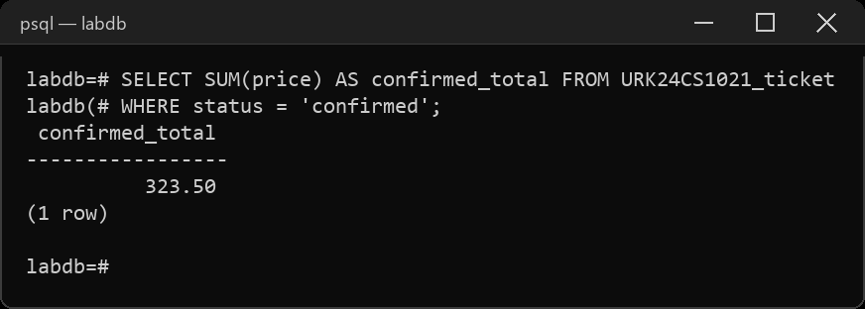
4. Find the minimum, maximum and average time taken for the given events.
Sample Code:
SELECT MIN(endtime - eventtime) AS min_duration,
MAX(endtime - eventtime) AS max_duration,
AVG(endtime - eventtime) AS avg_duration
FROM URK24CS1021_event;
Sample Output:
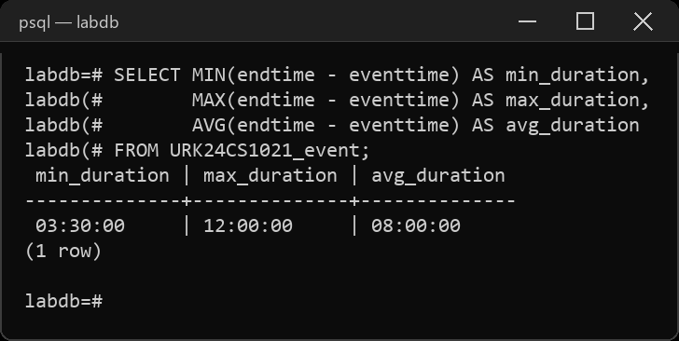
5. Retrieve distinct number of users.
Sample Code:
SELECT COUNT(DISTINCT userid) AS distinct_users FROM URK24CS1021_ticket;
Sample Output:
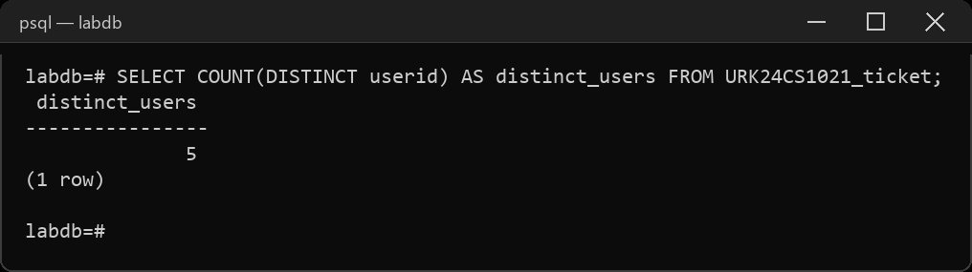
6. List names of events was more than 10 hours.
Sample Code:
SELECT name, endtime - eventtime AS duration FROM URK24CS1021_event
WHERE endtime - eventtime > INTERVAL '10 hours';
Sample Output:
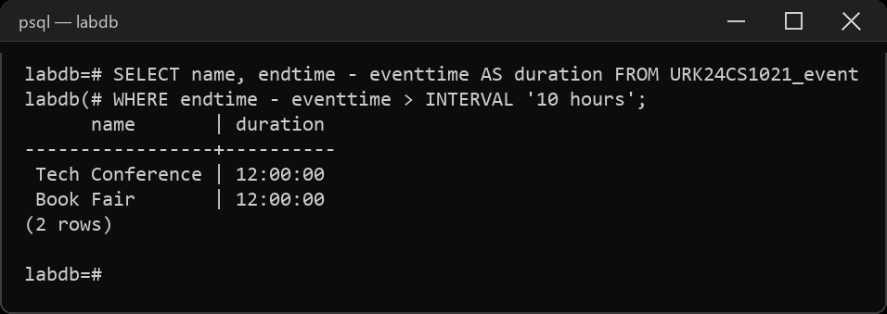
7. List the seat numbers of the users those whose tickets are confirmed.
Sample Code:
SELECT userid, seatnumber FROM URK24CS1021_ticket
WHERE status = 'confirmed' ORDER BY seatnumber;
Sample Output:
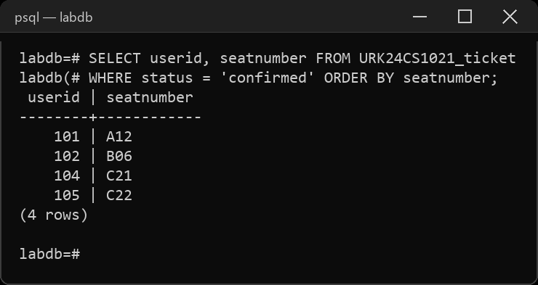
8. List user name and phone numbers those whose tickets reserved.
Sample Code:
SELECT u.name, u.phone FROM URK24CS1021_users u, URK24CS1021_ticket t
WHERE u.id = t.userid AND t.status = 'reserved';
Sample Output:
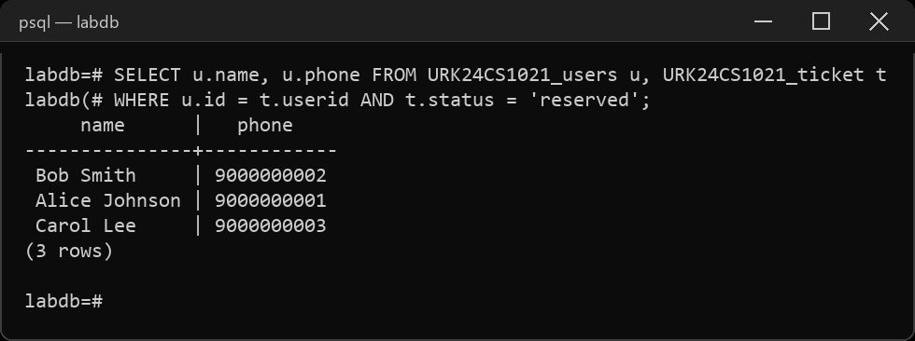
9. List the user details in the ascending order of their ticket price.
Sample Code:
SELECT u.id, u.name, u.email, u.phone, t.price
FROM URK24CS1021_users u, URK24CS1021_ticket t
WHERE u.id = t.userid ORDER BY t.price ASC;
Sample Output:
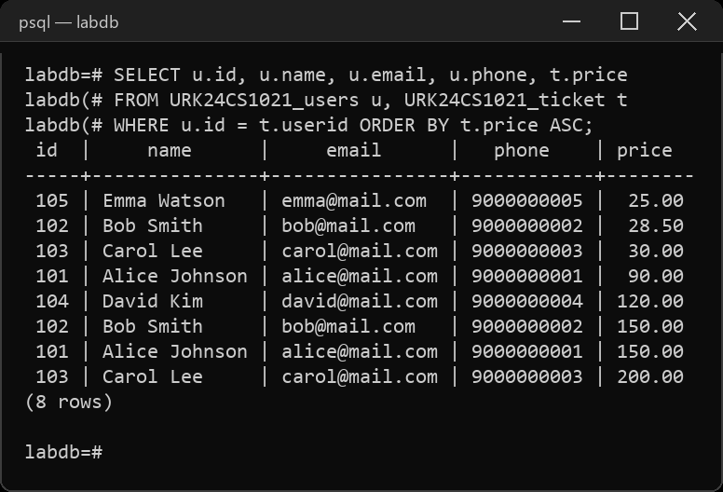
10. Modify the ticket price of the user based on the following: (a) if the price is greater than 30, give a concession of 2%; (b) if the price is lesser than or equal to 30, give a concession of 4%.
Sample Code:
SELECT ticketid, price FROM URK24CS1021_ticket ORDER BY ticketid;
UPDATE URK24CS1021_ticket SET price = CASE
WHEN price > 30 THEN price * 0.98
ELSE price * 0.96
END;
SELECT ticketid, price FROM URK24CS1021_ticket ORDER BY ticketid;
Sample Output:
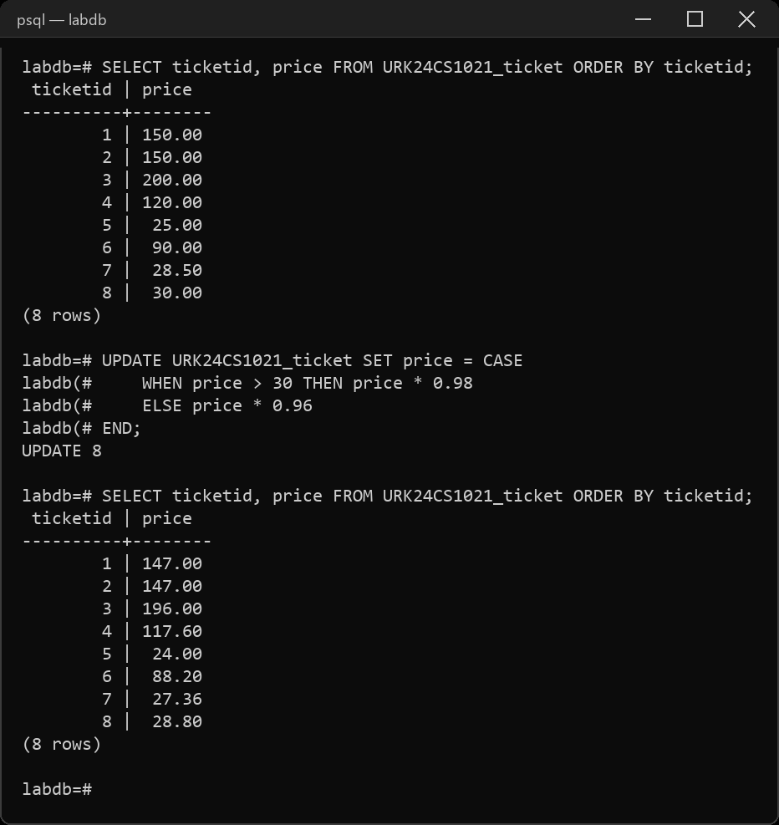
11. List the Venue name and address in each country.
Sample Code:
SELECT country, name, address FROM URK24CS1021_location
ORDER BY country, name;
Sample Output:
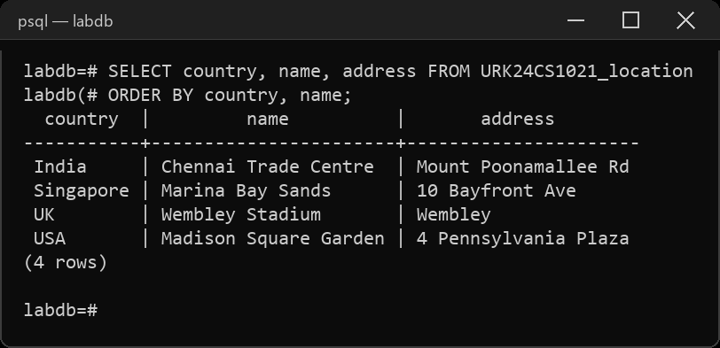
12. List all the city name in Alphabetical order.
Sample Code:
SELECT city FROM URK24CS1021_location ORDER BY city ASC;
Sample Output:
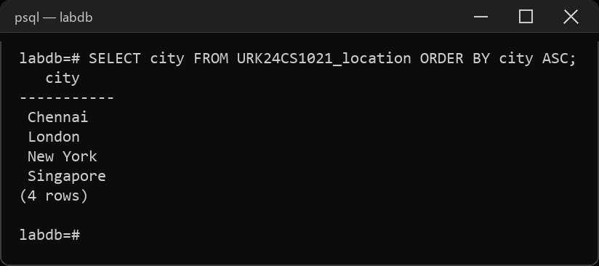
RESULT
The SQL queries were executed and the desired output was obtained.

