Ex. No. 3  Date: 05/08/2026 | ADVANCED SQL | URK24CS1021
Aim
To execute the given commands making use of aggregate functions, group by clause and order by clause.
Description
Aggregate functions take a collection of values and return a single value as the result: SUM returns the total, AVG the average, COUNT the number of tuples, and MIN and MAX the smallest and largest value in the collection. SUM and AVG need numeric input, while COUNT, MIN and MAX also work on non-numeric types. The DISTINCT keyword inside an aggregate expression eliminates duplicates before the function is applied. The GROUP BY clause applies an aggregate function to groups of tuples — tuples sharing the same value on every attribute named in the clause are placed in one group — and the ORDER BY clause returns the result of a query in sorted order, ASC for ascending and DESC for descending.
Questions
1. List the number of users in the user table.
SELECT COUNT(*) AS total_users FROM URK24CS1021_users;
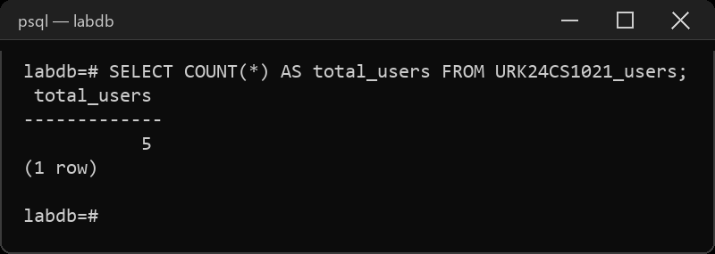
2. List the number of events conducted during 2023.
SELECT COUNT(*) AS events_2023 FROM URK24CS1021_event
WHERE eventdate BETWEEN '2023-01-01' AND '2023-12-31';
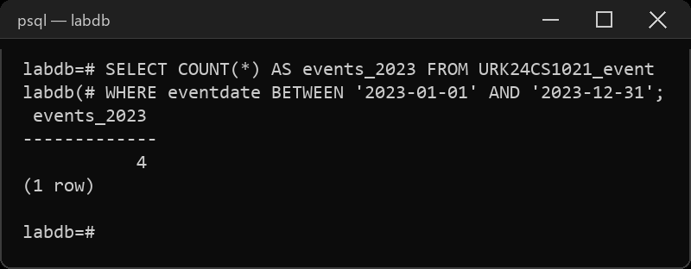
3. Calculate the total price for the confirmed tickets.
SELECT SUM(price) AS confirmed_total FROM URK24CS1021_ticket
WHERE status = 'confirmed';
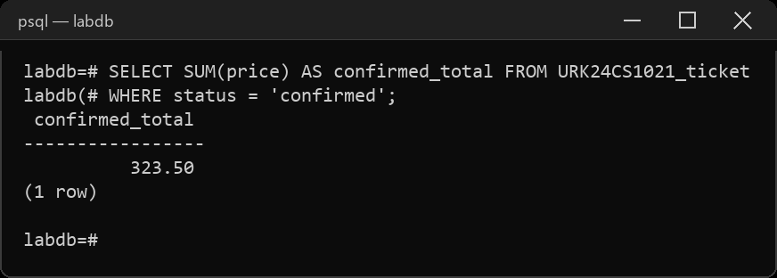
4. Find the minimum, maximum and average time taken for the given events.
SELECT MIN(endtime - eventtime) AS min_duration,
MAX(endtime - eventtime) AS max_duration,
AVG(endtime - eventtime) AS avg_duration
FROM URK24CS1021_event;
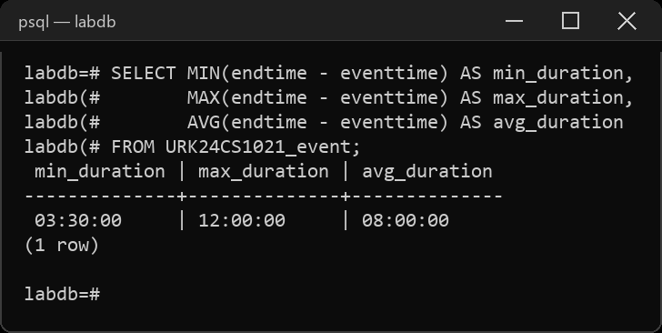
5. Retrieve distinct number of users.
SELECT COUNT(DISTINCT userid) AS distinct_users FROM URK24CS1021_ticket;
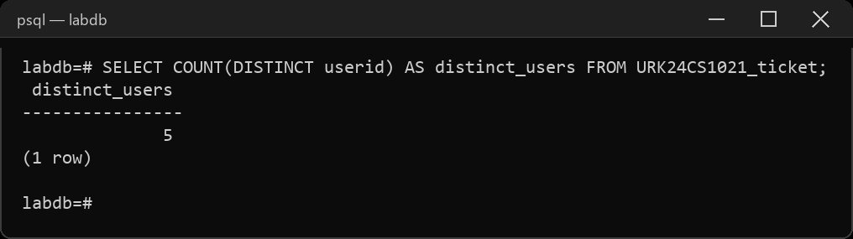
6. List names of events was more than 10 hours.
SELECT name, endtime - eventtime AS duration FROM URK24CS1021_event
WHERE endtime - eventtime > INTERVAL '10 hours';
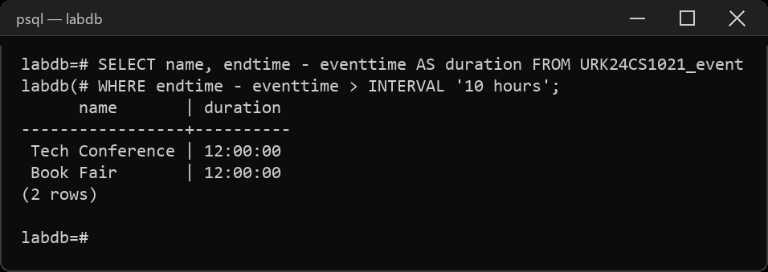
7. List the seat numbers of the users those whose tickets are confirmed.
SELECT userid, seatnumber FROM URK24CS1021_ticket
WHERE status = 'confirmed' ORDER BY seatnumber;
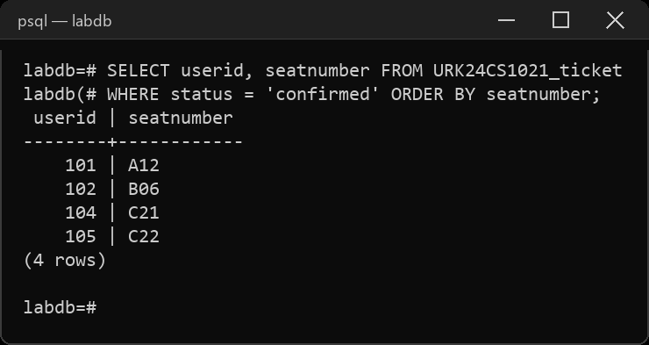
8. List user name and phone numbers those whose tickets reserved.
SELECT u.name, u.phone FROM URK24CS1021_users u, URK24CS1021_ticket t
WHERE u.id = t.userid AND t.status = 'reserved';
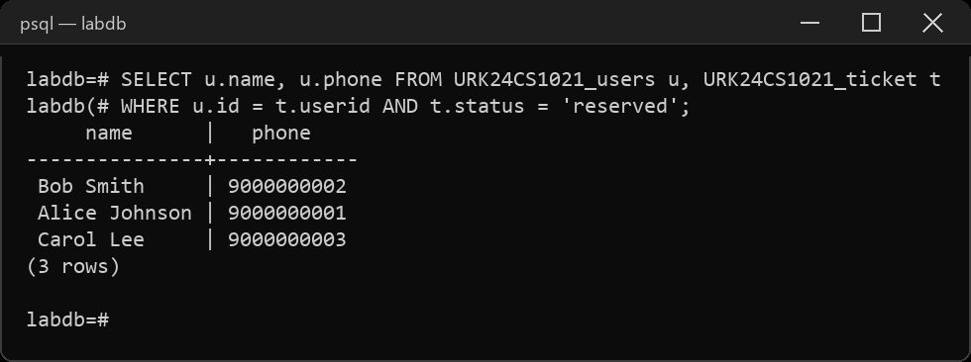
9. List the user details in the ascending order of their ticket price.
SELECT u.id, u.name, u.email, u.phone, t.price
FROM URK24CS1021_users u, URK24CS1021_ticket t
WHERE u.id = t.userid ORDER BY t.price ASC;
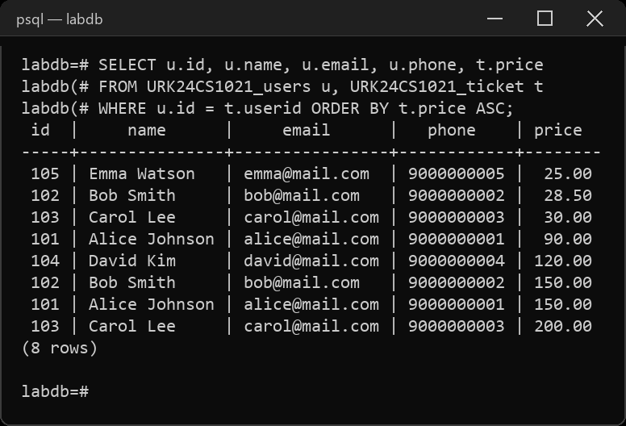
10. Modify the ticket price of the user based on the following: (a) if the price is greater than 30, give a concession of 2%; (b) if the price is lesser than or equal to 30, give a concession of 4%.
SELECT ticketid, price FROM URK24CS1021_ticket ORDER BY ticketid;
UPDATE URK24CS1021_ticket SET price = CASE
WHEN price > 30 THEN price * 0.98
ELSE price * 0.96
END;
SELECT ticketid, price FROM URK24CS1021_ticket ORDER BY ticketid;
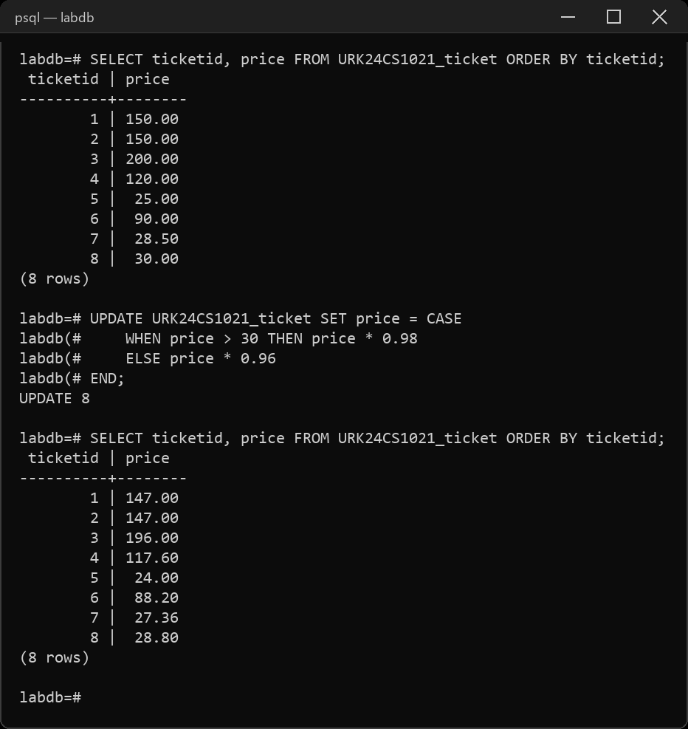
11. List the Venue name and address in each country.
SELECT country, name, address FROM URK24CS1021_location
ORDER BY country, name;
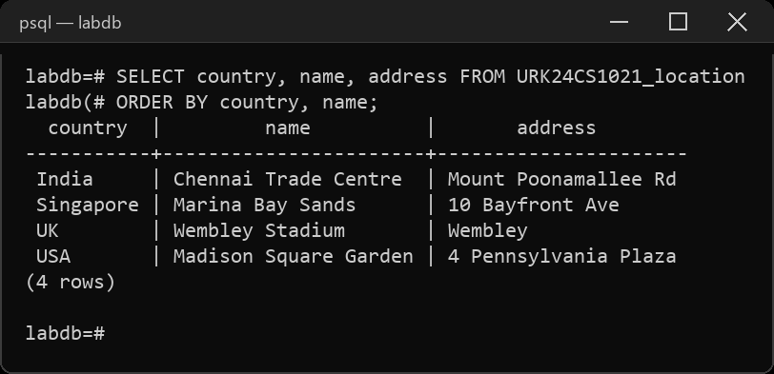
12. List all the city name in Alphabetical order.
SELECT city FROM URK24CS1021_location ORDER BY city ASC;
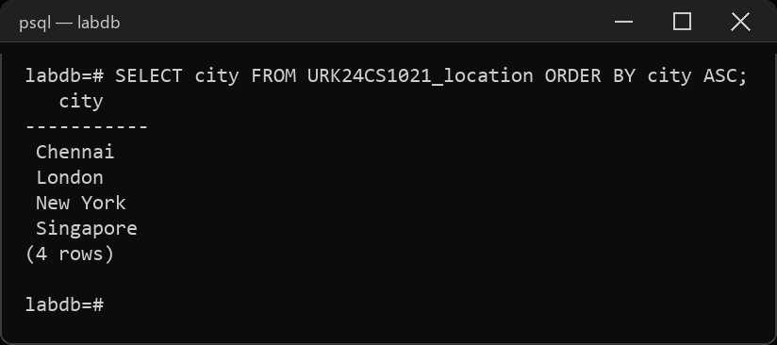
Result
The queries were executed and the desired output was obtained.

