Comparative Sequence and Structure Analysis of APP, PSEN1 and PSEN2: Conservation of Alzheimer's Disease Residues and Drug-Binding Sites Across Laboratory Model Organisms
A reproducible dry-lab bioinformatics study
Data retrieved 29 October to 3 November 2026. Report generated 03 November 2026.
Interactive results: https://nozheimers.vercel.app and https://nozheimers.vercel.app/explorer.html
Code and data: https://github.com/Kukyos/Nozheimers

Abstract
Background: mutations in APP, PSEN1 and PSEN2 cause early-onset Alzheimer's disease, and drug candidates are tested in animals before humans. Aim: to determine which laboratory organisms carry proteins close enough to the human ones for disease-mutation and drug studies. Methods: with the human proteins as the reference, we aligned their orthologs from four mammals (multiple alignment, Clustal Omega) and from 12 laboratory organisms (pairwise), superposed AlphaFold structures, mapped curated ClinVar pathogenic variants, and measured conservation of the residues that contact nine drugs in experimental PDB structures. Results: identity to human in mouse, rat, dog and cattle was 96.6-97.4% for APP, 91.7-94.0% for PSEN1 and 95.3-97.5% for PSEN2. 111 of 112 mapped pathogenic variants lie at residues identical in all five mammals. Mouse PSEN1 keeps 68 of 69 disease residues and all 5 drug pockets; mouse APP keeps all 9 disease residues but differs at 3 of 42 amyloid-beta residues. Conclusion: non-human primates, pig, cattle and dog carry essentially human versions of all three proteins; rodents suit presenilin and gamma-secretase drug studies, but amyloid-beta studies in rodents need the human APP sequence.

1. Introduction
Alzheimer's disease is the most common cause of dementia. A small fraction of cases are inherited and begin early, caused by mutations in APP [1], PSEN1 [2] or PSEN2 [3, 4]. APP is cut twice to release amyloid-beta, the peptide that accumulates in plaques [5]. Presenilin forms the catalytic core of gamma-secretase, which makes the second cut with two aspartate residues [6, 7].
Drugs and disease mechanisms are studied in animals before humans. Such a study transfers to patients only if the animal's protein has the same residues where it matters: at the sites mutated in patients, in the functional core, and where a drug binds. Sequence comparison counts the differences; structure comparison shows where they sit.
Research question: how conserved are APP, PSEN1 and PSEN2 between humans and laboratory organisms, and which organisms keep the human disease residues, functional core and drug-binding residues well enough to serve as test models?

2. Input
The human protein is the reference in every comparison; the other organisms are the inputs tested against it.
Table 1. Human reference proteins (MANE Select). The UniProt canonical sequences are identical to these RefSeq proteins, so residue numbers agree across databases.
Gene | Protein | Length (aa) | RefSeq protein | Transcript | UniProt | NCBI Gene
APP | amyloid-beta precursor protein isoform a precursor | 770 | NP_000475.1 | NM_000484.4 | P05067 | 351
PSEN1 | presenilin-1 isoform I-467 | 467 | NP_000012.1 | NM_000021.4 | P49768 | 5663
PSEN2 | presenilin-2 isoform 1 | 448 | NP_000438.2 | NM_000447.3 | P49810 | 5664

Table 2. Laboratory organisms compared with the human reference.
Group | Organism | Species | NCBI Taxon ID
Primates | Chimpanzee | Pan troglodytes | 9598
Primates | Rhesus macaque | Macaca mulatta | 9544
Rodents | Mouse | Mus musculus | 10090
Rodents | Rat | Rattus norvegicus | 10116
Other mammals | Dog | Canis lupus familiaris | 9615
Other mammals | Pig | Sus scrofa | 9823
Other mammals | Cattle | Bos taurus | 9913
Birds | Chicken | Gallus gallus | 9031
Amphibians | Western clawed frog | Xenopus tropicalis | 8364
Fish | Zebrafish | Danio rerio | 7955
Invertebrates | Fruit fly | Drosophila melanogaster | 7227
Invertebrates | C. elegans | Caenorhabditis elegans | 6239
The online explorer extends the comparison to any species with an NCBI ortholog call (832-866 species, depending on the gene).

Databases and tools: NCBI Gene, RefSeq and Datasets [8, 9, 10]; NCBI BLAST [11]; Clustal Omega via the EMBL-EBI Job Dispatcher [12, 13]; ClinVar [14]; UniProt [15]; AlphaFold DB [16, 17]; RCSB Protein Data Bank [18]; pSSdb, the Protein Secondary Structure Database (https://pssdb.mimuw.edu.pl); Biopython [19]; 3Dmol.js [20]; matplotlib [21].

3. Data and methods
All rules were fixed before results were seen. Every decision is logged in 01_metadata/methods_log.md, and every download is cached with its access date.
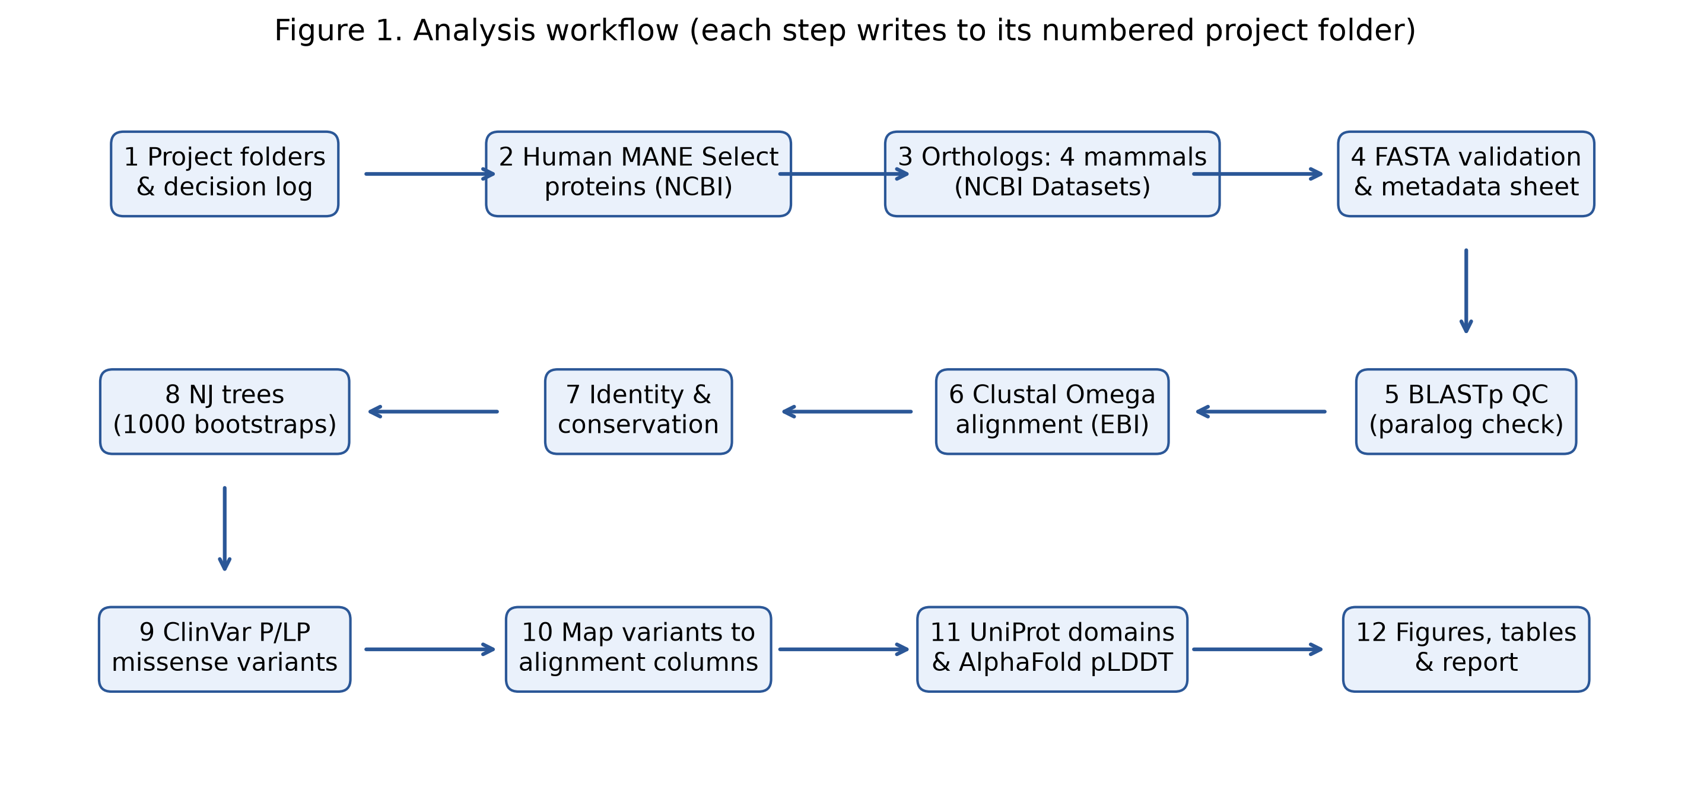
Figure 1. Workflow of the five-mammal analysis (pipeline.py), from sequence retrieval to interpretation.

3.1 Five-mammal comparison
- Human reference: the MANE Select transcript and protein from the NCBI Gene product report.
- Orthologs in mouse, rat, dog and cattle: NCBI ortholog calls. Among 126 candidate RefSeq proteins, the isoform with the highest global alignment score to human was kept (BLOSUM62 [22], gap open -11, extend -1), preferring a curated NP_ record within 5% of the best score.
- Quality control: FASTA validation, and BLASTp of each human protein against RefSeq protein to confirm that the top hit per species is the ortholog, not a paralog.
- Multiple alignment: Clustal Omega, protein, default parameters, one alignment per gene.
- Identity = identical residues / columns where both sequences have a residue. Coverage = those columns / human length.
- Trees: neighbour-joining [23] on p-distance with 1000 bootstrap replicates [24].
- ClinVar: missense records classified Pathogenic or Likely pathogenic, review status "criteria provided" or better, with an Alzheimer condition listed; mapped only when the transcript and reference residue match the human reference.

3.2 Laboratory organisms and structures
- Orthologs for 12 organisms from NCBI ortholog calls, mapped to UniProt. All UniProt entries linked to the gene were aligned to human and the best full-length match was kept. NCBI makes no call for fruit fly and C. elegans, so reviewed UniProt homologs were used (Appl and apl-1 for APP; Psn and sel-12, each a co-ortholog of both PSEN1 and PSEN2).
- Global pairwise alignment to human (BLOSUM62, gap open -11, extend -1).
- Structure comparison: the AlphaFold DB models of the human and organism proteins were superposed on C-alpha atoms (Kabsch [25]) using residues with pLDDT of at least 70 in both models. APP, a multi-domain protein with flexible linkers, was fitted on its best-fitting domain (E2, residues 374-565).
- Functional core: amyloid-beta (APP 672-713) for APP; the UniProt membrane-spanning helices for PSEN1 and PSEN2, with the catalytic aspartates PSEN1 D257/D385 and PSEN2 D263/D366.
- Drug pockets: human residues with any heavy atom within 4.5 angstrom of the drug in experimental PDB complexes (Table 9).
- Secondary structure: helix, sheet and coil assigned from each 3D model with a DSSP-style hydrogen-bond method [26], the same approach pSSdb applies to AlphaFold models, so pSSdb entries for the same UniProt accessions serve as an independent cross-check.
- Verdict, stated in advance so it can be challenged. Strong model: at least 90% identity, at least 95% of disease residues kept, at least 95% of the core identical, catalytic residues kept. Usable with care: at least 70% identity, catalytic residues kept, at least 85% of disease residues kept. Otherwise: distant model.
- Checks: human against itself gives 100% identity and 0 angstrom RMSD; the browser implementation reproduces the Python results exactly (site/test_live.js); MRK-560, reported as PSEN1-selective, has the pocket that differs most between human PSEN1 and PSEN2 (T281P, L282I).
Table 3. Tools, versions and parameters (01_metadata/analysis_settings.csv).
step | tool_or_resource | version_or_endpoint | parameters | date
2 Human references | NCBI Datasets v2 gene product_report; E-utilities efetch | https://api.ncbi.nlm.nih.gov/datasets/v2 | MANE Select transcript and protein per gene | 2026-11-03
3 Orthologs | NCBI Datasets v2 gene orthologs + product_report; Biopython PairwiseAligner | https://api.ncbi.nlm.nih.gov/datasets/v2/gene/id/{id}/orthologs | global alignment, BLOSUM62, gap open -11, extend -1; NP_ preferred within 5% of best score | 2026-11-03
5 BLAST QC | NCBI BLAST URL API, blastp | BLASTP 2.17.0+ | db refseq_protein; Entrez query "txid10090[ORGN] OR txid10116[ORGN] OR txid9615[ORGN] OR txid9913[ORGN]"; hitlist 100; matrix BLOSUM62; gap open/extend 11/1; expect 10 | 2026-11-03
6 Multiple alignment | EMBL-EBI Job Dispatcher Clustal Omega REST | CLUSTAL O(1.2.4) | stype=protein, outfmt=clustal_num, order=input, all other parameters default | 2026-11-03
7 Identity/conservation | pipeline.py (Python) |  | identity = identical / columns where both sequences have a residue; coverage = those columns / human length | 2026-11-03
8 Phylogeny | Biopython DistanceTreeConstructor (neighbour-joining) | Biopython 1.88 | p-distance (gap columns excluded pairwise); 1000 bootstrap replicates, seed 1; midpoint-rooted for display; no substitution-model selection | 2026-11-03
9 ClinVar | NCBI E-utilities esearch/esummary, db=clinvar | https://eutils.ncbi.nlm.nih.gov/entrez/eutils/ | term "<GENE>[gene] AND missense_variant[molecular consequence]"; selection rule in methods_log.md | 2026-11-03
11 Domains/structure | UniProt REST; AlphaFold DB API | rest.uniprot.org; alphafold.ebi.ac.uk/api | reviewed human entry; features transferred only if sequence identical; pLDDT from CA B-factor | 2026-11-03
12 Figures | matplotlib | 3.11.1 | 300 dpi PNG | 2026-11-03

4. Output (results)

4.1 Sequence retrieval and quality control
All 15 selected proteins passed validation. BLASTp confirmed the APP ortholog as the top hit in every species. The searches for PSEN1 and PSEN2 were still queued at NCBI when this report was generated and are marked pending; re-running pipeline.py fills them in.

4.2 Conservation across five mammals
Table 4. Pairwise identity of each species to the human reference (from the Clustal Omega alignment).
Gene | Species | Accession | Identity % | Coverage % | Shared columns | Gap columns
APP | Mus musculus | NP_001185752.1 | 96.62 | 100.0 | 770 | 0
APP | Rattus norvegicus | NP_062161.1 | 96.88 | 100.0 | 770 | 0
APP | Canis lupus familiaris | NP_001006601.2 | 96.88 | 100.0 | 770 | 0
APP | Bos taurus | XP_005201194.1 | 97.4 | 100.0 | 770 | 0
PSEN1 | Mus musculus | NP_001349200.1 | 92.87 | 99.14 | 463 | 8
PSEN1 | Rattus norvegicus | NP_062036.2 | 92.66 | 99.14 | 463 | 9
PSEN1 | Canis lupus familiaris | NP_001002943.2 | 93.99 | 99.79 | 466 | 1
PSEN1 | Bos taurus | NP_777146.1 | 91.65 | 100.0 | 467 | 11
PSEN2 | Mus musculus | NP_001122077.1 | 95.98 | 100.0 | 448 | 0
PSEN2 | Rattus norvegicus | NP_112349.2 | 95.31 | 100.0 | 448 | 0
PSEN2 | Canis lupus familiaris | NP_001271394.1 | 95.76 | 100.0 | 448 | 0
PSEN2 | Bos taurus | NP_776865.2 | 97.54 | 100.0 | 448 | 1

APP: 94.3% of human residues are identical in all five species; PSEN1: 85.4% of human residues are identical in all five species; PSEN2: 91.1% of human residues are identical in all five species.
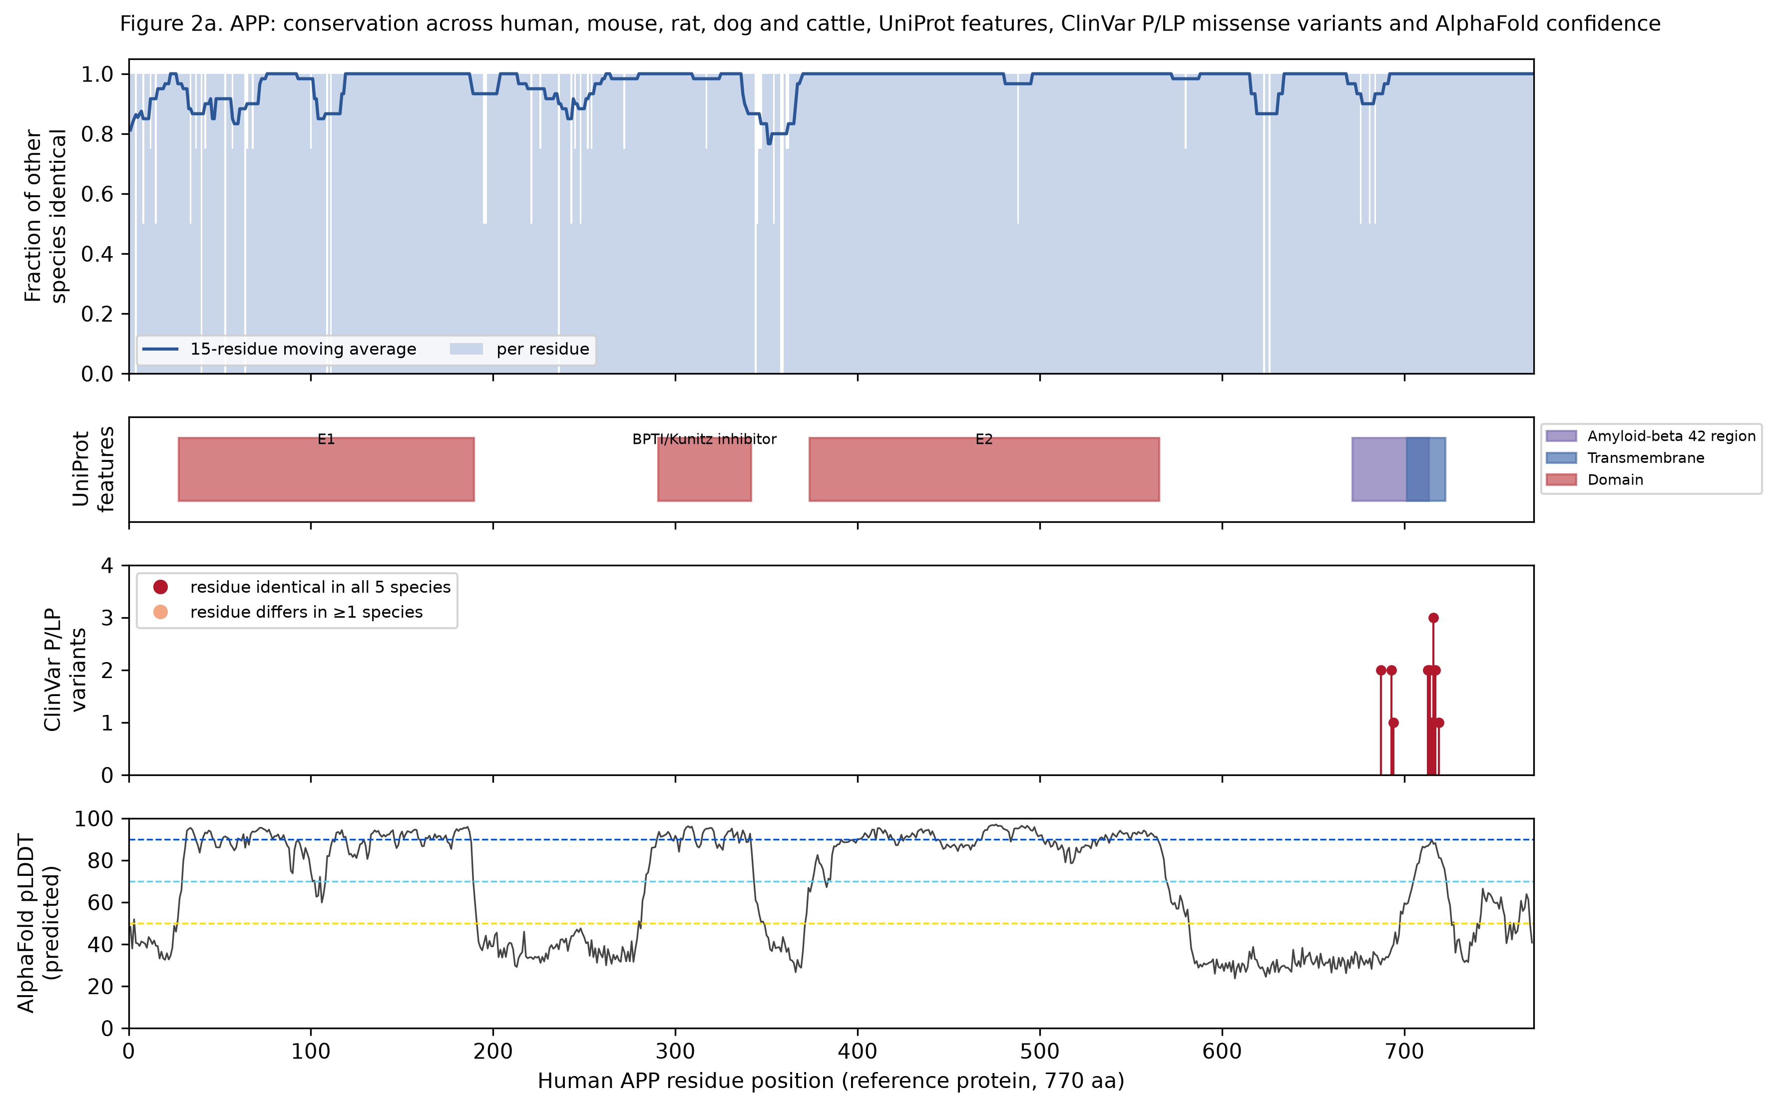
Figure 2a. APP: per-residue conservation across five species, UniProt features and ClinVar pathogenic variants.
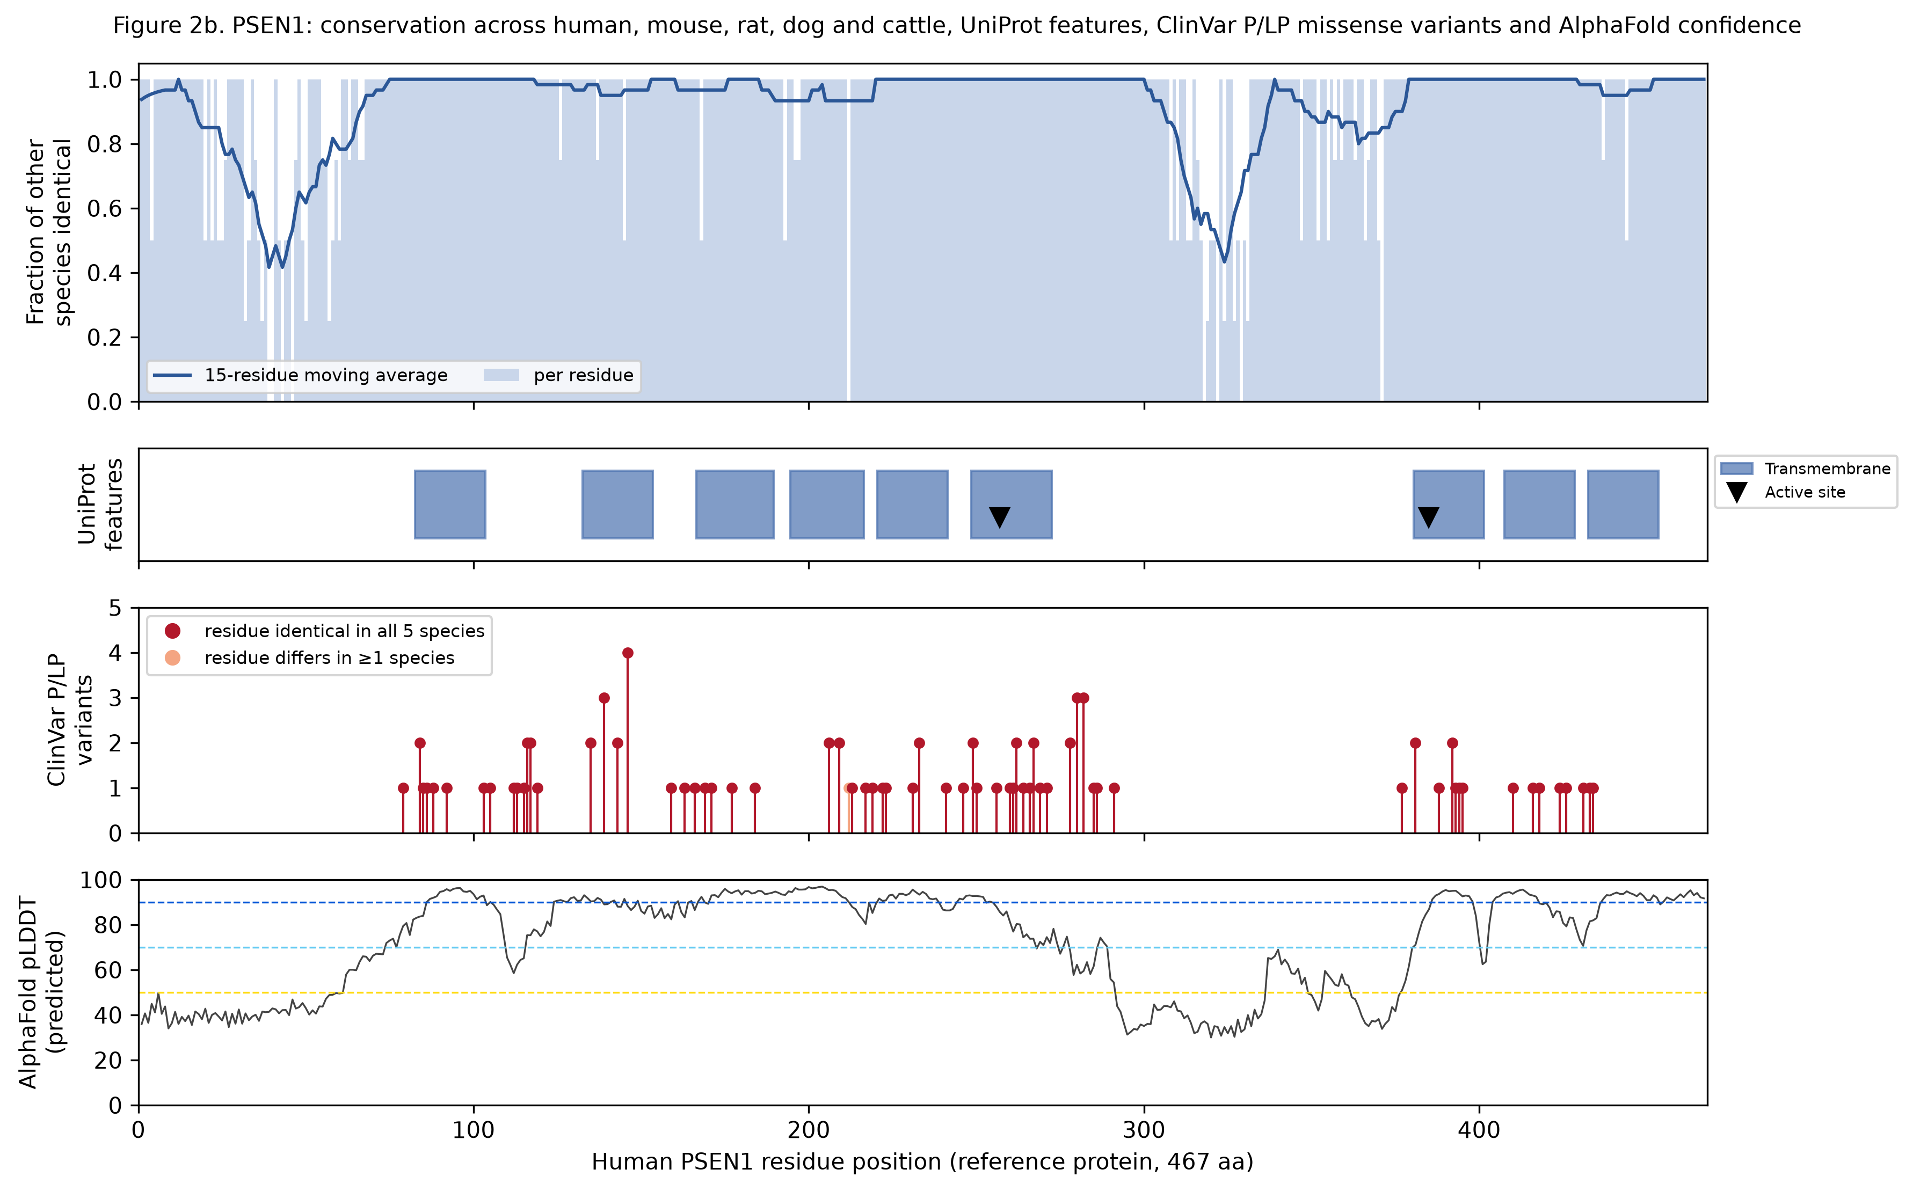
Figure 2b. PSEN1: per-residue conservation across five species, UniProt features and ClinVar pathogenic variants.
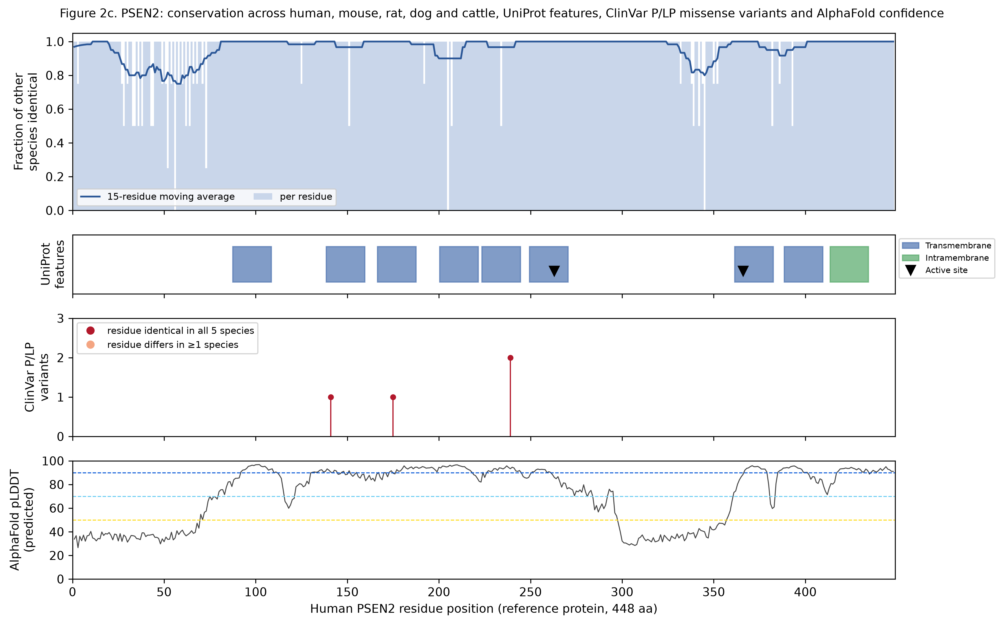
Figure 2c. PSEN2: per-residue conservation across five species, UniProt features and ClinVar pathogenic variants.

4.3 Disease variants
ClinVar missense records: APP 276, PSEN1 361, PSEN2 170. Of these, APP 16, PSEN1 92, PSEN2 4 met the selection rule, and all were mapped. 111 of 112 lie at residues identical in all five mammals.
Table 5. Curated pathogenic variants and conservation. The full list with ClinVar links is in 07_variants/variant_mapping.csv.
Gene | Variants | Residues | Variants at fully conserved residues | all residues fully conserved %
APP | 16 | 9 | 16 | 94.3
PSEN1 | 92 | 69 | 91 | 85.4
PSEN2 | 4 | 3 | 4 | 91.1

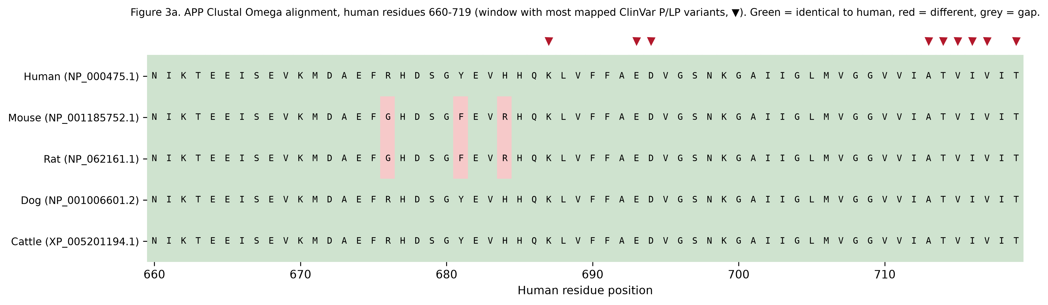
Figure 3a. APP: alignment window around the densest cluster of pathogenic variants.
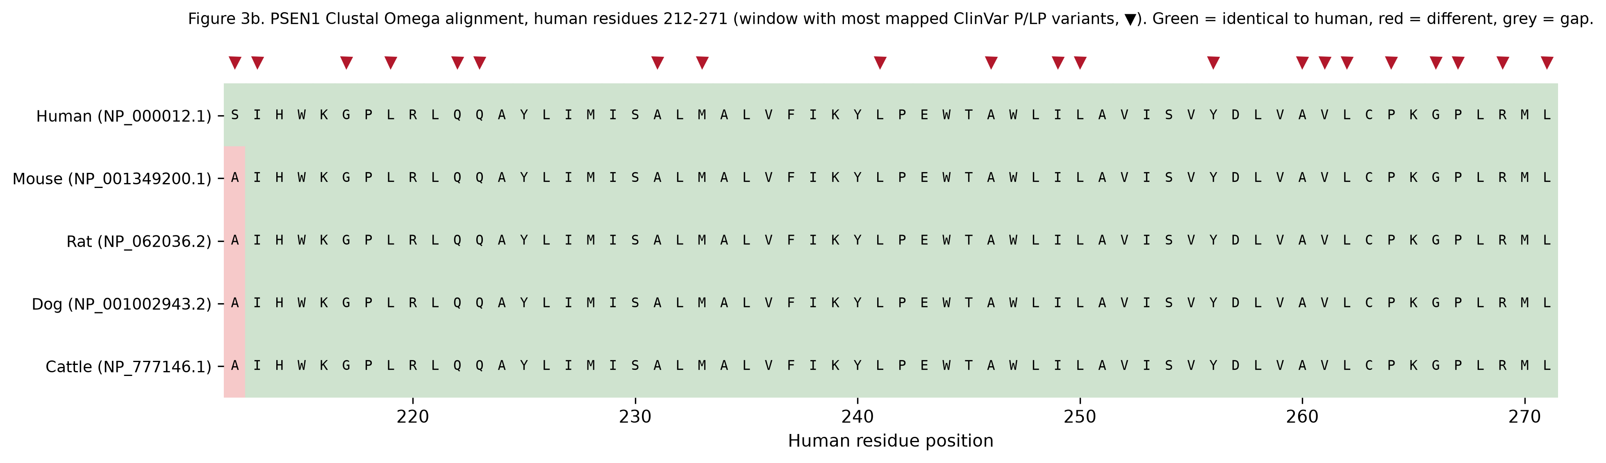
Figure 3b. PSEN1: alignment window around the densest cluster of pathogenic variants.
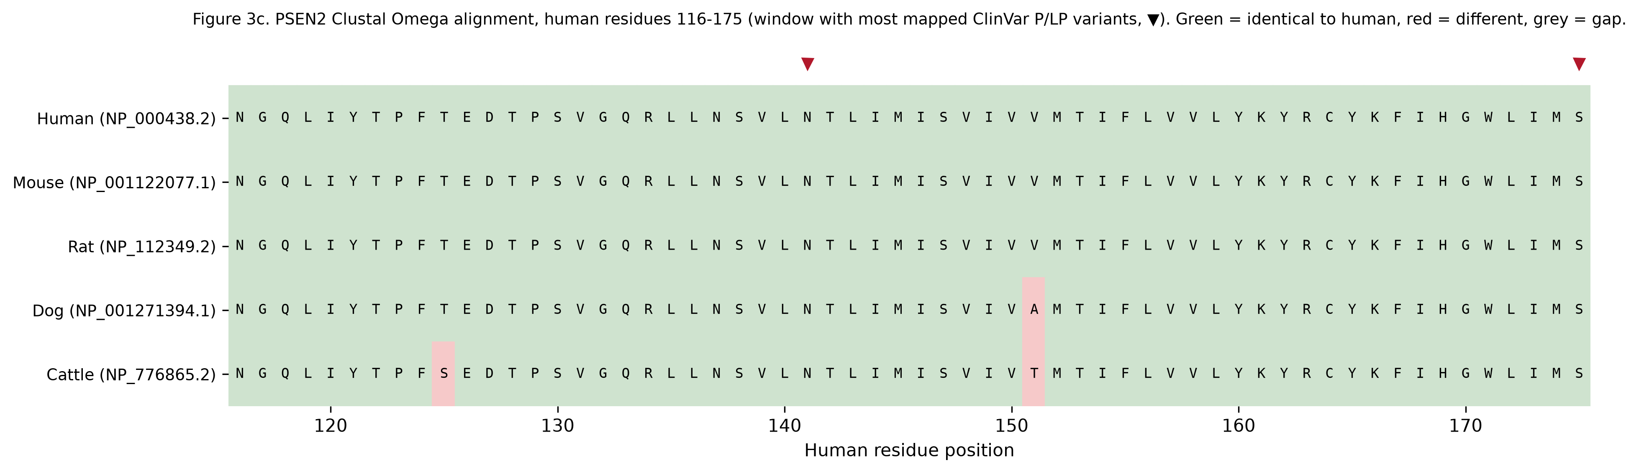
Figure 3c. PSEN2: alignment window around the densest cluster of pathogenic variants.
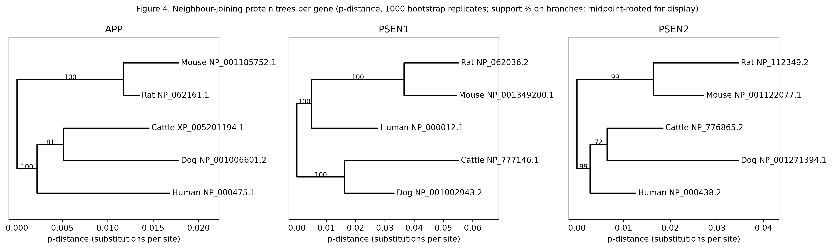
Figure 4. Neighbour-joining gene trees (p-distance, 1000 bootstraps). These are gene trees, not disease trees.

4.4 3D structure comparison
In the online explorer the organism model is superposed on the human model and can be rotated, coloured by difference, confidence, secondary structure, disease residues or drug pocket, and queried residue by residue.
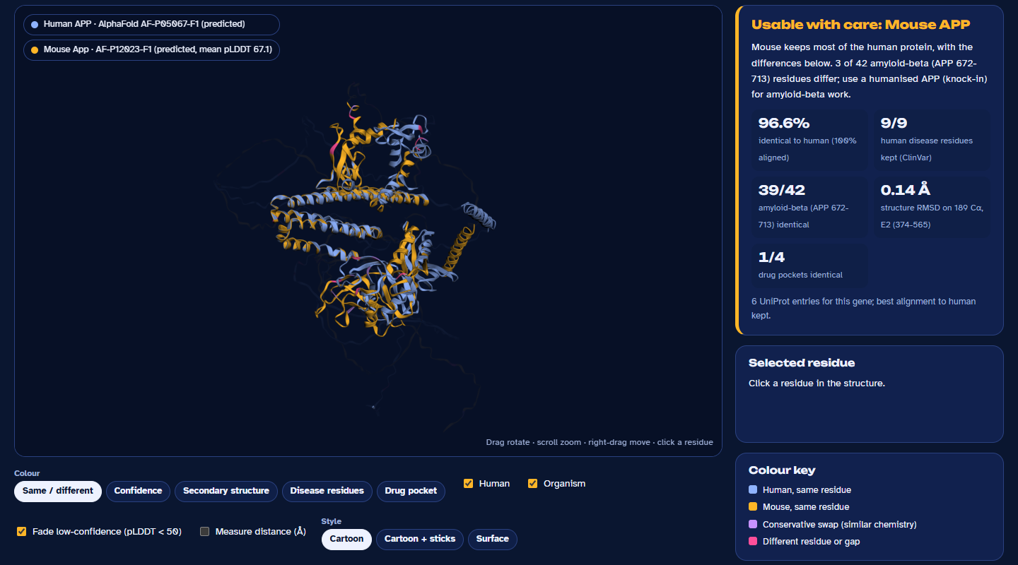
Figure 5a. Human APP (blue) and mouse App (amber) AlphaFold models superposed on the E2 domain; magenta marks residues that differ. Screenshot of the model-organism explorer.
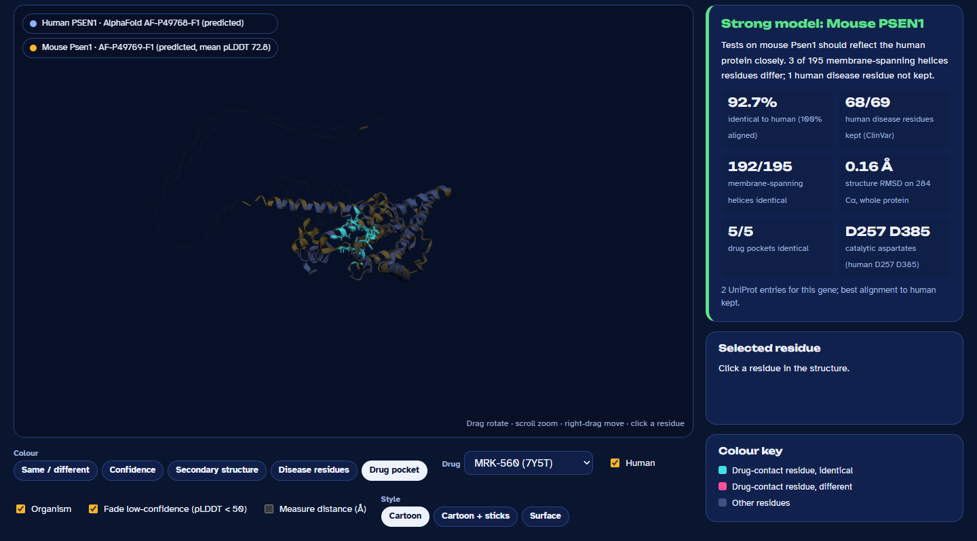
Figure 5b. Human and mouse PSEN1 superposed (0.16 angstrom RMSD); cyan sticks mark the residues that contact MRK-560 in PDB 7Y5T, all identical in mouse. Screenshot of the model-organism explorer.
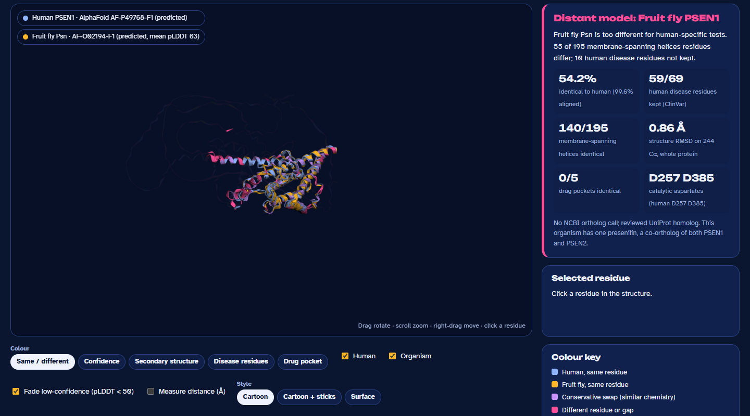
Figure 5c. Human PSEN1 and fruit fly Psn: the membrane core superposes closely (0.86 angstrom) despite 54% identity, but disease and drug-contact residues differ. Screenshot of the model-organism explorer.

4.5 Laboratory organisms
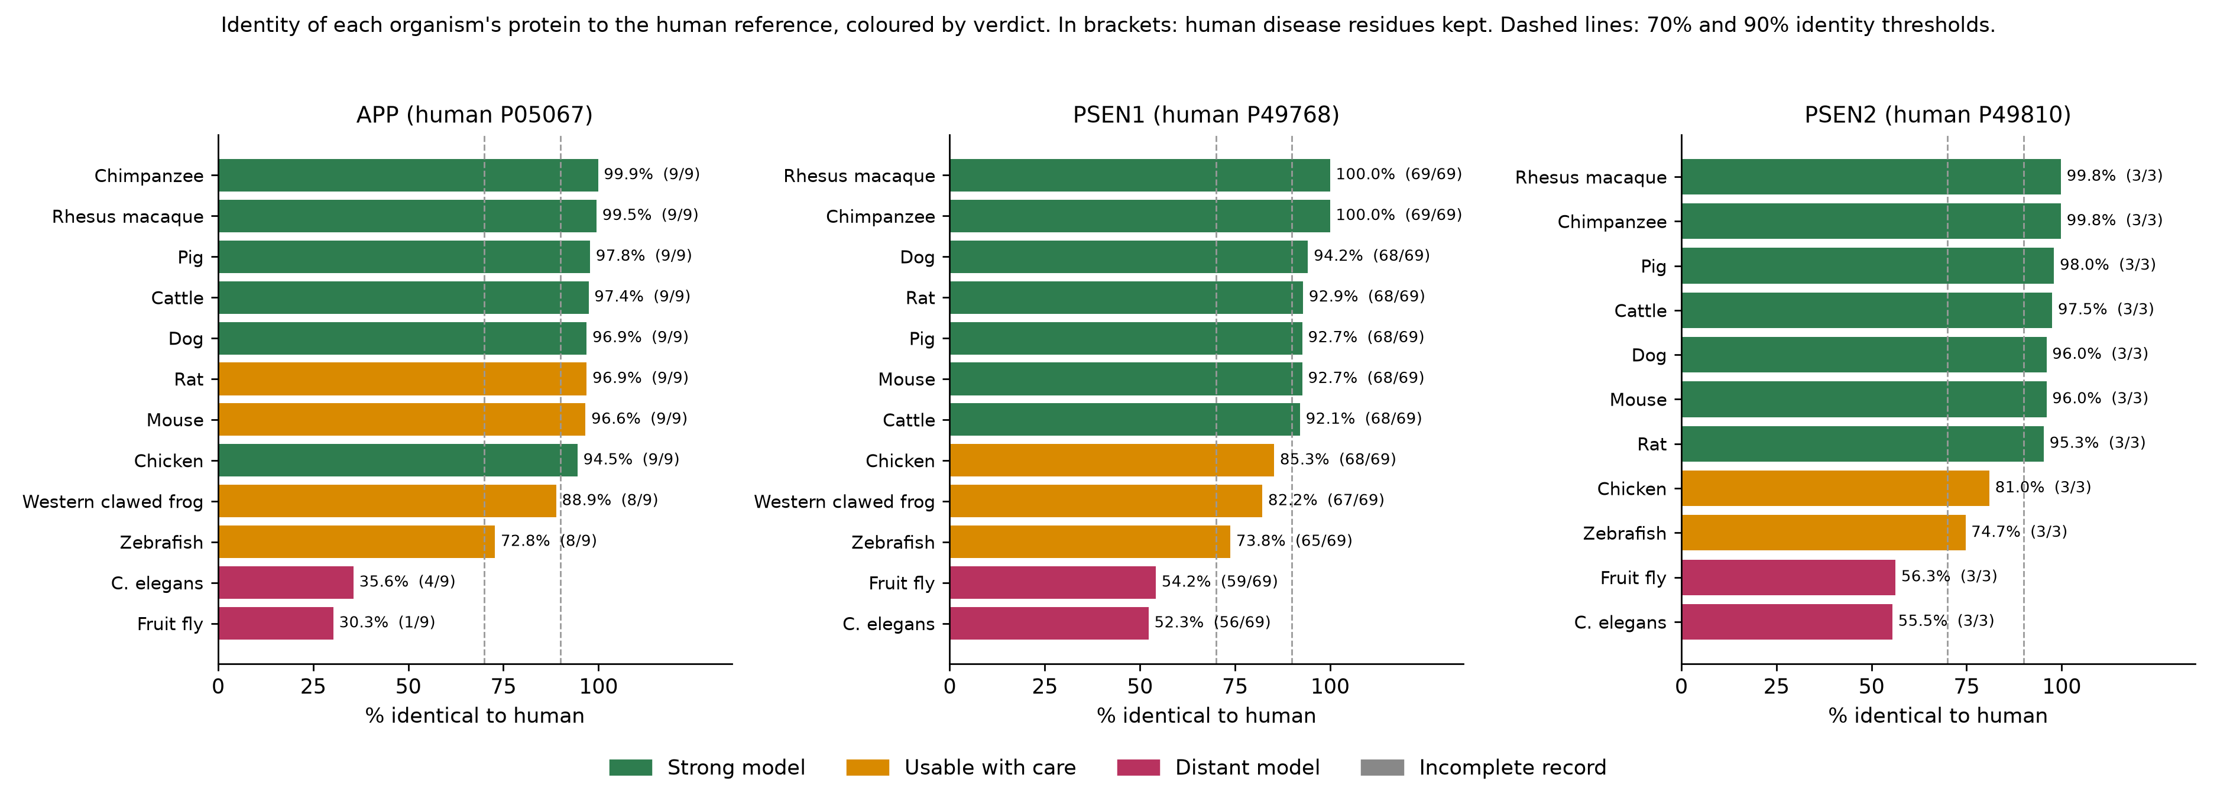
Figure 6. Identity of each laboratory organism's protein to the human reference, coloured by verdict.
Table 6. Human APP (P05067) against laboratory organisms. Core = amyloid-beta (APP 672-713). RMSD in angstrom over the number of C-alpha atoms in brackets.
Organism | UniProt | Identity % | Disease residues kept | Core identical | RMSD (CA) | Drug pockets identical | Verdict
Chimpanzee | Q5IS80 | 99.9 | 9/9 | 42/42 | 1.0 (188) | 4/4 | Strong model
Rhesus macaque | G7MNB1 | 99.5 | 9/9 | 42/42 | 0.43 (187) | 4/4 | Strong model
Pig | P79307 | 97.8 | 9/9 | 42/42 | 0.84 (180) | 4/4 | Strong model
Cattle | A0A3Q1LUG2 | 97.4 | 9/9 | 42/42 | 0.69 (188) | 4/4 | Strong model
Rat | P08592 | 96.9 | 9/9 | 39/42 | 0.83 (184) | 1/4 | Usable with care (needs human APP for amyloid-beta work)
Dog | A0A8I3P9H6 | 96.9 | 9/9 | 42/42 | 0.62 (186) | 4/4 | Strong model
Mouse | P12023 | 96.6 | 9/9 | 39/42 | 0.14 (189) | 1/4 | Usable with care (needs human APP for amyloid-beta work)
Chicken | Q9DGJ7 | 94.5 | 9/9 | 42/42 | 0.59 (187) | 4/4 | Strong model
Western clawed frog | Q6DJB6 | 88.9 | 8/9 | 37/42 | 0.56 (180) | 0/4 | Usable with care (needs human APP for amyloid-beta work)
Zebrafish | Q6NUZ1 | 72.8 | 8/9 | 34/42 | 1.11 (188) | 1/4 | Usable with care (needs human APP for amyloid-beta work)
C. elegans | Q10651 | 35.6 | 4/9 | 8/42 | 1.68 (145) | 0/4 | Distant model
Fruit fly | P14599 | 30.3 | 1/9 | 12/42 | 2.98 (186) | 0/4 | Distant model

Table 7. Human PSEN1 (P49768) against laboratory organisms. Core = membrane-spanning helices. RMSD in angstrom over the number of C-alpha atoms in brackets.
Organism | UniProt | Identity % | Disease residues kept | Core identical | RMSD (CA) | Drug pockets identical | Verdict
Chimpanzee | H2Q8K1 | 100.0 | 69/69 | 195/195 | 0.26 (273) | 5/5 | Strong model
Rhesus macaque | A0A5K1VUH6 | 100.0 | 69/69 | 195/195 | 0.25 (271) | 5/5 | Strong model
Dog | A0A8I3RZ86 | 94.2 | 68/69 | 194/195 | 0.23 (270) | 5/5 | Strong model
Rat | P97887 | 92.9 | 68/69 | 192/195 | 0.17 (282) | 5/5 | Strong model
Mouse | P49769 | 92.7 | 68/69 | 192/195 | 0.16 (284) | 5/5 | Strong model
Pig | Q0MS44 | 92.7 | 68/69 | 192/195 | 0.23 (272) | 5/5 | Strong model
Cattle | A7MBA9 | 92.1 | 68/69 | 188/195 | 0.23 (265) | 5/5 | Strong model
Chicken | Q4JIM4 | 85.3 | 68/69 | 190/195 | 0.18 (282) | 5/5 | Usable with care
Western clawed frog | A0A803KHG8 | 82.2 | 67/69 | 186/195 | 0.23 (264) | 5/5 | Usable with care
Zebrafish | F8W381 | 73.8 | 65/69 | 176/195 | 0.28 (262) | 2/5 | Usable with care
Fruit fly | O02194 | 54.2 | 59/69 | 140/195 | 0.86 (244) | 0/5 | Distant model
C. elegans | P52166 | 52.3 | 56/69 | 128/195 | 0.71 (273) | 0/5 | Distant model

Table 8. Human PSEN2 (P49810) against laboratory organisms. Core = membrane-spanning helices. RMSD in angstrom over the number of C-alpha atoms in brackets.
Organism | UniProt | Identity % | Disease residues kept | Core identical | RMSD (CA) | Drug pockets identical | Verdict
Chimpanzee | A0A2I3SVT3 | 99.8 | 3/3 | 168/168 | 0.29 (273) | - | Strong model
Rhesus macaque | F7A2D1 | 99.8 | 3/3 | 168/168 | 0.24 (271) | - | Strong model
Pig | Q0MS45 | 98.0 | 3/3 | 166/168 | 0.09 (285) | - | Strong model
Cattle | Q9XT96 | 97.5 | 3/3 | 166/168 | 0.11 (284) | - | Strong model
Mouse | Q3U4P5 | 96.0 | 3/3 | 163/168 | 0.3 (274) | - | Strong model
Dog | A0A8I3NJ39 | 96.0 | 3/3 | 166/168 | 0.22 (270) | - | Strong model
Rat | O88777 | 95.3 | 3/3 | 163/168 | 0.15 (283) | - | Strong model
Chicken | A0A8V0Z5X8 | 81.0 | 3/3 | 155/168 | 0.29 (272) | - | Usable with care
Zebrafish | Q90ZE4 | 74.7 | 3/3 | 145/168 | 0.18 (276) | - | Usable with care
Fruit fly | O02194 | 56.3 | 3/3 | 123/168 | 0.6 (244) | - | Distant model
C. elegans | P52166 | 55.5 | 3/3 | 109/168 | 0.46 (273) | - | Distant model
No ortholog listed for: Western clawed frog.

4.6 Drug-binding pockets
Table 9. Drugs in experimental human structures and the organisms whose drug-contact residues are identical to human. This is pocket conservation, not a docking simulation.
Drug | Type | Target | PDB | Method, resolution | Pocket residues | Organisms with identical pocket
Avagacestat | gamma-secretase inhibitor | PSEN1 | 6LQG | Electron Microscopy, 3.1 A | 19 | Chimpanzee, Rhesus macaque, Mouse, Rat, Dog, Pig, Cattle, Chicken, Western clawed frog
Semagacestat | gamma-secretase inhibitor | PSEN1 | 6LR4 | Electron Microscopy, 3.0 A | 16 | Chimpanzee, Rhesus macaque, Mouse, Rat, Dog, Pig, Cattle, Chicken, Western clawed frog
L-685,458 | transition-state inhibitor | PSEN1 | 7C9I | Electron Microscopy, 3.1 A | 24 | Chimpanzee, Rhesus macaque, Mouse, Rat, Dog, Pig, Cattle, Chicken, Western clawed frog, Zebrafish
E2012 | gamma-secretase modulator | PSEN1 | 7D8X | Electron Microscopy, 2.6 A | 9 | Chimpanzee, Rhesus macaque, Mouse, Rat, Dog, Pig, Cattle, Chicken, Western clawed frog, Zebrafish
MRK-560 | PSEN1-selective inhibitor | PSEN1 | 7Y5T | Electron Microscopy, 2.9 A | 22 | Chimpanzee, Rhesus macaque, Mouse, Rat, Dog, Pig, Cattle, Chicken, Western clawed frog
Aducanumab | anti-amyloid antibody | APP | 6CO3 | X-Ray Diffraction, 2.384 A | 6 | Chimpanzee, Rhesus macaque, Dog, Pig, Cattle, Chicken
Solanezumab | anti-amyloid antibody | APP | 4XXD | X-Ray Diffraction, 2.41 A | 10 | Chimpanzee, Rhesus macaque, Mouse, Rat, Dog, Pig, Cattle, Chicken, Zebrafish
Crenezumab | anti-amyloid antibody | APP | 5VZY | X-Ray Diffraction, 2.32 A | 12 | Chimpanzee, Rhesus macaque, Dog, Pig, Cattle, Chicken
Gantenerumab | anti-amyloid antibody | APP | 5CSZ | X-Ray Diffraction, 1.8 A | 10 | Chimpanzee, Rhesus macaque, Dog, Pig, Cattle, Chicken

Mouse amyloid-beta differs from human at H684R, R676G, Y681F, which changes the binding residues of Aducanumab, Crenezumab, Gantenerumab but not Solanezumab.

5. Interpretation
- Disease mutations concentrate on conserved residues: 111 of 112 pathogenic variants sit at residues identical in all five mammals, a higher share than the background conservation of each protein (Table 5). Conservation supports, but does not by itself establish, that these residues matter.
- The catalytic aspartates of PSEN1 and PSEN2 are identical in every organism tested, including fruit fly and C. elegans.
- For PSEN1 and gamma-secretase drug work, the strong models are Chimpanzee, Rhesus macaque, Mouse, Rat, Dog, Pig, Cattle. They keep the membrane core and all five experimental drug pockets identical to human.
- For APP and amyloid-beta work, the strong models are Chimpanzee, Rhesus macaque, Dog, Pig, Cattle, Chicken. Mouse and rat keep every APP disease residue but differ at three amyloid-beta residues, which changes three of the four antibody-binding sites; amyloid-beta studies in rodents therefore need the human APP sequence (knock-in or transgene).
- Zebrafish and frog are usable with care. Fruit fly and C. elegans are distant models, suited to basic genetics rather than to human-specific mutation or drug studies.

6. Conclusion
We can test PSEN1 and PSEN2 mechanisms and gamma-secretase drugs in mouse and rat, because their presenilins keep the human disease residues, catalytic core and drug-binding residues. For amyloid-beta and anti-amyloid antibodies, non-human primates, pig, dog and cattle carry the human sequence, while rodents need the human APP gene introduced. These are sequence- and structure-level predictions that motivate, but do not replace, experimental validation.

7. Limitations
- Conservation is one line of evidence. Pathogenicity is established clinically, and ClinVar classifications change.
- This analysis is not diagnostic and predicts nothing about any individual.
- Organism structures are AlphaFold predictions; flexible low-confidence regions are excluded from the RMSD.
- Pocket conservation is not docking: identical residues suggest, but do not prove, identical binding.
- Gamma-secretase also contains nicastrin, APH-1 and PEN-2, which were not compared; some drugs contact them.
- The trees use p-distance; substitution-model selection was not performed.

Data, code and AI use
All data come from public databases and are traceable by accession.version and access date. Code, raw downloads and outputs: https://github.com/Kukyos/Nozheimers. Interactive results: https://nozheimers.vercel.app. The scripts, website and this report were produced with the help of an AI assistant (Claude), and every number is computed from the saved outputs. Check your institution's rules on AI use and disclosure.

References
1. Goate A, Chartier-Harlin MC, Mullan M et al. (1991). Segregation of a missense mutation in the amyloid precursor protein gene with familial Alzheimer's disease. Nature 349(6311):704-706. https://doi.org/10.1038/349704a0
2. Sherrington R, Rogaev EI, Liang Y et al. (1995). Cloning of a gene bearing missense mutations in early-onset familial Alzheimer's disease. Nature 375(6534):754-760. https://doi.org/10.1038/375754a0
3. Levy-Lahad E, Wasco W, Poorkaj P et al. (1995). Candidate Gene for the Chromosome 1 Familial Alzheimer's Disease Locus. Science 269(5226):973-977. https://doi.org/10.1126/science.7638622
4. Rogaev EI, Sherrington R, Rogaeva EA et al. (1995). Familial Alzheimer's disease in kindreds with missense mutations in a gene on chromosome 1 related to the Alzheimer's disease type 3 gene. Nature 376(6543):775-778. https://doi.org/10.1038/376775a0
5. Selkoe DJ, Hardy J (2016). The amyloid hypothesis of Alzheimer's disease at 25 years. EMBO Molecular Medicine 8(6):595-608. https://doi.org/10.15252/emmm.201606210
6. De Strooper B, Saftig P, Craessaerts K et al. (1998). Deficiency of presenilin-1 inhibits the normal cleavage of amyloid precursor protein. Nature 391(6665):387-390. https://doi.org/10.1038/34910
7. Wolfe MS, Xia W, Ostaszewski BL et al. (1999). Two transmembrane aspartates in presenilin-1 required for presenilin endoproteolysis and γ-secretase activity. Nature 398(6727):513-517. https://doi.org/10.1038/19077
8. O'Leary NA, Wright MW, Brister JR et al. (2015). Reference sequence (RefSeq) database at NCBI: current status, taxonomic expansion, and functional annotation. Nucleic Acids Research 44(D1):D733-D745. https://doi.org/10.1093/nar/gkv1189
9. Morales J, Pujar S, Loveland JE et al. (2022). A joint NCBI and EMBL-EBI transcript set for clinical genomics and research. Nature 604(7905):310-315. https://doi.org/10.1038/s41586-022-04558-8
10. O’Leary NA, Cox E, Holmes JB et al. (2024). Exploring and retrieving sequence and metadata for species across the tree of life with NCBI Datasets. Scientific Data 11(1). https://doi.org/10.1038/s41597-024-03571-y
11. Camacho C, Coulouris G, Avagyan V et al. (2009). BLAST+: architecture and applications. BMC Bioinformatics 10(1). https://doi.org/10.1186/1471-2105-10-421
12. Sievers F, Wilm A, Dineen D et al. (2011). Fast, scalable generation of high‐quality protein multiple sequence alignments using Clustal Omega. Molecular Systems Biology 7(1). https://doi.org/10.1038/msb.2011.75
13. Madeira F, Madhusoodanan N, Lee J et al. (2024). The EMBL-EBI Job Dispatcher sequence analysis tools framework in 2024. Nucleic Acids Research 52(W1):W521-W525. https://doi.org/10.1093/nar/gkae241
14. Landrum MJ, Lee JM, Benson M et al. (2017). ClinVar: improving access to variant interpretations and supporting evidence. Nucleic Acids Research 46(D1):D1062-D1067. https://doi.org/10.1093/nar/gkx1153
15. The UniProt Consortium, Bateman A, Martin MJ et al. (2024). UniProt: the Universal Protein Knowledgebase in 2025. Nucleic Acids Research 53(D1):D609-D617. https://doi.org/10.1093/nar/gkae1010
16. Jumper J, Evans R, Pritzel A et al. (2021). Highly accurate protein structure prediction with AlphaFold. Nature 596(7873):583-589. https://doi.org/10.1038/s41586-021-03819-2
17. Varadi M, Anyango S, Deshpande M et al. (2021). AlphaFold Protein Structure Database: massively expanding the structural coverage of protein-sequence space with high-accuracy models. Nucleic Acids Research 50(D1):D439-D444. https://doi.org/10.1093/nar/gkab1061
18. Berman HM (2000). The Protein Data Bank. Nucleic Acids Research 28(1):235-242. https://doi.org/10.1093/nar/28.1.235
19. Cock PJA, Antao T, Chang JT et al. (2009). Biopython: freely available Python tools for computational molecular biology and bioinformatics. Bioinformatics 25(11):1422-1423. https://doi.org/10.1093/bioinformatics/btp163
20. Rego N, Koes D (2014). 3Dmol.js: molecular visualization with WebGL. Bioinformatics 31(8):1322-1324. https://doi.org/10.1093/bioinformatics/btu829
21. Hunter JD (2007). Matplotlib: A 2D Graphics Environment. Computing in Science & Engineering 9(3):90-95. https://doi.org/10.1109/mcse.2007.55
22. Henikoff S, Henikoff JG (1992). Amino acid substitution matrices from protein blocks. Proceedings of the National Academy of Sciences 89(22):10915-10919. https://doi.org/10.1073/pnas.89.22.10915
23. Saitou N, Nei M (1987). The neighbor-joining method: a new method for reconstructing phylogenetic trees. Molecular Biology and Evolution . https://doi.org/10.1093/oxfordjournals.molbev.a040454
24. Felsenstein J (1985). CONFIDENCE LIMITS ON PHYLOGENIES: AN APPROACH USING THE BOOTSTRAP. Evolution 39(4):783-791. https://doi.org/10.1111/j.1558-5646.1985.tb00420.x
25. Kabsch W (1976). A solution for the best rotation to relate two sets of vectors. Acta Crystallographica Section A 32(5):922-923. https://doi.org/10.1107/s0567739476001873
26. Kabsch W, Sander C (1983). Dictionary of protein secondary structure: Pattern recognition of hydrogen‐bonded and geometrical features. Biopolymers 22(12):2577-2637. https://doi.org/10.1002/bip.360221211
27. Kozlowski LP. pSSdb: Protein Secondary Structure Database (submitted). https://pssdb.mimuw.edu.pl
28. RCSB PDB entries 6LQG, 6LR4, 7C9I, 7D8X, 7Y5T, 6CO3, 4XXD, 5VZY, 5CSZ, 6IYC, 7Y5Z and 5OQV, https://www.rcsb.org/structure/ followed by the entry ID.

