Smart India Hackathon 2026 Idea Proposal
Problem Statement ID: | SIH26067
Problem Statement Title: | Develop a web-based interactive 3D visualization platform that integrates numerical ocean model outputs and in-situ observations.
Team ID: | K26125
Team Name: | Team Null
1. Executive Summary
VVater is a browser-native 3D ocean platform for INCOIS. A user picks a box anywhere on Earth, a day from 1993 to the forecast horizon and one of 23 model variables, and the model's own depth levels are lifted out as a block that can be cut open and seen from the side. Argo floats stand inside it, each with its QC flag, data mode and source file, and one click compares a float with the model on its own day. Data is read where Copernicus and INCOIS publish it, so there is no archive to build. It is built and measured: against an independent glider, the INCOIS analysis is within 0.31 °C below 300 m but off by 2.89 °C in the upper 300 m, the layer cyclones feed on: hidden in a pooled number, plain in 3D. It serves forecasters, fishermen, students and the public.
2. The Problem & Existing Landscape

2.1. Problem Definition
INCOIS generates three-dimensional model fields of temperature, salinity, currents and biogeochemistry, and receives profiles from Argo floats and gliders. The problem statement puts the gap plainly: “no integrated, web-based 3D visualization platform currently exists that can simultaneously render model fields and in-situ instrument observations in a single interactive environment”, so forecasters “are therefore forced to toggle between disparate software packages, making it difficult to rapidly correlate model predictions with observational evidence.”
Why it matters now: the theme is Disaster Management, and the part of the ocean that decides a Bay of Bengal cyclone's intensity is the warm upper layer, which a map of the surface cannot show and a single depth slice shows only one level at a time. The brief lists what this delays: “timely hazard assessment, search-and-rescue support, fishery advisories, climate monitoring”.
What we found building it, each measured by our evaluation harness:
• The model needs checking too. 6 of 68,022 cells of the INCOIS Bay of Bengal analysis read 40.04–44.42 °C at depth and fail the published Argo global range test. A renderer that trusts its input paints a heatwave that never happened.
• Observations cover very little of the model. In a ±5-day window only 510 of 10,488 analysis cells (4.86 %) contain any measurement at all.
• A pooled error hides where the model is wrong. Against the assimilated Argo floats the analysis looks close (0.71 °C RMSE); against an independent glider it is 1.58 °C, and banding by depth puts almost all of that in the upper 300 m (2.89 °C).
• The brief's own data links are dead. Both the Argo and glider links are ftp:// and port 21 is blocked; every source we use is an HTTPS path we found and tested.
Those most affected are INCOIS's operational forecasters, and through their advisories coastal communities and fishermen; the brief also names students, the public and policymakers, for whom model output is “typically inaccessible”.

2.2. Current State of the Art & Competitive Analysis
National: INCOIS and ISRO already publish rich ocean data; what is missing is one 3D scene where model and instruments meet.
Existing Solution | How it works | Strengths | Weaknesses/Gaps
INCOIS Digital Ocean (MoES, launched Dec 2020) | As announced: a web environment for data integration, “3D and 4D (3D in space with time animation) data visualization”, analysis and download of in-situ, satellite and model data on a georeferenced 3D ocean. | Government platform; brings in-situ, remote-sensing and model data together; the closest national incumbent. | The address given at launch (do.incois.gov.in) did not resolve from our network on 2026-09-26, so we could not assess it first-hand. The announcement does not describe model–float co-location, QC-flag display, or cutting a volume open.
INCOIS Live Access Server (las.incois.gov.in) | NOAA PMEL's Live Access Server: on-the-fly plots and custom subsets of gridded model output, drawn server-side with Ferret; OPeNDAP access. | Mature and reliable; serves INCOIS model output; subsetting and download. | Static 2D plots one request at a time; no interactive 3D volume; instrument profiles are not drawn in the same view as the model.
INCOIS ERDDAP (erddap.incois.gov.in) | Data server: 15 gridded and 2 tabular datasets with subsetting, graphs and WMS. | Open, no credentials; the Argo analysis ships a per-cell error field. | A data service, not a viewer: graphs are 2D, and the error field is never drawn.
MOSDAC (ISRO Space Applications Centre) | Satellite ocean products (surface currents, sea-surface salinity, ocean subsurface, eddies) with downloads and image galleries. | National satellite products, openly listed. | Product downloads and galleries; no interactive 3D view and no Argo or glider overlay on the portal.
Global: The leading tools are strong at maps or at profiles, and none puts both in one cut-open 3D block.
Existing Solution | How it works | Strengths | Weaknesses/Gaps
Copernicus MyOcean Pro Viewer (EU) | Web viewer over the whole Copernicus catalogue: depth and time navigation, vertical profile, transect and time-series graphs, compatible in-situ data, a 3D globe option. | Official, complete catalogue, exports, shareable links. | The ocean is a map at one depth at a time; profiles and transects are separate graphs, not a volume you can walk around or cut; not built for INCOIS products.
Ocean Data View / webODV (Alfred Wegener Institute) | Desktop software for station profiles, sections and time series; webODV serves Argo collections online. | The standard tool for profile analysis; imports Argo, WOD, WOCE and more; free for non-commercial use. | Desktop-first and expert-oriented; 2D sections; model fields and floats are not in one 3D scene.
Argovis (University of Colorado Boulder) | REST API and web app to search, co-locate and visualise Argo, ship profiles, drifters and gridded products. | Fast, FAIR, a co-location API; we use it as our Argo fallback. | Maps and profile charts in 2D; no 3D volume of an ocean model.
earth.nullschool.net | Animated globe of surface currents and SST from OSCAR, Copernicus and NOAA products. | Striking and intuitive; widely used for outreach. | Surface only, no depth; no observations; states “no guarantee of accuracy”.
3. The Proposed Solution

3.1. Solution Overview
VVater lifts a block out of the ocean model, anywhere and on any day, and sets it on the sea surface so it can be seen from the side, the one direction a map cannot show. Its faces are sections painted from the model's native depth levels; any side can be moved inwards to look inside. Argo floats stand in the block as vertical sticks and click through to a profile against the model. Around it the globe is painted with the same variable and colour bar, with that day's currents and winds moving over it. An assistant builds views on request, and a six-lesson course turns the same data into teaching.
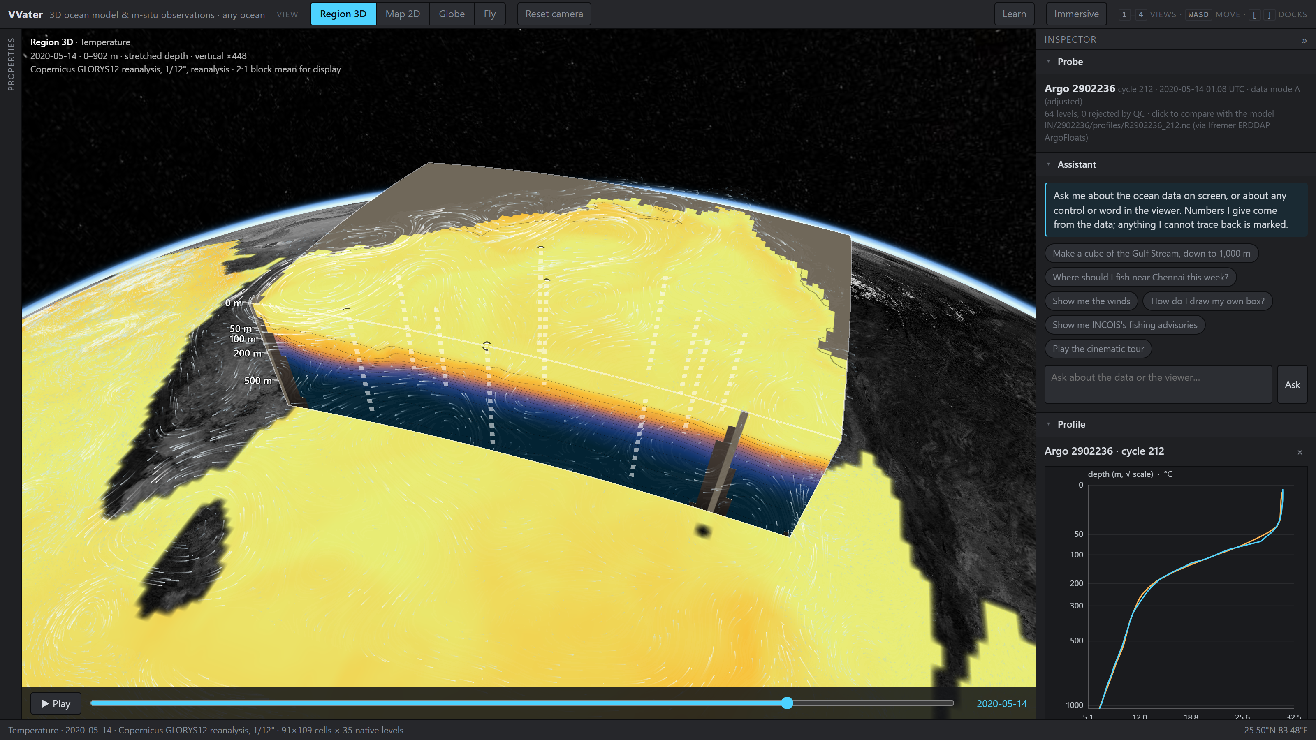
Figure 1. The running build: the Bay of Bengal on 2020-05-14, before Cyclone Amphan, cut open on the model's 35 native levels. One of 17 Argo floats is clicked: the probe shows its data mode, QC count and source file; the profile compares it with the model.

3.2. Core Objectives
Objective 1: Build a cube generator that serves any box, any day and any of the catalogue's 23 variables on the model's native depth levels only, and opens a prepared cube in under a second. Done: 0.08 s for the Amphan cube from the disk cache, 1.15 MB to the browser.
Objective 2: Draw every in-situ observation inside the model with its QC flag, data mode and source file, never dropping a failed reading, and co-locate it with the model level by level. Done: 29 Argo profiles and 98 glider casts co-located; 510 of 11,525 Argo levels that fail QC are drawn as rejected.
Objective 3: Give the controls the brief names (variable selector, depth slices and cut planes, day-by-day timeline, colour bar with palette, range and log scale, opacity, vertical exaggeration, isosurface) and open interfaces (REST, OGC WMS, NetCDF and delimited text). Done: the text parser reproduces the NetCDF path exactly, 222 of 222 casts identical.
Objective 4: By the end of the grand finale, close the four known gaps in section 5.1 and put the platform in front of INCOIS forecasters, recording what they could and could not do unassisted. In progress.

3.3. Novelty and Innovation
Novelty 1: The ocean as a block you can cut. Every ocean viewer we examined shows the ocean as a map, one depth at a time. VVater cuts a block of any size out of the model and looks at it from the side, so a thermocline, an oxygen-poor layer or the edge of a current is seen, not inferred from a stack of maps. The block carries the model's native levels and never more: upsampling would invent structure in the thermocline, the layer that matters most.
Novelty 2: Observations stand inside the model. Floats are not dots on a surface but sticks standing in the model at their true depths. A reading that fails QC is drawn as rejected, never silently dropped, and one click compares the float with the model on the float's own day.
Novelty 3: The model gets quality control too. The model is range-tested before it is drawn: impossible cells are masked and counted on screen. The INCOIS analysis's own error field is drawn, so uncertain water renders faint. And observed minus modelled is binned into a residual volume where only measured cells are filled: 95 % of the Bay stays empty, because nobody measured it.
Novelty 4: Any day, any variable, no archive to build. The platform holds no copy of the ocean. It reads only the cloud-store chunks a box touches, so every day from 1993 for 17 variables is one request away and a day seen once opens from the cache. Which model a day comes from is written on screen, and a forecast is always labelled a forecast.
Novelty 5: An assistant that acts, and cannot quietly invent a number. The assistant builds cubes and sets controls on request, but reaches data only through our own API, and any number in its reply that cannot be traced to a tool result is flagged on screen. The course's quiz answers are computed from the block on screen, never from the language model.

3.4. Success Metrics
Every figure here is produced by the repository's evaluation script (docs/13-eval-results.md); nothing is estimated.
Performance: Amphan cube (91×109 cells × 28 levels) opens in 0.08 s from the disk cache, 1.15 MB to the browser. Over a cold, full session touching every feature, 97 of 97 requests answered, peak memory 639 MB. A cold open waits on Copernicus and is not claimed.
Accuracy: Co-location against the INCOIS analysis: 0.71 °C RMSE over 29 Argo profiles (a consistency check: the analysis assimilates them) and 1.58 °C over 98 independent glider casts. Target, met: independent error above the fit residual, as theory predicts; an inverted depth axis or swapped lat/lon would give errors of order 10 °C.
Data integrity: 510 of 11,525 Argo levels fail QC and all are shown as rejected; 6 impossible model cells are masked and counted; the text and NetCDF parsers agree on 24,611 of 24,611 levels.
User adoption: Not yet measured. Target for the finale: INCOIS forecasters complete three tasks unassisted (build a cube, open a float against the model, find where the model is least certain), with completion and time recorded.
4. Technical Architecture & Feasibility
4.1. Technical Approach & System Design
Two tiers. A static TypeScript viewer on CesiumJS runs in any modern browser with nothing installed. One Python process (FastAPI) serves cubes, floats, surface layers, wind, fishing advisories and the assistant as JSON and raw float32 arrays, plus OGC WMS for the Bay layers. Data is fetched on demand from its publishers and cached by chunk on disk.
From request to picture:
• Ask. A box, a day and a variable, drawn by hand, picked from nine named scenarios or asked of the assistant. The URL carries the whole view.
• Pick the model for that day. The catalogue resolves each day to the reanalysis where it exists and the analysis & forecast after it; forecast days are labelled.
• Read only what the box touches. The Copernicus ARCO zarr chunks inside the box are read from S3 and cached on disk; nothing else is downloaded.
• Check and shape. Values outside the variable's published range are masked and counted; density and sound speed are derived with TEOS-10; the block keeps its native levels and is averaged horizontally to at most 160 cells a side for display, with the factor stated on screen.
• Paint. The browser paints six faces as sections through the data, a sea floor from bathymetry, and any cut the user makes.
• Floats. Core and BGC Argo in the box within ±2 days come from Ifremer's ERDDAP with every level's QC flag, data mode and file name; temperature is converted to potential temperature before comparison. Clicking a float co-locates it with the model on its own day through a tested module.
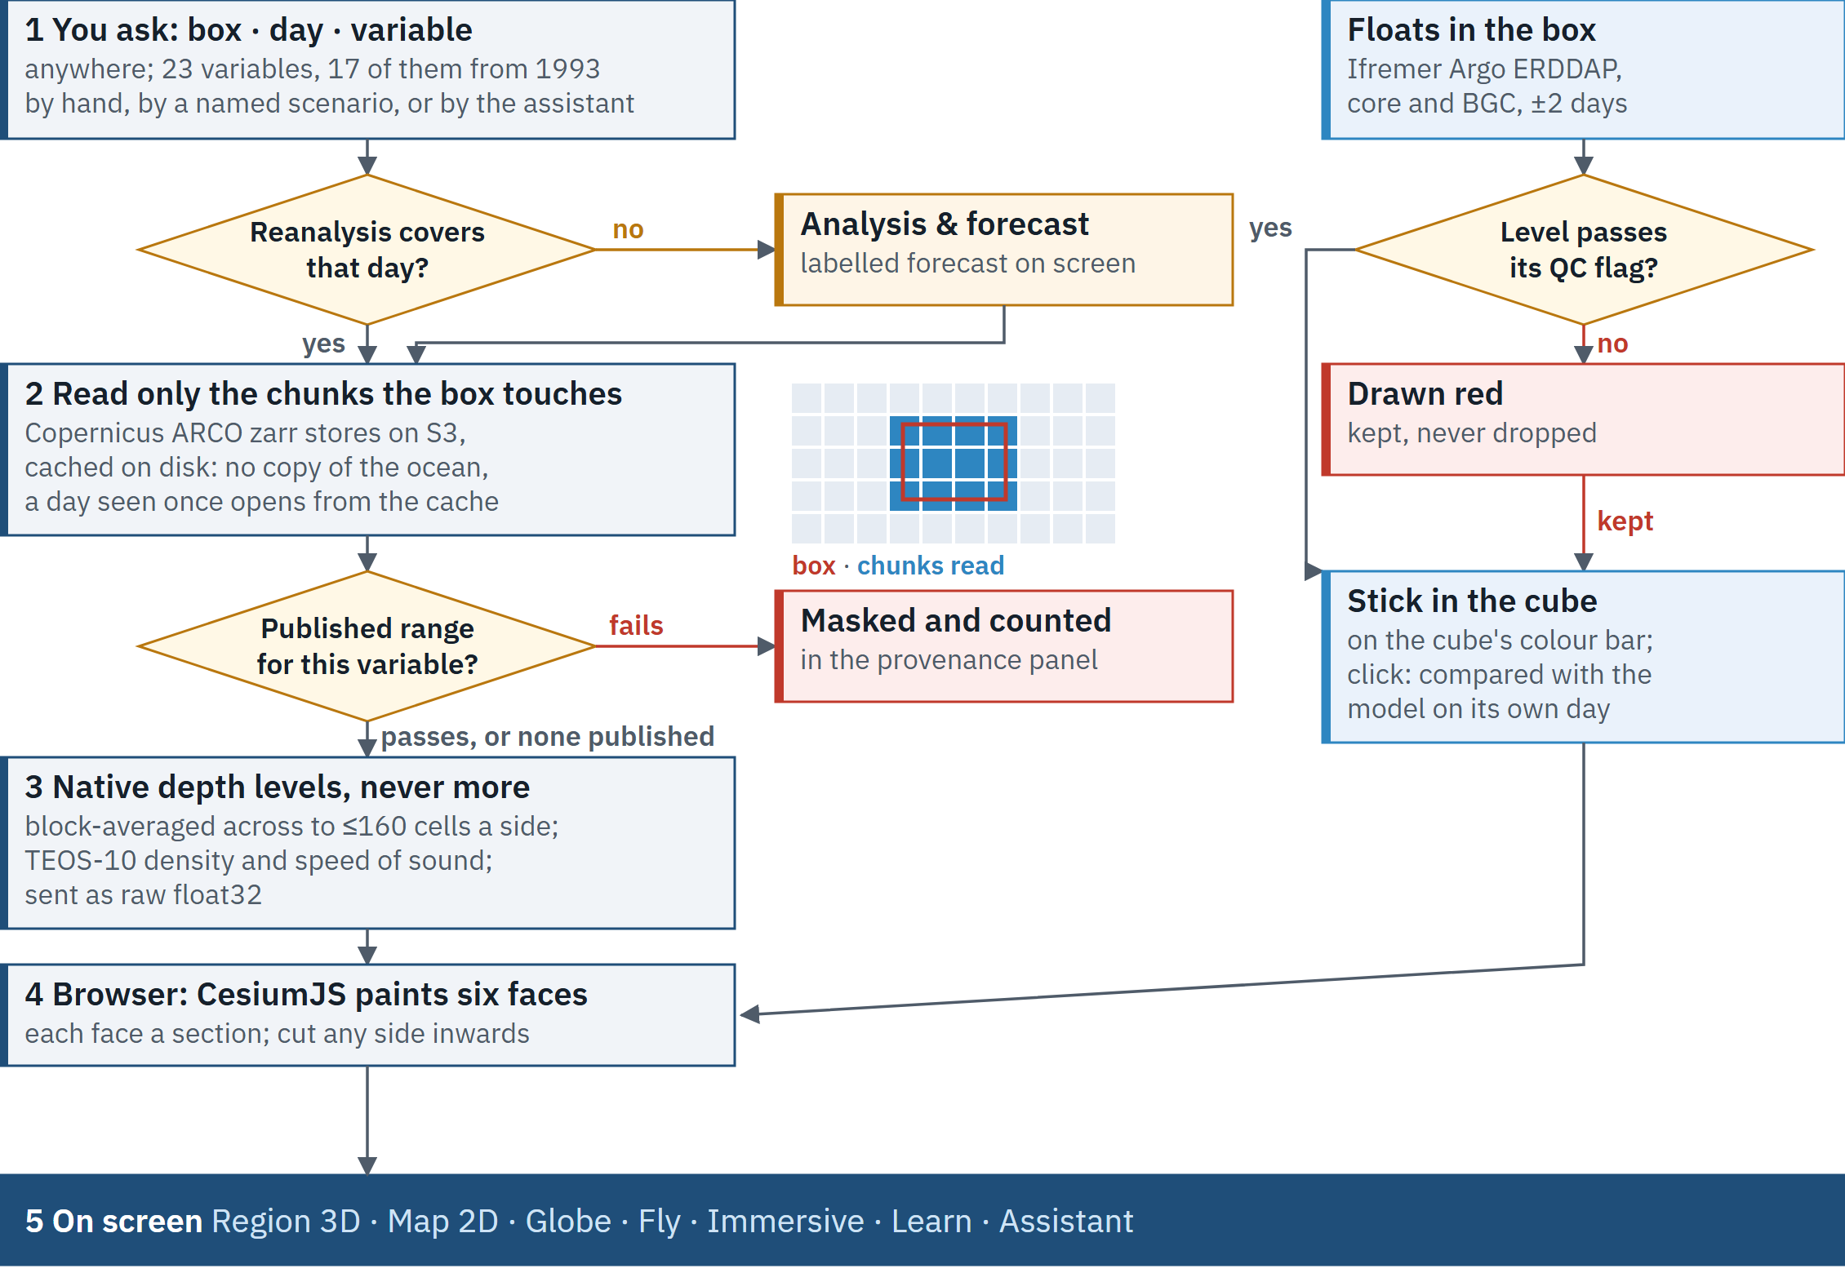
Figure 2. How a cube is made, and what happens to data that fails a test: masked and counted, or drawn as rejected, never dropped.
The INCOIS Bay of Bengal analysis is also drawn as a true voxel volume with its uncertainty, observation density and residual, over the one date where INCOIS, Argo, a glider and Copernicus are all present. That is where the depth-banded result below comes from.
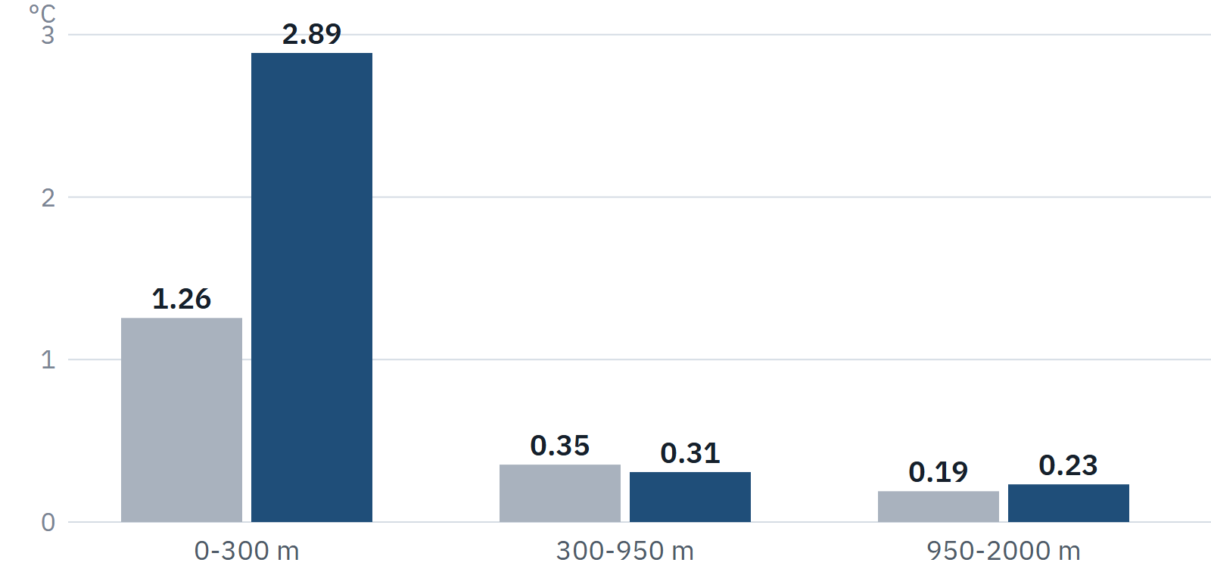
Figure 3. RMSE of the INCOIS analysis by depth band: Argo (grey, assimilated) and the independent glider (blue). Below 300 m they agree; the error is in the upper 300 m.

4.2. Tech Stack
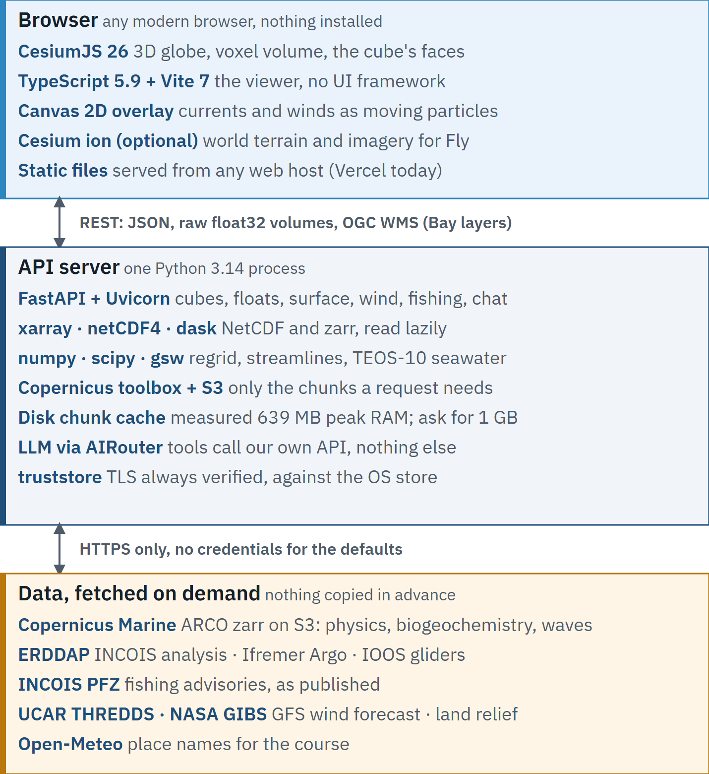
Figure 4. The build in three tiers, with pinned versions.
Category | Technology / Tool
Frontend | CesiumJS (@cesium/engine 26.3.0, @cesium/widgets 16.2.0), TypeScript 5.9, Vite 7, no UI framework; Canvas 2D particle overlay for currents and winds; optional Cesium ion terrain and imagery
Backend | Python 3.14, FastAPI + Uvicorn; xarray, netCDF4, zarr and dask for NetCDF and cloud stores; numpy, scipy and gsw (TEOS-10); copernicusmarine toolbox; truststore so TLS is always verified
Database | None. Data stays with its publishers; a disk chunk cache holds what has been read, and uploaded CSV casts live in memory
AI/ML Model(s) | No trained model. The assistant uses hosted language models through AIRouter (openai/gpt-4.1-mini, then google/gemini-2.5-flash, then deepseek/deepseek-v4-flash); it calls our API's tools and nothing else, and untraceable numbers are flagged
Cloud Services | Copernicus Marine ARCO stores on S3; INCOIS, Ifremer and IOOS ERDDAP; UCAR THREDDS (GFS wind); NASA GIBS (land relief); static hosting (Vercel) and one API server
Standards | CF Conventions (read defensively, every assumption recorded), OGC WMS 1.3.0, REST/JSON, Argo QC flags, IOOS QARTOD

4.3. Hardware & Data Requirements
No hardware is built or bought. The client is any modern browser; the server requirement below is measured, not estimated. Prices are not given because the server is meant to run on existing INCOIS infrastructure.
Hardware Component | Quantity | Estimated Unit Price (₹)
Any computer or tablet with a WebGL 2 browser | per user | Nothing to buy
API server or VM: 1 GB RAM minimum (measured peak 639 MB), 1–2 vCPU, 5–10 GB persistent disk for the chunk cache | 1 | Existing infrastructure
Projector or large display for outreach (optional) | per venue | Existing equipment
Total cost: no new hardware. One server-class VM on existing infrastructure.
Datasets, all read over HTTPS from their publishers, licences as each publisher states them:
Dataset Name | Source/URL | License Type
Copernicus Marine GLORYS12 reanalysis and global analysis & forecast, physics and biogeochemistry (ARCO zarr) | data.marine.copernicus.eu/product/GLOBAL_MULTIYEAR_PHY_001_030 | Copernicus Marine Service licence: free and open, attribution required
INCOIS Argo 10-day Variational Analysis (incois_argo_10d_VAM), with per-cell error | erddap.incois.gov.in/erddap | Free use and redistribution, no warranty (dataset licence attribute)
Argo core and BGC floats | erddap.ifremer.fr/erddap; data-argo.ifremer.fr | Argo open data policy: freely available; acknowledgement and the Argo DOI requested
U.S. IOOS Glider DAC, deployment ru29-20180812T0220 | gliders.ioos.us/erddap | “May be redistributed and used without restriction” (dataset licence)
INCOIS Potential Fishing Zone advisories | incois.gov.in/MarineFisheries/TextDataHome?mfid=1 | Public advisories, shown as published and attributed
Collection strategy: nothing is copied in advance. Each request reads the chunks or rows it needs and caches them on disk; every observation keeps its QC flag, data mode and source file. The brief's two FTP links are dead from a normal network (port 21), so the Argo GDAC HTTPS mirror and the IOOS Glider DAC replace them. Wind (NCEP GFS via UCAR) and land relief (NASA GIBS) are display layers, attributed on screen.
5. Project Plan & Team

5.1. Work Plan & Milestones
Phase / Milestone | Key Tasks | Estimated Duration
Before the finale: built and measured | Cube generator over 23 variables; floats inside the model with QC; co-location and the evaluation harness; four views, immersive and cinematic; winds, waves and fishing advisories; the assistant; the six-lesson course; INCOIS Bay volume with uncertainty and residual; OGC WMS. Every number in this proposal comes from the harness. | Complete, whole team
Hours 0–6: floats readable at a glance | Colour each float stick by its values even behind a face (today it draws as white dashes there); the assistant reports the depth it actually built; drawing a box clears the old cube. ACCEPTED: a misfit is visible without opening a chart; no reply states a depth the viewer did not build. | 6 h, Frontend + Assistant
Hours 6–12: the float window, measured | The harness bins float-minus-model misfit by time separation and picks the window where it stops growing, replacing today's provisional ±2 days. ACCEPTED: a cube-wide misfit number in docs/13-eval-results.md. | 6 h, Lead + Ocean science
Hours 12–18: the brief's own glider archive | Index the EGO/Coriolis glider catalogue (the archive the dead FTP link served) by position, and read its gliders with their QC. ACCEPTED: a second glider source in the viewer and in the harness. | 6 h, Ingestion
Hours 18–24: cyclone heat potential as a map | Integrate heat above 26 °C over every grid column of the analysis, as a globe layer and a WMS layer. ACCEPTED: the map matches the per-float values the harness already checks. | 6 h, Ocean science + Ingestion
Hours 24–30: host and frame rate | Move the API to a host with 1 GB or more; measure frame rates on the demo machine and the venue display and record them. ACCEPTED: the live site answers with the laptop off; measured fps written down. | 6 h, QA and deploy
Hours 30–36: INCOIS walk-through and pitch | Forecasters or mentors run the three tasks in 3.4 unassisted; record completion, time and every hesitation, and fix the top friction point. ACCEPTED: results reported as measured, whatever they are. | 6 h, whole team

5.2. Team Roles and Responsibilities
Team Member | Role | Key Contributions & Relevant Skills
Mr. A Mohamed Armaan | Team Lead: data pipeline and evaluation | The cube generator and its native-levels rule; the co-location module; the evaluation harness every number comes from. Planning and review.
Ms. Pooja Shree Ravichandar | Frontend: 3D viewer | The CesiumJS scene: the cube's painted faces and cuts, the four views and cameras, colour bar and layer controls, the float sticks and profile panel.
Ms. Aashisha Wincy A | Ocean science and outreach | Argo QC conventions, TEOS-10 conversions and cyclone heat potential; the six-lesson course and its sources; liaison with INCOIS scientists.
Mr. Jerem Agsae Jebaz | Assistant and language | The tool-calling assistant, its whitelisted viewer actions and the number check; the user guide it reads; the course in Indian languages.
Mr. Denny Mathew | Data ingestion and interoperability | NetCDF and delimited-text parsers, CF normalisation, the ERDDAP, ARCO and glider sources, the fishing advisory reader and the OGC WMS endpoint.
Mr. Jonathan Jerald Eapen | QA, hosting and deploy | Tests and fixtures, the hosting measurement, deploys, graphics tiers and frame-rate measurement.
Outcomes:
VVater runs end to end today, and its source, documents and measured numbers are public at github.com/Kukyos/VVater. The live site currently depends on a development machine for its API; section 5.1 moves it to a proper host. The outcome it is built for is faster, better-founded advisories: a forecaster sees the warm layer a cyclone feeds on in 3D and sees where the model is uncertain or unmeasured before trusting it. Between the two Amphan cubes the Bay's mean surface temperature falls by 0.77 °C, and the cold wake is visible on one colour bar.
• Forecasters: model and instruments in one scene instead of several programs.
• Fishermen: INCOIS's own fishing-zone advisories for all fourteen sectors, beside that day's waves and wind; our own indicator is labelled not an advisory.
• Students and the public: a six-lesson course for classes 8–12 on real data, and an immersive view for exhibitions.
• Economics: open source, no licences, no archive to buy or store; one server with 1 GB of memory measured sufficient (639 MB peak).
We have not measured time saved per advisory and will not estimate it; the finale walk-through is the first step towards that number.
Stretch Goal:
Stream the volume in tiles so full 1/12° resolution and long time animations fit in the browser; particle trajectories integrated through a sequence of days rather than one day's flow; a depth-aware model range test agreed with INCOIS; the course in Hindi, Tamil and Bengali; more sensors (CTD, moorings, HF radar, ADCP) through the same parser table the Argo, glider and CSV paths already share.
Research References:
1. SIH 2026 Problem Statement 26067, INCOIS / MoES, quoted verbatim — github.com/Kukyos/VVater/blob/main/docs/01-problem-statement.md
2. Press Information Bureau (2020-12-30). Launch of INCOIS ‘Digital Ocean’ — pib.gov.in/PressReleseDetailm.aspx?PRID=1684418
3. NOAA PMEL, Live Access Server — ferret.pmel.noaa.gov/LAS
4. INCOIS ERDDAP — erddap.incois.gov.in/erddap
5. MOSDAC, Space Applications Centre, ISRO — mosdac.gov.in
6. Copernicus Marine, MyOcean Pro features — help.marine.copernicus.eu/en/articles/4794675-overview-of-myocean-pro-features
7. Schlitzer R., Ocean Data View — odv.awi.de
8. Argovis: Building a FAIR Ocean Data Service. J. Atmos. Oceanic Technol. 42(11), 2025 — argovis.colorado.edu
9. earth.nullschool.net, About — earth.nullschool.net/about.html
10. Copernicus Marine GLORYS12 (GLOBAL_MULTIYEAR_PHY_001_030) — data.marine.copernicus.eu
11. Argo GDAC and Ifremer ERDDAP — data-argo.ifremer.fr; erddap.ifremer.fr/erddap
12. U.S. IOOS Glider DAC — gliders.ioos.us/erddap
13. INCOIS Potential Fishing Zone advisories — incois.gov.in/MarineFisheries/TextDataHome?mfid=1
14. Wong A. et al., Argo Quality Control Manual — doi.org/10.13155/33951
15. U.S. IOOS QARTOD manuals — ioos.noaa.gov/project/qartod
16. CF Conventions for NetCDF — cfconventions.org
17. OGC Web Map Service 1.3.0 — ogc.org/standards/wms
18. IOC, SCOR and IAPSO (2010), TEOS-10 — teos-10.org
19. Leipper D. & Volgenau D. (1972), Hurricane heat potential of the Gulf of Mexico, J. Phys. Oceanogr. 2 — doi.org/10.1175/1520-0485(1972)002<0218:HHPOTG>2.0.CO;2
20. Thyng K. et al. (2016), True colors of oceanography, Oceanography 29(3) — doi.org/10.5670/oceanog.2016.66
21. CesiumJS — cesium.com/platform/cesiumjs
22. Repository: source, documents and every measured number — github.com/Kukyos/VVater
______________

