|  |
| --- |
|  |

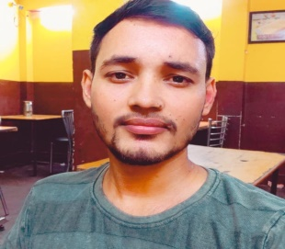

Contact

**Address:**

RasulPur Kursath,Tikra Asivan Unnao 209801

**Phone:**

6386039833

**Email:**

Kuldeepkumar17feb@gmail.com

Skill Highlights

* UI designer
* UI/UX developer
* Communication
* Creative design
* Innovative
* Service-focused

Programming

CORE JAVA

JAVASCRIPT

BOOTSTRAP

HTML

CSS

REACT JS

JQUERY

Languages

English ,Hindi

Summary

Working towards to become a Web Developer specializing in front end development as well as full stack developer. Also want to lead an organization in top projects.

Projects

**Front End Developer**

* Online quiz (2nd year)
* Facebook Home Page (3rd year)
* Tic Tac Too Game
* Student Performance Tracking System. (4th year)
* Music Concert website (working)
* Login Page
* Tip Calculator

Qualification

**High School** : From State Board -2012

**Intermediate** : From State Board **(PCM)** - 2016

**Bachelor of Technology** : **Computer Science**- 2020

**DSMNRU**, LUCKNOW

Hobbies

* Music, Movies
* Video Games
* Study
* Travel
* Making new friends

KULDEEP KUMAR