RETAIL DEMAND LAB
Technical Project Documentation Report
Retail sales forecasting, demand-spike detection, and inventory review support
E
Prepared from source code, persisted metrics, predictions, datasets, and result visualizations
Workspace: BigData / Review3

group : 11
Team Members :
CB.SC.U4CSE23309 – abhiram bikkina
CB.SC.U4CSE23312 – balla kumar basavaraju
CB.SC.U4CSE23313 – chappidi kuladeep reddy
CB.SC.U4CSE23315 – damarapati pavan krishna
Table of Contents

In Microsoft Word, right-click the table and choose Update Field if page numbers need refreshing.

This is website link:
https://retaildemandanalysis.onrender.com/

this is github link:
https://github.com/Kuladeep-Reddy-C/SalesAnalysis-BDA

1. Project Overview
Retail Demand Lab is a full-stack batch analytics case study for turning historical retail transactions into a short-horizon demand signal. Its research question is whether product demand history, selling price, calendar context, and seasonality can predict the next seven days well enough to support inventory-review prioritisation. The verified implementation combines Pandas and PySpark data preparation, tree-based regression, rolling-origin evaluation, demand-spike detection, persisted outputs, a Streamlit dashboard, and optional API/serving layers.

1.1 Dataset and objective
The reproducible analytics inputs are the cleaned CSV exports in Review2: sales_processed_clean.csv, prices_processed_clean.csv, and calendar_processed_clean.csv. The sales file contains 505,032 observations, 264 products, one store (CA_1), one state (CA), and 1,913 relative day identifiers. The calendar covers 2011-01-29 through 2016-06-19; the joined daily dataset used by the persisted run covers 2011-01-29 through 2016-04-24. Total observed units are 492,504. Prices contain 204,234 rows across 282 weeks.
The supervised target is daily units sold, sales. The primary model features are lag_1, lag_7, lag_28, rolling_7, rolling_28, sell_price, day_of_week, month_num, and is_event. The principal holdout is chronological: 28 validation days followed by 28 test days. The production-style recursive forecast is capped at seven days by pipeline.py, and the sampling interval is daily.

1.2 Architecture and execution flow
The main entry point is run_pipeline.py. Its default engine is Spark, while analytics.__main__ runs the Pandas reference path. Both paths read the Review2 CSV exports, validate and join the inputs, create leakage-aware temporal features, split chronologically, train tree regressors, persist predictions and metrics, and expose results to presentation/serving components. Historical rows can also be replayed as day-sized JSON micro-batches; this is explicitly simulated historical replay, not a live broker feed.
Workflow diagram (adapted to the verified implementation):
Review2 CSV ingestion -> schema/value checks -> sales-calendar and sales-price many-to-one joins -> EDA and temporal feature engineering -> chronological train/validation/test split -> Pandas or Spark tree regression -> test metrics and rolling-origin backtest -> recursive seven-day forecast and spike detection -> CSV/JSON/SQLite persistence -> Streamlit/API visualization and demand-review decision support.
Primary references: config.py (Config); analytics/preprocess.py (read_inputs, build_daily_dataset, add_features); analytics/pipeline.py (run, recursive_forecast); analytics/spark_pipeline.py (run); run_pipeline.py.

2. Data Preprocessing and Justification
Preprocessing is implemented in analytics/preprocess.py and analytics/spark_features.py. The operations below are verified from code and generated artifacts. No unimplemented technique is presented as completed.

2.1 Ingestion, validation, and joins
- read_inputs() loads the three CSV files and checks required columns. Sales and prices are coerced to numeric; calendar dates are parsed; negative sales or prices are rejected. This establishes a consistent numeric target and prevents impossible values from silently entering training.
- quality_report() records row counts, null cells, and duplicate natural keys. The persisted quality evidence reports 505,032 sales rows, 204,234 price rows, 1,969 calendar rows, zero duplicate-key rows, and 7,542 calendar null cells in optional event/SNAP fields.
- build_daily_dataset() joins sales to calendar using d and then to prices using store_id, item_id, and wm_yr_wk. Both joins use validate="many_to_one", which guards against accidental row multiplication. Calendar matching is complete; 96,789 price rows have no exact price match and are retained.
- Missing prices are imputed with the item-level median and then the global median. The boolean is_available preserves whether an exact price was present, and price_match is retained for auditability. This avoids discarding demand observations but means imputed price values should not be interpreted as observed prices.

2.2 Feature engineering
add_features() sorts within each item-store series and computes lag_1, lag_7, lag_28, rolling_7, and rolling_28. Rolling values use shift(1), so the current day sales value is excluded. This is the central leakage-control mechanism: a prediction for day t uses history through t-1. Calendar context is reduced to day_of_week, month_num, and the binary is_event flag. Rows without the required history are dropped before model fitting.
The Pandas and Spark implementations use equivalent window concepts. Spark uses partitioned window functions in add_spark_features(); the project documentation states that a fixture test checks parity for lag and rolling outputs after the required history.

2.3 Split and leakage assessment
The persisted Pandas split is: train 2011-02-26 to 2016-02-28 (482,856 rows), validation 2016-02-29 to 2016-03-27 (7,392 rows), and test 2016-03-28 to 2016-04-24 (7,392 rows). This is appropriate for forecasting because future dates are not randomly mixed into training. Feature windows are historical within each item-store series, and recursive forecasting appends predictions rather than using future actual sales as lag inputs.
A limitation is that the validation set is created but is not used for documented hyperparameter tuning or model selection; the reported model comparison is therefore a fixed test-window comparison rather than a complete train-validation selection protocol. No normalization, standardization, categorical encoding, time-series decomposition, or neural sequence generation is implemented.

2.4 Preprocessing summary
Preprocessing Step | Implementation | Justification | Effect on Data | Source File
Load and validate | CSV read, required-column checks, numeric/date coercion, reject negative values | Protects the target and join keys from invalid input | Creates typed sales, price, and calendar frames | analytics/preprocess.py
Quality report | Counts nulls and duplicate natural keys | Makes data-quality risks visible | 7,542 calendar null cells; zero duplicate-key rows | analytics/preprocess.py; results/metrics/data_quality.csv
Many-to-one joins | Sales-calendar on d; price on store/item/week; validate many_to_one | Adds calendar and price context without row multiplication | 505,032 joined rows; 96,789 unmatched prices retained | analytics/preprocess.py
Price imputation | Item median, then global median; is_available flag | Retains demand rows while exposing availability | Missing exact prices receive a fallback value | analytics/preprocess.py
Temporal features | Grouped historical lags and shifted rolling means | Captures short/weekly/monthly memory while excluding current target | Adds nine model inputs; early-history rows contain NaN | analytics/preprocess.py; analytics/spark_features.py
Chronological split | 28 validation days and 28 test days | Matches deployment direction and reduces future leakage | Train 482,856; validation/test 7,392 each | config.py; analytics/pipeline.py

3. Machine Learning Models and Their Justification
The principal Pandas pipeline implements three supervised regressors. The Spark path implements three separate MLlib regressors with different hyperparameters. Baseline functions exist in analytics/baselines.py, but the main pipeline does not call all of them; they should not be confused with models represented in model_metrics.csv.

3.1 Pandas regressors
- DecisionTreeRegressor: max_depth=8, min_samples_leaf=5. It supplies a constrained single-tree reference and captures nonlinear feature interactions, but can have higher variance.
- RandomForestRegressor: n_estimators=80, max_depth=14, min_samples_leaf=2, n_jobs=-1. Bootstrap aggregation reduces variance and is useful for nonlinear tabular demand features.
- HistGradientBoostingRegressor: learning_rate=0.08, max_depth=4, max_iter=120, min_samples_leaf=15. It sequentially improves residual errors and is the model passed to recursive_forecast() in the current Pandas pipeline.

3.2 Spark regressors
analytics/spark_pipeline.py builds a Spark VectorAssembler feature vector and evaluates Spark DecisionTreeRegressor (maxDepth=6), RandomForestRegressor (numTrees=24, maxDepth=8, minInstancesPerNode=5), and GBTRegressor (maxIter=15, maxDepth=4, maxBins=32). The run is local[*] with 16 shuffle partitions and 4 GB driver/executor settings; this demonstrates a distributed-processing API but is not a multi-node speed benchmark.

3.3 Model comparison
Model | Task | Input | Output | Key Parameters | Evaluation Metrics
Pandas Decision Tree | Daily sales regression | 9 temporal/context features | sales prediction | depth 8; leaf 5 | MAE, RMSE, WAPE, bias, MASE
Pandas Random Forest | Daily sales regression | Same 9 features | sales prediction | 80 trees; depth 14; leaf 2 | MAE, RMSE, WAPE, bias, MASE
Pandas HistGradientBoosting | Daily sales regression and recursive forecast | Same 9 features | sales prediction / 7-day forecast | lr .08; depth 4; 120 iterations; leaf 15 | MAE, RMSE, WAPE, bias, MASE
Spark Decision Tree | Spark daily regression | Spark assembled features | Spark prediction | maxDepth 6 | MAE, RMSE, WAPE
Spark Random Forest | Spark daily regression | Spark assembled features | Spark prediction | 24 trees; depth 8; min node 5 | MAE, RMSE, WAPE
Spark GBT | Spark daily regression | Spark assembled features | Spark prediction | 15 iterations; depth 4; 32 bins | MAE, RMSE, WAPE

The implemented baseline module additionally contains zero, global mean, item/store mean, last value, seasonal naive using lag_7, 28-day moving average, and SBA Croston. However, the persisted main model_metrics.csv contains the three Pandas ML models, not all seven baselines. Rolling-origin evaluation does compare Random Forest with moving-average and seasonal-naive alternatives.
Source references: analytics/pipeline.py (run); analytics/spark_pipeline.py (run); analytics/baselines.py (add_baseline_predictions, add_croston_prediction).

4. Time-Series Forecasting Models and Their Justification
The project does not implement SARIMAX, ARIMA, GRU, LSTM, Bi-LSTM, TCN, Transformer, or other neural forecasting architectures. Its forecasting approach is supervised tabular regression with temporal lag/rolling features, plus explicit baselines and a recursive multi-step procedure.

4.1 Recursive seven-day forecast
recursive_forecast() uses the HistGradientBoosting model, the latest known item-store history, and the latest known item-store price. For each future day it computes lag and rolling features, predicts sales, appends that prediction to the working history, and uses it for later steps. The horizon is min(config.test_days, 7), which is seven days under the current configuration. This captures temporal dependence through engineered history rather than a recurrent neural state.
Conceptually, for item-store series i and future step h, the forecast is y_hat(i,t+h) = f(lag_1, lag_7, lag_28, rolling_7, rolling_28, price, weekday, month, event), with predicted values recursively entering subsequent lag/rolling calculations. This is operationally simple and auditable, but errors can compound across steps and the latest known price is held forward.

4.2 Rolling-origin forecasting evaluation
rolling_backtest.py evaluates four weekly forecast origins and horizons one through seven. The Random Forest uses 40 trees, max_depth=10, min_samples_leaf=3 in this diagnostic, while moving-average and seasonal-naive forecasts provide strong simple references. Future predictions are recursively appended, so the backtest does not use future actual sales as history.
Forecasting Model | Forecast Horizon | Input Window | Configuration | Strengths | Limitations | Actual Result
Random Forest rolling forecast | 1-7 days | lag/rolling features | 40 trees; depth 10; leaf 3 | Nonlinear interactions; strong at short horizons | Recursive errors; not best at every horizon | Better than alternatives at horizons 1-4
28-day moving average | 1-7 days | 28 historical values | rolling_28 | Strong, transparent smoothing baseline | Slow to react to abrupt changes | Best aggregate seven-day WAPE: 0.4089
Seasonal naive | 1-7 days | 7-day lag | lag_7 | Simple weekly reference | Repeats stale weekly behavior | Aggregate seven-day WAPE: 0.5027
HistGradientBoosting recursive forecast | 7 days | lag/rolling features plus context | lr .08; depth 4; 120 iterations | Lowest fixed test errors in Pandas comparison | Recursive deployment path not directly compared in same table | Produces seven_day_forecast.csv

5. Model Evaluation and Performance Analysis
The evaluation code is in analytics/metrics.py, analytics/pipeline.py, analytics/rolling_backtest.py, and analytics/model_evidence.py. MAE and RMSE are lower-is-better absolute-error measures; WAPE is the sum of absolute errors divided by total actual volume and is lower-is-better; bias indicates signed average error; MASE scales error by a training-series naive reference, with values below 1 indicating improvement over that reference when comparable.

5.1 Pandas test results
Model | MAE | RMSE | WAPE | Bias | MASE
decision_tree | 1.0725961871034415 | 2.4324460375561925 | 0.9031360080953 | -0.04189455361821913 | 0.9895986485650811
random_forest | 1.069942453593163 | 2.424579223011737 | 0.9009015396925232 | -0.027364478680637582 | 0.9871502610665991
gradient_boosting | 1.0677303149271378 | 2.4139059929964626 | 0.8990388982733116 | -0.037046176733010416 | 0.9851092977845564

On this fixed holdout, HistGradientBoosting has the lowest MAE (1.0677), RMSE (2.4139), and WAPE (0.8990), narrowly ahead of Random Forest (MAE 1.0699; RMSE 2.4246; WAPE 0.9009). The differences are small, so they should be treated as measured ranking on this split, not proof of broad superiority.

5.2 Spark results and execution evidence
Spark Model | MAE | RMSE | WAPE
decision_tree_spark | 1.0802212682216792 | 2.4393471725564 | 0.9095563976187097
random_forest_spark | 1.078265140176841 | 2.4363675005538945 | 0.9079093195337976
gradient_boosting_spark | 1.0729476253350358 | 2.432682584527879 | 0.9034319223689012

Spark metrics are close but not identical to Pandas metrics because the estimators and parameters differ. The saved Spark run is local[*]; it verifies a Spark execution path, not distributed scaling or cluster speedup. The saved environment and timing JSON files are the authoritative source for runtime claims.

5.3 Rolling-origin and statistical evidence
The rolling diagnostic reports Random Forest WAPE 0.4182, moving-average WAPE 0.4089, and seasonal-naive WAPE 0.5027 for aggregated seven-day demand. Random Forest is stronger at horizons 1-4, while the moving average is stronger at horizons 5-7. model_evidence.py performs bootstrap confidence analysis and a Poisson noise-floor simulation; the persisted confidence interval crosses zero, so a statistically conclusive Random Forest advantage is not established.
Demand-spike validation injects five-times synthetic spikes and evaluates the detector. The saved precision is 0.0081 and recall is 0.2121. This is weak validation evidence and does not support describing the detector as highly accurate.

5.4 Runtime and evaluation limitations
The project records preprocessing, training, prediction, row-count, split, and environment information in results/metrics. These are workstation measurements and should not be presented as a cluster benchmark. R², ROC-AUC, precision/recall/F1 for a classifier, uncertainty intervals for forecasts, and calibrated prediction intervals are not part of the primary regression evaluation. Spike precision/recall is available only for the synthetic injected-spike check.

6. Visualization Analysis from the results Directory
The results/charts directory contains seven PNG visualizations. Each image below is the original persisted artifact, embedded without modification. Static generation is traced to analytics/eda.py: generate_charts(); the daily trend is also produced by preprocessing. Interactive dashboard views in dashboard/app.py are additional runtime plots, not separate persisted PNGs.

6.1 Dataset and exploratory visualizations
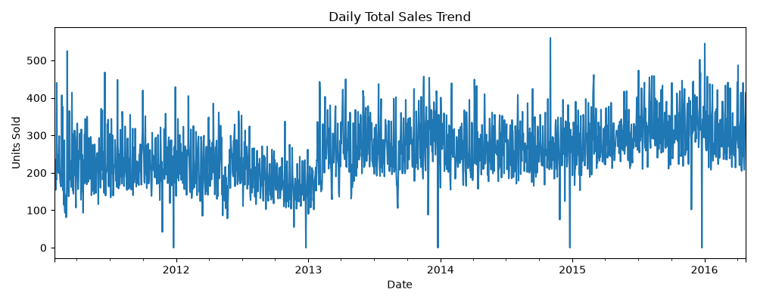
Figure 1. Daily Total Sales Trend. Source: analytics/eda.py generate_charts(); joined daily_dataset.csv.
The x-axis spans the historical date range and the y-axis is total units sold. The dense series shows substantial day-to-day variation, a lower period around 2012, a level increase around 2013, and generally higher activity toward 2015-2016, with occasional near-zero and high spikes. It supports the need for temporal features and robust evaluation, but the chart alone does not establish causality or stationarity.
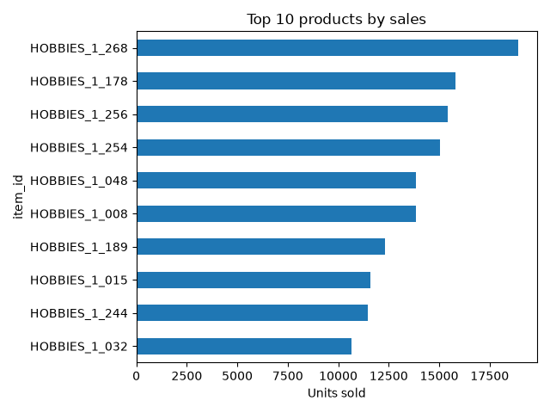
Figure 2. Top 10 Products by Sales. Source: analytics/eda.py generate_charts(); grouped sales.
The horizontal bars rank item_id values by total units. HOBBIES_1_268 is visibly the largest, followed by HOBBIES_1_178 and HOBBIES_1_256. The concentration shows heterogeneous product demand and motivates item-level lags and grouped features. It is a one-store view, so it cannot support cross-store product conclusions.
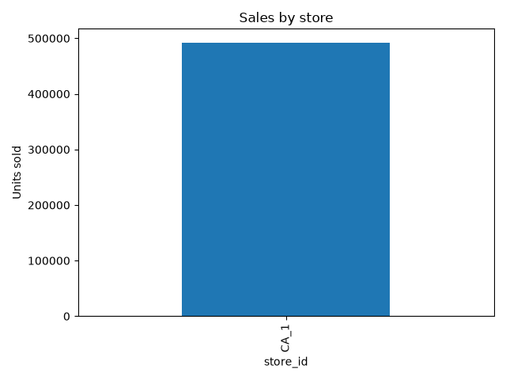
Figure 3. Sales by Store. Source: analytics/eda.py generate_charts(); grouped sales.
The chart contains one bar, CA_1, at approximately 492,504 units. This is an important scope diagnostic: the available data has one store, so no cross-store comparison or store-level generalization can be inferred from this figure.
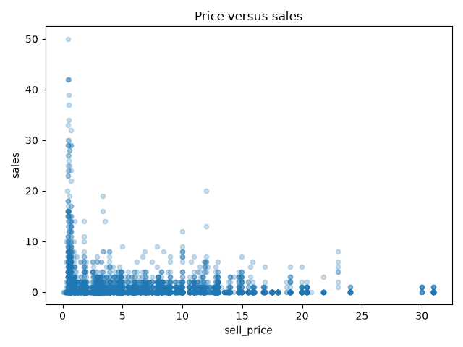
Figure 4. Price versus Sales. Source: analytics/eda.py generate_charts(); sell_price and sales observations.
The x-axis is sell_price and the y-axis is sales. Most observations cluster near low prices and low sales, with a small number of high-sales points at low prices and sparse points at larger prices. The plot is observational and highly concentrated; it does not prove price elasticity, and imputed prices are present in the joined data.

6.2 Forecast and model diagnostics
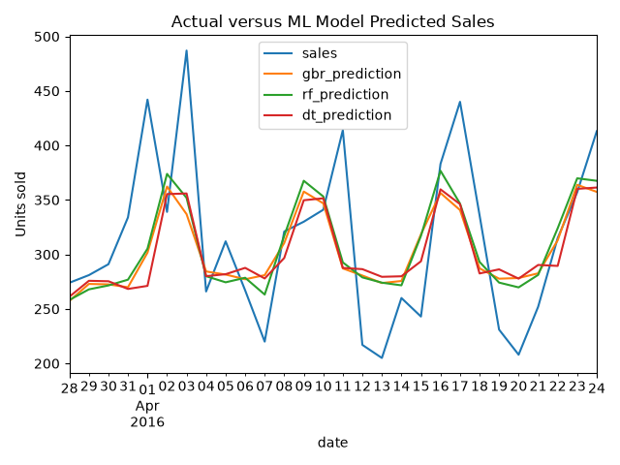
Figure 5. Actual versus ML Model Predicted Sales. Source: analytics/eda.py generate_charts(); test_predictions.csv.
The x-axis is date from 28 March to 24 April 2016 and the y-axis is units sold. The blue actual series has sharp peaks and troughs; gradient boosting, random forest, and decision tree predictions are smoother and generally remain near the central demand level. The models capture broad level changes but miss several extreme peaks and troughs, which is consistent with the nonzero RMSE and the limitations of recursive/tree regression for abrupt shocks.
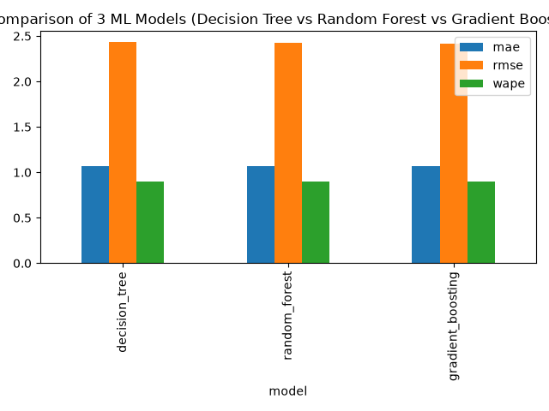
Figure 6. Comparison of Three ML Models. Source: analytics/eda.py generate_charts(); model_metrics.csv.
Grouped bars compare MAE, RMSE, and WAPE for decision_tree, random_forest, and gradient_boosting. Gradient boosting is marginally lowest across all three displayed metrics, random forest is next, and the decision tree is highest. Because the chart uses different metric scales in one axis, exact values should be read from model_metrics.csv rather than bar height alone.
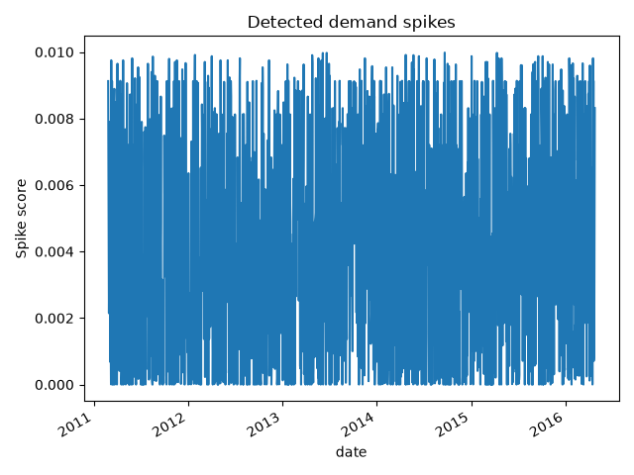
Figure 7. Detected Demand Spikes. Source: analytics/eda.py generate_charts(); predictions/demand_spikes.csv.
The x-axis is date and the y-axis is spike score. Scores are bounded by the one-sided Poisson-tail rule and plotted across the full historical population. The dense vertical texture indicates many flagged observations, but visual density is not precision. The saved injected-spike precision/recall values are weak, so this figure supports inspection of the detector output rather than a claim of reliable anomaly classification.

6.3 Other important result artifacts
CSV and JSON artifacts complement the images: test_predictions.csv supports Figure 5; model_metrics.csv supports Figure 6; demand_spikes.csv supports Figure 7; horizon_metrics.csv supports rolling-origin analysis; feature_importance.csv supports model transparency; seven_day_forecast.csv supports the operational forecast; run_summary.json and spark_run_summary.json record execution context. results/stream contains labelled simulated replay metrics and simulated spikes, while results/checkpoints contains Spark Structured Streaming checkpoint state.

7. Integrated Results and Findings
The evidence describes a coherent but bounded result. The dataset has rich longitudinal history but only one store, missing exact prices for 96,789 joined observations, strong product heterogeneity, and visible temporal variation. Historical lags and shifted rolling means are therefore sensible features, and the implementation correctly avoids using same-day sales in those windows.
On the fixed Pandas holdout, HistGradientBoosting is the best of the three implemented Pandas regressors by MAE, RMSE, and WAPE, and it is the model used for the seven-day recursive forecast. The advantage over Random Forest is small. In the more demanding rolling-origin comparison, Random Forest beats simple baselines only at horizons 1-4, while the 28-day moving average wins at horizons 5-7 and in aggregate seven-day WAPE. These results mean model choice depends on evaluation design and horizon; they do not justify an unconditional claim that a complex model always improves planning.
Figure 5 shows why error metrics remain material: predictions smooth the observed demand and underrepresent extreme peaks. Figure 1 shows broad temporal level changes; Figure 2 shows item concentration; Figure 3 limits store-level claims; Figure 4 is descriptive rather than causal; and Figure 7 must be read alongside weak synthetic spike validation. The project provides evidence of useful short-horizon signal and an auditable review-ranking workflow, but not proof of inventory savings, stockout reduction, causal price response, or live-system performance.

8. Conclusion
Review3 implements an auditable retail demand workflow: three CSV inputs are validated and joined, missing prices are retained with explicit availability flags, leakage-aware lag and rolling features are generated, chronological splits feed Pandas and Spark tree regressors, and results are persisted for forecasting, spike analysis, serving, and visualization. The primary operational forecast is a recursive seven-day HistGradientBoosting forecast; rolling-origin diagnostics additionally compare Random Forest with moving-average and seasonal-naive baselines.
The strongest verified fixed-window result is HistGradientBoosting with MAE 1.0677, RMSE 2.4139, and WAPE 0.8990. The broader evidence is more nuanced: Random Forest is stronger at early rolling horizons, while the 28-day moving average is strongest for aggregate seven-day WAPE. The charts confirm substantial demand variability, product concentration, smoothed model predictions, one-store scope, and a spike detector requiring improvement.
The project’s main strengths are reproducible persisted artifacts, explicit join and leakage checks, comparable tree-model experiments, Spark parity work, and a clear separation between historical replay and live data. Its next technical priorities are validation-based tuning, stronger baselines and uncertainty estimates, multi-store evaluation, better spike labels, and consistent frontend data integration.

Verified findings checklist
- Nine report sections are present in the required order.
- Seven original result visualizations are embedded and interpreted.
- Metrics and dataset counts are taken from persisted project artifacts.
- Source references identify the principal modules and functions.
- Unimplemented neural/statistical models are explicitly excluded.
- Limitations distinguish measured facts from recommendations.

Selected source and artifact index
Area | Verified references
Inputs | Review2/sales_processed_clean.csv; Review2/prices_processed_clean.csv; Review2/calendar_processed_clean.csv
Preprocessing | Review3/analytics/preprocess.py; Review3/analytics/spark_features.py
Models | Review3/analytics/pipeline.py; Review3/analytics/spark_pipeline.py; Review3/analytics/baselines.py
Evaluation | Review3/analytics/metrics.py; Review3/analytics/rolling_backtest.py; Review3/analytics/model_evidence.py
Visualization | Review3/analytics/eda.py; Review3/results/charts/
Results | Review3/results/metrics/; Review3/results/predictions/; Review3/results/stream/
Presentation/serving | Review3/dashboard/app.py; Review3/api/main.py; Review3/serving/store.py

