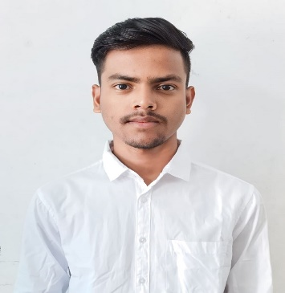
Email: kulamanimohanta90@gmail.com
Phone: +91-6370410602
LinkedIn: LinkedIn.com
GitHub: GitHub.com
Location: Keonjhar, Odisha, India
KULAMANI MOHANTA

An enthusiast Computer Science and Engineering student with a solid foundation in full-stack development, particularly the MERN stack. Seeking to leverage my expertise and passion for software development to contribute effectively to a dynamic team and enhance my skills in a professional environment.
Education:
Bachelor of Technology in Computer Science and Engineering CGPA: 8.66
Government College of Engineering, Keonjhar, Odisha
Expected Graduation: June, 2025
Higher Secondary Education Percentage: 86.16
Sri Aurobindo Science College, Madhupatna, Cuttack, Odisha
Completed: [2021]
Technical Skills:
- Programming Languages: JavaScript, C, Python, Java
- Web Development: HTML, CSS, React, Bootstrap, Node.js, Express.js, Postman
- Databases: MongoDB(mongoose), SQL
- Tools & Technologies: Git, GitHub, Visual Studio
Soft Skills:
Languages:
- English
- Hindi

- Problem Solving
- Analytical Thinking

Internships:
Web Developer Intern
Corizo, Bengaluru, Karnataka
May, 2023 – June, 2023
- Collaborated and maintained web applications using the MERN stack.
Projects and Certifications:
1. Full Stack Todo list app (GitHub Repo)
2. Job Finder App using MERN Stack (visit site)
3. Random Image Generator using React (visit site)
Certification:
IBM Full Stack Software Developer (certificate)
Issued by: IBM
Date: July, 2024
Declaration: I hereby declare that all the information provided above is true to the best of my knowledge and belief.
KULAMANI MOHANTA

