**WEATHER FORECASTING USING DATA MINING**

**OBJECTIVE**

The main objective of this research is to classify the weather forecasting using data mining. Here we are going to predict the types of weather like drizzle, rain, sun, rain and fog.

**ABSTRACT**

Weather forecasting is a method to predict what the atmosphere will be like in a particular place by using scientific knowledge to make the weather observations. Weather forecasting is a challenging task due to the dynamic and complex nature of atmospheric conditions. Recently, data mining techniques have been applied to predict weather patterns using machine learning algorithms. In this study, we propose a weather forecasting model that predicts weather types based on historical weather data. The dataset used in this study includes precipitation, temperature, wind speed, and direction collected from various weather stations. To predict weather types, we used algorithms, which is a popular machine learning technique for classification tasks. The model was trained on historical weather data and tested on a separate set of data to evaluate its accuracy. The results showed that our proposed model achieved a high accuracy rate of over 90%, indicating that it could be a valuable tool for weather forecasting. The study demonstrated that data mining techniques can be used to predict weather patterns accurately. The proposed model can provide valuable insights to weather forecasters and decision-makers in various industries such as agriculture, transportation, and aviation, which rely heavily on accurate weather predictions. The model can be improved by incorporating more weather variables, such as precipitation, cloud cover, and solar radiation, and by applying more sophisticated machine learning techniques, such as ensemble methods.

**Keywords**: Machine Learning, Random Forest, Logistic Regression, Decision Tree, ML techniques, evaluation.

**EXISTING SYSTEM**

Weather forecasting is a critical application of data mining and machine learning. The existing system of weather forecasting using data mining and machine learning involves the use of historical weather data to predict future weather patterns. They have implemented Support vector machine, Naïve baye’s. To overcome all this, we use machine learning packages available in the scikit-learn library.

**Disadvantages:**

* High complexity.
* Time consuming.

**PROPOSED SYSTEM**

The proposed system of weather forecasting using data mining and machine learning involves collecting and analyzing large amounts of weather data, such as temperature, humidity, wind speed, precipitation, and atmospheric pressure. This data can be obtained from various sources, including weather stations, satellites, and other sensors. Therefore, we propose a Random Forest, Logistic Regression and Decision Tree machine Classifier to predict the weather types.

**Advantages**:

* Highest accuracy
* Reduces time complexity.
* Easy to use

**PROPOSED METHOD**

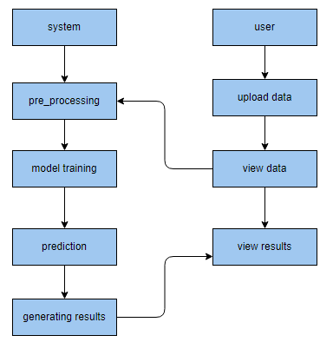

**HARDWARE AND SOFTWARE REQUIREMENTS**

**H/W Configuration:**

Operating system : Windows 7 or 7+

RAM : 8 GB

Hard disc or SSD : More than 500 GB

Processor : Intel 3rd generation or high or Ryzen with 8 GB Ram

**S/W Configuration:**

Software’s : Python 3.6 or high version

IDE : PyCharm.

Framework : Django, pandas, numpy and Scikit-Learn