Appsmith App
Frontend deployement.
Local Setup
Following steps to be followed:-
- Clone the repository in your local machine .

git clone https://github.com/appsmithorg/appsmith.git
cd appsmith
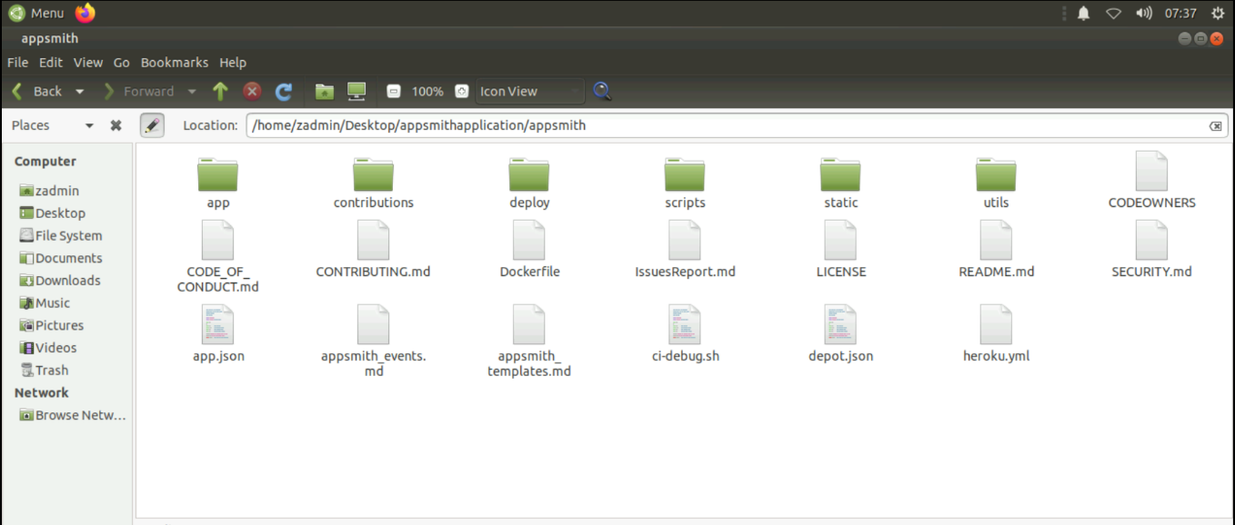
- Open the code in Visual studio code and open new terminal
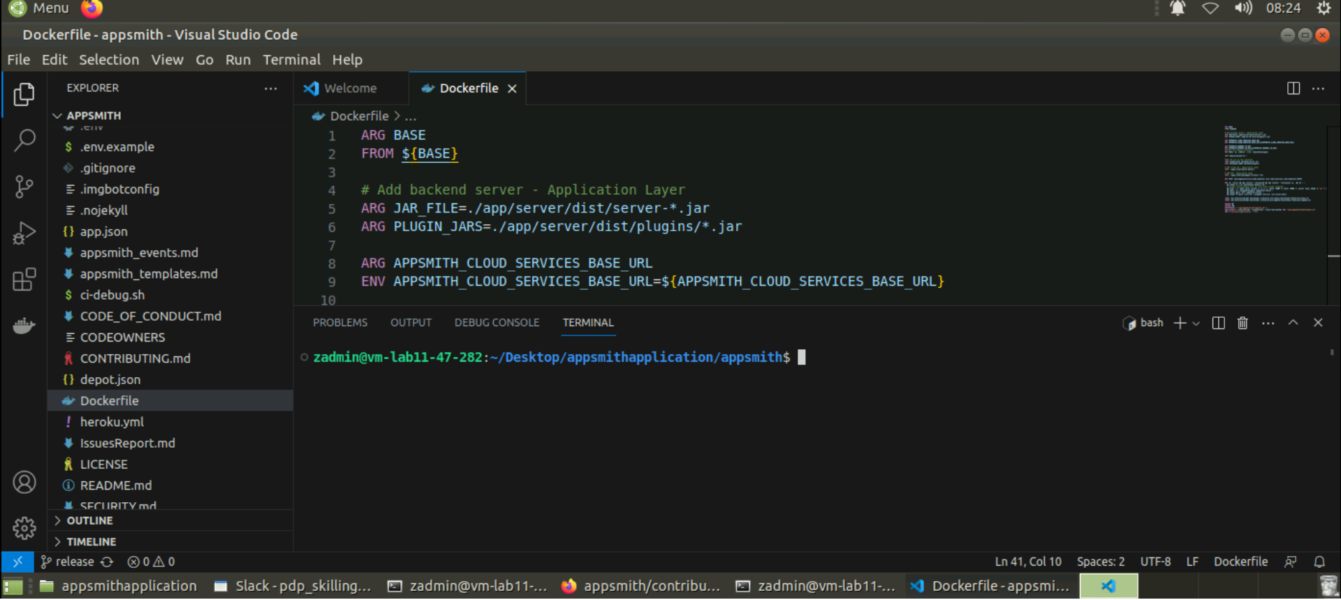
3.We need to have following things installed in our system :-
I.Docker
II.Mkcert(steps to install )
mkcert is a simple tool for making locally-trusted development certificates.
- On Linux, you can easily install mkcert using the following command
- curl -s https://api.github.com/repos/FiloSottile/mkcert/releases/latest \
- | grep "browser_download_url.*linux-amd64" \
- | cut -d : -f 2,3 | tr -d \" \
- | wget -i - -O mkcert
- chmod +x mkcert
sudo mv mkcert /usr/local/bin
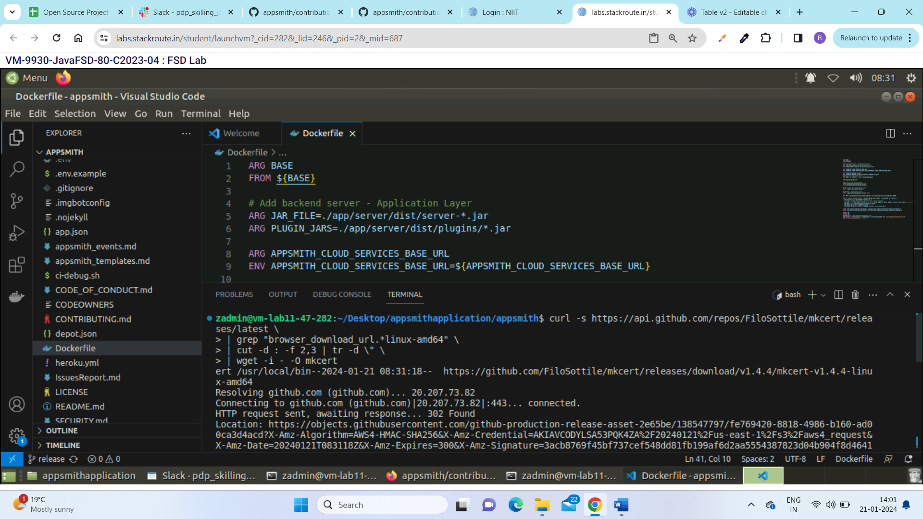

Ill.Yarn installed.
npm install -g yarn.

IV. Nvm
nvm install 18.17.1
nvm use 18.17.1
V. NGINX
dpkg -l | grep nginx
docker pull nginx
docker run -d -p 80:80 --name mynginx nginx
sudo docker ps -a

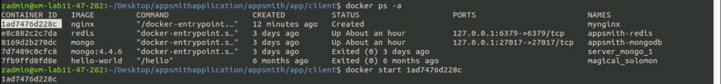
After this the docker will create nginx then we need to start and up the status.
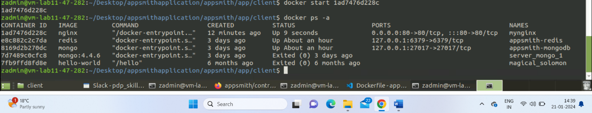

4. Create local HTTPS certificates
- Run the following command from the project root.
cd app/client/docker && mkcert -install && mkcert "*.appsmith.com" && cd ../../..
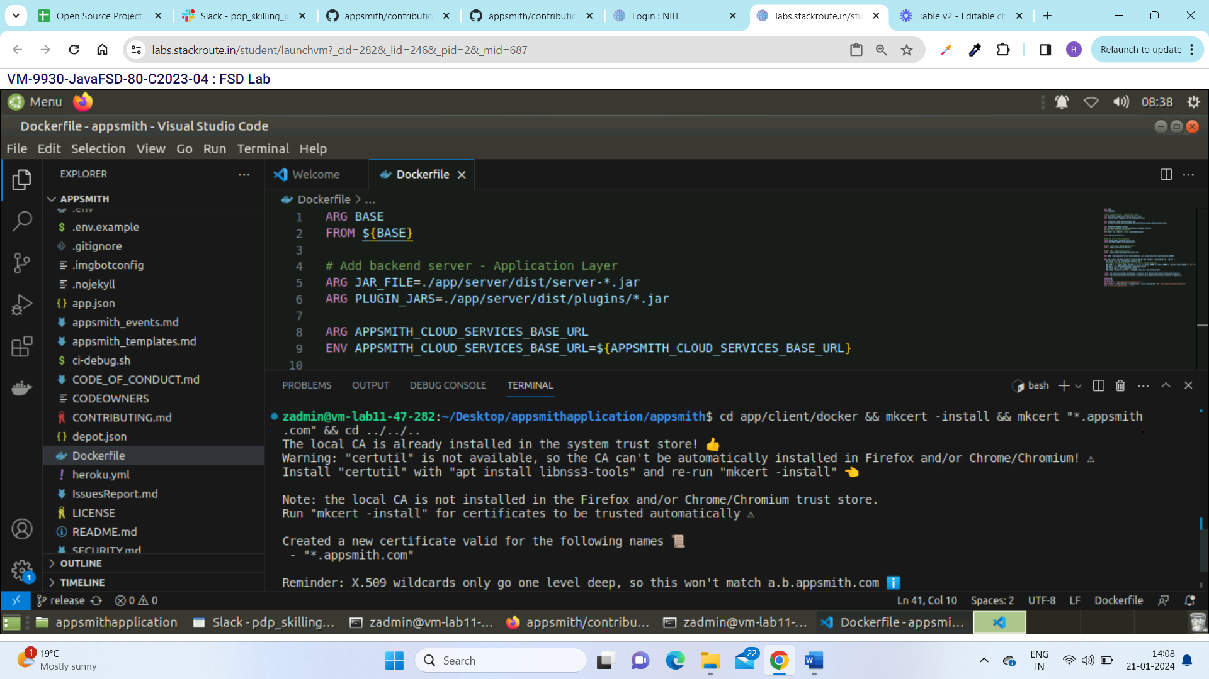

This command will create 2 files in the docker/ directory:
- _wildcard.appsmith.com-key.pem
- _wildcard.appsmith.com.pem
5. Add the domain dev.appsmith.com to /etc/hosts.

echo "127.0.0.1 dev.appsmith.com" | sudo tee -a /etc/hosts

- Please check that the string is copied properly
cat /etc/hosts | grep appsmith

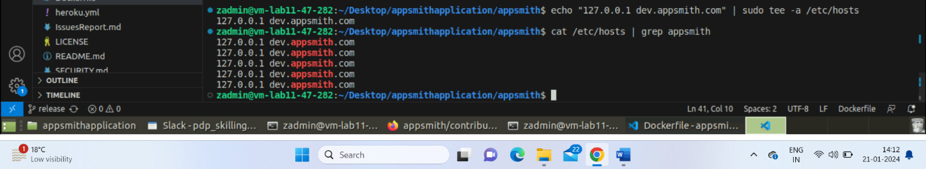
6. Run cmd:

cp .env.example .env

7. Run Backend server
The backend server should be running.
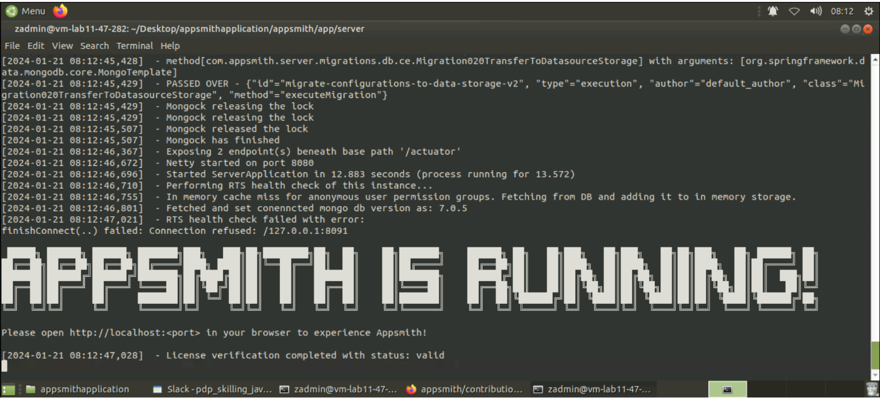

8. Pass the server name as an argument to this command to use that server as backend.
cd app/client
./start-https.sh
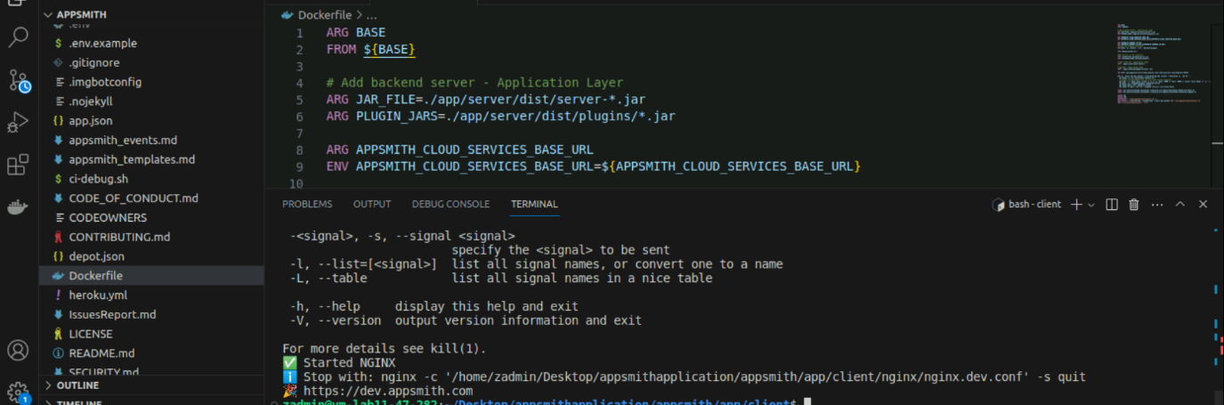

9.Steps to build & run the code:

Run yarn install.

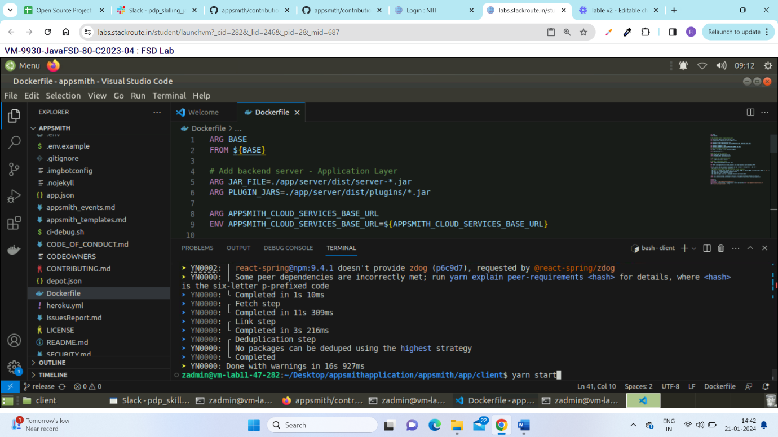
This process will install yarn in Your system than we need to start the server by

yarn start

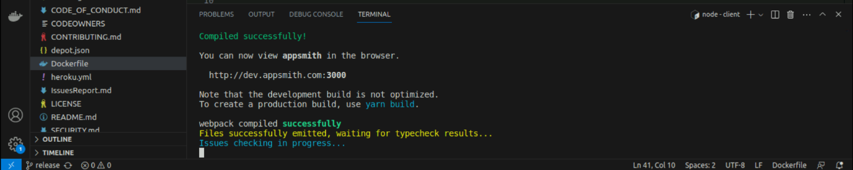

10.Run the server in the browser

https://dev.appsmith.com



