Appsmith App
Backend Deployement in Local machine. (Linux)
Following steps to follow :-
Local setup
As the server codebase is written in Java and is powered by Spring + WebFlux we need Java and Maven installed to build the code. In addition we also need one instance of MongoDB and Redis each to run Appsmith server. Lastly, we will set up IntelliJ IDEA to let you edit the code. Let's get those prerequisites installed on your machine.
- Clone the Appsmith repository and in terminal clone it.
git clone https://github.com/appsmithorg/appsmith.git
cd appsmith
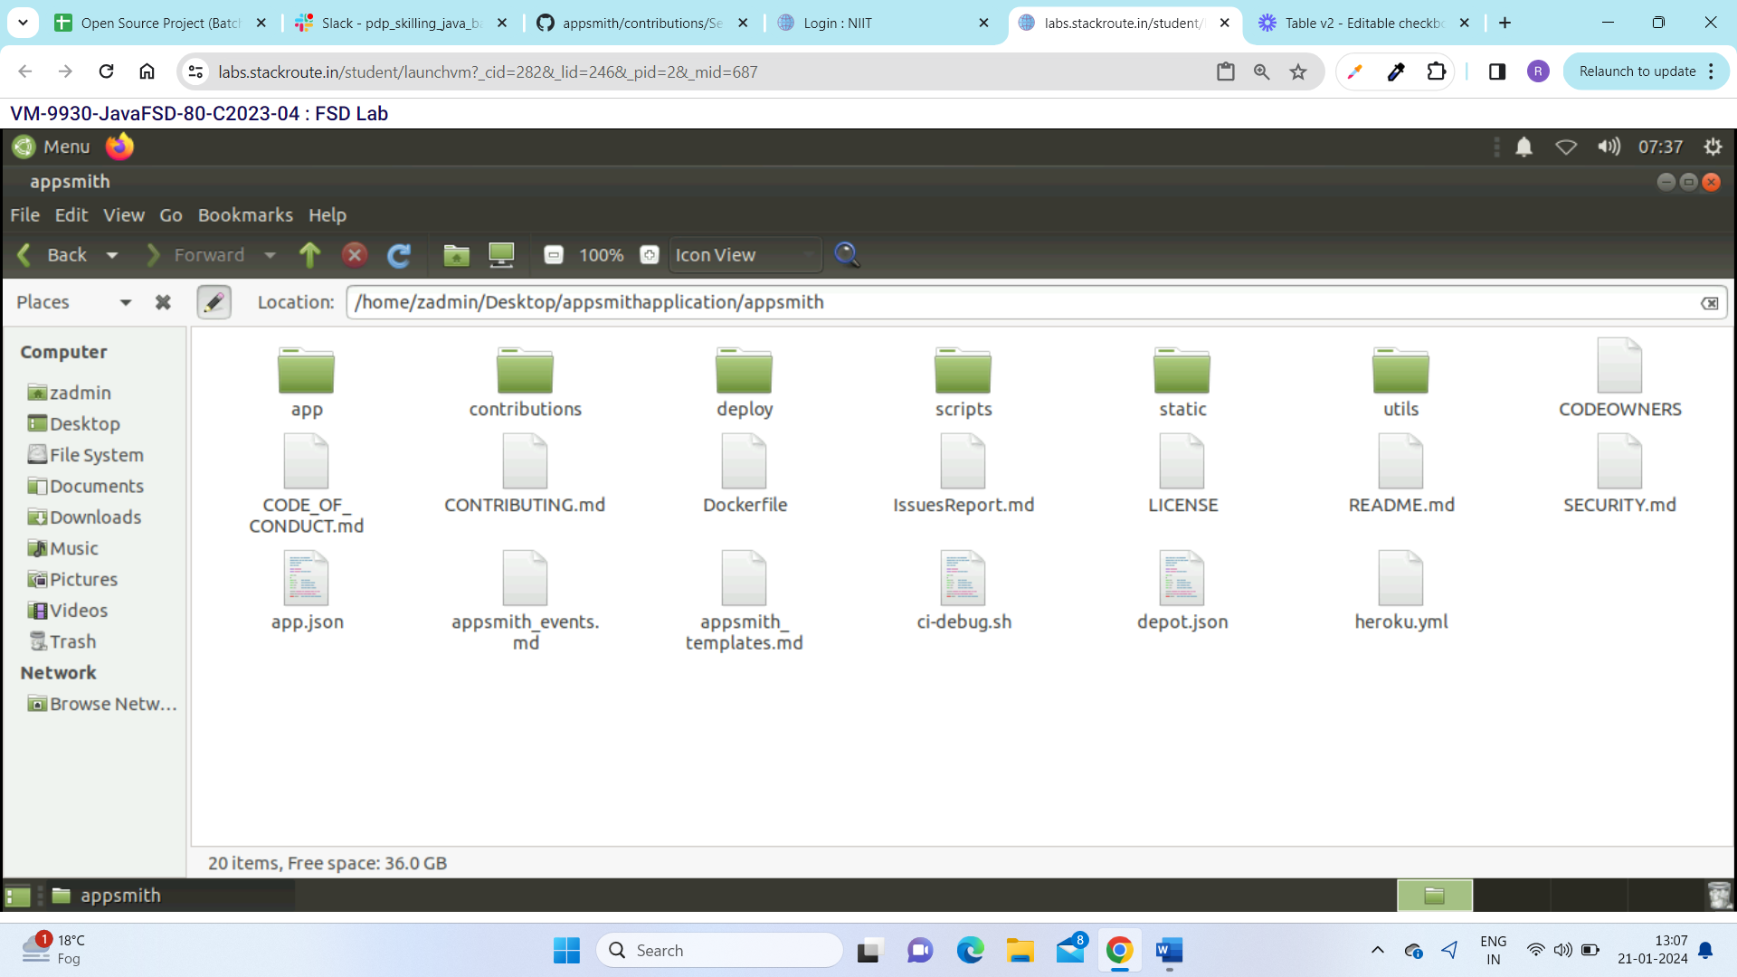
- Setting up a local MongoDB instance
The following command will start a MongoDB docker instance locally:
docker run -d -p 127.0.0.1:27017:27017 --name appsmith-mongodb --hostname=localhost -e MONGO_INITDB_DATABASE=appsmith -v /path/to/store/data:/data/db mongo --replSet rs0

Enabling replica set for mongo
. Mongo running inside docker
Please follow the below steps for enabling the replica set with mongo running inside the docker
  - Connect to the mongo db running with a mongo shell. Use the below command
  - mongosh
  - Once you are inside the mongo shell run the below command.
  - rs.initiate({"_id": "rs0", "members" : [{"_id":0 , "host": "localhost:27017" }]})

3.Setting up a local Redis instance
- The following command will start a Redis docker instance locally:
docker run -d -p 127.0.0.1:6379:6379 --name appsmith-redis redis.

4.Run the docker command to see all the docker container are up and running

docker ps -a

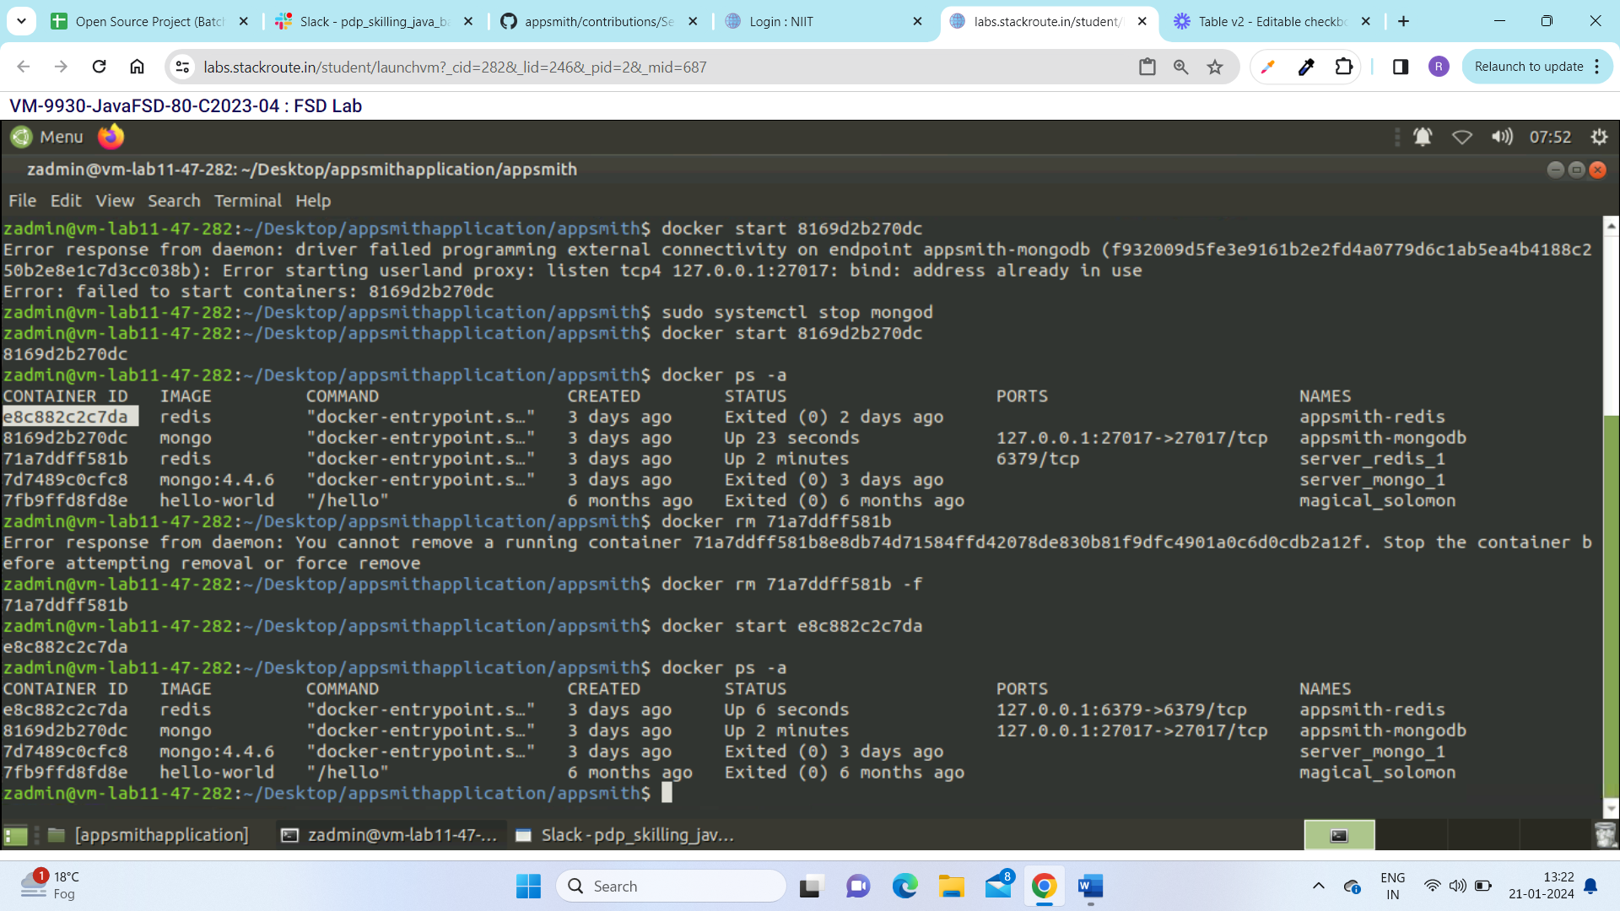

5. Building and running the code

Change your directory to app/server
Run the following command:
mvn clean compile

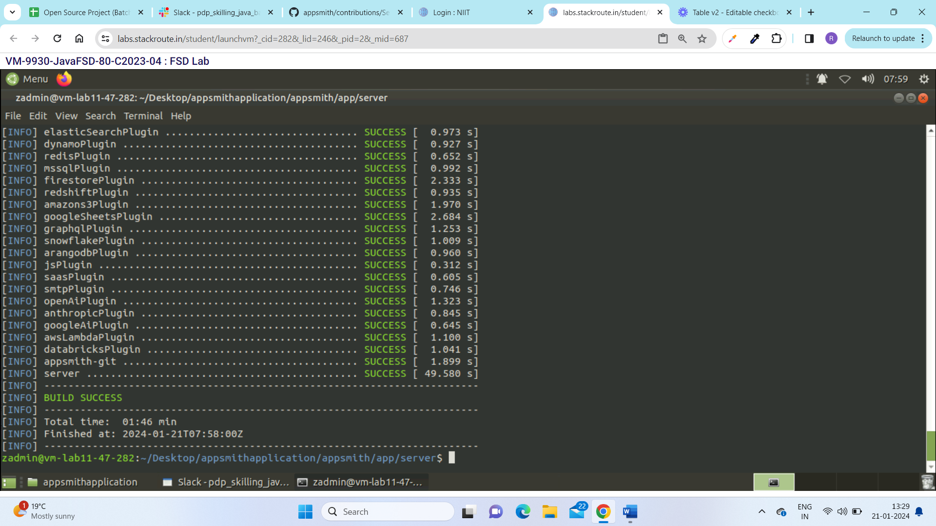

Setup Environment file
Create a copy of the envs/dev.env.example

cp envs/dev.env.example .env

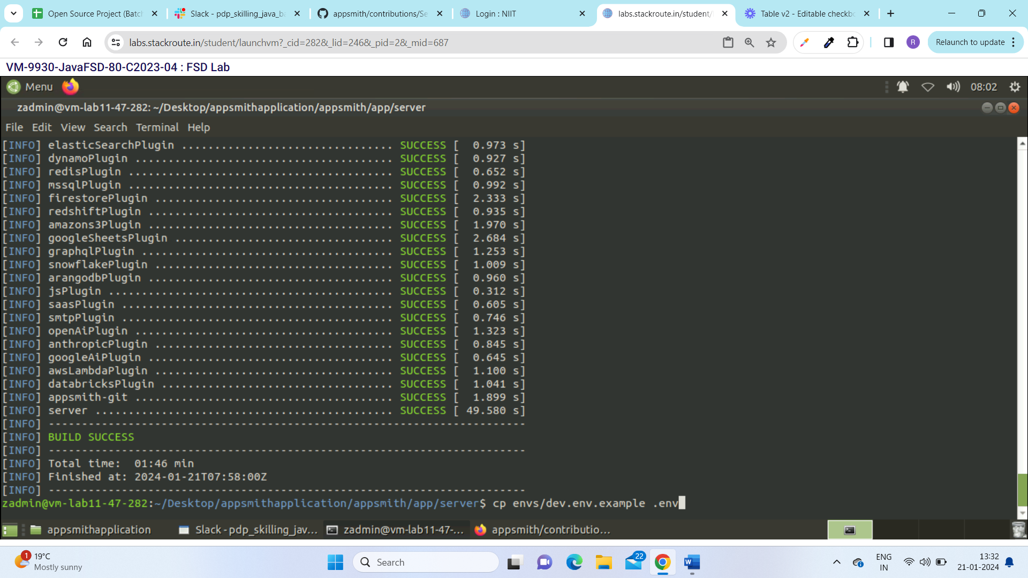
4.Run the following command to create the final JAR for the Appsmith server:
./build.sh -Dmaven.test.skip
- This command will create a dist folder which contains the final packaged jar along with multiple jars for plugins as well.
- If you want to run the tests, you can remove -DskipTests flag from the build cmd.

5. Start the Java server by running
./scripts/start-dev-server.sh

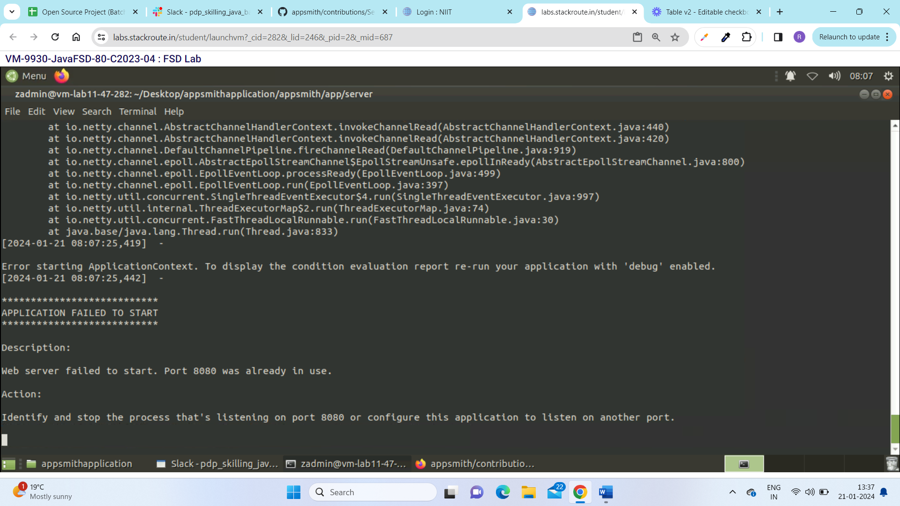

If we face such web server failure then we need to stop the tomcat for that we need to write the command

sudo systemctl stop tomcat

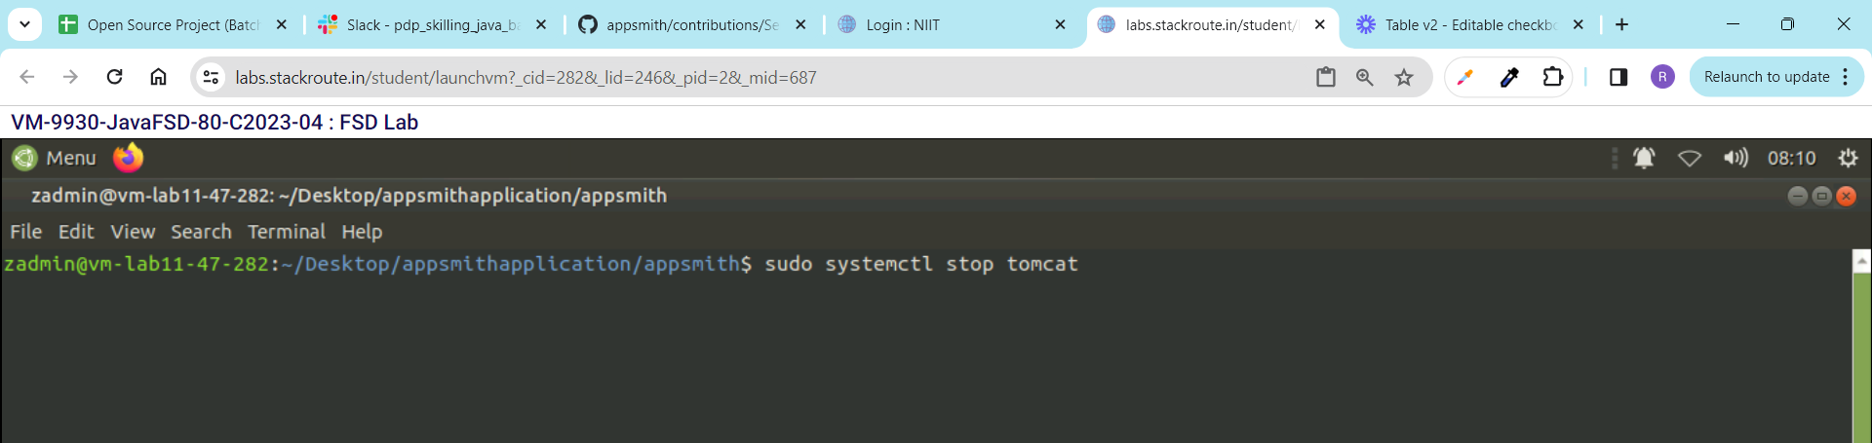

Then rerun the same command mention above.



