**Assignment_5**

**Automation And Selenium**

**Submitted by Kuldeep Parmar**

1. **What is Automation Testing?**

Automation Testingis a type of software testing in which test cases are executed with using any automated tools

So automation testing refers to any approach that makes it possible to run tests without human intervention

Traditional testing has been done manually. A human follows a set of steps to check whether things are behaving as expected While an automated test is created once and then can run any time needed

For a long time, developers have automated their unit testing That is, the tests that check whether a given function is working properly. Then automated testing frameworks like selenium were developed. These allow modules or entire applications to be tested automatically

These frameworks allow a test script to interact with your UI, replicating the actions of a user

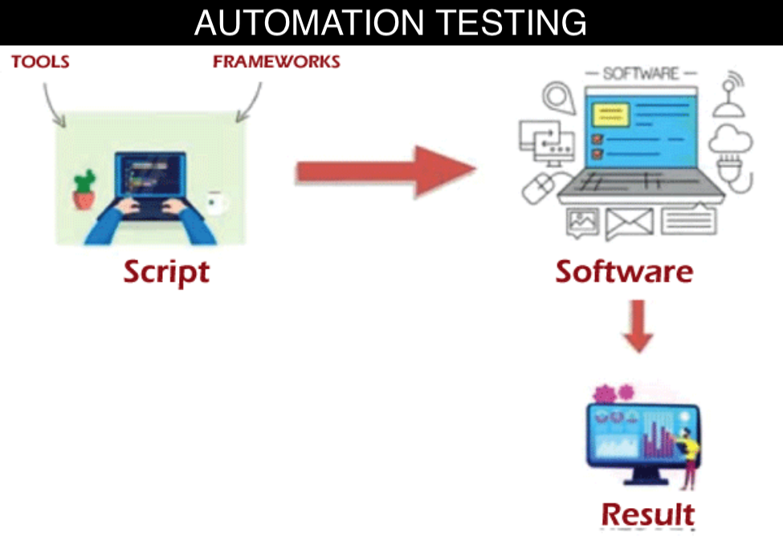

For instance, they allow you to find a specific button and click it or locate a text entry box and fill it out correctly. They also allow you to verify that the test has completed correctly

As a result, automation testing reduces the time and effort needed for extensive and repetitive testing tasks

1. **Which Are the Browsers Supported by Selenium IDE?**

Selenium IDE supports the following browsers

* Google Chrome
* Mozilla Firefox
* Safari
* Internet Explorer
* Microsoft Edge
* Opera

1. **What are the benefits of Automation Testing?**

* Faster Execution
* Repeatability
* Cost-Effective Over Time
* Saving Costs
* Faster Feedback Loop
* Better Allocation of Resources
* Guarantees Higher Accuracy
* Increased Test Coverage
* Early Detection of Bugs
* Increased Test Reliability
* Enhanced Regressions Testing

1. **What are the advantages of Selenium?**

Advantages of Selenium for Automation Testing

* Selenium automates browsers. That’s it!
* Language and Framework Support
* Open-Source Availability
* Multi-Browser Support
* Support Across Various Operations
* Ease of Implementation
* Reusability and Integrations
* Flexibility
* Parallel test execution and faster market launch

1. **Why should testers opt for Selenium and not QTP?**

**Features of Selenium**

* Open-source tool that performs a very specific task in which the source code is openly published for use and modification from its original design, free of charge
* Frequent regression testing
* Rapid feedback to developers
* Virtually unlimited iterations of test case execution
* Support for Agile and extreme development methodologies
* Disciplined documentation of test cases
* Customized defect reporting
* Finding defects missed by manual testing

**Selenium has four Components**

* Selenium IDE
* Selenium RC
* Selenium WebDriver
* Selenium Grid

Selenium supports Languages i.e. Java, C#, PHP, Python, Perl, Ruby

**Selenium over QTP**

|  |  |  |
| --- | --- | --- |
| **Parameters** | **Selenium** | **QTP** |
| License | Open-source | Licensed |
| Flexibility | Run across different browsers | Run only on Windows |
| Programming language | Supports many languages like Java, Python, C# and so on | Supports only VBScript |
| IDE basis | Works on Eclipse, •Net, NetBeans, etc | Works only on QTP developed IDE |
| Repository | Does not have an object repository of its own | Has its own object repository |
| Environment | Allows all additional plugins | Supports SAP, Oracle and includes no add-ons to the software |