**Q1:-Experiment with Anders Blockchain.**

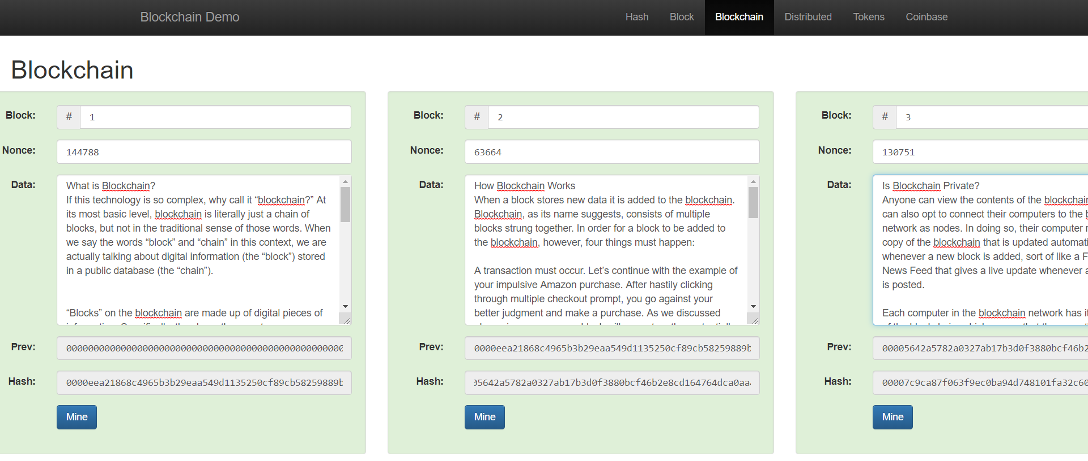

**Q2:-Make a sample contract on remix.Ethereum.org and publish it on your github.**

**SimpleStorage.sol file:-**

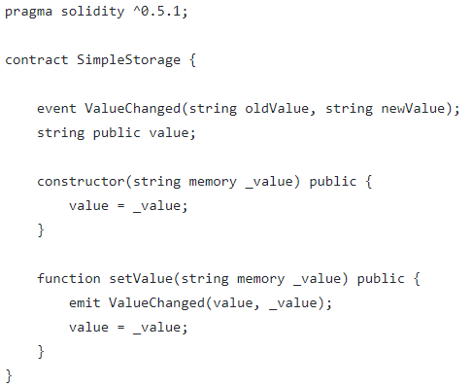

This simple contract defines a string named value that gets initialized in the constructor and gets saved in the storage. This string is updated with the method setValue. When the value is updated, it emits an event ValueChanged.

**SimpleStorage_test.sol file :-**

